CUNY and the City: Potholes and Bicycle Lane Access
  - DATA / DHUM 73000 | Project 1 | Fall 2026 | Jean-Marc Petit

Research question and broader purpose
How did reports of potholes and blocked bicycle lanes differ around selected CUNY campuses from 2020 to 2025, and what can maps and monthly charts tell us about those differences? This study is part of a broader investigation of access to CUNY across the boroughs. Access involves more than the availability of information; it also includes campus facilities, transportation, and conditions in the surrounding streets. I selected these two issues because they can affect people traveling by bicycle or scooter, while recognizing that they represent different problems and should be examined separately.

Data and visualizations
I used New York City’s 311 Service Requests data, collected by the city from requests submitted by the public and made available through NYC Open Data. The period is January 2020 through December 2025. The fields include request identifier, date, complaint category and detail, location coordinates, and borough. I grouped the two complaint types separately and matched geocoded reports to reference points around CUNY campuses. The Tableau and Python versions were designed around 26 locations and a 500-meter radius. Missing coordinates, changing classifications, and overlapping campus areas affect what can be counted.
The dashboard uses a map to show where complaints were reported, bars to compare campus areas, and monthly lines to show changes over time. The monthly lines represent New York City as a whole, while the campus map and bars concern selected nearby locations. That difference matters: they are not different views of an identical population. The visualizations help identify clusters and changes in reporting, but a 311 complaint is not confirmation that a street was hazardous. Higher totals can also reflect differences in reporting behavior, infrastructure, and geographic coverage.
Published Tableau dashboard:
https://public.tableau.com/app/profile/jean.marc.petit/viz/JeanMarcCUNYandtheCity/00CUNYANDTHECITYALLRESEARCH

Why compare three platforms?
I generally prefer open-source applications because I can inspect the process, keep control of files, and repeat the work without relying entirely on one vendor. I nevertheless understand why Tableau is useful in this course: it lets students build readable maps and charts quickly and provides an established way to publish work on Tableau Public. Using a separately hosted dashboard may simplify embedding on CUNY Academic Commons, but it does not eliminate security risks. Public data and third-party content still need to be checked before publication.
I therefore compared Tableau, Python with Plotly, and Apache Superset with a separate Leaflet map. I also wrote a step-by-step manual for each, covering installation, data preparation, charts, checks, and sharing. The manuals were an important part of the comparison: explaining each step made it easier to identify hidden assumptions and judge whether another student could reproduce the result.

Findings and conclusion
Tableau was the most approachable for creating a visual presentation from prepared data. Python required programming but made the collection, checks, and generation of the dashboard more repeatable. Superset required the most setup because it involved a database and additional services, although that structure would be useful for a continuing project shared by several researchers. The detailed Leaflet map is a separate component, not a native Superset chart.
This was not a controlled performance test. Tableau and Python used the intended 26-campus, 500-meter design; the Superset teaching prototype used three example locations and a 1,000-meter radius. Their totals cannot be compared directly. Similarly, the small compressed packages do not contain full installed software or necessarily a verified complete snapshot of all data. The broader lesson is that selecting a visualization tool should follow the research question, audience, and need to maintain the work. I would use Tableau for a clear public presentation, Python to collect and verify records, and Superset for a longer-term shared research service. The next step is to standardize the campus coordinates and complaint definitions so the three results can be compared on identical data.
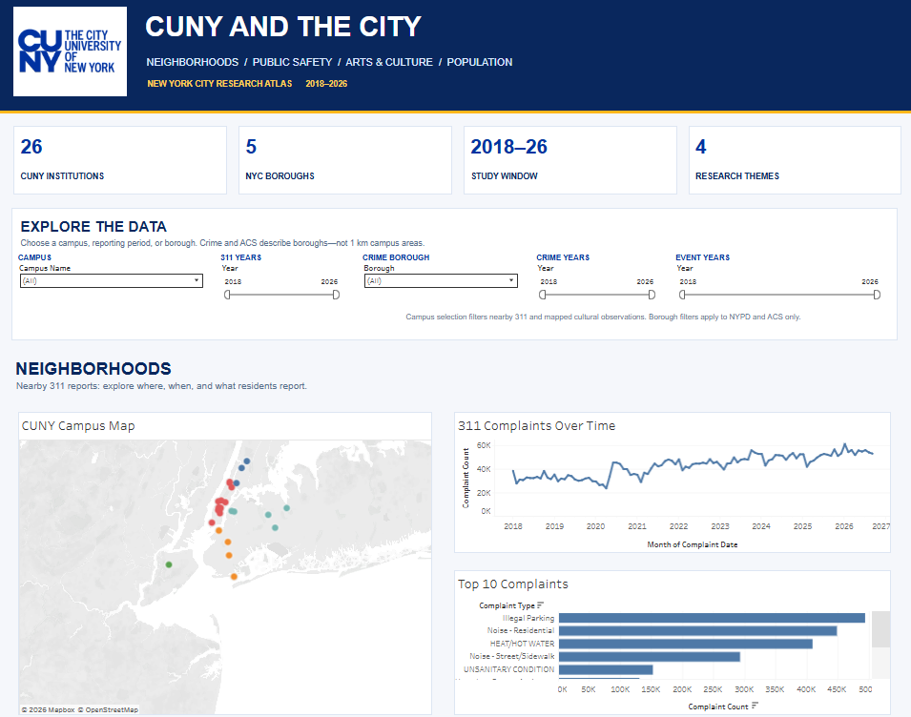
Figure 1. Tableau dashboard view
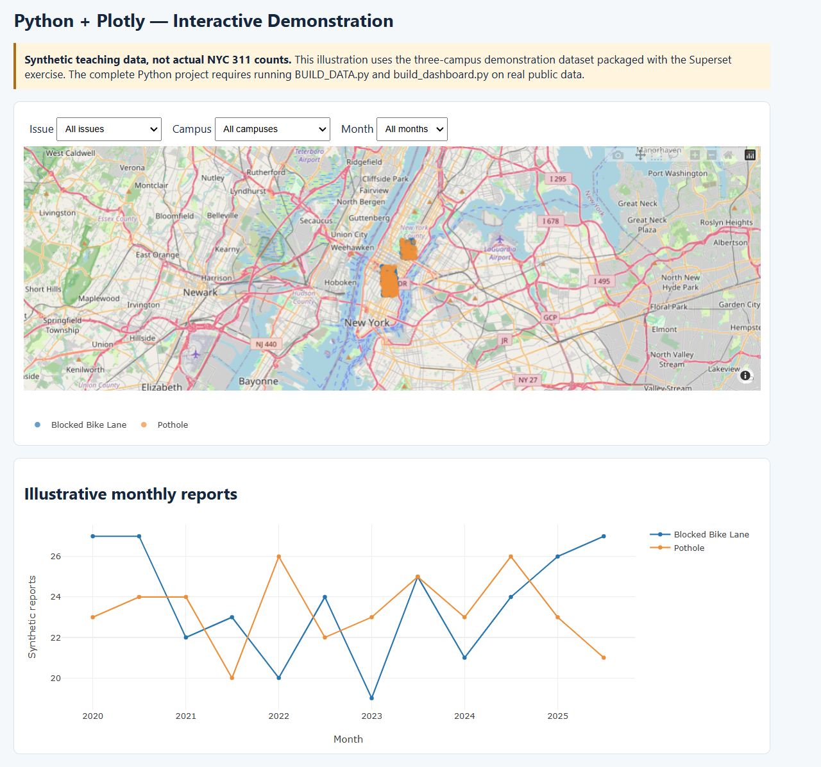
Figure 2. Python dashboard view
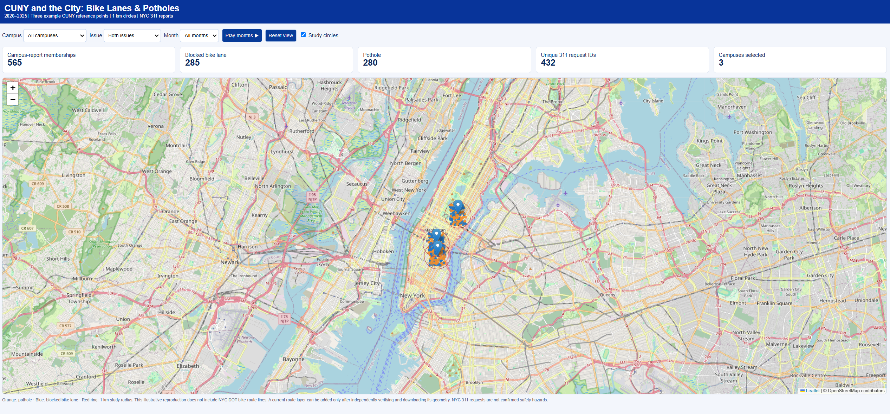
Figure 3. Leaflet street-map view
Project page: https://jeanmarcpetit.commons.gc.cuny.edu/

Supplementary evaluation: workflow, storage, time, and reproducibility
The comparison below reflects the supplied ZIP archives, technical comparison, and three instruction manuals. ZIP sizes are measured from the attached files; times and installed storage are planning estimates rather than recorded trials.
Specification | Tableau Public | Python + Plotly | Superset + Leaflet
Measured project ZIP | 8.90 MB | 1.38 MB | 6.79 MB
Install / initialize (estimate) | 10–25 min | 10–25 min | 30–90 min
Fetch 2020–2025 data (estimate) | 10–60+ min | 10–60+ min | 10–60+ min
Geographic matching (estimate) | 30–120+ min manually | 2–30 min computing | 2–30 min computing
Build / rebuild (estimate) | 45–120 min manually | 5–20 min to run prepared code | 60–180 min configuration
Test and save (estimate) | 15–30 min | 10–30 min | 20–60 min
Suggested free disk space | 5 GB | 5 GB | 20 GB
Practical RAM guidance | 8–16 GB | 8–16 GB | 16–32 GB preferred
Main strength | Quick visual design | Auditable automation | Shared database dashboards
Main difficulty | Preparing / refreshing data | Writing and maintaining code | Setup and maintenance
Note. Package sizes are measured; installation and workflow times are planning estimates, not benchmarks.

What the figures mean
The Python package is the smallest, at 1.38 MB, followed by Superset at 6.79 MB and Tableau at 8.90 MB. All three fit under a 20 MB attachment ceiling in their present compressed form. But these are mostly instructional materials and scripts, not complete working installations with downloaded datasets, database volumes, and dependencies. A ZIP file should therefore not be mistaken for the full storage requirement of an operational system.
Tableau has the clearest first-use workflow: connect a prepared file, make a map and charts, and publish. Python involves writing or understanding scripts at the beginning, but once these exist, the same process can be rerun and checked systematically. Superset requires extra components, particularly a database and the application service, but it can serve repeated analysis by multiple users. The time estimate of 5–20 minutes for Python refers to running existing code, not the original development and debugging effort, so it does not prove Python is faster to develop.

Limits of the comparison
The programs were not benchmarked on the same hardware using identical geographic definitions and validated complete datasets. For Tableau and Python the intended study uses 26 CUNY reference locations and 500-meter buffers. The Superset teaching prototype covers three example locations and 1,000-meter buffers. The manuals also note that some historical live-data and integration checks remain incomplete. I can compare the work required, the kinds of result each produces, and the demands of reproducing it, but not legitimately rank the three products by equivalent count accuracy or measured speed.

Overall assessment
Preparing three manuals was as useful as preparing three dashboards. Each manual exposes where a student needs another dataset, a command, a quality check, or an explanation of a choice. Tableau is best suited to introducing visualization and communicating results. Python is the foundation I would choose for collecting and validating data. Superset is the strongest candidate for a continuing team-based research service, provided someone can maintain the server and database. I would not replace one with another automatically: a shared, documented data workflow could support all three while keeping the research definitions consistent.

References
Apache Software Foundation. (n.d.). Apache Superset. https://superset.apache.org/
New York City Office of Technology and Innovation. (n.d.). 311 service requests from 2020 to present [Data set]. NYC Open Data. https://data.cityofnewyork.us/d/erm2-nwe9
Open Worldwide Application Security Project. (n.d.). Third party JavaScript management cheat sheet. https://cheatsheetseries.owasp.org/cheatsheets/Third_Party_Javascript_Management_Cheat_Sheet.html
Plotly Technologies Inc. (n.d.). Plotly Python open source graphing library. https://plotly.com/python/
Tableau. (n.d.). Tableau Public FAQ. https://help.tableau.com/current/pro/desktop/en-us/public_faq.htm

