CUNY and the City: Potholes and Bicycle Lane Access
  - DATA / DHUM 73000 | Fall 2026 | Project 1 | Jean-Marc Petit
Revised Project 1 proposal | two paragraphs and visualization sketch

Paragraph I — Research question
How did reports of potholes and blocked bicycle lanes vary near selected CUNY campuses from 2020 through 2025, and what do maps and monthly charts reveal about those patterns? This is one part of my broader research on access to CUNY across the boroughs, including information, transportation, physical facilities, and the streets surrounding campuses. The intended audience is CUNY students and staff, especially those who travel by bicycle or scooter; the two issues will be studied separately because they describe different conditions, not a single measure of safety. As a secondary part of the exercise, I will compare Tableau, Python, and Apache Superset to understand how each handles the work of producing and sharing the visualizations.

Paragraph II — Dataset and variables
I will use New York City’s 311 Service Requests data for January 2020 through December 2025, retaining reports classified as potholes or blocked bicycle lanes and documenting the exact complaint-category and detail filters. I will examine service request ID, creation date, complaint type and detail, borough, latitude, and longitude, and derive month, campus area, distance from campus, and report counts; geocoded reports will be matched to selected campus reference points using a 500-meter radius. I plan to show a map of report locations, a bar chart comparing campus areas, and monthly trends, and to document the Tableau, Python, and Superset workflows in separate manuals so that their ease of use and reproducibility can be assessed; any citywide trend will be labeled separately from campus-area counts.

Proposed visualization sketch
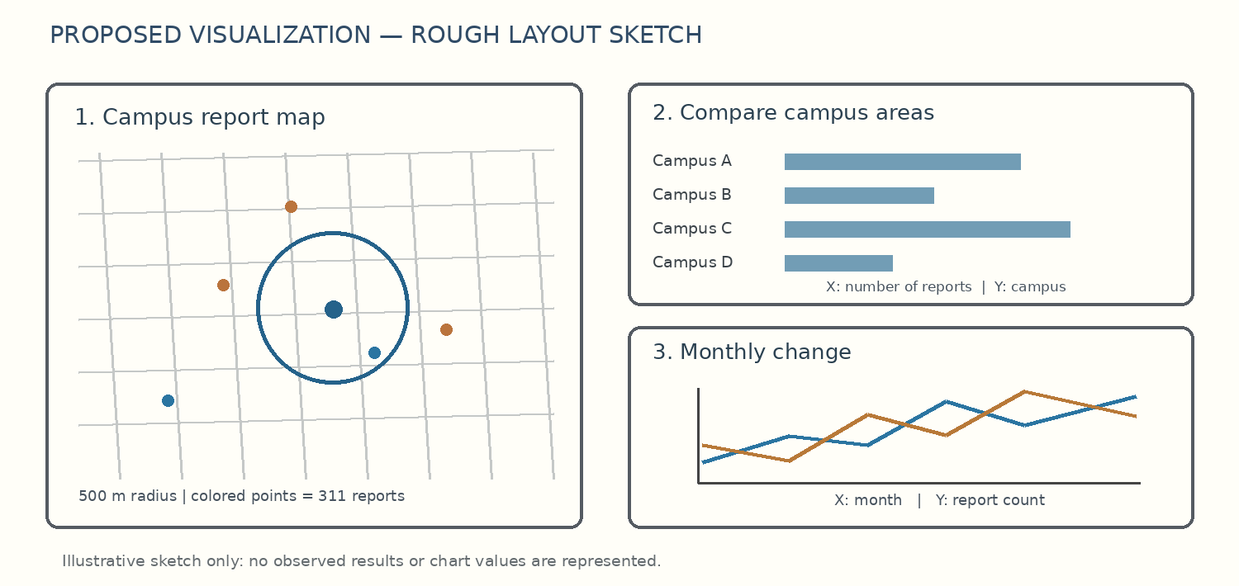
Sketch labels: map points = report locations; the circle marks a 500-meter campus area. Bar chart: x-axis = report count, y-axis = campus. Line chart: x-axis = month, y-axis = number of reports; each complaint category remains a separate series.
Source: NYC Open Data, 311 Service Requests from 2020 to Present: https://data.cityofnewyork.us/d/erm2-nwe9

