CUNY and the City
GUIDE 2 | Python + Plotly | Beginner programming route
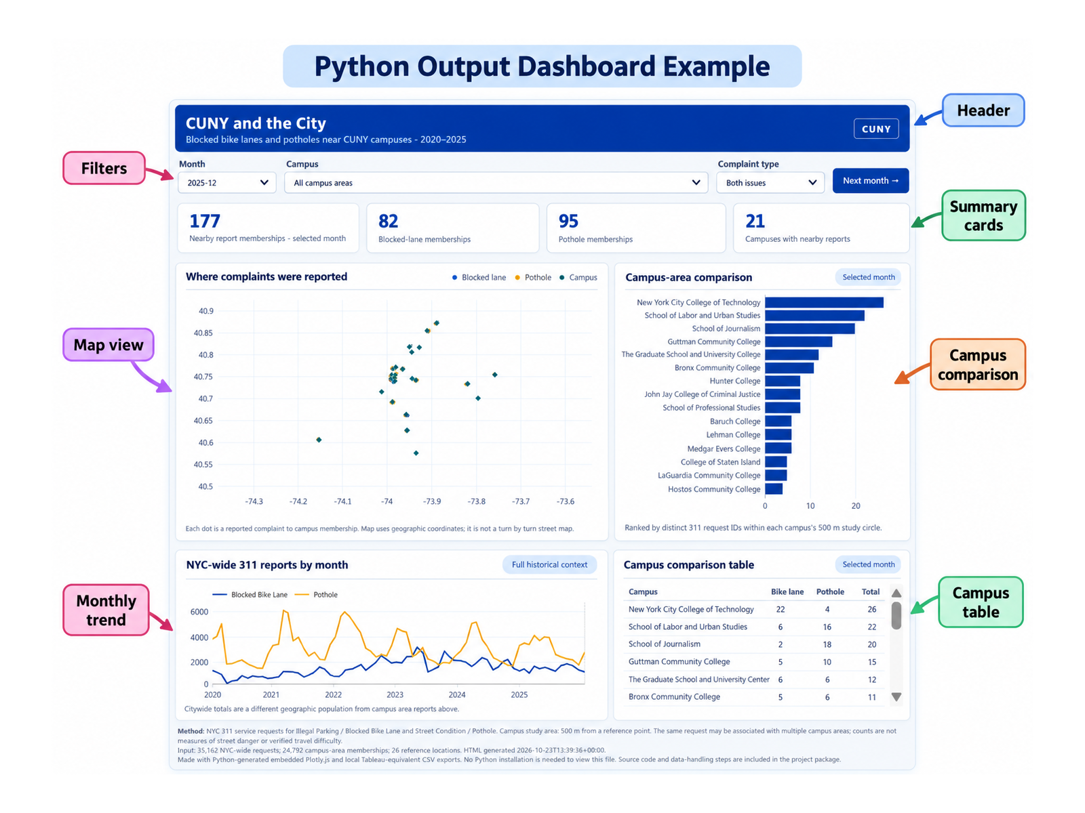
Actual Python dashboard produced by Project 1. This is the target output for this guide.
Our common research question Where and when were pothole and blocked-bike-lane 311 requests reported near CUNY campus areas during 2020–2025? What do the patterns reveal, and what are their limits?

Use this manual with the accompanying files in the same download. Each step has an action, a reason, and a check. Figures are annotated instructional illustrations or labeled reference screenshots, not claims of a completed live installation.

1 What the program will do
Python fetches and prepares public 311 records, writes five CSVs, runs quality checks, and creates a standalone interactive HTML dashboard with a campus map, NYC-wide trend and campus bars. This follows the 26-campus/500-meter study definition, subject to verifying the source campus list.
Word | Everyday meaning
Python | Instructions the computer runs
CSV | Plain-text spreadsheet-like data
Script (.py) | A file containing Python commands
Plotly | Software library for interactive charts
HTML | A webpage saved as a file

2 Put everything in one project folder
- Install Python 3 from python.org and enable the Windows launcher if offered.
- Extract the included Python student kit into a folder called Project 1. Check that BUILD_DATA.py, QA_DATA.py, BUILD_DASHBOARD.bat, and 02_PROGRAMS\build_dashboard.py are present.
- In File Explorer open Project 1, click the address bar, type cmd and press Enter.
py --version
Check your work A version number means Python is available. If you see “not recognized,” repair your Python installation before continuing.

3 Learn how one line fetches public data
py -c "import urllib.request; print(urllib.request.urlopen('https://data.cityofnewyork.us/resource/erm2-nwe9.json?$limit=1').read(180))"
py starts Python; urllib.request opens a public webpage; read(180) prints the first 180 bytes. This is only a one-record demonstration; it is not the six-year research download.

4 Run the complete workflow
- From Command Prompt in Project 1, run the data builder below. It may take time and requires internet access.
- Open 03_DATA\tableau. Check that five CSV files were created and that 03_campuses.csv contains the intended locations.
- Run the quality-check program and review its output.
- Double-click BUILD_DASHBOARD.bat to install Plotly if necessary and create 04_WEB_DASHBOARD\CUNY_and_the_City.html.
- Double-click the resulting HTML file and test the Month and Issue menus.
py BUILD_DATA.py
py QA_DATA.py
# Then double-click BUILD_DASHBOARD.bat in File Explorer
Check your work The HTML page displays a map, two monthly lines, campus bars and controls. If a CSV is missing, check the filename and whether the data builder completed successfully.

5 Understand the code with small examples
# Read rows from a CSV file
import csv
with open('02_map_points.csv', newline='', encoding='utf-8') as f:
rows = list(csv.DictReader(f))
print(len(rows))
import csv brings in a file-reading tool. with open opens the file. DictReader uses the first line as column names. len(rows) counts records. In the actual project the script uses a folder path, not this abbreviated classroom example.
# One report can be near multiple campuses
by_campus = {}
for row in rows:
by_campus.setdefault(row['campus'], set()).add(row['unique_key'])
# set() keeps each request ID only once within each campus
The set() instruction prevents double-counting the same ID within a campus; overlapping campus circles can still legitimately share a request.
# Plotly draws geographic points
import plotly.graph_objects as go
fig = go.Figure()
fig.add_trace(go.Scattermap(lat=[40.75], lon=[-73.98],
mode='markers', name='Example 311 point'))
The coordinate pair says where to draw the point. The full builder reads the latitude and longitude fields from the real CSV. This is a tiny explanatory excerpt, not the complete builder.

6 Read your finished dashboard
Annotated view of the actual Python output. The labels point to the main dashboard parts.
- Select Month = 2022-05: only the map markers should change.
- Select Issue = Blocked Bike Lane: orange pothole dots should disappear.
- Reopen the saved HTML file and confirm the charts still appear.
- Describe one finding and one limitation: a 311 report is not proof of a confirmed street hazard.
Important The 2020–2025 citywide trend and 500-meter campus comparisons concern different populations. The live six-year retrieval and historical numeric parity have not been verified end to end.

7 If a command fails
Problem | First thing to check
py not recognized | Reinstall/repair Python launcher
Missing CSV | Run BUILD_DATA.py from Project 1 root
No map background | Check internet connection for map tiles
Incorrect counts | Verify issue classification, 26 campus points and extraction date

