CUNY and the City
GUIDE 3 | Apache Superset + Leaflet | AI-assisted college route
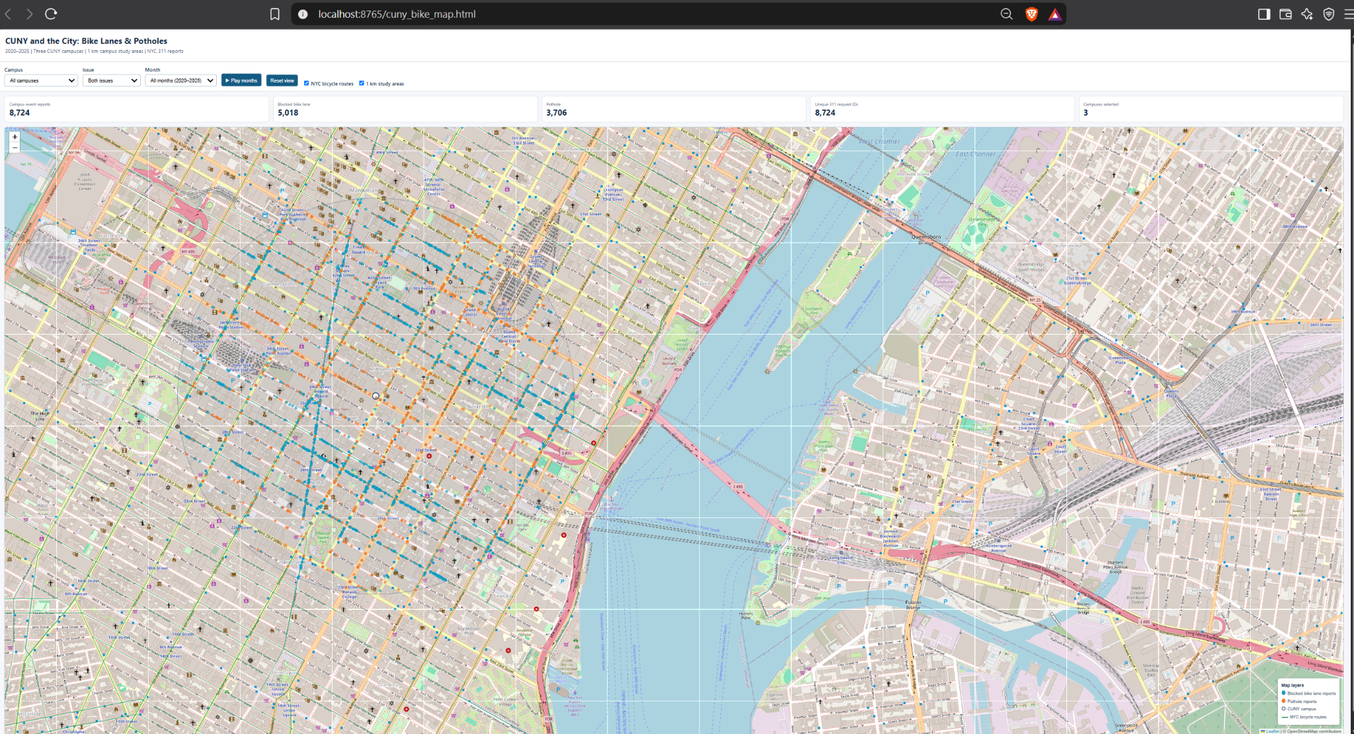
Target/reference: annotated image; menu appearance may vary by software version.
Our common research question Where and when were pothole and blocked-bike-lane 311 requests reported near CUNY campus areas during 2020–2025? What do the patterns reveal, and what are their limits?

Use this manual with the accompanying files in the same download. Each step has an action, a reason, and a check. Figures are annotated instructional illustrations or labeled reference screenshots, not claims of a completed live installation.

1 What you are actually building
This is a three-campus, 1,000-meter teaching prototype—not the 26-campus, 500-meter Tableau/Python study. Apache Superset supplies charts and tables; the detailed screenshot is a separate Leaflet HTML map with playback controls, not a built-in Superset screen.
Component | Function
Python / NYC Open Data | Downloads and prepares report records
PostgreSQL | Stores matched data and monthly summaries
Apache Superset | Creates metrics, trend charts, comparison bars and filters
Leaflet / JavaScript | Custom street map, point layers and month playback

2 Install software and test the starter kit
- Install Python 3, Docker Desktop (WSL 2 backend), and Git for Windows; restart if needed and launch Docker Desktop.
- Extract the provided complete Superset replication ZIP into Project 1. In File Explorer, type powershell in the address bar to open a terminal in that folder.
- Run the commands below; all three should print version information.
- Run the synthetic practice demo. It generates five example CSVs and an HTML map; those numbers are not real NYC research results.
py --version
docker --version
git --version
powershell -ExecutionPolicy Bypass -File .\01_DEMO.ps1
Check your work Five demo CSVs appear in data, and the interactive local page opens at http://localhost:8765/cuny_bike_map.html.

3 Fetch public data and match campuses
The complete project script makes public NYC Open Data requests, checks distances using the Haversine formula and saves five CSVs. Unlike the one-record teaching example, the live run spans 2020–2025.
powershell -ExecutionPolicy Bypass -File .\02_REAL_DATA.ps1
Check data/03_campuses.csv and data/05_quality_checks.csv before analysis. The three location points are illustrative until confirmed by the instructor. Report counts may differ from the historical screenshot.
# Distance rule explained in plain language
meters = distance(lat, lon, campus_lat, campus_lon)
if meters <= 1000:
matches.append(record)
distance() uses Earth-coordinate mathematics to measure meters between a complaint and a campus reference point. Only reports up to 1,000 meters away enter that campus group.

4 Load PostgreSQL and start Superset
- Leave Docker Desktop open. Run the loader script to create the class database and populate its tables.
powershell -ExecutionPolicy Bypass -File .\04_LOAD_DATABASE.ps1
- In a separate PowerShell window, start Apache Superset using the commands below; this requires network access and Docker images.
git clone https://github.com/apache/superset.git
cd superset
git checkout tags/6.0.0
docker compose -f docker-compose-image-tag.yml up -d
- Open http://localhost:8088. In Settings → Database Connections → + Database, choose PostgreSQL; use host.docker.internal, port 5433, database cuny311 and the project’s local account/password.
- Test connection. Create datasets for public.cuny_311_events and public.cuny_311_monthly. A PostgreSQL driver must be available in the Superset container; otherwise follow its documented installation instructions.
Check your work Both datasets are visible inside Superset. Do not confuse the application’s internal database with the separate cuny311 project database.

5 Make the charts in Superset
- Charts → + Chart → dataset cuny_311_monthly → Line Chart: X/time = month, series = issue, metric SUM(reports).
- Create a horizontal Bar Chart: dimension campus; metric SUM(reports).
- Create a Table with campus, month and issue and metric SUM(reports).
- On cuny_311_events make two Big Number cards: COUNT(*) for campus memberships and COUNT(DISTINCT unique_key) for distinct complaints.
- Dashboards → + Dashboard: add the charts and native filters for campus, month and issue if the version supports them.
Counting rule COUNT(*) on a monthly summary counts summary rows, not complaints. Use SUM(reports). A single distinct request can be in multiple 1 km circles.

6 Create and use the custom map
# From the Project 1 kit folder
powershell -ExecutionPolicy Bypass -File .\03_OPEN_MAP.ps1
Reference controls from the original HTML map: Campus, Issue, Month, playback and reset.
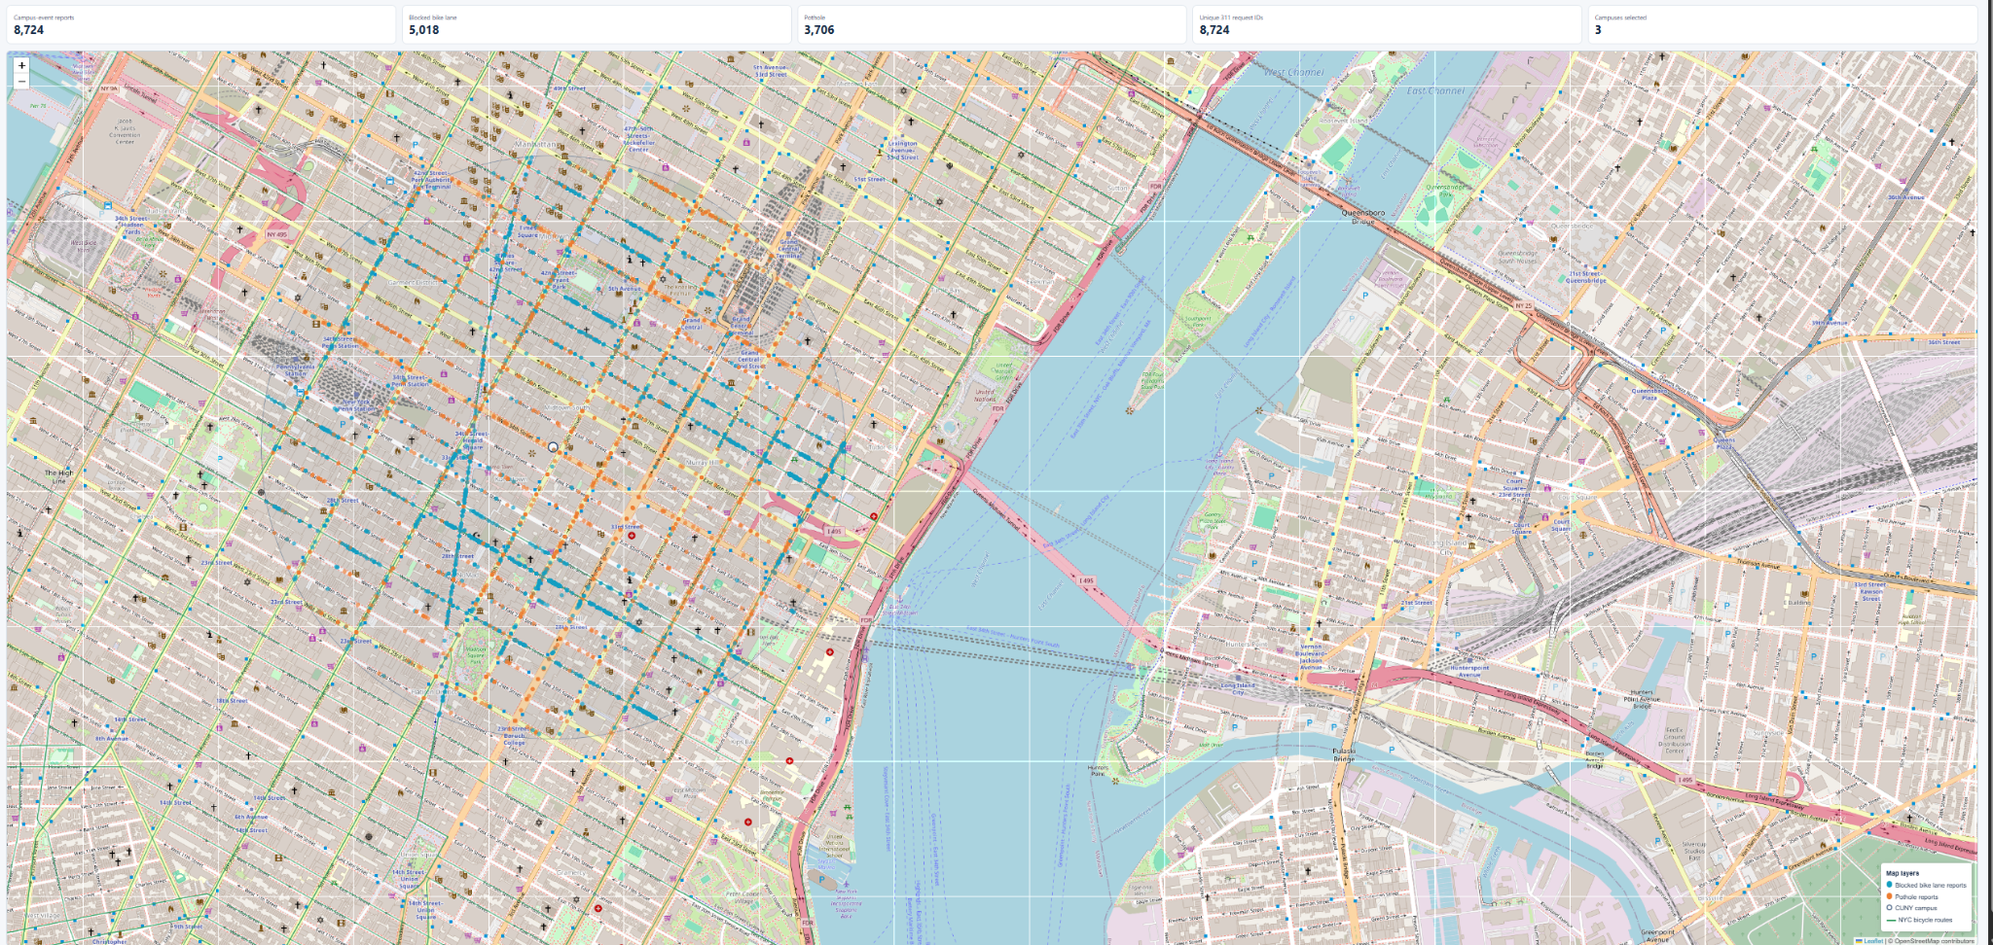
Reference street map from the original project; the teaching recreation omits the NYC DOT bicycle-route overlay.
Open http://localhost:8765/cuny_bike_map.html. Change Campus, Issue, Month and use Play Months and Reset. Keep the PowerShell server window open. Superset is a separate browser tab.

7 AI assistance: what happened and how to document it
AI was used to draft and troubleshoot setup scripts and the map generator. The teaching-kit code is a new reconstruction. The prompts below are examples for disclosure and teaching, not verified transcripts of the original exchange.
Example prompt | How to check the answer
Write Python code to fetch pothole and blocked bike lane reports for 2020–2025. | Check data source, years and complaint classification.
Match reports within 1 km of three CUNY reference points. | Check coordinate list and meter units.
Load five prepared CSV files into PostgreSQL. | Check database row totals.
Create a Leaflet map with campus, issue and month filters. | Try every filter and the reset button.
Suggested disclosure: AI helped draft and troubleshoot scripts; I executed and reviewed the programs, checked the definitions, and remain responsible for the analysis.

8 Final test and limits
- Confirm real-data CSVs replaced the synthetic demo files.
- Check the three coordinates and report definitions before publishing any findings.
- Confirm the PostgreSQL tables, Superset charts, and separate Leaflet page open.
- Verify distinct request IDs versus campus membership rows; record retrieval date.
- Do not call this a pixel-perfect reproduction: the original NYC DOT bicycle-route overlay and some historical settings are unavailable.
Validation status The synthetic teaching demo ran previously. Live six-year downloading, Docker/Superset integration, campus coordinates and exact historical parity have not been fully tested together.

