CUNY and the City
GUIDE 1 | Tableau Public | No programming required
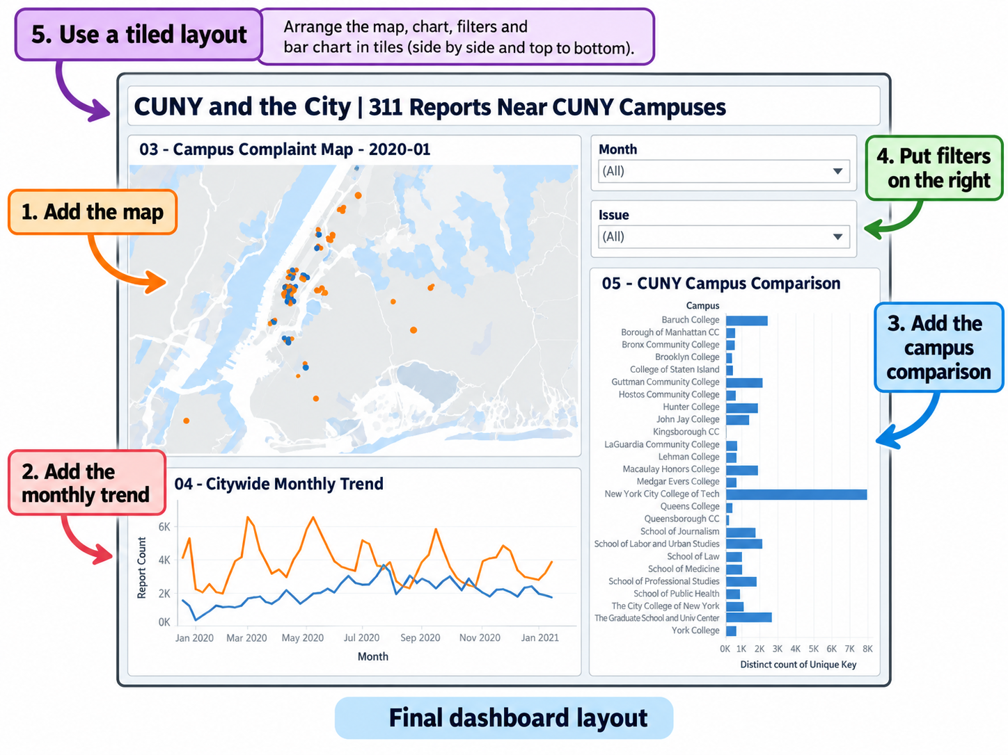
Target/reference: annotated image; menu appearance may vary by software version.
Our common research question Where and when were pothole and blocked-bike-lane 311 requests reported near CUNY campus areas during 2020–2025? What do the patterns reveal, and what are their limits?

Use this manual with the accompanying files in the same download. Each step has an action, a reason, and a check. Figures are annotated instructional illustrations or labeled reference screenshots, not claims of a completed live installation.

1 What you will build
A map of reports around 26 CUNY campus reference locations (500-meter circles), a NYC-wide monthly line chart, a campus comparison, and Month/Issue selectors. The map and campus bars use local matches; the trend uses all NYC.
File | Use
02_map_points.csv | Map and campus bars
04_citywide_monthly.csv | Citywide trend
03_campuses.csv | Reference coordinates
01_campus_monthly.csv | Optional campus-month totals
05_quality_checks.csv | Check and document data

2 Open your project files
- Unzip the supplied Tableau package into a folder named Project 1. Open File Explorer and create 03_DATA\tableau and 04_TABLEAU.
- Place all five prepared CSV files in 03_DATA\tableau. If the ZIP does not contain those prepared files, follow the raw-data instructions in section 7 before continuing.
- Open Tableau Public Desktop. Click Connect → Text file, choose 02_map_points.csv; then Data → New Data Source → Text file, choose 04_citywide_monthly.csv. Keep the sources separate.
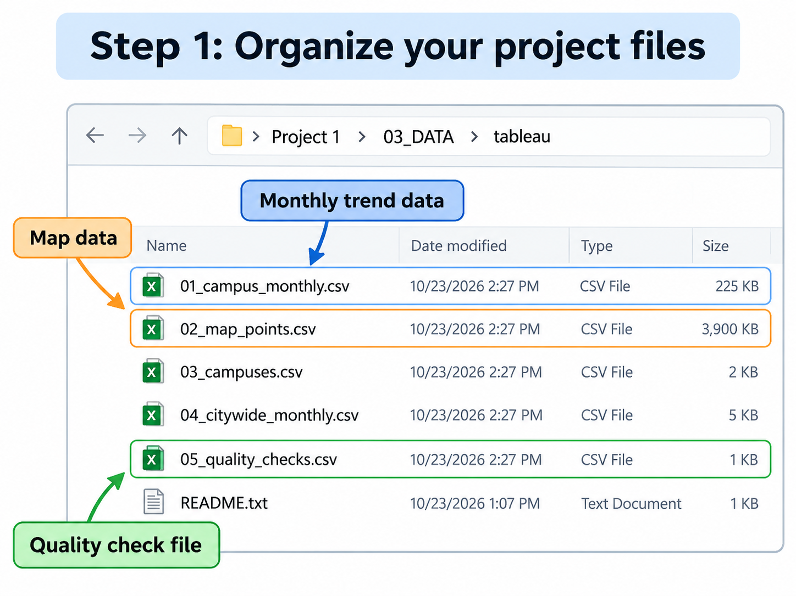
Check the file names and folders; do not change CSV column names.
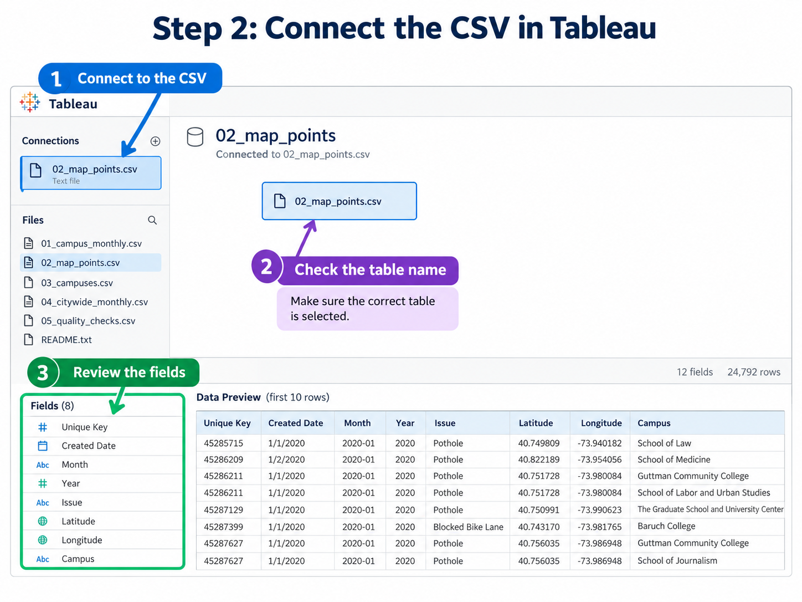
Connect the map data first, then the independent citywide data source.
Check your work The Data pane lets you switch between 02_map_points and 04_citywide_monthly. Latitude and Longitude are geographic; Month is ordered chronologically.

3 Make the map: where?
- Create a worksheet named 03 - Campus Complaint Map and select 02_map_points.
- Drag Longitude to Columns and Latitude to Rows. Choose Circle under Marks.
- Drag Issue to Color (blue: Blocked Bike Lane; orange: Pothole). Drag Unique Key to Detail.
- Drag Issue to Filters and choose Show Filter. Drag Month to Pages and also to Filters → Show Filter.
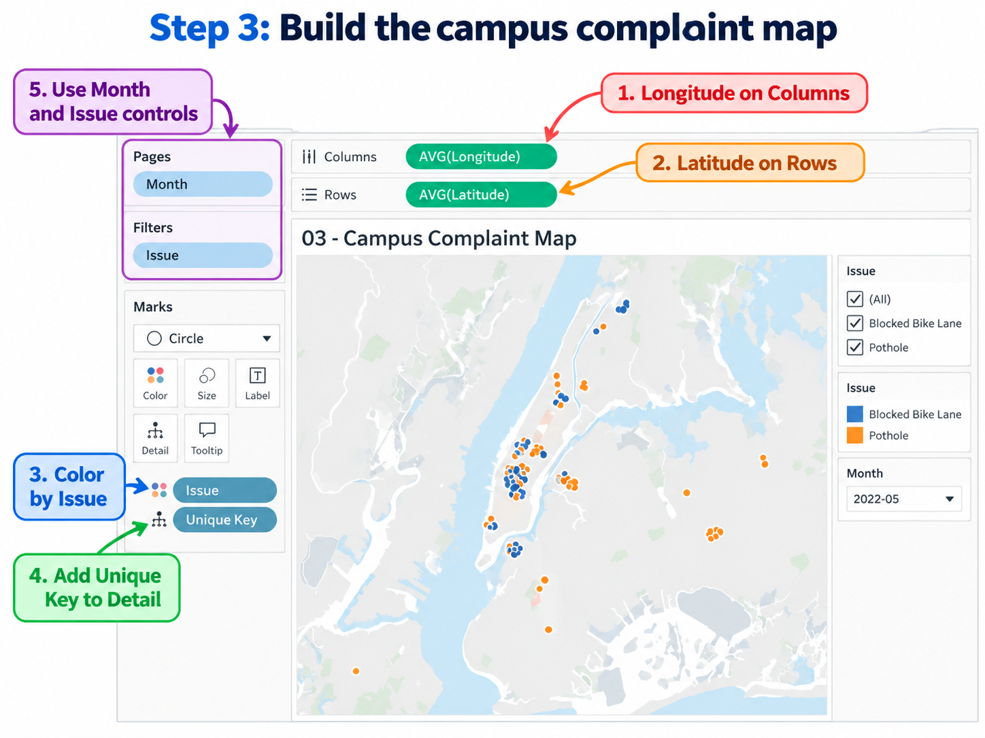
Columns/Rows position dots; Color shows issue; Detail keeps separate report IDs.
Check your work Blue and orange points appear; Month and Issue both have selectors. If there is only one point, check Unique Key on Detail.

4 Make the line chart: when?
- Create a worksheet named 04 - Citywide Monthly Trend from 04_citywide_monthly.
- Drag Month to Columns and SUM(Report Count) to Rows.
- Choose Line under Marks and move Issue to Color. Keep 2020–2025 ordered left to right.
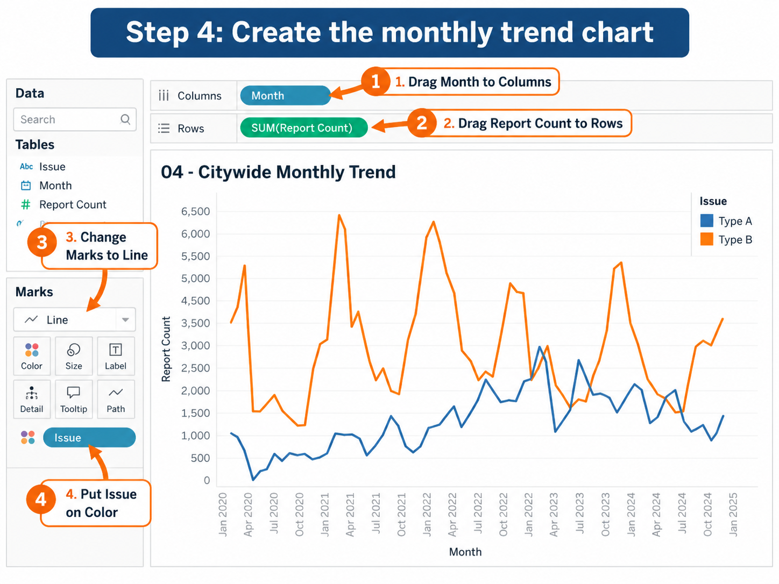
Instructional screenshot. Read the series as Pothole (orange) and Blocked Bike Lane (blue); ignore placeholder legend labels in the illustration.
Check your work Two lines show NYC-wide requests, not just reports within campus areas.

5 Compare campuses and arrange the dashboard
- New worksheet → 05 - CUNY Campus Comparison. Select 02_map_points.
- Drag Campus to Rows and Unique Key to Columns; change Unique Key to Measure → Count (Distinct), displayed as CNTD(Unique Key).
- Sort bars from most to fewest requests.
- New Dashboard → custom 1500 × 1000 → Tiled. Put Map upper left, Monthly Trend below, Campus Comparison at right.
- From the map sheet menu, show Month and Issue filters in the upper-right section. Add title CUNY and the City | 311 Reports Near CUNY Campuses.
- Save to 04_TABLEAU and publish to Tableau Public only if your instructor asks.
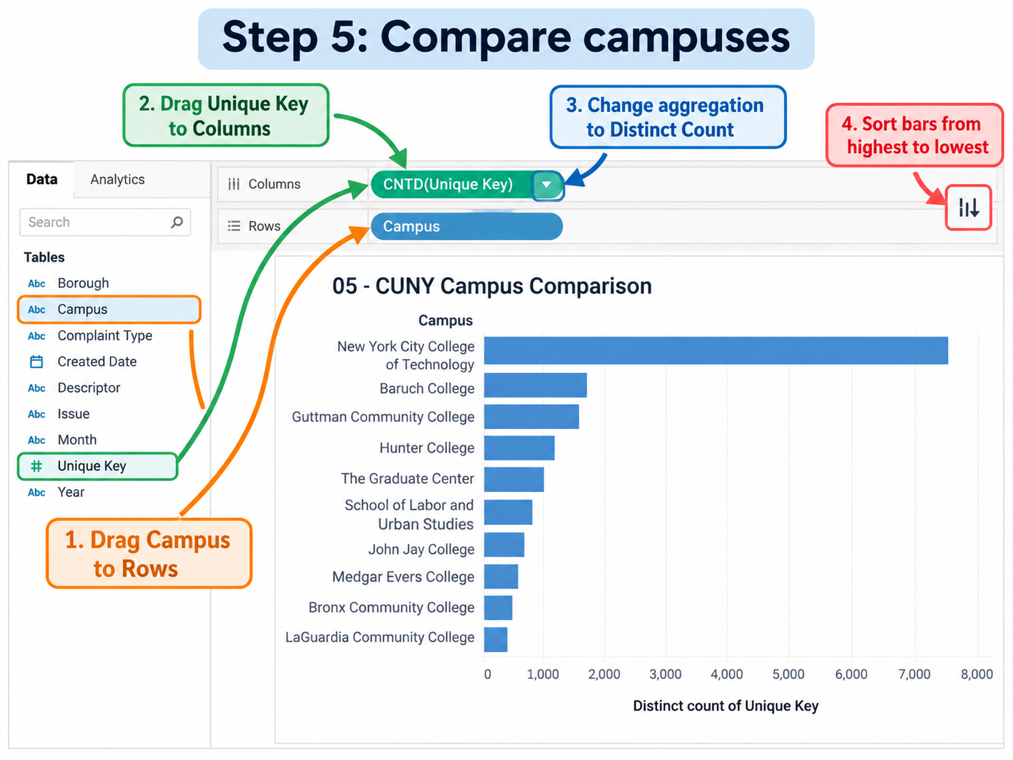
Count (Distinct) avoids counting the same request twice inside one campus area.
Final three-view arrangement and filter positions.
Test Choose a month and then Blocked Bike Lane. The map should change; the citywide chart and campus bars remain full-period context in this design.

6 Plain-English Tableau glossary
Term | Meaning
Rows / Columns | Places data vertically or horizontally in a chart
Marks | Controls dots, bars, lines and their appearance
Detail | Tells Tableau what makes individual marks distinct
CNTD / Count (Distinct) | Counts each 311 report ID once within a group
Filter | Lets the reader include or exclude part of the data

7 If you start from raw public data
Prepared CSVs are essential to this no-programming Tableau route. Downloading raw 311 records alone does not assign campus names. The earlier QGIS workflow remains a methodology outline, not a verified complete beginner exercise.
- Get 2020–2025 NYC Open Data 311 records (dataset erm2-nwe9) and confirm the exact Issue values used.
- Obtain and verify all 26 campus coordinate reference points.
- In QGIS, import the geographic points; reproject to a coordinate system measured in meters. Create 500-meter campus buffers and spatially join matching requests.
- Export the five CSV schemas listed above. Confirm unique IDs, missing coordinates, campus count, extraction date, and any overlap between buffers.
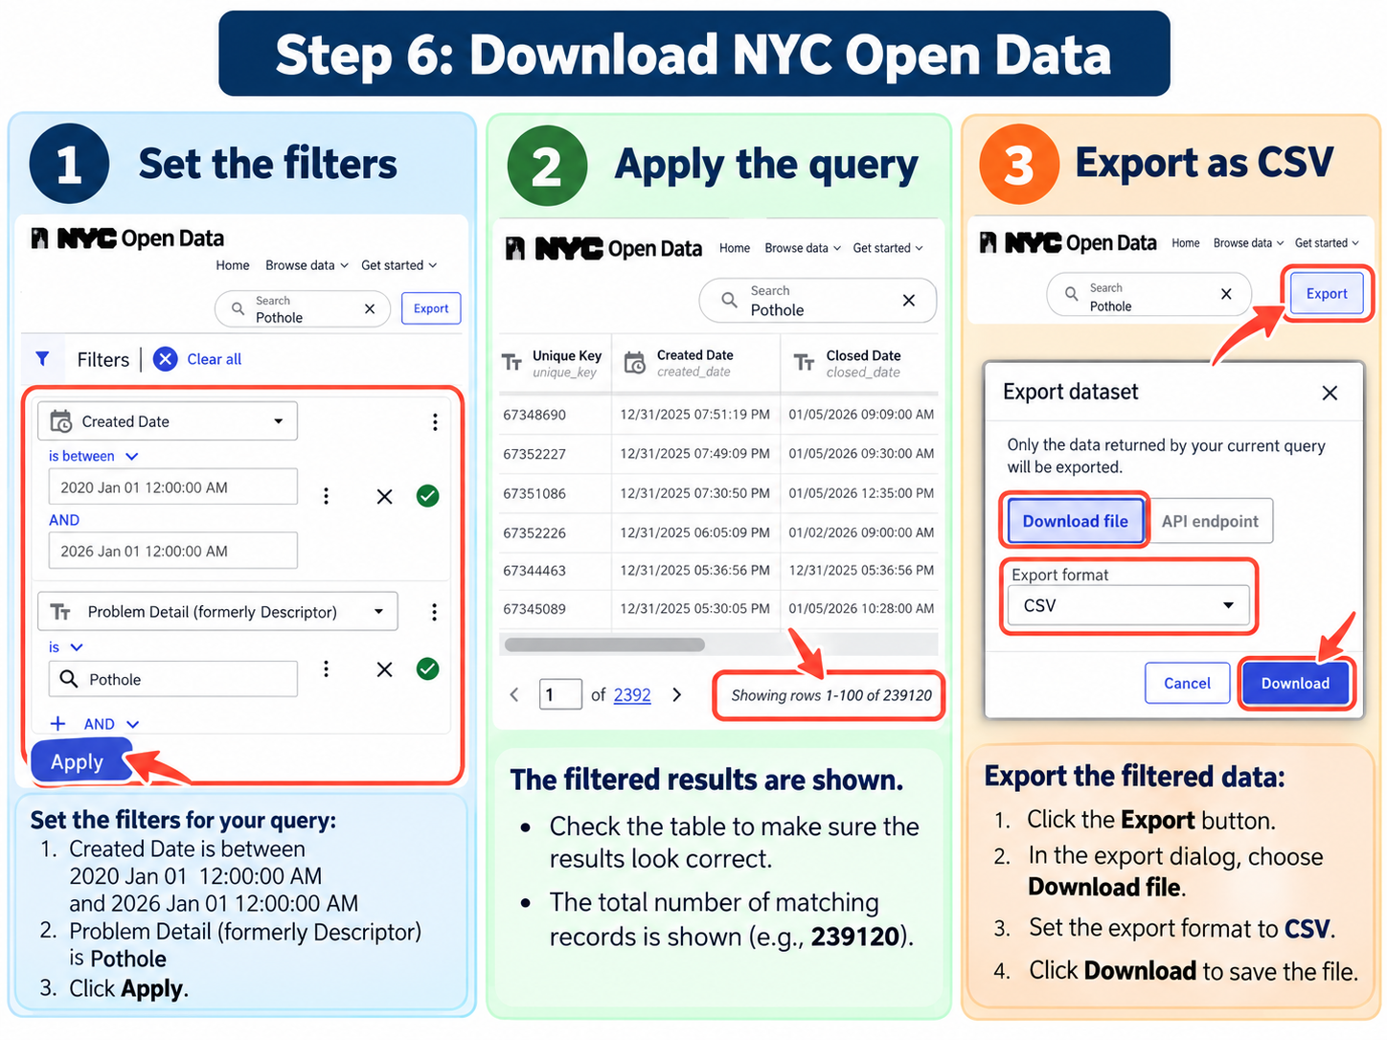
Illustration of filtering public data and exporting CSV. Geographic matching is a separate step.
Required for exact replication Keep the original five approved CSVs with the manual. The accompanying project archive contains a workbook and scripts, but not a verified, fixed snapshot of all five output CSVs. Fresh public data may not produce the same counts.

