CUNY and the City
  - Project 1 | Technical specifications and decision guide
Tableau Public • Python + Plotly • Apache Superset + Leaflet
Purpose Compare total storage, data retrieval, build and processing time, hardware needs, maintenance, and the kinds of projects each system handles best.
Important: package sizes quoted below are measured from the supplied materials in the previous review; software footprints and time estimates are planning ranges, not controlled benchmarks. All three implementations have not been tested end to end with identical live data.

1 Executive comparison
Specification | Tableau Public | Python + Plotly | Superset + Leaflet
Working style | Drag-and-drop charts | Scripts + interactive HTML | Database + charts + separate web map
Audience | First-time visualization learner | Beginner learning programming | College student comfortable with software setup
Coding | No for visual build; QGIS for raw matching | Yes, supplied programs | Python, PowerShell, SQL/configuration
Research geometry | 26 campuses, 500 m | 26 campuses, 500 m | 3 example campuses, 1,000 m
Local data store | CSVs / Tableau extracts | CSVs + SQLite | CSVs + PostgreSQL
Best for | Teaching & communication | Transparent research & automation | Shared institutional dashboards
Main obstacle | Raw-data geographic preparation | Code maintenance and fetch verification | Docker/database integration

2 Package sizes and disk planning
Measured package files are small because they contain guides and code rather than a complete installed environment or full six-year dataset.
Measurement | Tableau | Python | Superset
Supplied ZIP (reported) | 8.49 MB | 1.38 MB | 6.79 MB
Word manual (reported) | 8.84 MB | 1.37 MB | 6.52 MB
Source scripts, approximate | 8 KB | 19 KB | 13 KB
Installed software + dependencies (estimate) | 1.5–3 GB | 0.2–1 GB | 5–15 GB
Project data/database (estimate) | 0.01–0.5 GB | 0.1–1 GB | 0.1–2 GB
Suggested free disk allowance | 5 GB | 5 GB | 20 GB

ZIP size does not predict the size of a working project. Downloads, temporary extracts, PostgreSQL volumes, Docker images, and map assets drive actual storage consumption.
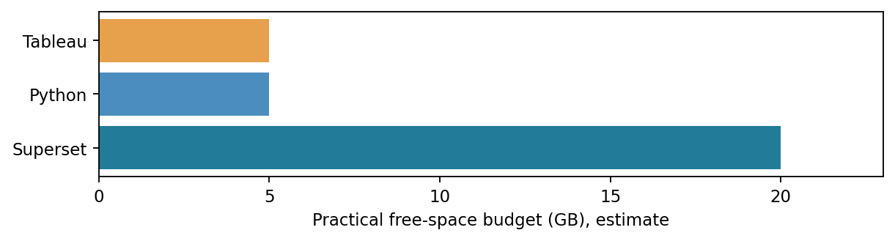

3 Hardware and installation
Resource | Tableau | Python | Superset
OS | Windows 11 | Windows 11 | Windows 11 with Docker/WSL2
Practical RAM | 8–16 GB | 8–16 GB | 16–32 GB preferred
CPU | 4 cores preferred | 4 cores preferred | 6–8 cores helpful
Dedicated GPU | Not required | Not required | Not required
Network | Downloads, basemap, publishing | API, dependencies, map tiles | Installation, API, map tiles
Setup complexity | Low | Low to medium | High

4 Estimated workflow times
Estimated ranges presume SSD, reasonable broadband, compatible installation and a first-time student. API failures or missing dependencies can add substantial time.
Task | Tableau | Python | Superset
Install/initialize | 10–25 min | 10–25 min | 30–90 min
Fetch six years of 311 | 10–60+ min | 10–60+ min | 10–60+ min
Prepare geographic matches | 30–120+ min manually | 2–30 min computation | 2–30 min computation
Construct/rebuild views | 45–120 min manually | 5–20 min run + check | 60–180 min configuration
Test and save | 15–30 min | 10–30 min | 20–60 min

Data fetching: what actually happens
The scripts query NYC Open Data by issue and month. Each request returns a manageable page of records, which the program saves locally. For 72 months and two issue categories, at least 144 month/issue queries are possible before pagination. Tableau can consume prepared CSVs, while Python and Superset pipelines can generate CSV summaries and matched campus records automatically.
Download time depends on how many records match, API responses, network speed, rate limits, retries and field selection. A fresh data fetch is not equivalent to reopening an existing dashboard.

5 Performance, refresh and scale
Capability | Tableau | Python + Plotly | Superset
Already-built dashboard | Opens interactively | HTML loads locally | Web dashboard after server starts
Change map filters | Yes | Yes | Yes (Leaflet separately)
Repeat data fetch | Extra procedure | Scriptable | Scriptable ingestion
Run nightly refresh | External automation required | Suitable for Task Scheduler | Pipeline + database schedule
Millions of rows | Optimized extracts may help | Chunking/DB optimizations necessary | Database/index optimization necessary
Multiple viewers | Public publishing | Requires hosting/sharing HTML | Designed for managed shared access
Local offline use | Possible with prepared data; basemap varies | HTML yes; map tiles may not | Needs local services; map tiles may not

The supplied student scripts are educational implementations, not demonstrated million-record benchmarks. For large and recurring workloads, test indexing, memory, query plans, and data refresh behavior on the real hardware.

6 Research reproducibility and limitations
Check | Tableau / Python | Superset prototype
Campus reference points | 26 intended; coordinate list must be verified | Three example points; must be verified
Distance rule | 500 meters | 1,000 meters
NYC-wide trend | Separate from nearby campus reports | Separate geographic population from local membership counts
Overlap accounting | One request may match multiple campuses | Same issue; do not sum memberships as unique citywide IDs
Current validation | Full public-data workflow not fully verified | Full Docker integration and exact map parity unverified

The three dashboards are not directly comparable in their counts until they use the same campuses, reference coordinates, radius, complaint definitions, and extraction date. NYC 311 entries reflect public reporting behavior, not independently verified street danger.

7 Which should you choose?
Your primary goal | Recommended system | Reason
Learn visualization from zero | Tableau | Minimal code; transparent chart assembly
Repeatable research and statistical testing | Python | Auditable data preparation and automation
Share standardized dashboards with a group | Superset | One database serving many charts and users
Publish a presentation quickly | Tableau | Convenient visual editing and Tableau Public
Create an independently hosted interactive HTML | Python + Plotly | Portable single-file result for small to moderate studies
Build a managed long-term campus analytics service | Superset + Python ingestion | Database-backed access, governance and recurring updates

Recommended long-term arrangement
NYC Open Data + verified CUNY coordinates → one Python collection/validation pipeline → SQLite or PostgreSQL → Tableau for teaching and presentation, Superset for a shared research service. This avoids keeping three incompatible definitions of the same underlying data.

8 What to budget for a classroom exercise
For a short undergraduate class, supply verified CSVs and use Tableau so class time is spent interpreting visualizations. For an introductory programming course, supply the complete Python kit and run a demo before the live data fetch. For a database/analytics course, Superset is appropriate, but the instructor should pre-test Docker, PostgreSQL drivers, authentication, and host networking.
If exact replication is the grading standard, freeze the dataset, campus list, date window, issue mapping and software versions. Preserve an audit file containing download date, total records, dropped missing coordinates, campus memberships and distinct IDs.

Verification and sources
Official reference sites: Tableau Public https://public.tableau.com/ ; Apache Superset quickstart https://superset.apache.org/user-docs/quickstart/ ; NYC 311 dataset https://data.cityofnewyork.us/d/erm2-nwe9 ; Socrata API documentation https://dev.socrata.com/ ; Docker Desktop https://www.docker.com/products/docker-desktop/ .
Timing and hardware ranges are decision-planning estimates. Package sizes were reported from the project ZIP review. No identical-machine benchmark or completed live integration test is claimed.

