# Lab: SID

|  |
| --- |
| * This is worth 10 points and due tonight. * Follow the usual naming convention. Place your answers on the separate tasks file and submit it. DO NOT use this file for submission. * Please **zoom in** your screenshots. |

# Task 1: Getting SID, SAT in Windows

* Obtain the SID of the current login with **WMIC** command. Attach a screenshot for the SID and highlight it in red/yellow.

* Obtain the SID of the current login in the Registry. Attach a screenshot for the SID and highlight it in red/yellow.

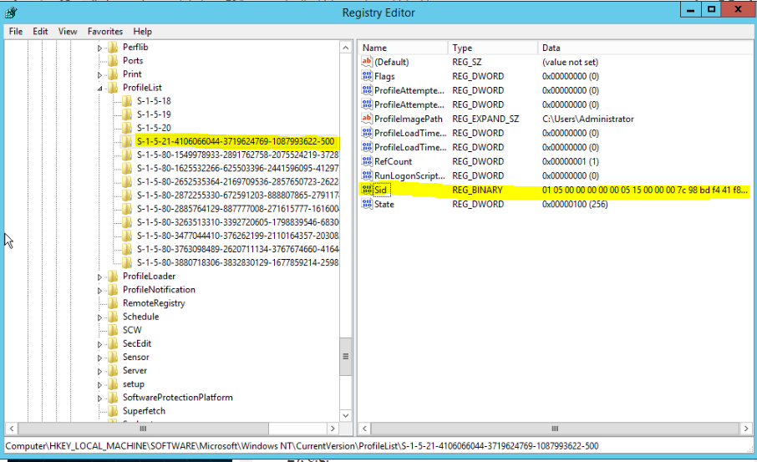

# Task 2: Getting SID in SQL Server

* Get the SID of the account you used for SQL Server login.
* A. SID: 0x0105000000000005150000007C98BDF441F8B4DD1677D940F4010000.



* B. What is the role of the function “fn_SIDToString” in the above?

The role of the function is to change the current SID value into the string value “S-“.

* C. Show in screenshots that the SID from SQL Server for the administrator login and that from Windows Server are the same. Compare the SIDs in a string format (not binary).





They are the same in string format.

* D. SID: 0x8EBFE506333408408CFD721DA0E0C76.

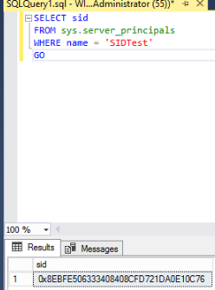

* E. SID: 0x5142703121CAAF49A3061EC79DE1B5EE.



* F. Are the SIDs of login SIDTest the same? Describe the reason why they are (not) the same?

They are not the same. They are not the same because, the login record was deleted, and the SID value changes when a new login record is created. That is why they don’t match up anymore.

# Task 3: Learn PowerShell Scripting

* Run your script and report the output in a screenshot.

