Installing The Android Development Environment

* Download Android Studio - <https://developer.android.com/studio/index.html> (note, if you are on an older version than 2.3, you can upgrade from within studio, you don’t need to install from scratch).

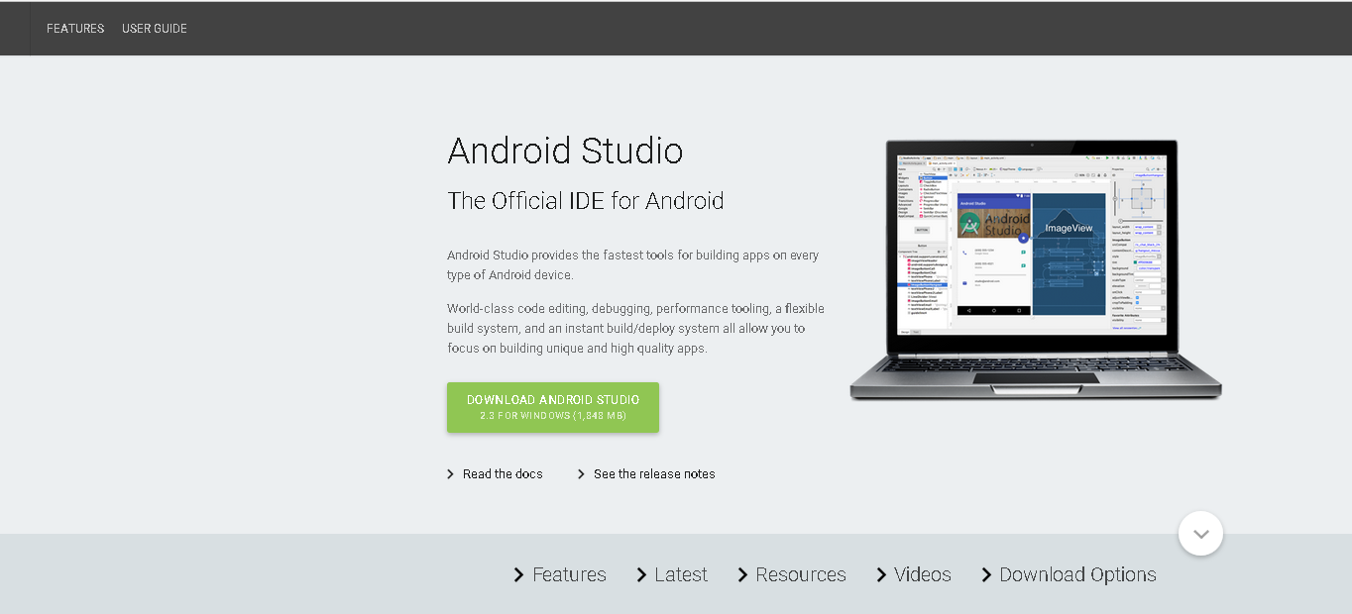

System Requirements

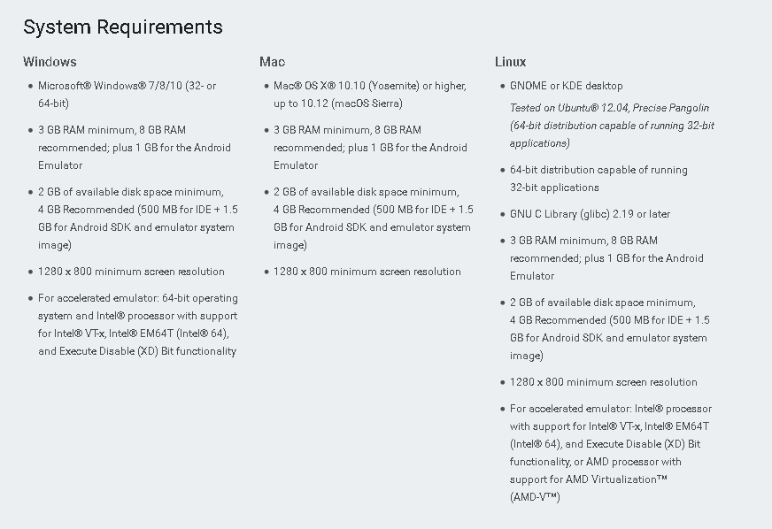

* I would let it install the SDK’s and Android Virtual Device – we’ll need to install them anyway – note you may need to be running as administrator to do this – on my machines, the SDK’s wouldn’t install because of permission issues until I came in as Administrator. Because of the SDK’s, this could take a long time, I let it go overnight.

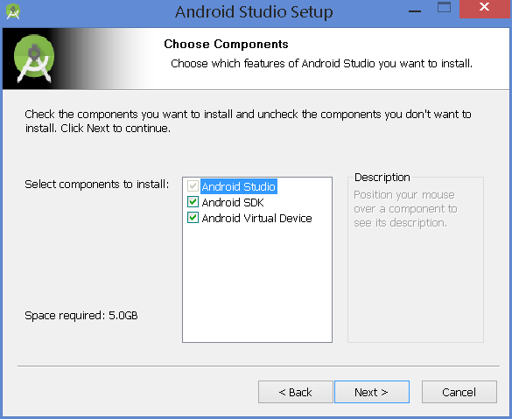

* If things go well, you should be able to bring up Android Studio. Go ahead and create a default project.
* Now we will check for the SDK’s and virtual devices.

Once the program is up and running, go to Tools/Android/SDK Manager. I would pretty much install everything, then we won’t have compatibility issues between working at home and here and also with my sample programs. One thing people tend to overlook is the tools – some are actually necessary so include those too.

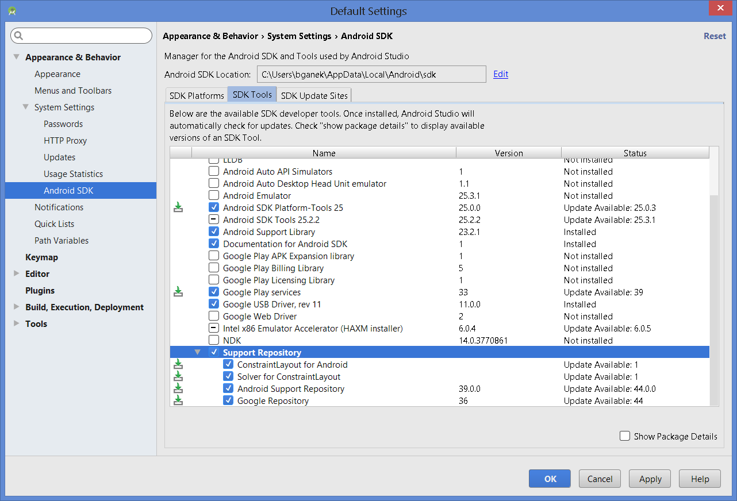

* To get to the emulators, select Tools/Android/AVD Manager. I’ve created two that I use, small with two different SDK versions. Click on Create Virtual Device on the bottom left, I think select 3.4” WQVGA (you can modify this later if necessary, I just want to get a running start).   
    
  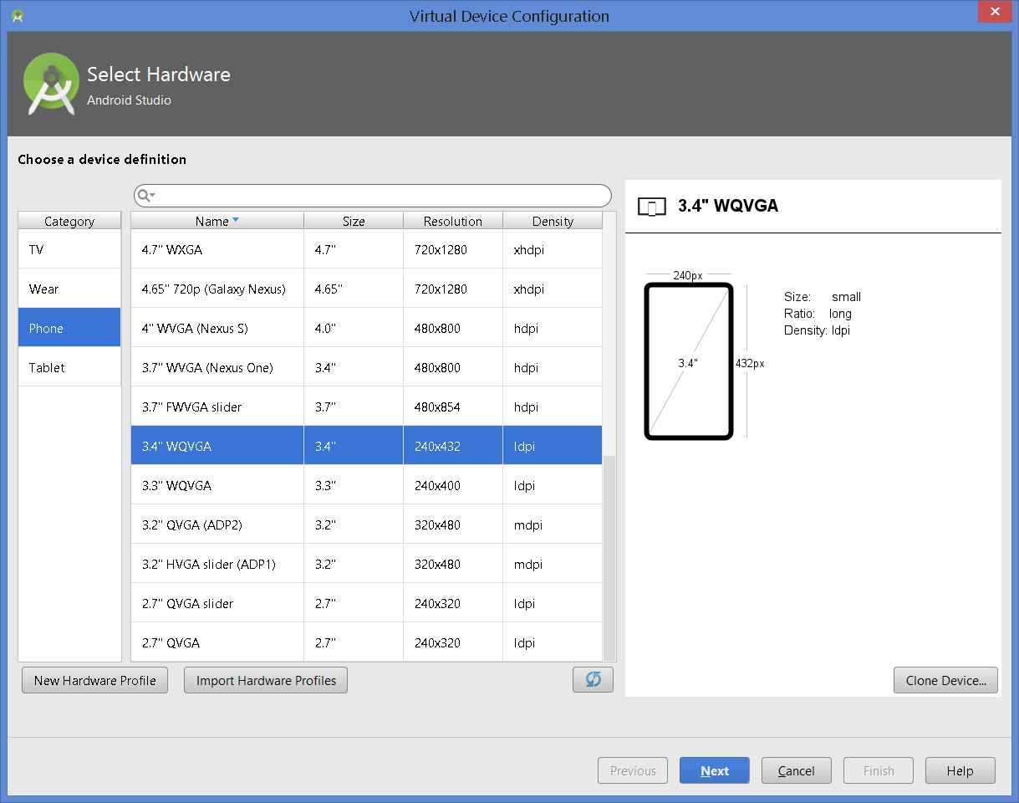
* Select 2.3.3 for the API (from the X86 tab if your computer has it)

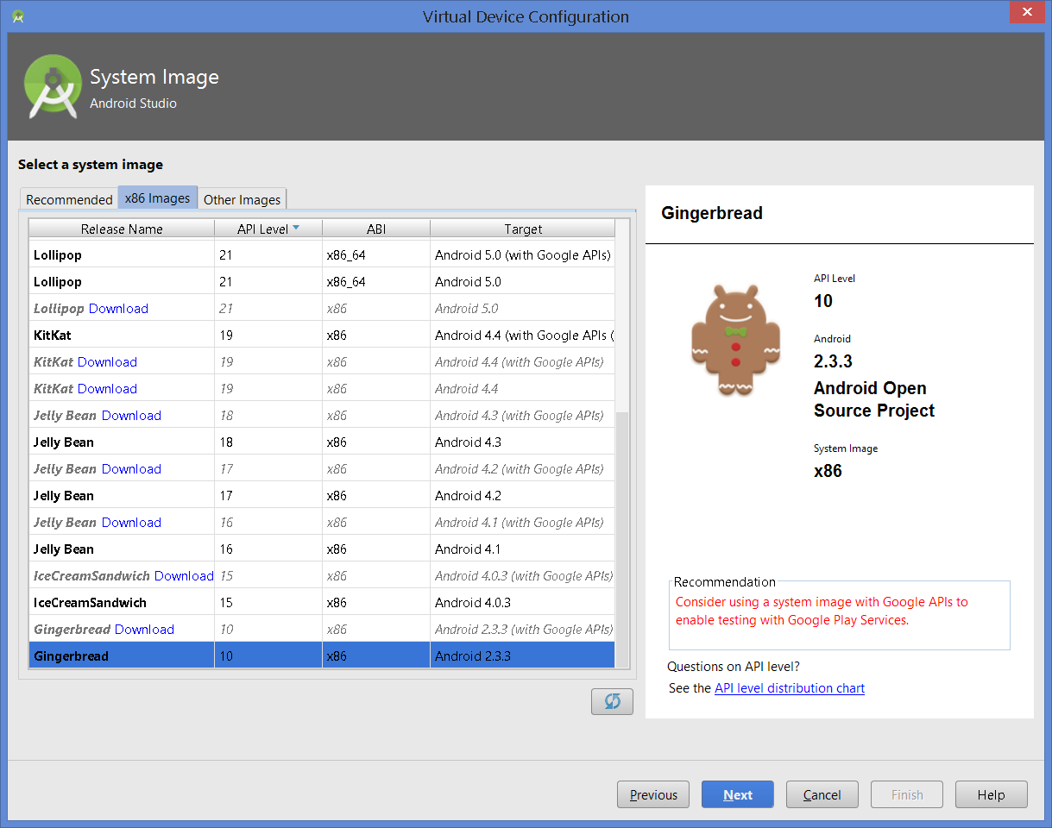

* You can leave the emulator default name
* To take advantage of instant run, you should also create an emulator that is at least at API 21.
* That should do it.