# GGG Website Rollout – UX/Design Department EVM Case Study

## Scenario Summary

At Week 2 of the GGG website rollout, the UX/Design team was:  
- 35% complete instead of the planned 50%  
- Already spent $900 of a $1,200 budget  
- CPI = 0.47 (over budget) and SPI = 0.70 (behind schedule)  
- Projected EAC = $2,553.19 — more than double the original budget  
  
Without intervention, the project was on track to significantly miss cost and schedule goals. The TCPI of 3.12 confirmed the remaining work would require unsustainable efficiency levels.

## Progress Snapshot

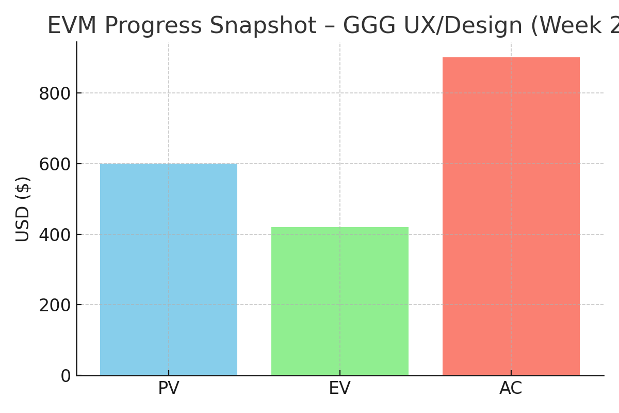

## EVM Summary Table

|  |  |
| --- | --- |
| Metric | Value |
| BAC | $1,200.00 |
| PV | $600.00 |
| EV | $420.00 |
| AC | $900.00 |
| CV | $-480.00 |
| CPI | $0.47 |
| SV | $-180.00 |
| SPI | $0.70 |
| EAC | $2,553.19 |
| ETC | $1,653.19 |
| VAC | $-1,353.19 |
| TCPI | $3.12 |

## What We Adjusted (Changes Made)

- Paused development on 3 non-critical UX features:  
 • A micro-interaction panel on the homepage  
 • A testimonial carousel  
 • Custom scroll animations for mobile  
- Refocused the team on core page wireframes and MVP layout  
- Met with stakeholders (Marketing, Dev, Exec) to approve scope reduction  
- Created a Phase 2 backlog to revisit paused items post-launch

## Lessons Learned

You don’t always need to deliver everything. You need to deliver what matters most, on time, and within capacity.  
  
This project taught me to:  
- Lead difficult conversations around cost and scope  
- Protect team morale by reducing unrealistic pressure  
- Use data (EVM) to communicate risk without panic  
- Apply coaching instincts: pause, reassess, and pivot for progress—not perfection  
  
The win wasn’t just launching the website. The win was doing it in a way that preserved trust, quality, and momentum.