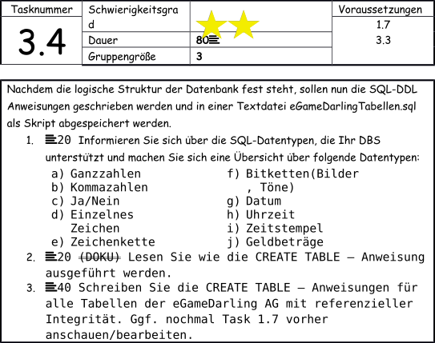

LÖSUNG

#1

a) INT
1, 2, 4…

b) FLOAT
0.8 , 4.2, 13.3..

DOUBLE
0.815, 4.20, 13.37

c) BOOLEAN
YES/NO, TRUE/FALSE, 1/0

d) CHAR
X, i, z...

e) VARCHAR
YOURMOMLOL

f) BLOB (Bitketten (Töne, Bilder))
0 – 65,535 bytes
SIMILAR TO BIT

g) DATE
YYYY/MM/DD

h) TIME
HH:MM:SS.ssssss

i) TIMESTAMP
YYYY/MM/DD – HH:MM:SS
automatic

j) DECIMAL
234.50 EUR
sets fixed number (best for monetary values)

#3

CREATE DATABASE IF NOT EXISTS egamedarling;
USE egamedarling;

CREATE TABLE accounts (
accountid VARCHAR(30),
password VARCHAR(30),
email VARCHAR(30),
avatar BLOB,
nickname VARCHAR(30),

UNIQUE (accountid),

PRIMARY KEY (accountid)
);

CREATE TABLE gamers (
gamerid VARCHAR(30),
name VARCHAR(30),
surname VARCHAR(30),
gender VARCHAR(30),
residence VARCHAR(30),
birthday DATE,
occupation VARCHAR(30),
PFaccountid VARCHAR(30),

UNIQUE (gamerid),

PRIMARY KEY (PFaccountid),
CONSTRAINT PFaccountidgamer
FOREIGN KEY (PFaccountid) REFERENCES accounts(accountid)
ON DELETE CASCADE
ON UPDATE NO ACTION
);

CREATE TABLE games (
gameid VARCHAR(30),
gamename VARCHAR(30),

PRIMARY KEY (gameid)
);

CREATE TABLE genres (
genreid VARCHAR(30),
genrename VARCHAR(30),

PRIMARY KEY (genreid)
);

CREATE TABLE hobbies (
hobbyid VARCHAR(30),
hobbyname VARCHAR(30),

PRIMARY KEY (hobbyid)
);

CREATE TABLE statuses (
statusid VARCHAR(30),
content VARCHAR(30),
created TIMESTAMP,

PRIMARY KEY (statusid)
);

-- -- -- CORRELATING TABLES

CREATE TABLE accountsgamers (
PFaccountid VARCHAR(30),
PFgamerid VARCHAR(30),

PRIMARY KEY (PFaccountid, PFgamerid),

CONSTRAINT accgamacc
FOREIGN KEY (PFaccountid) REFERENCES accounts(accountid)
ON DELETE CASCADE,

CONSTRAINT accgamgam
FOREIGN KEY (PFgamerid) REFERENCES gamers(gamerid)
ON DELETE CASCADE
);

CREATE TABLE gamersgames (
PFaccountid VARCHAR(30),
PFgameid VARCHAR(30),

PRIMARY KEY (PFaccountid, PFgameid),

CONSTRAINT gamgamacc
FOREIGN KEY (PFaccountid) REFERENCES accounts(accountid)
ON DELETE NO ACTION
ON UPDATE NO ACTION,

CONSTRAINT PFgamgamgam
FOREIGN KEY (PFgameid) REFERENCES games(gameid)
ON DELETE CASCADE
ON UPDATE NO ACTION
);

PFgamerid VARCHAR(30),
PFhobbyid VARCHAR(30),

PRIMARY KEY (PFgamerid, PFhobbyid),

CONSTRAINT gamhobgam
FOREIGN KEY (PFgamerid) REFERENCES gamers(gamerid)
ON DELETE CASCADE
ON UPDATE NO ACTION,

CONSTRAINT gamhobhob
FOREIGN KEY (PFhobbyid) REFERENCES hobbies(hobbyid)
ON DELETE CASCADE
ON UPDATE NO ACTION
);

CREATE TABLE gamesgenres (
PFgameid VARCHAR(30),
PFgenreid VARCHAR(30),

PRIMARY KEY (PFgameid, PFgenreid),

CONSTRAINT gamgengam
FOREIGN KEY (PFgameid) REFERENCES games(gameid)
ON DELETE CASCADE
ON UPDATE NO ACTION,

CONSTRAINT gamgengen
FOREIGN KEY (PFgenreid) REFERENCES genres(genreid)
ON DELETE CASCADE
ON UPDATE NO ACTION
);

CREATE TABLE accountsstatuses (
PFaccountid VARCHAR(30),
PFstatusid VARCHAR(30),

PRIMARY KEY (PFaccountid, PFstatusid),

CONSTRAINT accstaacc
FOREIGN KEY (PFaccountid) REFERENCES accounts(accountid)
ON DELETE CASCADE
ON UPDATE NO ACTION,

CONSTRAINT accstasta
FOREIGN KEY (PFstatusid) REFERENCES statuses(statusid)
ON DELETE CASCADE
ON UPDATE NO ACTION
);

DOKUMENTATION

BENÖTIGTE ZEIT: 100 min

SCHWIERIGKEITSGRAD: Geht so.

VERBESSERUNGSVORSCHLÄGE: Viele kleine Fehler bei den Verknüpfungen der Tabellen gehabt. Logisch durchblicken ist noch etwas schwer.

