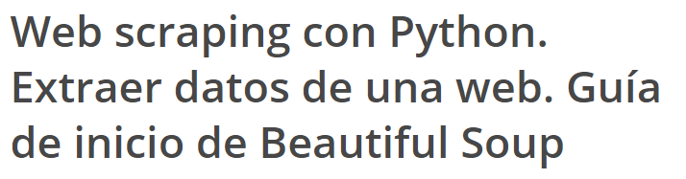

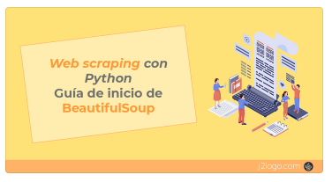

<https://j2logo.com/python/web-scraping-con-python-guia-inicio-beautifulsoup/>