**3.1 Empirical Strategy**

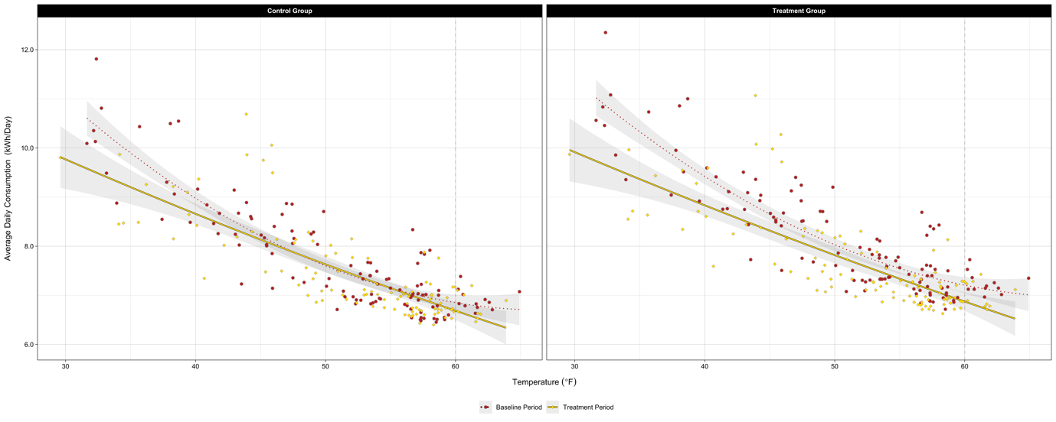

FIGURE, which shows household average daily electricity consumption over temperature, clearly demonstrates the motivation of this research project.[1] As illustrated in the figure, household demand for electricity grew as the temperature decreased. In other words, in addition to temperature-insensitive electricity demand (i.e., for non-temperature-control uses), there was a sizeable demand for electricity for heating (i.e., for temperature-control use) in Irish households, which is highly responsive to temperature variations. The figure also shows two significant points regarding the changes in the average daily consumption of the treated household after introducing the TOU prices: first, for a given temperature, they seem to consume electricity equally or less; second, the size of reduction in their electricity demand appears to depend on temperature. Being motivated by the two observations, I determine not only how much consumption changes on average in response to the time-varying tariffs but also how their impact varies across days with different temperatures in this research. In other words, the dynamic-pricing-causing effects on temperature- and non-temperature-control electricity uses are separately estimated to figure out the primary source of energy savings.

Instead of merely leaning on randomization, I employ a difference-in-differences (DID) approach to estimate the dynamic-price-inducing electricity savings. Because the CER experiment dataset primarily utilized in the following empirical analysis was generated from a carefully developed randomized controlled trial (RCT), in principle, the effect of the TOU tariffs on household electricity consumption can be measured simply through the difference in average usage between the two groups during the baseline period.[2] However, such a naive control/treatment difference is not valid here due to the non-trivial difference in electricity demand between the control and treatment groups during the baseline period. The poor balance in household demand for electricity during the benchmark period was the very reason the previous studies exploiting the same dataset also adopted the same identification strategy.

I include the temperature as an explanatory variable directly in my econometric model. In the previous papers using the identical dataset, fixed-effects (FEs) were utilized to control for time-varying factors that influence household electricity consumption. Since those studies focused on quantifying how households responded, on average, to the TOU price regimes newly introduced, adding such FEs to their models served their research purpose. In other words, they did not need to model the relationship between temperature and household electricity consumption explicitly. However, a primary interest of this research is to understand how electricity savings vary with the temperature after shifting to TOU prices. Therefore, more flexible controls rather than FEs, not sweeping out temperature variations across days, are required in my empirical analysis. For that reason, I extend the typical panel DID specification that contains three indicator variables by adding interaction terms between the indicator and temperature variables.[3] That is, I estimate the average treatment effects (ATEs) of the dynamic prices on household electricity demand by exploiting the within-household electricity consumption changes across not only periods but temperatures.[4]

**3.2 (…)**

(…)

1. An important feature also stands out from the figure: the minimum household electricity consumption occurs around 60. This phenomenon supports the setting of the reference temperature for calculating daily HDDs at the very level.
2. Because random assignment of participating households puts selection bias right, observed differences in electricity consumption between the control and treatment groups after introducing the TOU tariffs are only attributable to their differences in exposure to the time-varying electricity prices.
3. Under three identifying assumptions, applying the DID strategy to measure energy savings obtained from adopting the TOU prices makes sense. First, the parallel trend assumption is required for the DID estimator. Considering that the 30-minute interval meter reads for participating households were collected from a trial, the assumption means that the pre-treatment-period load profile for the treated households should be very similar to that for the non-treated households. FIGURE A showing average within-day load profiles for the two groups during the baseline period supports the plausibility of the parallel trend assumption. In addition, the electricity consumption profile for the control group illustrated in FIGURE B, which smoothly evolved over the entire experiment period although heavily fluctuated day to day, suggests its high reliability as a counterfactual under the assumption.

   The second identifying assumption necessary for the plausibility of the identification strategy employed is the assumption of common temporal shocks. This assumption implies that a treatment-status-irrelevant unexpected event occurring at the same time as or following the deployment of the dynamic prices should have the same impact on both the control and treatment groups. Although the common shocks assumption cannot be tested directly, the similar trends in electricity demand profiles for the control and treatment groups shown in FIGURE B support the assumption required for the DID approach.

   Third, the stable unit treatment value assumption (SUTVA) must hold too. The SUTVA requires that introducing TOU prices did not affect the electricity consumption of the untreated households. That is, the SUTVA allows no spillovers. During the recruitment process, the locational distribution of the participating households was aligned with that of the total Irish population to construct a representative sample of the national population. Because only a few thousand households scattered geospatially participated in the nationwide experiment, it is unlikely that the treated households influenced the households allocated to the control group. This again supports the SUTVA required under the DID identification strategy.
4. The attrition rate during the RCT was about 20%. The main reasons for participant attrition were changes in tenancy and supplier. Due to the imperfect compliance, the estimates must be interpreted as local average treatment effects (LATEs). However, according to CER (2011), attrition was unlikely to be associated with the RCT. Furthermore, the level of attrition varied only marginally across treatment status.