**3.1 Empirical Strategy**

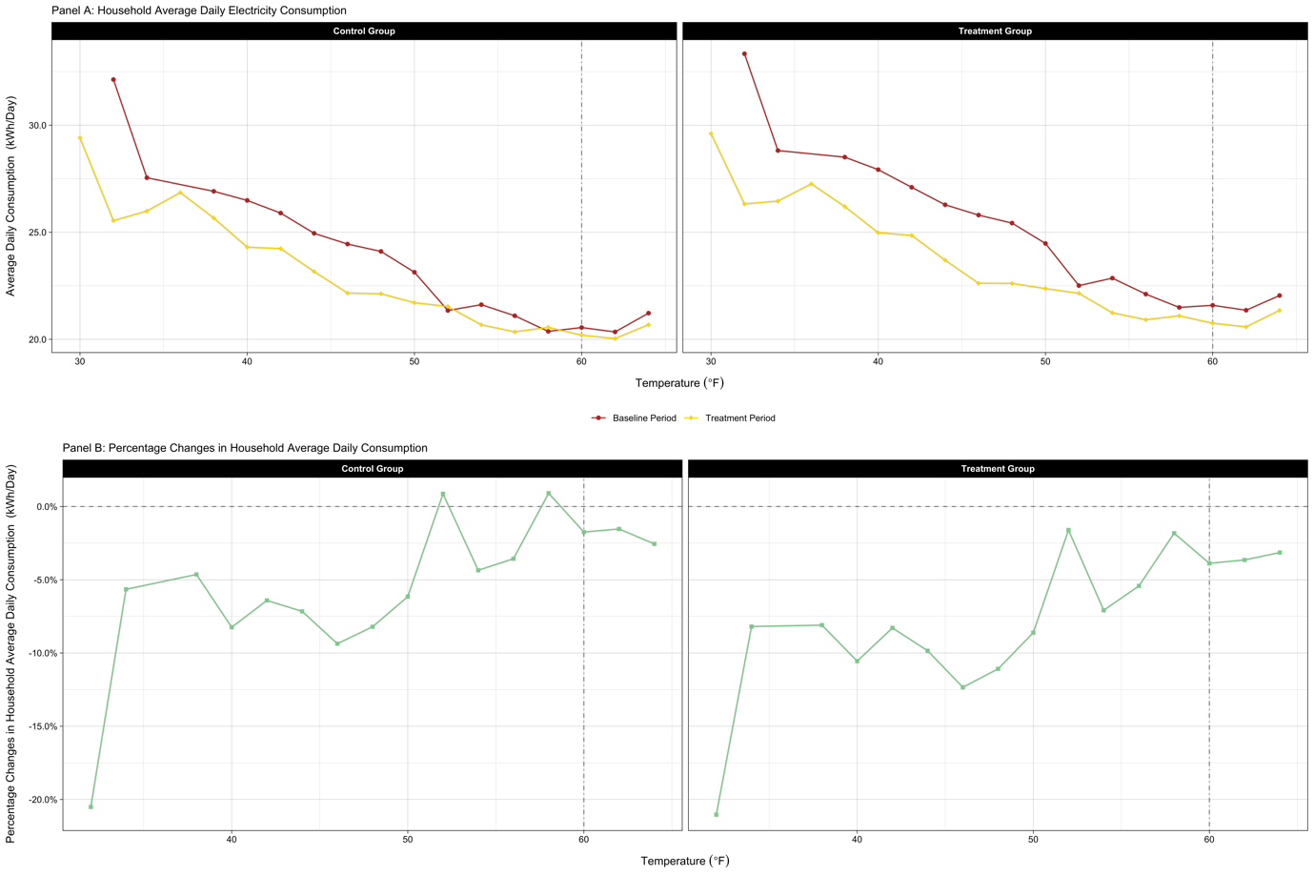

*When using observations during the entire experiment period* 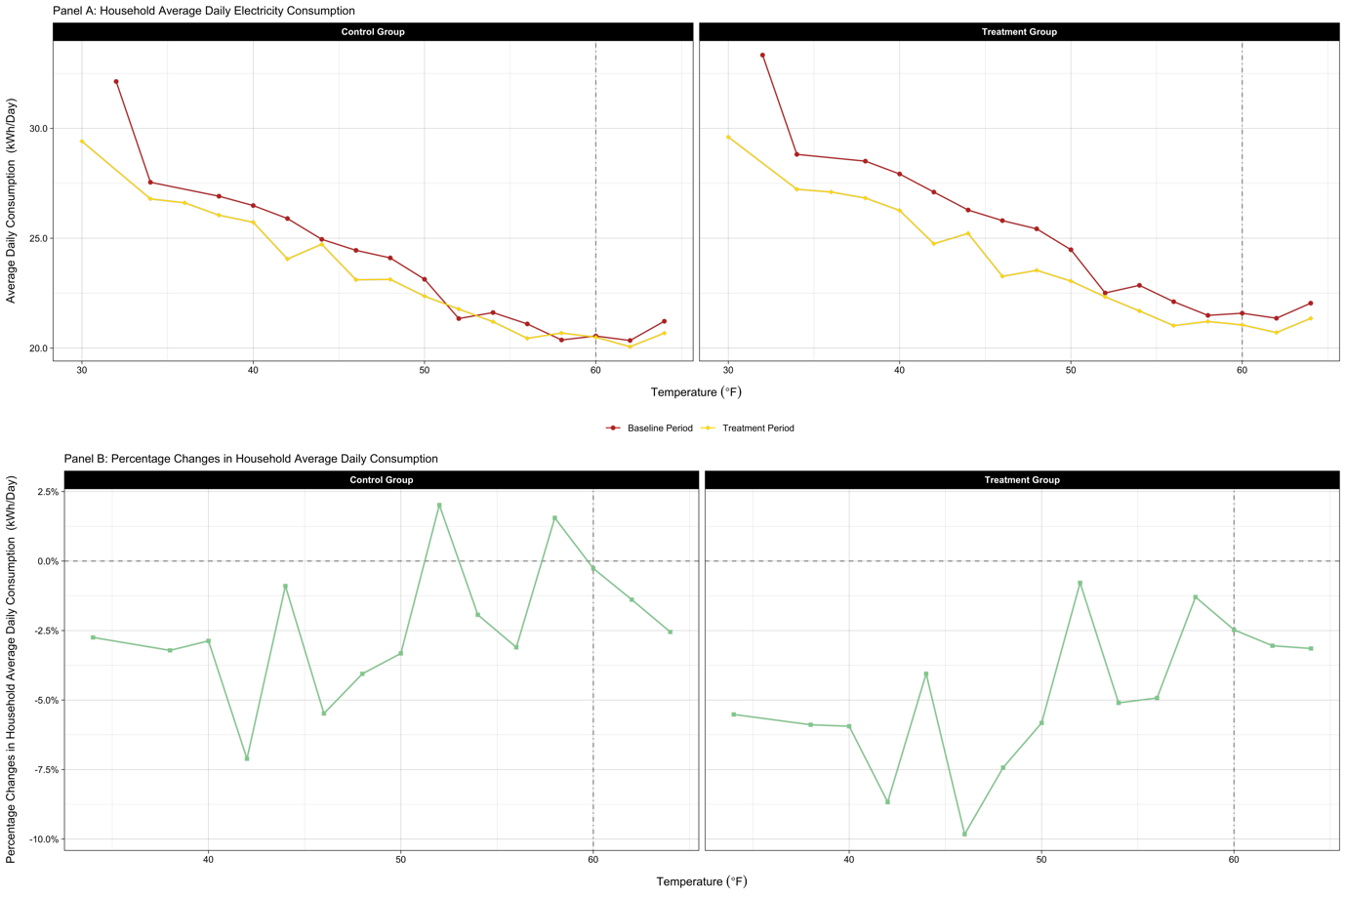

*When using observations in the two second halves (i.e., from July to December)*

FIGURE, which shows household average daily electricity consumption over temperature and pre-and-post differences in the consumption, clearly demonstrates the motivation of this research project.[1] As illustrated in Panel A of the figure, household demand for electricity grew as the temperature decreased. In other words, in addition to temperature-insensitive electricity demand (i.e., for non-temperature-control uses), there was a sizeable demand for electricity for heating (i.e., for temperature-control use) in Irish households, which is highly responsive to temperature variations. In addition, Both panels in the figure collectively show three interesting points regarding the changes in household average daily demand for electricity after introducing the TOU prices: first, during the treatment period, households in the treatment group consumed less electricity over the entire temperature range, while those in the control group equally consumed in temperate days[2]; second, for a given temperature, the treated reduced their electricity consumption by a larger percentage; and third, the size of reduction in their electricity demand appears to depend heavily on temperature. Being motivated by those observations, in this research, I determine not only how much consumption changes, on average, in response to the time-varying tariffs but also how their impact varies across days with different temperatures in this research. In other words, the dynamic-pricing-causing effects on temperature- and non-temperature-control electricity uses are separately estimated to figure out the primary source of energy savings.

Instead of merely leaning on randomization, I employ a difference-in-differences (DID) approach to estimate the dynamic-price-inducing electricity savings. Because the CER experiment dataset primarily utilized in the following empirical analysis was generated from a carefully developed randomized controlled trial (RCT), in principle, the effect of the TOU tariffs on household electricity consumption can be measured simply through the difference in average usage between the two groups during the treatment period.[3] However, such a naive control/treatment difference is not valid here due to the non-trivial difference in electricity demand between the control and treatment groups during the baseline period. The poor balance in household demand for electricity during the benchmark period was the very reason the previous studies exploiting the same dataset also adopted the same identification strategy.

I include the temperature as an explanatory variable directly in my econometric models. In the previous papers using the identical dataset, fixed-effects (FEs) were utilized to control for time-varying factors that influenced household electricity consumption. Since those studies focused on quantifying how households responded, on average, to the TOU price regimes newly introduced, adding such FEs to their models served their research purpose. In other words, they did not need to explicitly model the relationship between temperature and household electricity consumption to estimate the average treatment effects (ATEs). However, a primary interest of this research is to understand how electricity savings vary with the temperature after shifting to TOU prices. Therefore, more flexible controls rather than FEs, not sweeping out temperature variations across days, are required in my empirical analysis. For that reason, I extend the typical panel DID specification that contains three indicator variables by adding interaction terms between the indicator and temperature variables.[4] That is, I estimate the ATEs of the dynamic prices on household electricity demand by exploiting the within-household electricity consumption changes across not only periods but temperatures.[5]

**3.2 Average Responses to Time-of-Use Prices**

**3.2.1 Half-Hourly Average Treatment Effects**

Utilizing a panel DID identification strategy, I first measure the impact of the TOU prices on 30-minute-interval household electricity consumption. To obtain the ATE for each half-hour interval, I estimate the following specification:

$${kWh}_{itw} = β_{w}\left({I[Treatment \& Post]}_{it}∙{I[30-Minute Interval = w]}_{w}\right) + α_{iw} + γ_{dw}+ δ_{m} + ε_{itw}$$

The term ${kWh}_{itw}$ is the electricity consumption by household *i* on the day *t* during the half-hourly time window *w*. The indicator variable ${I[Treatment \& Post]}_{it}$ is equal to one only if household *i* is in the treatment group and the day *t* is in the treatment period, while the indicator variable ${I[30-Minute Interval = w]}_{w}$ takes the value of one when the half-hourly interval is *w*. The terms $α_{iw}$, $γ_{dw}$, and $δ_{m}$ are household-by-half-hourly-interval, day-of-week-by-half-hourly-time-window, and month-of-year fixed effects, respectively. In the specification, the point estimates of $β_{w}$ representing the ATE for each 30-minute interval *w* are the parameters of interest. I cluster the standard errors at the household and the day of experiment levels to correct for serial correlation.

FIGURE summarizes the estimated ATEs in the form of a time profile. As also demonstrated in Prest (2019), the time profile shows dominant electricity savings during peak hours (i.e., from 5:00 p.m. to 7:00 p.m.). The result indicates that the TOU tariffs served their purpose to resolve the peak demand problem. In the following empirical analysis, I continually focus on household electricity demand responses to the time-varying prices during the peak rate period.

**3.3 (…)**

(…)

1. An important feature also stands out from the figure: the minimum household electricity consumption occurs around 60. This phenomenon supports the setting of the reference temperature for calculating daily HDDs at the very level.
2. In Panel A, non-treated households consumed more electricity during the baseline period, especially on days with higher heating need. The fact that the total HDDs during the baseline period were generally greater than those during the treatment period for a given temperature bin could explain the phenomenon.
3. Because random assignment of participating households puts selection bias right, observed differences in electricity consumption between the control and treatment groups after introducing the TOU tariffs are only attributable to their differences in exposure to the time-varying electricity prices.
4. Under three identifying assumptions, applying the DID strategy to measure energy savings obtained from adopting the TOU prices makes sense. First, the parallel trend assumption is required for the DID estimator. Considering that the 30-minute interval meter reads for participating households were collected from a trial, the assumption means that the pre-treatment-period load profile for the treated households should be very similar to that for the non-treated households. FIGURE A showing average within-day load profiles for the two groups during the baseline period supports the plausibility of the parallel trend assumption. In addition, the electricity consumption profile for the control group illustrated in FIGURE B, which smoothly evolved over the entire experiment period although heavily fluctuated day to day, suggests its high reliability as a counterfactual under the assumption.

   The second identifying assumption necessary for the plausibility of the identification strategy employed is the assumption of common temporal shocks. This assumption implies that a treatment-status-irrelevant unexpected event occurring at the same time as or following the deployment of the dynamic prices should have the same impact on both the control and treatment groups. Although the common shocks assumption cannot be tested directly, the similar trends in electricity demand profiles for the control and treatment groups shown in FIGURE B support the assumption required for the DID approach.

   Third, the stable unit treatment value assumption (SUTVA) must hold too. The SUTVA requires that introducing TOU prices did not affect the electricity consumption of the untreated households. That is, the SUTVA allows no spillovers. During the recruitment process, the locational distribution of the participating households was aligned with that of the total Irish population to construct a representative sample of the national population. Because only a few thousand households scattered geospatially participated in the nationwide experiment, it is unlikely that the treated households influenced the households allocated to the control group. This again supports the SUTVA required under the DID identification strategy.
5. The attrition rate during the RCT was about 20%. The main reasons for participant attrition were changes in tenancy and supplier. Due to the imperfect compliance, the estimates must be interpreted as local average treatment effects (LATEs). However, according to CER (2011), attrition was unlikely to be associated with the RCT. Furthermore, the level of attrition varied only marginally across treatment status.