Group 3 Project
Jake Laure, Zach Lanter, Michael Purtle

Problem Introduction
Counter-Strike 2 is a highly influential first-person shooter featuring tactical five-on-five battles between the Counter-Terrorist (CT) and Terrorist (T). The CTs must defend two bombsites labeled A or B, and the Ts must attempt to detonate a bomb on either bombsite. A round is won by either: the CT-team eliminating the T-side from the round or defusing the bomb, with the T-side being able to do the same except they have to blow up either site.
In this work, we leverage a kernel density estimate of past kill locations to identify, “hot spots” on each map and then formulate a risk-aware p-median model that.
- Selects p Counter-Terrorist positions to cover high density kill areas with minimal travel distance
- Penalizes placements in historical dangerous zone
- Enforces both a maximum assignment radius and minimum distance from walls for each possible Counter-Terrorist site.
By solving this mixed-integer program we obtain defender layouts that balance coverage (keeping every threat spot nearby) and safety (avoiding line-of-sight traps). yielding data-driven insights into optimal opening positions.
A core problem in Counter-Strike is the positioning of players around the map, and what is the best position given any situation within the game. Typically, it’s subconsciously understood where a player should play at the start of the round, due to the game’s twenty-year history. But this doesn’t account for if any specific team leans towards attacking one bombsite or another. By analyzing data on where kills occur across the map, we can identify high-risk areas that need to be covered. Then position players to cover them effectively while minimizing direct exposure. Now the problem becomes how can we cover dangerous spots around the map, while not putting any of the players at any immediate risk. Finally, we quantify how much of the map each proposed placement covers, subject to physical constraints (line‑of‑sight walls and a maximum assignment radius).

Mathematical Model
We adopt the classical p-median facility-location framework (Aswani, 2016). Formally, we define an undirected graph
$$G = \left(I,J,E\right)$$
Where
- $I$Is the set f demand nodes (each $i ∈ I$represents a location or T-sided kills we wish to cover)
- $J$ is the set of candidate facility sites (each $j ∈ J$is a potential CT position)
- $E ⊆ I × J$Contains edges $\left(i, j\right)$ linking each demand node to every facility site
Each edge $\left(i, j\right)$ carries a non-negative cost $d_{ij}$ (distance from $i$to j), and each demand node $i$has an associated weight $h_{i}$ capturing its importance. Given a budget of $p$facilities to open, the goal is to pick exactly $p$nodes in $J$to minimize the total weight distance from every demand point to its nearest open facility.
Classic Formulation of p-median:
$I$ = Set of demand location
$J$= Set of possible location of facilities
Decision Variables:
$Y_{ij }∈ \left\{1, 0\right\}$ 1 if demand node if I assigned to facility located at j ∈ J
$X_{j} ∈ \left\{1, 0\right\}$ 1 if facility located at j ∈ J
Objective:
$$\min{} \sum_{j∈J }^{ }{\sum_{i∈I }^{ }{h_{i}}} d_{ij }Y_{ij}$$
_{Constraints:}
$$\sum_{j∈J_{ij}^{Y}}{}= 1, ∀_{i} i ∈ I$$
$$Y_{ij}- X_{j} ≤ 0 ∀_{i} ∈ I, ∀_{j} ∈ J$$
$$\sum_{ j∈J}^{ }{X_{j}} = p$$

*Note: need to add cite, and add what is p and fix notation for this stuff
The regular p-median formulation only looks for a facility location arbitrary without any consideration of risk. For our model I propose that we wish to place p Counterterrorist (CT defenders on to two-dimensional map to minimize the expected exposure risk of player exposure. Our risk measure comes from a kernel-density estimate of historical kill locations, and respecting physical constraints (walls) as well as maximum player distance.
Formulation:
Sets
I = Set of Terrorist kill locations to cover
J = Set of possible counter-terrorist locations

Parameters
$x_{i}$ = x coordinate at $i∈I$
$y_{i}$ = y coordinate at $i∈I$
$Φ\left(x_{i}, y_{i}\right)$ = Kernal density estimator (KDE) to treat dangerous areas as imports to cover
$d_{ij}$ = Distance from demand Terrorist kill position $i ∈ I$to possible counter terrorist locations $j∈J$
$Φ\left(j\right)$ = KDE risk at possible counter-terrorist position $j∈J$
$p$ = Number of Counter-Terrorist positions to choose
$λ$= Tuning parameter for risk
$d_{max} = \max\left(d_{ij}\right)$ maximum value of demand weights
$$r_{max}= \max\left(Φ\left(j\right)\right)$$
$\frac{1}{d_{max}}$ = Normalized constant for distance
$\frac{1}{r_{max}}$ = Normalized constant for risk
$Ω\left(x_{i}, y_{i}\right)$ = Distance from wall function
M = $\max\left(d_{ij}\right)$ Used to control feasibility in wall rule constraint
$d^{*}$= Distance from wall threshold
$\overline{d}$ = Distance from Terrorist point threshold

Decision Variables
$X_{ij}∈\left\{0,1\right\}$ 1 if $i ∈ I$is assigned to possible Counter-Terrorist Position at $j ∈ J$
$Y_{j}∈\left\{0,1\right\}$ 1 if possible counter terrorist position is selected as a counter-terrorist position $j ∈ J$
Constraints
$\sum_{j∈J}^{ }{X_{ij}} = 1 ∀_{i}∈ I$ Assignment
$X_{ij}≤Y_{j} ∀_{i} ∈ I ∀_{j}∈ J$ Linking Constraint
$\sum_{j∈J}^{ }{Y_{j}} = p$ Counter-Terrorist placement
$v^{*}≤d^{*}+ M ×\left(1-Y_{j}\right) ∀_{j} ∈ J$ Wall constraint
$d_{ij}×X_{ij}≤\overline{d}$ Distance Cap

Objective Function
$$\min{} \frac{1}{d_{max}}\sum_{i∈I}^{ }{\sum_{j∈J}^{ }{Φ\left(x_{i},y_{i}\right)d_{ij}}}X_{ij}+λ \frac{1}{r_{max}} \sum_{j∈J}^{ }{Φ\left(j\right)Y_{i}}$$
Weighted Cover cost
- What it is: For each T-side kill location $i$, we are looking at the distance $d_{ij}$ to whichever CT position j it’s assigned to and multiply by
  - $Φ\left(x_{i}, y_{i }\right)$: the “danger level” of that kill point (higher in hotspots)
  - $X_{ij}$: the binary assignment indicator
- Why it matters:
  - By weighting distance with $Φ\left(x_{i},y_{i}\right)$, you force the model to prioritize covering the most dangerous kill zones more tightly.
  - Dividing by $d_{max}$ simply normalizes so that this term stays in a comparable numeric range.
Facility Risk Penalty
- What it is: For each candidate CT site j, there is a penalty that is proportional to
  - $Φ\left(j\right)$: h ow risky that except spot from the KDE
  - $Y_{j}$: \whether you place a CT there
- Why is matters:
  - This term discourages putting defender right in the hottest peeked angles
  - The tuning parameter $λ$balances “cover where it’s dangerous” against “keep defenders safe”
  - Dividing by $r_{max}$ normalizes the risk magnitudes
How They Work Together
- Low $λ$: care more about raw coverage CTs will be closer to hotspots.
- High $λ$: care more about safety CTs will stand further from the hottest points (but could leaves areas uncovered)
What is not in the Objective (but enforced)
- Distance-cap Constraint ensures every kill lies within a maximum range of its assigned CT
- Wall-proximity constraint keeps selected CT positions near cover

Results
This model is just a proof of concept; the specific values below may be affected by modeling simplifications (see Limitations and Future Work). Because the distance‐cap constraint can significantly affect coverage quality, we solve two variants—one with the cap and one without—and compare the resulting defender layouts and coverage performance.
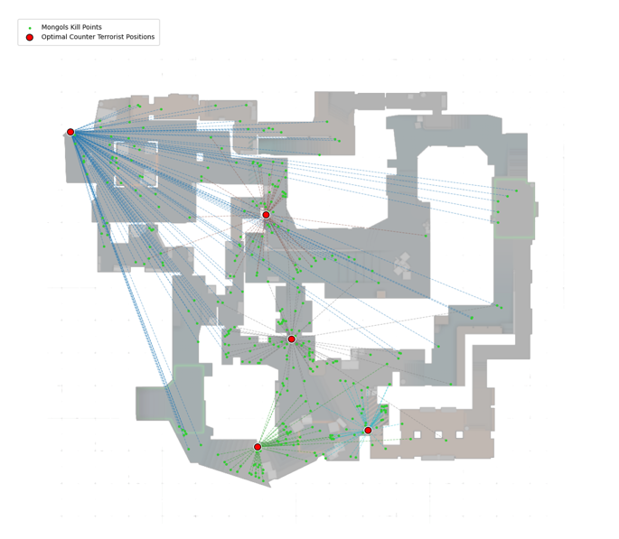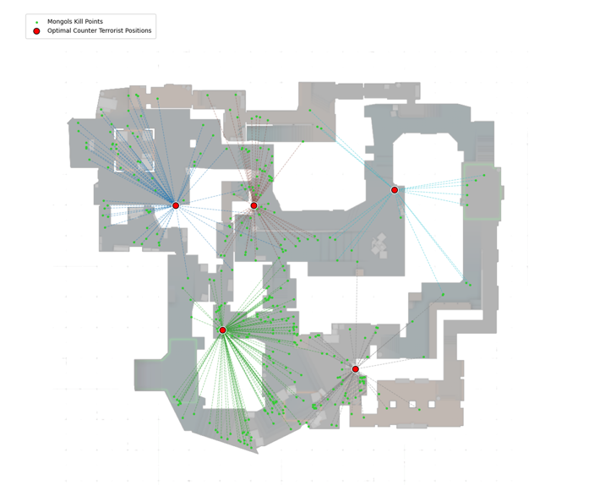
Defend positions for $p$ = 5 and $λ$= 0.5978
- Left: Model without the maximum distance cap applied.
- Right: Model with the distance cap
Although both layouts look broadly similar, the distance cap version (right) pushed one of the defenders into an impractically remote “no man's land”. This occurs because the optimizer was trying to cover all the kill locations because of the maximum distance threshold.

Defender Positions for $p$= 5 and $λ$= 3.50
- Left: Model with the distance cap
- Right: Model without the distance cap
Now both graphs have produced different results that can determine the results of a round within the game. On the left since the distance cap is enforced it tries to cover the points within the middle of the map. While it is almost determining where the safest spot is. The ideal spot in that situation is further within the donut looking space, but we take the result with great optimism. On the right since we don’t need to cover all the points within a certain range, the optimizer will then follow the KDE to the safest but yet the most dangerous place we want to cover.
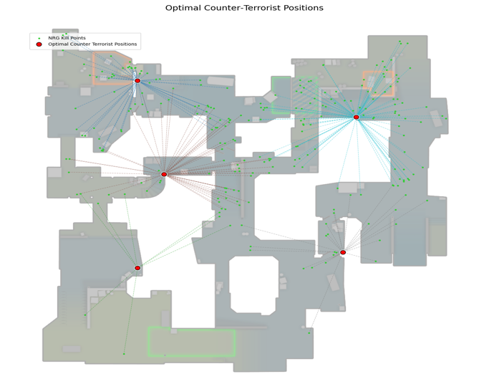
Defender position for $p$ = 5 and $λ$ = 15
- Left: Model without the distance cap
- Right: Model with distance cap
Ideally, neither graph would be good positions, but that is expected. The graph on the right put's players in compromising and unrealistic starting positions that would get you yelled at by teammates. In practice this means CTs would be standing in the open and in common angels that get peaked. The right graph pushes CTs into awkward positions, cover-adjacent spots sometimes tucked so far off-axis that large parts of the map aren’t covered.
Data Collection
Data is gathered by web scraping a professional counter-strike news site HLTV, which allows users to download professional repays. Once downloaded the replays are then parsed with a parser with golang with the demoinfo-cs module. Where each replay is parsed for each event in the game kill, bomb plant, etc. Once parsed the data is exported to a JSON file where it is then sent to webserver written in python with fastAPI. Then the JSON is parsed and stored using SQLite.
Limitations and Future Directions
Since we wanted to be quick, easily interpretable proof of concept, we used a static kill clusters and simple distance/risk objectives. In reality, the entire CT side is more dynamic and complex. A natural next step would be to parse the entirety of the replays frame by frame, then project each player (x,y) positions on to a two-dimensional map, then compute a Voronoi tessellation at each frame. This is commonly used in soccer analytics—and would tell us how much territory each CT would control over time. By combining those time-indexed Voronoi maps with our risk surfaces and optimization, you could start to develop a truly adaptive CT setup that responds to the flow of the round.
Conclusion
In summary, our spatial optimizer experiments reveal a fundamental trade-off in CT positioning maximizing raw coverage of know T-side kill hot spots invariably draws defenders into the very lines of fire, while enforcing strict proximity constraints forces them into impractical, under-defended corners. This tension shows that purely distance based or purely risk adverse layouts fall short of tactical reality.

References
Aswani, R. (2016). IEOR 151 Lecture 13: Facility location problem [Lecture notes]. University of California, Berkeley. Retrieved from https://aswani.ieor.berkeley.edu/teaching/FA16/151/lecture_notes/ieor151_lec13.pdf

