Week 2 homework

John Lasheski

November 2, 2014

Output for part a

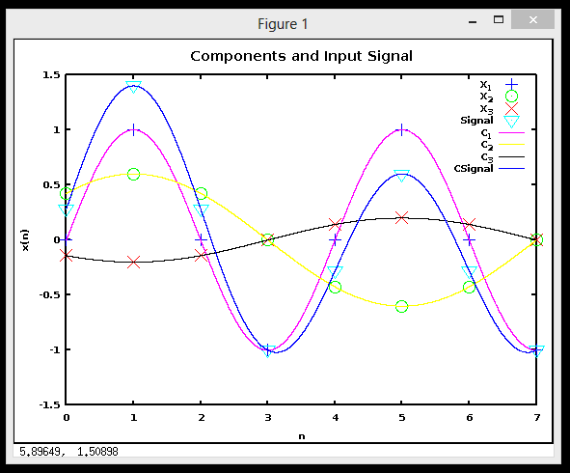

Output for part b

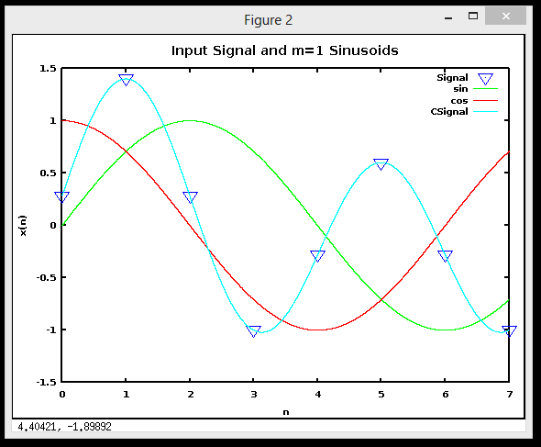

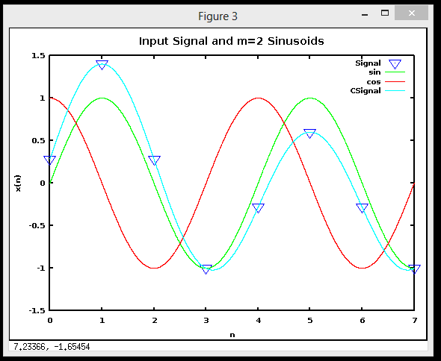

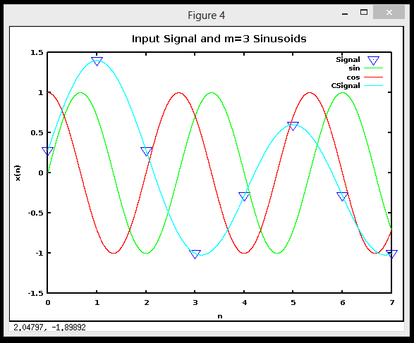

Output for parts c & d

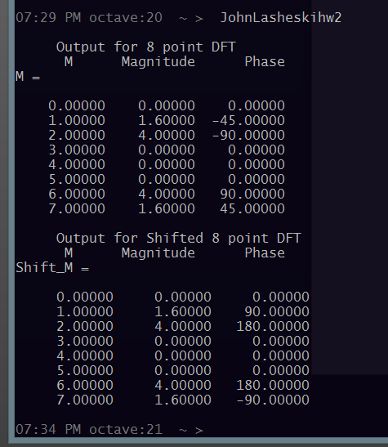

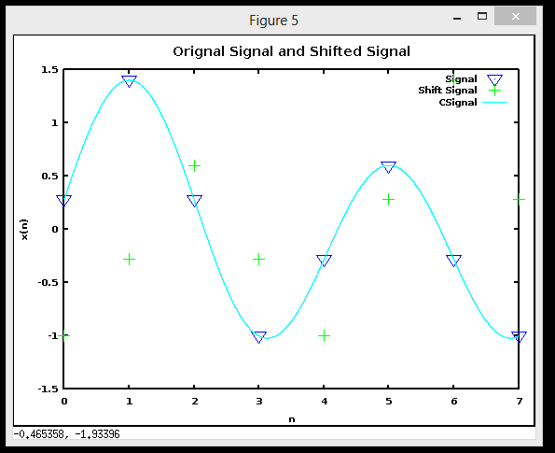

The effect of the shift appears to be a reflection of the signal about the middle. The magnitude for each m stayed the same, but the phases were changes such that we now have a mirror image of the original signal.

Output for part e

