John Lasheski
CMSC465, Homework 3

The use of Nth-primitive roots of unity, N a power of 2, as sample points in the DFT enables the savings of the FFT.
- Explain, making use of the complex plane if you wish, why the 8th primitive roots of unity reappear in the 16th primitive roots of unity.

Both 8 and 16 are powers of 2. 2^3 = 8 , and 2^4 = 16.

I wrote some simple functions in octave to plot and test out the roots of unity. The output is pasted below.

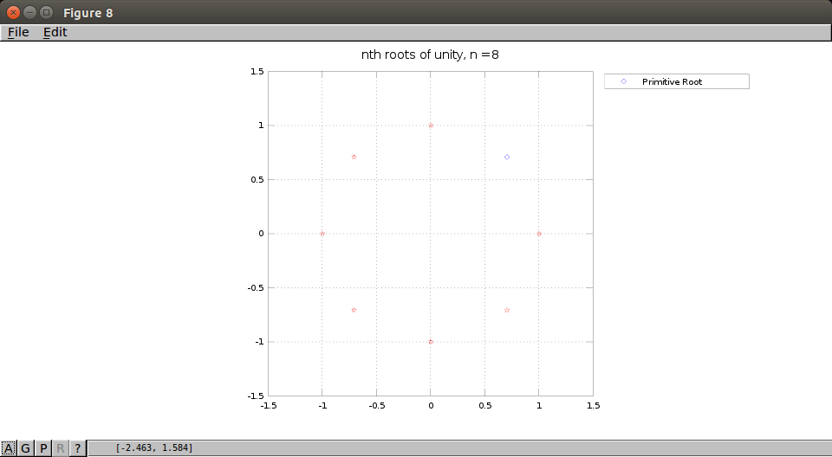

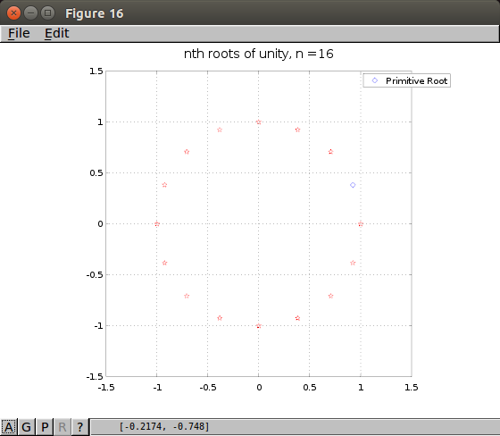

I was curious and ran a test, this works for powers of 3 too. 3^2 = 9th roots were included in the 3^4 = 27th roots.

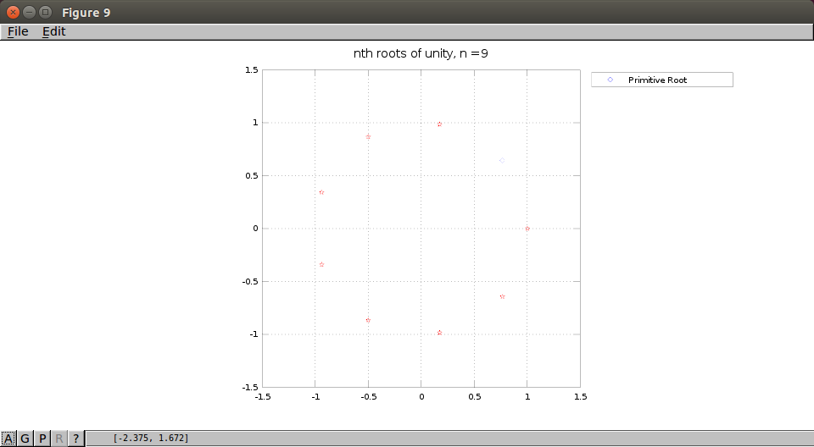
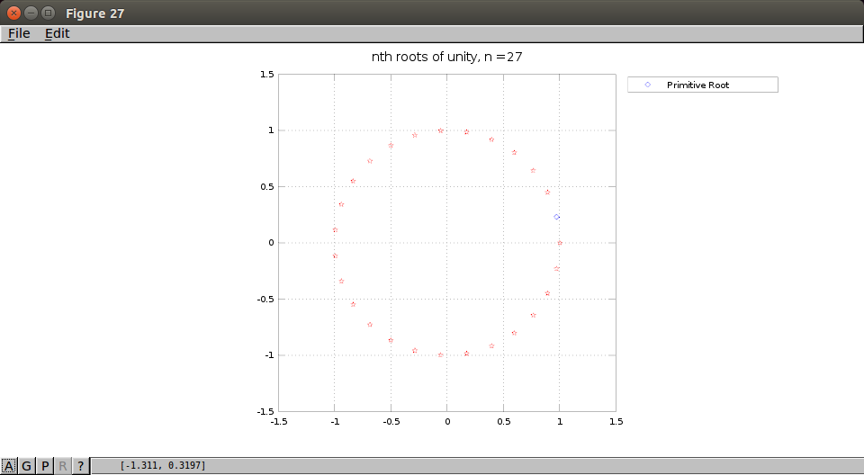

- Next, consider factorization. If the first, third, fifth and so on 16th roots of unity were factored, so that the first of the 16th roots of unity were factored out, what relation would the other factors bear, to the 8th primitive roots of unity?

The remaining factors of the 16th roots unity entirely compose the 8th roots of unity. The two sets are equal.

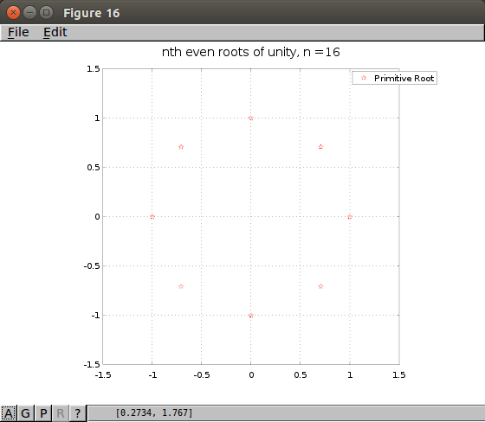

- Do the 4th primitive roots of unity appear within the 8th primitive roots of unity?

Yes, the 4th roots of unity do appear within the 8th roots of unity.

- What has the appearance of these primitive roots, specifically where in the sequence of the Nth primitive roots of unity, the occurrence of these primitive roots of divisors of N is located, got to do with the permutations that are carried out in the decimation in time and decimation in frequency algorithms

The appearance of these roots allows us a major costs savings on the computation of the DFT algorithm. I think of it as running the calculations in parallel almost, rather than running the computations in series. Depending on how we order the bits, the decimation in frequency or decimation in time algorithm will be used. When the bits are ordered normally the frequency algorithm is used, or of we group the bits by even pairs and odd pairs, the time algorithm is used.

- Explain the meaning of the graph given in Figure 7.3, signal flow diagram.

Figure 7.3 shows the Cooley-Tukey algorithm for decimation in time calculation of the FFT. It shows how the even bits and odd bits are paired separately and then recombined in the correct sequence.

