Lab 7: Digital Clock

Purpose: Design and build a digital clock using FPGA; learn how to control the four-digit common anode seven-segment LED displays onboard.

Demonstration: By next Tue. 1PM

Description:
The human eye has a property known as Persistence of Vision (POV), which causes it to hold an image briefly. The brighter the image, the longer it holds in our eyes. The feature of POV can be used to time-multiplex a display by rapidly cycling through each of the four 7-segment displays on your board. 400Hz clock is suggested to be used in this lab. Your circuit will need to display the minute (two digits) and second (two digits). For example, “0955” means 9 minutes and 55 seconds.

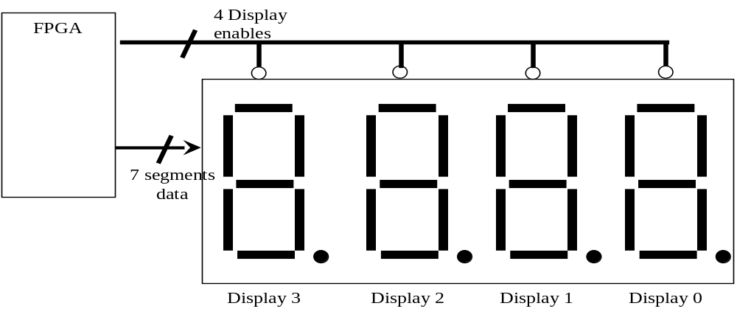

Procedure:
- Understand the block diagram on the next page
- Develop Verilog code for each block and test them
- Develop a plan to integrate the blocks
- Integrate blocks incrementally and test at each step
- Document your “lessons learned” in a word document

Report:
- Your report shall address the most valuable lesson you have learned so far
- Follow the IEEE format
- Page limit: 1 page text excluding figures, codes, etc.

Block Diagram
