Assessment #2

COVID-19 Prediction Model Write-Up

Name: Jonathan Nali
Student number: A00152708
Email: Jonathan.Nali@Student.Torrens.edu.au
Learning facilitator: Rubina Sarki

CLR204
Classification and Regression
Table of Contents
Method Employed and Model Building Comments 1
I. Data Analysis 2
II. Data Pre-processing & Correlation 2
III. Evaluation Metrics 2
Results 3
I. Evaluation Metrics & Hyperparameter Observations 4
Issues, Limitations & Comparison 6
I. Missing data 6
II. Imbalance data 6
III. Typos and incorrect data 6
Reference 6
Appendix 8
8

Method Employed and Model Building Comments
The key libraries and packages utilised for task 1 were Pandas, Matplotlib, NumPy, Scikit-learn, datetime and warning. The data

Data Analysis
The fabrication of the Covid-19 prediction model followed the data science lifecycle rigorously, the dataset was obtained, prepared and partially pre-processed by the authors of the study with the intention of fulfilling the requirements of this study (Iwendi et al., 2020). Exploratory data analysis techniques of mapping and categorization were utilised to differentiate and sort the patient symptoms into 5 main categories (malaise, fatigue and body pain, cold symptoms, cough and fever) to further understand the data. The patient outcome counts by gender, and age plots were also generated using matplotlib and seaborn to visualise the disparity between the deaths and recovered patients.

Data Pre-processing & Correlation
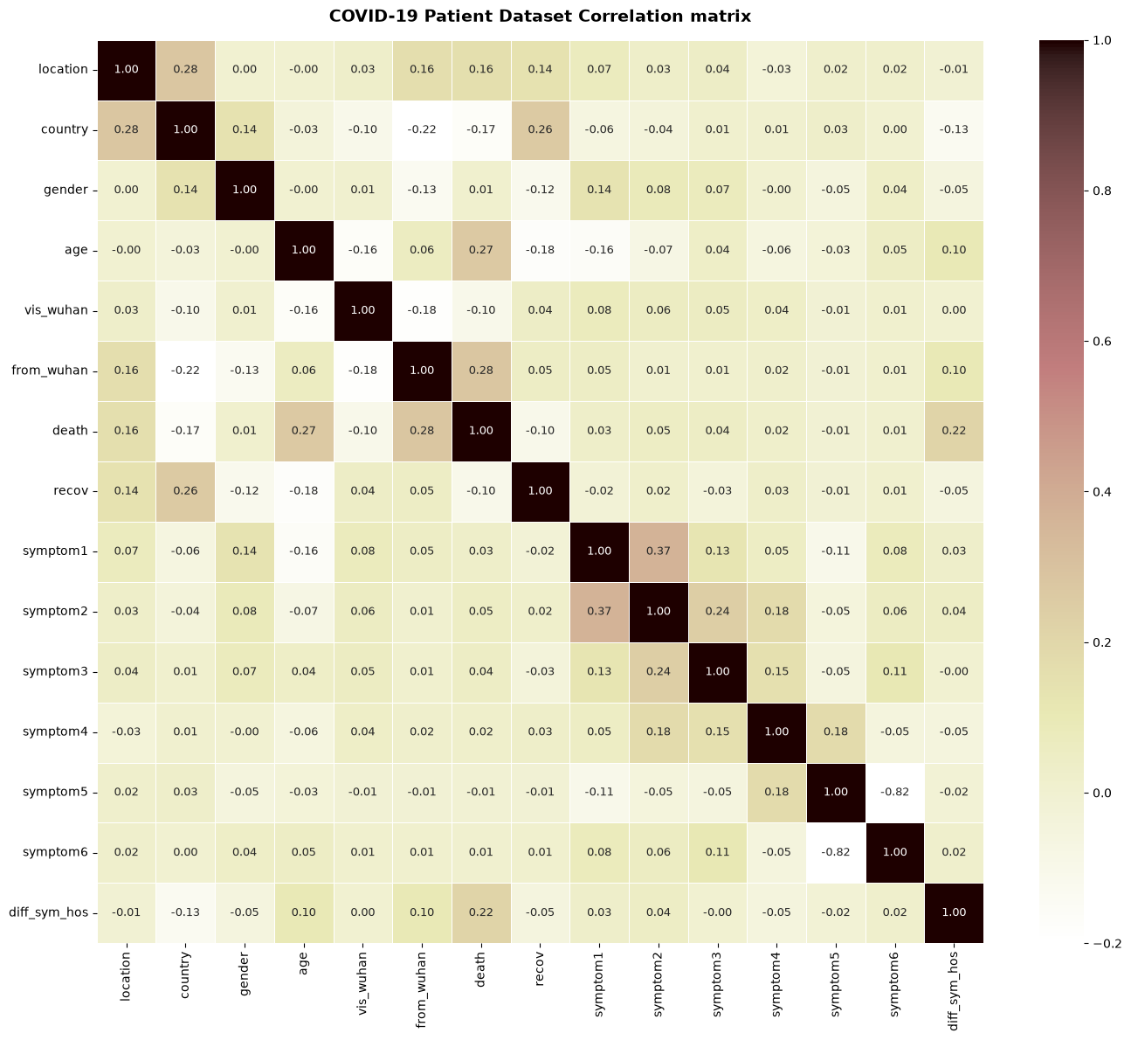
The pre-processing stage focused mainly on identifying the time between first symptoms and hospital visits (diff_sym_hos), and the conversion of strings formats into numeric variables with the assistance of the label encoder class. The correlation matrix used the pre-processed data that to better understand the relationship between variables from their Pearson coefficients, the correlation matrix can be seen in figure 1 below.

Figure 1. Correlation matrix between variables

Evaluation Metrics
The supervised classification pipeline assisted in the construction of the evaluation plots by utilising the train test split class to divide the data into testing and training sets that aided in the calculation of the confusion matrix (TN, TP, FN and FP) values that were directly used to identify the individual values for recall, precision, F1 and accuracy (the formulas are below) . Decision trees were constructed with the random forest classifier as the main predictive model because they reduced overfitting and the n_estimator values of 1, 10, 25 and 100 were configured in the trees to show how scaling up affected the splitting criteria and decision paths.
$$Accuracy=\frac{ TP + TN}{TP+TN+FP+FN} (0.0 < Accuracy < 1.0)$$
$$Precision=\frac{TP}{TP+FP}$$
$$F1 score=2× \frac{Precision × Recall}{Precision+ Recall}$$
$$Recall =\frac{TP}{TP+FN}$$

Results
The pre-processed dataset was used to train the 5 machine learning models and gridsearchCV was utilised for hyperparameter optimisation. This assisted in finding the values for confusion matrix (True positive, True negative, False positive and False negative), these values were used to identify the scores for recall, precision, F1 and accuracy which resulted in the identification of the best performing prediction model.

Evaluation Metrics & Hyperparameter Observations
The training and evaluation of the machine learning models resulted in the identification of the evaluation metrics scores and confusion metrics values as seen in the figures below (fig. 2 – fig. 11 ). Data analysis revealed that there was bias in the data, a larger ‘recovered’ count (94.19%) compared to the ‘death’ count (5.81%), and as Iwendi et al. (2020) stated, “Since the dataset we used can be an imbalanced dataset, we will be using F1 Score as the primary metric for comparison”. This imbalance in the training data was depicted in the decision tree models and was identified by a gini value of less than 0.5.
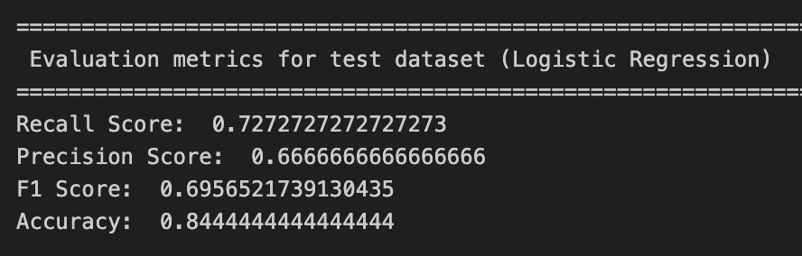
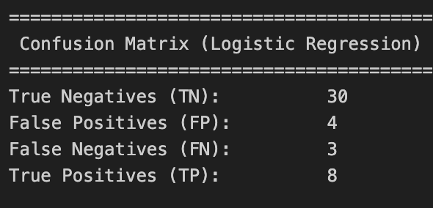
Evaluating the data revealed that Boosted random forest had the better overall evaluation metric scores (recall, accuracy and F1) which indicates that it is the better predictive model. The optimal parameter that yielded the top performance for the model were a criterion of ‘gini’, max depth of 10, min sample leaf of 1, min sample split of 5 and the n_estimators of 200 (Fig. 12 ) which implies that, 200 individual decision trees are used for a better accuracy, reduced overfitting and resulting in stable predictions.
Figure 3. Evaluation metrics (Logistic regression)
Figure 2. Confusion matrix (Logistic regression)
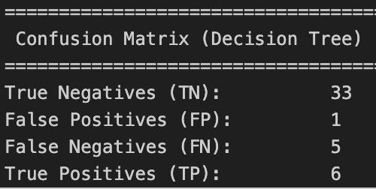
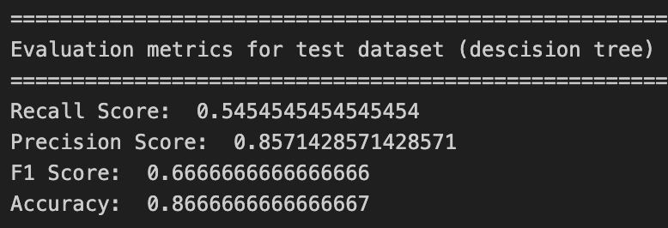
Figure 4. Confusion matrix (Decision tree)
Figure 5. Evaluation metrics (Decision tree)

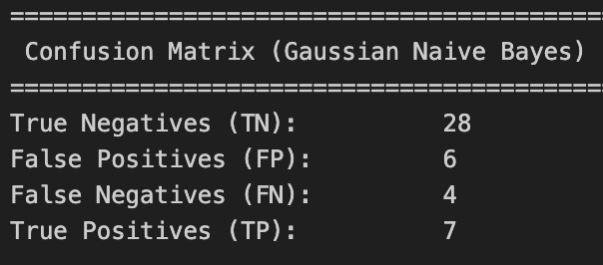
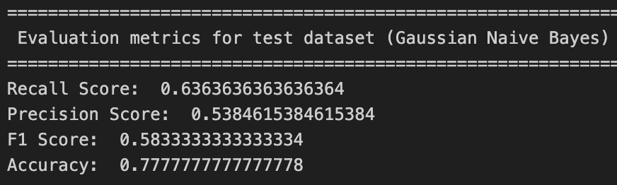
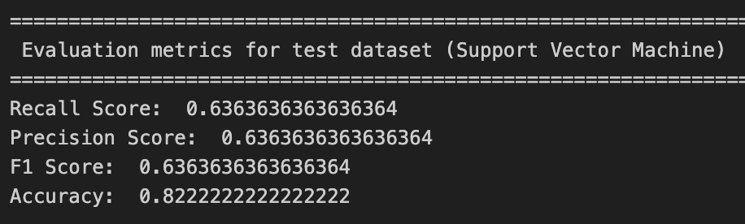
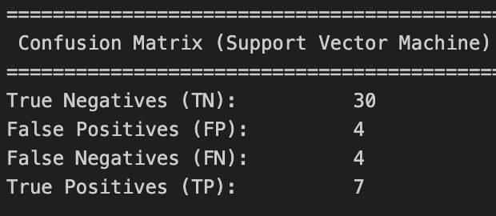
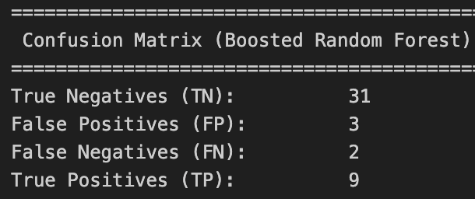
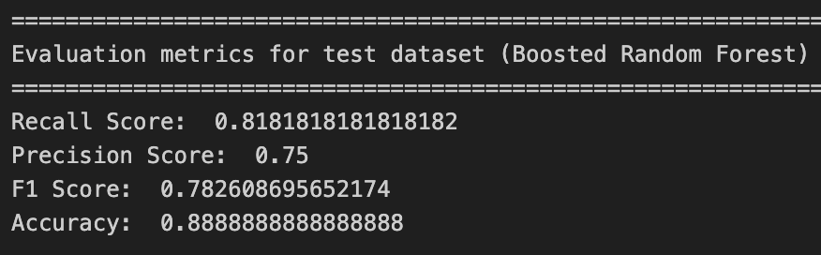
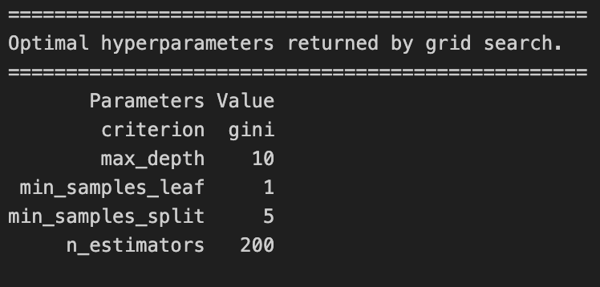
Figure 9. Evaluation metrics (Support vector machine)
Figure 11. Evaluation metrics (Boosted random forest)
Figure 7. Evaluation metrics (Gaussian naïve bayes)
Figure 6. Confusion matrix (Gaussian naïve bayes)
Figure 8. Confusion matrix (Support vector machine)
Figure 10. Confusion matrix (Boosted random forest)

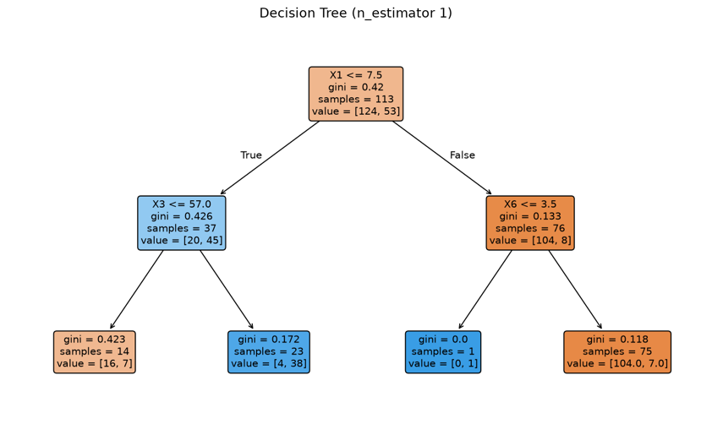
Figure 12. Optimal hyperparameter returned by grid search

Figure 13. Decision tree (n_estimator = 1)

Issues, Limitations & Comparison

Missing data
Iwendi et al. (2020) stated that “The dataset consists of multiple missing values which cause an error when passed directly as an input”, data analysis revealed the issues with the missing data, a good example of this is of the variables sym_on and hosp_vis, they were identified to have 636 missing data (58.62%) each, when taken into account their use in the analysis and training of the models, it was a big issue due to it affecting the other variables and models results.

Imbalance data
The death and recovered variables were the most skewed variables in the dataset, ‘recovered’ had a larger count of 1022 patients (94.19%) and ‘death’ had a smaller count of 63 (5.81%). This limitation was solved by the creation of a smaller dataset to balance out the data for training models. This was a big concern due to ‘death’ and ‘recov’ being the primary variables of the study that would be used for correlation analysis and model training. According to Iwendi et al. (2020) “the Gini index in all the leaf nodes of all the trees is <0.5, which indicates the training dataset is imbalanced”, because of this, the models were configured as stated by Iwendi et al. (2020) “for optimizing the performance of the model we have reduced the depth of trees to 2 and increased the number of estimators (decision trees) in the random forest to 100”. This was one of the methods done to deal with the imbalance.

Typos and incorrect data
The minor issues and inconsistencies included typos that were solved manually and wrong sym_on and hosp_vis entries ( the hosp_vis date was before the sym_on date).

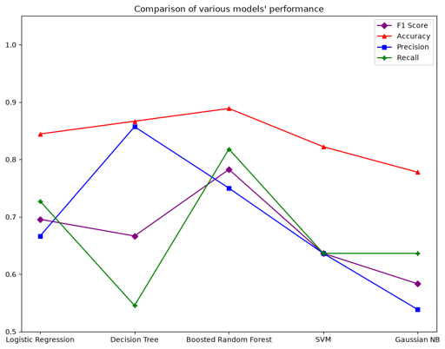
The comparison of models’ performance plot successfully visualised the evaluation metrics scores which displayed that the boosted random forest was the superior model among the 4 (excluding the logistic regression.

Figure 14. Comparison of various models performance plot

Reference

Iwendi, C., Bashir, A. K., Peshkar, A., Sujatha, R., Chatterjee, J. M., Pasupuleti, S., Mishra, R., Pillai, S., & Jo, O. (2020). COVID-19 patient health prediction using boosted random forest algorithm. Frontiers in Public Health, 8, Article 357. https://doi.org/10.3389/fpubh.2020.00357

Appendix
Figure 1. Correlation matrix between variables

Figure 4. Confusion matrix (Decision tree)
Figure 5. Evaluation metrics (Decision tree)
Figure 3. Evaluation metrics (Logistic regression)
Figure 2. Confusion matrix (Logistic regression)

Figure 11. Evaluation metrics (Boosted random forest)
Figure 9. Evaluation metrics (Support vector machine)
Figure 12. Optimal hyperparameter returned by grid search
Figure 10. Confusion matrix (Boosted random forest)
Figure 8. Confusion matrix (Support vector machine)
Figure 6. Confusion matrix (Gaussian naïve bayes)
Figure 7. Evaluation metrics (Gaussian naïve bayes)
Figure 14. Comparison of various models performance plot
Figure 13. Decision tree (n_estimator = 1)

