The AnyRail program, Copyright © 2023 DRail Software, can export a track plan to a JMRI PanelPro XML file with a Layout Editor formatted Panel.

Fair disclosure:
WHAT FOLLOWS is dependent upon the English (EN) language choice from within the AnyRail menu:
FILE >> Options >> Languages item.
NO OTHER LANGUAGE CHOICE HAS BEEN TESTED AS OF THIS TIME
Developed with PanelPro version 5.3.4+Raae2040ea3
under Java 11.0.13
on Windows 10 amd64 v10.0
Tested with AnyRail Version 6.51.0

If the track plan has defined "Sections," then there is a one-to-one translation to "Blocks" in the exported Panel file.

AnyRail allows duplicated Section names.

The first exported PanelPro Block systemName is always "IB1" and the rest of the systemName values are numbered sequentially.

An exported Block systemName might be "IB123" for some iteration, but have a different "IB" number the next time the plan is exported.

The exported PanelPro Blocks do not have any assigned occupancy Sensors.

The AnyRailBuildBlockSensorList script implements a simplistic rule to provide a unique occupancy Sensor for each AnyRail exported Block.

Each AnyRail exported PanelPro Block has a userName that is constructed by concatenating four strings that are separated with the Low Line character AKA the "_" character.
1) The character "B"
2) The numeric portion of the Block systemName,
3) The specific AnyRail Section name, if actually defined, with the possibility that the Section name includes one or more Low Line characters.
4) The pull-down choice for the "Usage" value.

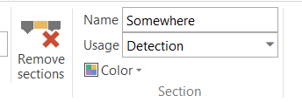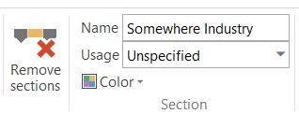

If the AnyRail Section name were something like "Somewhere," and the selected Usage is "Detection," then the exported Block systemName might be "IB123" and if so, the exported Block userName would look like "B_123_ Somewhere_Detection" and similarly, some other block might have a userName that could look like "B_21_ Somewhere Industry_Unspecified"

To augment the exported PanelPro file, for each named Section and hence each exported Block with systemName "IBxxx", this script will create a new occupancy Sensor with a systemName "ISxxx" with matching digits "xxx."

Each discovered Block will be reported on the JMRI Script Output window followed by a report for the resulting occupancy Sensor data.

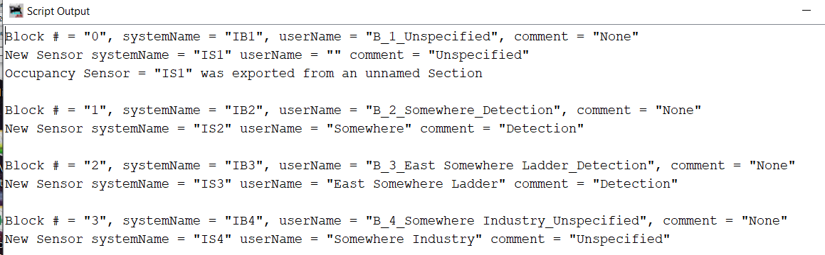

Usually, the Sensor assigned to the exported Block will be set to the AnyRail Section name, but some contingency is built in for AnyRail Sections with names that are either not unique or even left blank.

Any Block that is discovered to not have a userName fitting the recognized AnyRail exported Block format will be reported on the Script Output window, but no Sensor will be created.

The script allows the option of renaming the exported Block’s userName to match the newly created occupancy Sensor’s non-blank userName, but a simple edit of the value for
isRenameBlocks = False
If the option is set to rename the exported Block, then it's userName and it's comment field will match those of the created occupancy Sensor.

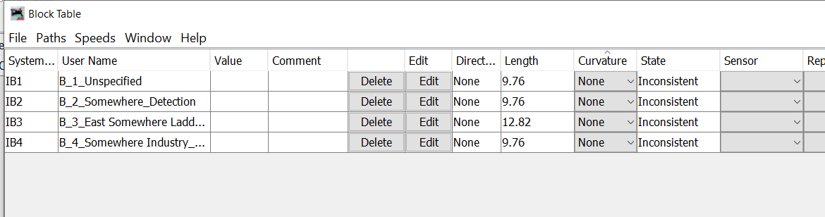
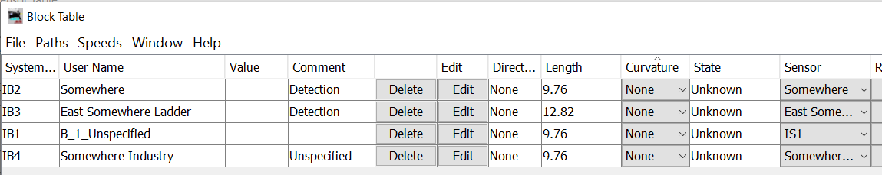

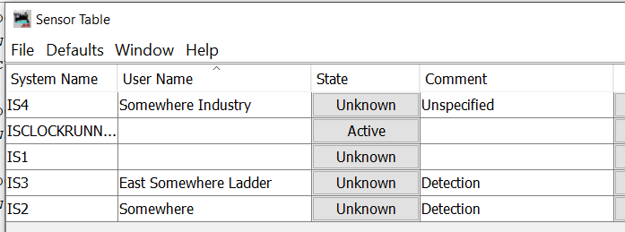

In this example, the exported Block IB1 comes from an unnamed AnyRail Section. The script creates a corresponding occupancy Sensor IS1 but does not provide the Sensor userName or change the Block userName.

Each time it becomes necessary to modify the AnyRail track plan and export a new version of the PanelPro file, the user is forced to rebuild the list of Sensors that define the related Occupancy status for each Block.

The AnyRailBuildBlockSensorList script automates what would be a tedious and error prone process when done manually. It does however, require careful attention to the AnyRail track plan details.

This script is intended be executed EXACTLY ONCE on each NEWLY EXPORTED PanelPro XML file. Since the script will not override any previously assigned occupancy Sensor for any Block, there is some protection if it were to be run a second time.

