clase 1

Jackson

14/9/2019

## Creación de vectores

v <- numeric(20)  
 v

## [1] 0 0 0 0 0 0 0 0 0 0 0 0 0 0 0 0 0 0 0 0

v1<-rep(0,20)  
 v1

## [1] 0 0 0 0 0 0 0 0 0 0 0 0 0 0 0 0 0 0 0 0

v2<-rep(c(1,4),times=c(4,8))  
 v2

## [1] 1 1 1 1 4 4 4 4 4 4 4 4

v3<-rep(2:4,times=c(4,9,10))  
 v3

## [1] 2 2 2 2 3 3 3 3 3 3 3 3 3 4 4 4 4 4 4 4 4 4 4

v4<-seq(4,10)  
v4

## [1] 4 5 6 7 8 9 10

v5<-4:10  
v5

## [1] 4 5 6 7 8 9 10

v6<-seq(50,120,length=1000)  
head(v6, n=10)

## [1] 50.00000 50.07007 50.14014 50.21021 50.28028 50.35035 50.42042  
## [8] 50.49049 50.56056 50.63063

hist(v6,border = 'white', col=2)

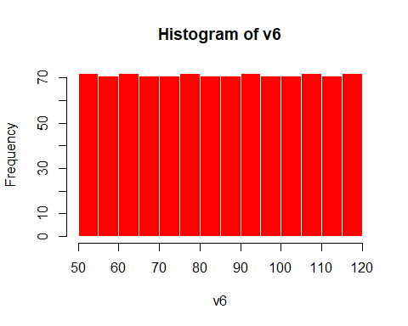

v7<-seq(50,120,by=10)  
v7

## [1] 50 60 70 80 90 100 110 120

## Ejemplos de la función rep

rep(1, 10)

## [1] 1 1 1 1 1 1 1 1 1 1

rep(1:3, 2)

## [1] 1 2 3 1 2 3

rep(1:3, each=2)

## [1] 1 1 2 2 3 3

rep(1:3, times=c(8, 9, 5))

## [1] 1 1 1 1 1 1 1 1 2 2 2 2 2 2 2 2 2 3 3 3 3 3

## otra forma de vectores

x4<-c(1,3,2,10,5)  
x4

## [1] 1 3 2 10 5

y<-1:8  
y+2

## [1] 3 4 5 6 7 8 9 10

2*y

## [1] 2 4 6 8 10 12 14 16

y^2

## [1] 1 4 9 16 25 36 49 64

z<-4:8   
z

## [1] 4 5 6 7 8

## cálculos basicos

x4+z

## [1] 5 8 8 17 13

x4*z

## [1] 4 15 12 70 40

x4/z

## [1] 0.2500000 0.6000000 0.3333333 1.4285714 0.6250000

x4^z

## [1] 1 243 64 10000000 390625

x4**z

## [1] 1 243 64 10000000 390625

## manipular vectores

x<-c(12,16,13,15,18,22,31,10)  
length(x) #longitud o numero de datos

## [1] 8

x[4]

## [1] 15

x[3:5]

## [1] 13 15 18

x[-2]

## [1] 12 13 15 18 22 31 10

x[x>16]

## [1] 18 22 31

sort(x,decreasing = TRUE)[3]

## [1] 18

x>16

## [1] FALSE FALSE FALSE FALSE TRUE TRUE TRUE FALSE

sum(x[x>16])

## [1] 71

(1:length(x))[x<=14]

## [1] 1 3 8

z<-as.logical(c(1,0,0,1))  
z

## [1] TRUE FALSE FALSE TRUE