Introduction
After delivery, any number of reasons may necessitate modifying the courseware produced by Oak Grove Technologies (OGT). OGT understands that circumstances change, and knowledge grows, and for this reason, we’ve created this document to assist performing maintenance edits in the 82 lessons that make up the five modules within the VA-NAGE 2017 Master Agreement Curriculum.
This document was created assuming a particular set of skills on the part of the developer who will be making edits to the courseware. It is assumed that the developer is familiar with HTML5, CSS, JavaScript, JQuery, and JSON formatted data files. It is also assumed that the developer has worked with standard code that is exported from the Project Access and Management (PAM) system; the preferred authoring platform of VHA EES.
This document also contains the specific development conventions that are unique to the modules, identifying file locations, editing procedures, and design standards that might affect any changes.

Specific Terminology
LCA – The term “LCA” stands for “Labor Contract Agreement.” This term is sometimes used instead of “LMR-NAGE” to identify the Master Agreement Curriculum production effort.
Master Agreement – The subject matter for the curriculum is the 2017 Master Agreement by and between the U.S. Department of Veterans Affairs (VA) and the National Association of Government Employees (NAGE) union. It is referred to in this document as the “Master Agreement.”
Subject Matter Expert (SME) – Throughout this project, the designers of this curriculum worked with Subject Matter Experts from the VA’s Office of Labor Management Relations (LMR) and the National Association of Government Employees (NAGE) union (both at the National-level and local VA-level), who provided their expertise and ensured the curriculum’s alignment with their organizational and training program objectives.
Project Access and Management (PAM) – The production and client review system used to create and review the HTML pages created during the Development Phase for this project. A component of the “myInstruo” authoring platform created by Instructus Media, this is also the repository where the Final Source Package deliverable is stored. Note that the Storyboards were created using an OGT PowerPoint (PPT) template. Once accepted by the EES and the Client, the content of these Storyboards was inputted into PAM’s Storyboard system so it could be outputted as courseware using the Course Generator button. Note that revisions made to the modules during Development and Implementation Phases were not retroactively applied to the PPT or PAM Storyboards.
Curriculum – This term was used to describe the group of all five modules that make up the learning intervention produced for EES and the LMR-NAGE Client.
Module – A module is a group of individual lessons. Each lesson provides instruction on a single article within the Master Agreement, of which there are 72. The 72 articles are distributed across the five modules according to a general title and category, which are as follows:
- Module 1: Rights, Regulations, and Responsibilities;
- Module 2: Time, Leave, and Compensation;
- Module 3: Counseling, Performance, and Grievances;
- Module 4: Title 38 and Hybrid Title 38 Employees;
- Module 5: Safety, Health, and Assistance.
For each module there is also a “Module Introduction” and “Module Conclusion” lesson that are intended to be taken at the beginning and end of each module, respectively. The “article” lessons are intended to be taken in any order. Note that this document uses the term module differently from how PAM uses the term. What this document calls a “lesson” is the equivalent of what PAM refers to as a “module” (or in some places within the PAM system as a “course”). In addition, each module is a “Project” in PAM listed under its EES eLP, thus an individual Project was created in PAM for each of the five modules in the curriculum. When the modules were implemented in the TMS, they were each assembled as a “Program.”
Lesson – A lesson is a single instructional intervention with a Terminal Learning Objective (TLO) which describes the desired proficiency (or competency) of the learner after he/she has completed said lesson. A lesson is made up of one or more topics. Note that this document uses the term “lesson” differently than how PAM uses the term. What this document calls a “topic” is the equivalent of what PAM refers to as a “lesson.” In addition, each lesson is a PAM “Task Group” within its module’s “Project.”
Topic – A series of one or more pages within a lesson which support a single Enabling Learning Objective (ELO). Together, these ELOs support achievement of their lesson’s TLO (thus “enabling” the learner to reach the terminal objective). A topic’s pages will contain onscreen text and images. Some pages may have interactivity and most pages will be narrated. Note that this document uses the term “topic” differently than how PAM uses the term. What this document calls a “topic” is the equivalent of what PAM refers to as a “lesson.”
Project – An organizational group within PAM. Each project contains one or more “Task Groups.”
Task Group – An organizational group within PAM. Each Task Group provides an “authoring platform” to create an individual learning intervention. For the LCA project, a Task Group was used to produce a single lesson.
The following table provides a map of certain terms discussed in this section.
Standard PAM Terms | OGT LCA Terms | TMS Implementation
Project | Module | Program
Module (or Course) | Lesson | SCO (or Item, or Course)
Lesson | Topic | n/a

Accessing the Code
Developers can access the relevant code from PAM within six separate Projects titled:
- LMR-NAGE Master Glossary
- LMR-NAGE Mod1
- LMR-NAGE Mod2
- LMR-NAGE Mod3
- LMR-NAGE Mod4
- LMR-NAGE Mod5
The “LMR-NAGE Master Glossary” Project contains the “Master Curriculum Glossary” Task Group which can be used to modify the glossary terms via the PAM interface. This interface can allow those not familiar with editing courseware code to update and maintain the glossary terms and definitions. Detailed instructions on editing the glossary are in the “Glossary Links” section of this document.
This Task Group also contains a version of the Prototype developed during the Design Phase to gain EES and Client approval of the GUI, as well as key graphics and interactions, prior to the Development Phase.
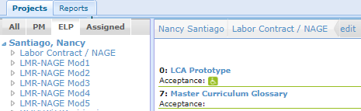
Each module’s Project contains a Task Group for each lesson within the module (e.g., “Mod1_Lesson00: Module Introduction”). There is also an “extra” Task Group for each module’s Project used to store its “Final Source Package” deliverable (e.g., “Mod1_All_Lessons: Final Source Package”).
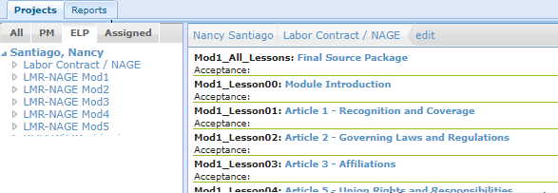
The final courseware code for each individual lesson (aka “runtime”) can be located and downloaded for editing purposes from two different Task Groups.
- Either from its associated Lesson Task Group (e.g., Mod1_Lesson00: Module Introduction,” …
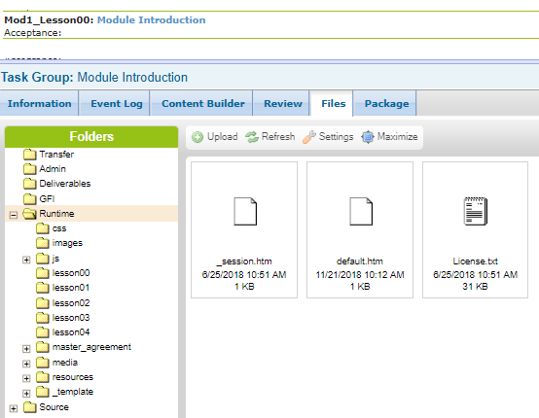
- Or in the “Source > runtime_zipped” folder located in a module’s “Final Source Package” Task Group, where each lesson’s final runtime is in its own zipped folder:
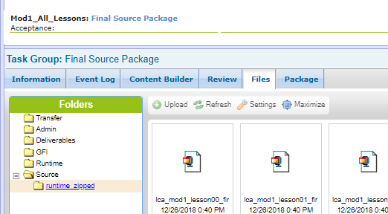
Both versions of the final runtime are identical, but the “open” (i.e., unzipped) version in each lesson was used to generate its Sharable Content Object (SCO) during the Implementation Phase.
If the courseware is updated, OGT recommends that both runtime repositories are kept up to date with the latest code.

File Structure
As navigating the folders and files of each lesson’s runtime code will be necessary to perform edits, this section briefly describes the general nature of each folder in the final runtime, which has been customized from the standard “out of the box” code generated by myInstruo.
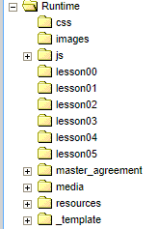
Folder Name | Purpose
css | This folder contains specific CSS that controls the layout and visual aspects of the elements in the curriculum. OGT has modified this folder heavily. This folder should be uniform across all lessons in each module.
images | This folder contains onscreen images that were created by OGT for each of the modules. This folder will be unique to each lesson.
js | This folder contains specific functional JavaScript and JQuery used to provide specific functions within each lesson. This folder includes files that define screens with additional or unique interactivity within the curriculum. Most files in this folder will be identical to across all lessons. Two types of files in this folder will be unique to a lesson:  - the config.js file, and  - any knowledge check files (labeled with the pattern “kc_02_006.js.)  The filename of the knowledge check files corresponds to the topic and page where knowledge check is included. The above example would be on page 6 (006) of topic 2 (02) of this particular lesson.
Topic Folders  For example:  lesson00  lesson01  lesson02  lesson03  lesson… | These folders contain the HTM pages for each topic within a lesson. As explained in the Specific Terminology section above, OGT has used these “Topic Folders” to contain the content for each individual “topic” within a lesson. In other words, OGT refers to “lesson00” as Topic 00, “lesson01” as Topic 01, and so on.  These folders are created in such a way that certain aspects are uniform across each module. These are described below.  - lesson00: Contains the initial welcome splash screen to the module, introduction to the module, and program 508 controls.  - lesson01: Contains an introduction to the article covered by the lesson, as well as the “Read the Contract” exercise page, “What Do You Recall?” exercise page, and “How Confident Are You” exercise page.  - lesson02 and beyond: Varied instructional content screens that go into more detail about the article covered by the lesson.  - Final Lesson Folder (lesson number varies depending upon the number of lessons in a module): Concludes the module. The last lesson folder should always contain the “End of Lesson Instructions” page.
master_agreement | A custom folder that contains the files that support the “Read the Contract” exercise page, as well as the “Master Agreement Reference Tool.” This includes functional code elements, as well as the actual text of the contract. This folder should be uniform across all lessons in the curriculum.
media | This folder contains the narration aspects of a lesson. The audio for each page has been included here, as well as the accompanying closed captioning. This folder will be unique to each lesson.  In addition, OGT has included a folder titled “recall” that contains 13 different versions of a certain audio clip. In an effort to avoid making the audio directions for the “What Do You Recall?” exercises sound stale, we incorporated 13 different options that are randomly selected each time a learner navigates to a page. Each audio has a slightly different inflection.
resources | This folder contains standard learner resources, such as the help and glossary information that has been customized for this curriculum. This folder should be uniform across all lessons in the curriculum.
_template | This folder contains overarching myInstruo files. OGT has modified this folder with updated images to adjust the visual aesthetic of each module to customer preferences. This folder should be uniform across all lessons in each module (i.e., the curriculum).

This document will refer to the locations of various files and folders, generally offering the location of those files/folders within the structure of a lesson’s runtime. Each of these paths is written assuming the developer is in the runtime folder that contains the default.htm file. When outlining a file path, this document will use the “>” character to indicate a folder or file that is inside of another folder. For example, the “custom.CSS” file inside the “CSS” folder would be called “CSS>custom.CSS” in the body of this document.

Editing Specific Features
Below are the features that were created specifically for the courseware, as well as information relevant to making modifications to those features or the information contained.

General Audio

Modifying Audio Files
Audio files are located within a lesson’s “media” folder. Simply replacing an existing audio file with a new audio file with the same name will replace the audio in the lesson. Make certain you also replace the existing .vtt file with an updated closed captioning file.

Naming Convention
Each audio file is identified by a number, such as 01_02_03_004. This naming convention identifies what page within the lesson the file corresponds to.
Filename  Component | OGT LCA Terms | Details
01_ | Module | The first number, 01 in the above example, corresponds to the “module.” This was the term used to identify which of the 5 major groupings of content that exists in the program.
02_ | Lesson | The second number, 02 in the above example, corresponds to the “lesson” in OGT terms.
03_ | Topic | The third number, 03 in the above example, corresponds to the “topic” in OGT terms. This is the subdivision of the above “lesson” and corresponds PAM use of the term “lesson.”
004 | Page | The fourth number, 004 in the above example, corresponds to the page. This is the subdivision of the above “topic” and corresponds an individual page within a lesson. Note that page numbering occurs at the lesson-level. In other words, page numbering does not start over at “Page 1” when the learner enters a new topic within a lesson.

Swapping to a Different Audio File
If you need to modify which audio file a page refers to, that is identified in the variable array “playlist” in the “location” variable. Make certain you also replace the existing .vtt file with the relevant timed closed captioning files.

“Default Settings for Page Content” Page
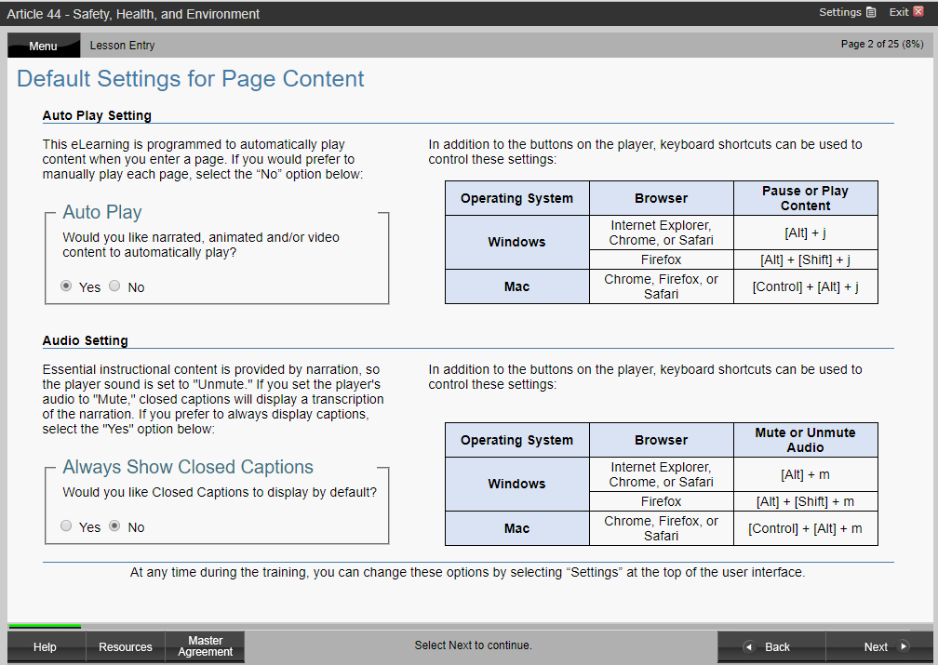

Toggles
This page is where the learner can set the default functionality of auto play and always-on captions. The onscreen language is included in “Lesson00> 00_002.htm.” The code to create the toggle boxes is created via the default functions “drawCCDisplayOption” and “drawAutoPlayOption” defined in the “_template>js>global.js” file.

Keyboard Shortcuts
This page also provides information regarding the keyboard shortcuts (or “hotkeys”) for the default functionality of auto play and closed captions. This information allows users of accessible technology to more easily toggle software features on and off. The text informing the user of these hotkeys is on the “Lesson00>00_002.htm” page, but the hotkeys themselves are defined in the “js>custom.js” file using the “accesskey” attribute.

“Read the Contract!” Exercise
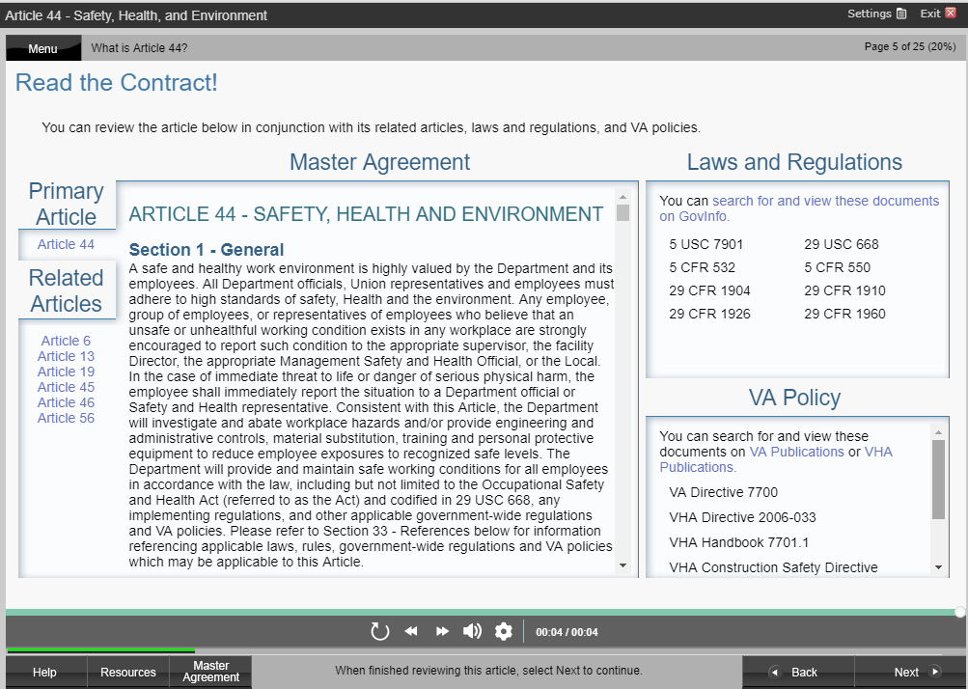

Standards
The “Read the Contract!” exercise within each lesson has several standards to which the content was created, which should be noted if edits are to be made.
The items under the “Related Articles,” “Laws and Regulations,” and “VA Policies” sections were defined primarily by references within the 2017 NAGE Master Agreement. This was supplemented with SME input.
When including “Laws and Regulations,” each item was verified to be discoverable via searching on the GovInfo.gov website. If a particular item was not available on that website, a separate section was created with an alternative government website wherein the learner could search for additional information. Examples of other websites used include items from the Equal Employment Opportunity Commission website and the National Archives website. OGT did not include or use links to specific search pages or individual items on any website as it is not a best practice due to the risk that those links might change without warning, thus sending the learner to a 404 error.
When including “VA Policies,” each item was searched for within the VA Publications search page and VHA Publications website. When introducing the list, only relevant links were included; meaning if no items on the VHA page were included, a link to the VHA page was not included. This is also true if the VA Publications database did not contain any listed items.
Both VA and VHA Publication links were included if an item(s) was available from both websites.
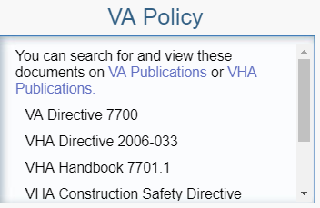
Example: Module 5, Lesson 1 Safety, Health, and Environment.

Modifying the Text of the Contract
The text that appears in the “Master Agreement” section requires modifying the article text in the appropriate HTML document in the “master_agreement>master_agreement” folder.
These changes will also affect the contents of the Master Agreement Reference Tool as these two interactions draw the text from the same file.
Please note that changing this text will NOT affect the “What Do You Recall?” exercise pages. Any changes to the contract will require updates to individual exercises.

Adding or Removing Related Articles
To add Related Articles items, open the “lesson01>01_003.js” file and include the additional article numbers in the “relatedArticles” array.

Adding or Removing Laws and Regulations
Laws and Regulations were added in one of two ways. In situations where all items were searchable via a single website, the list was included in the “lesson01>01_003.js” file in the “lawsAndRegs” array as text. By default, the link included was to the GovInfo.gov website. This link could be manually changed on the “lesson01>01_003.htm” page if every document in the list was searchable only on one website.
In situations where all documents were searchable only via multiple government websites, this list was manually created in HTML on the “lesson01>01_003.htm” page, separating the files into groups based on which website the document was searchable. Please see Module 5, Lesson 2 for an example.
If no items are included in the “lawsAndRegs” array, by default, the code will remove the text informing learners where to find documents, and the Laws and Regulations box will contain only the text “(No laws or regulations.)”

Adding or Removing VA Policy
VA Policies were added in one of two ways. In situations where all items were searchable via a single website, the list was included in the “lesson01>01_003.js” file in the “policies” array as text. By default, the link included was to the VA Publications search page. This link could be manually changed on the “lesson01>01_003.htm” page.
If no items are included in the “policies” array, by default, the code will remove the text informing learners where to find documents, and the VA Policies box will contain only the text “(No VA policies.)”

“What Do You Recall?” Exercise
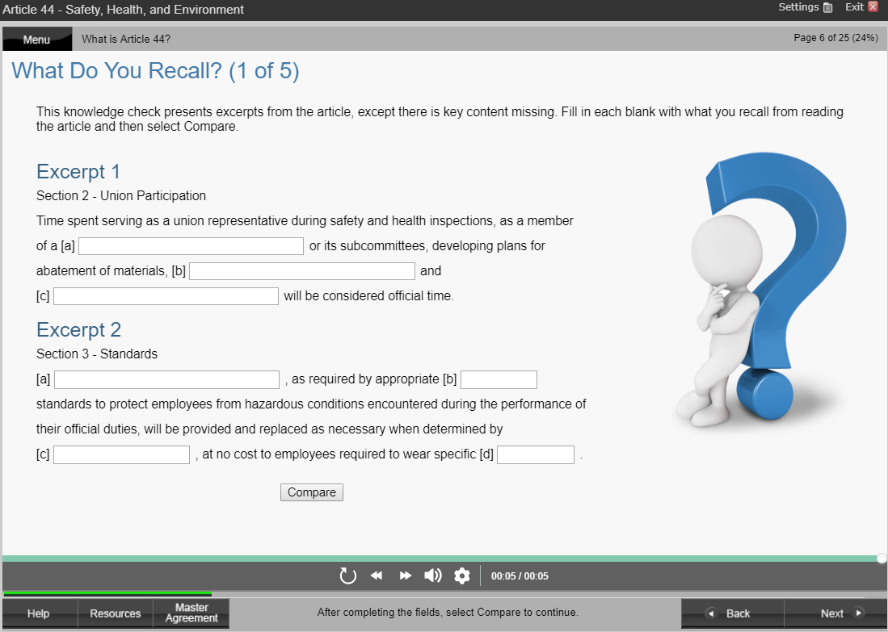

Standards
The “What Do You Recall” exercise has several standards to which the content was created, which should be noted if edits are to be made.
This exercise was frequently divided over multiple pages. In situations where this was the case, the title of the page included the current exercise page and the total number of pages in the series [e.g., What Do You Recall? (2 of 4)].
Each page was separated into excerpts. Each excerpt was a continuous block of text from an article in the Master Agreement and each excerpt listed the section number within the article. Effort was made to minimize blocks of text to a single section where possible, striving for no more than one paragraph per excerpt, though exceptions were infrequently made. The number of excerpts per page was limited to three, but fewer were included where excerpt length was long.
Blanks within an excerpt were lettered sequentially, restarting in each excerpt with [a]. The size of the blank was determined based on the length of text within the box. Blanks typically consist of a single word or phrase, only rarely including a complete independent clause. Single word blanks were selected as small or medium. Multi-word blanks ranged from medium to large. Since this exercise allows a learner to practice recall, care was taken to select blanks that could not easily be deduced (or recognized) by information within the excerpt or the title of the excerpt.
The number of total blanks for each page is limited at 10 to optimize a learner’s cognitive load.
When the “Compare” button is selected, each filled-in blank on the left should correspond to an answer on the right column of the page. The right column should be numbered according to both the excerpt and the letter associated to the blank within that excerpt. For example, the answer for blank [c] from excerpt 2 should be labeled “2c.”
Each blank’s label included all text before it, up to the previous question or the excerpt header.
Question Pages start after page 3 and typically include all but the final page for lesson01. The final page is typically the “How Confident Are You” exercise.

Modifying Question Text/Label
Question text can be modified by changing the HTML on question pages. These pages are included in the “lesson01” folder (or Topic 01 in OGT terms) for each lesson. Please note that changing this text will NOT affect the contract language included in the “Read the Contract” exercise or the Master Agreement Reference Tool.
Please note that because of how the label for each question is created, this means that manual line breaks in the form of <br> tags are necessary to ensure the text is properly contained to the question section on the page.
In addition, sometimes, immediately after a blank, text will begin on the next line even if it seems there is still enough space for more text. This can be accommodated by using the <br> tag to create a segment of text that is small enough to fit on the previous line.

Modifying Answers
The answers that are displayed in the text boxes after the user selects “Compare,” are defined on the same HTML page as the questions. These answers are in the “agreementArray” string array variable. These can be modified. The array is structured to include the answers in order. The first blank should be the first answer in this list, the second blank should be the second answer, and so on.
You can modify the answers that correspond to the blank you’re trying to include. If you increase the length of the answer, you may consider modifying the size of the blank by changing the containing <div> tag to use the “medInput” or “largeInput” class.

Adding Blanks
When adding an additional blank, you will likely wish to copy an existing label text and blank to create it. Once this is done, modify the question text. Once you’ve modified the question text, you will need to insert a new answer into the “agreementArray” string array variable. Make certain you insert the answer in the correct location in the array.
You will also need to modify the “You Answered” section of the page to include more blanks. To do this, you will need to copy existing feedback answers within the <div> that has the “feedbackAnswers” ID. After inserting the new blank, make certain the number of <p> tags in this div corresponds to the number of answers in the “agreementArray” variable.
Finally, you will need to renumber the <p> tags within the “feedbackAnswers” <div> to match the blanks in the excerpts on screen. Remember, if you add an additional excerpt, you’ll need to renumber the subsequent pages as well.

Removing Blanks
To remove a blank, you will need to delete the entire <div> with the class “smallInput,” “medInput,” or “largeInput.” If you are removing the question text/label as well, then you may delete the <span> that contained the blank you removed. These spans will have the “chunkHolder” class. If you want the excerpt text to remain on screen, you will need to:
- replace the text that was contained in the blank
- shift the entire question text to either
  - the label of the following blank within the same excerpt OR
  - the tail of the previous “chunkHolder” <span> if there are no additional blanks in that excerpt; if none exists, you may need to create a <span> with no class that is inside the “chunkHolder” <span> but outside the <div> with the “smallInput,” “medInput,” or “largeInput” class
Once you’ve modified the question text, you will need to remove the old answer from the “agreementArray” string array variable. Make certain you remove from the answer in the correct location in the array.
You will also need to modify the “You Answered” section of the page to remove the extra blank. To do this, you will need to simply delete the feedback answer within the <div> that has the “feedbackAnswers” ID that corresponds with the blank you removed. After removing the blank, make certain the number of <p> tags in this div corresponds to the number of answers in the “agreementArray” variable.
Finally, you will need to renumber the <p> tags within the “feedbackAnswers” <div> to match the blanks in the excerpts. Remember, if you remove an entire excerpt, you’ll need to renumber the subsequent pages as well. You may even consider shifting an excerpt from a subsequent page into the current page.

“How Confident Are You?” Exercise

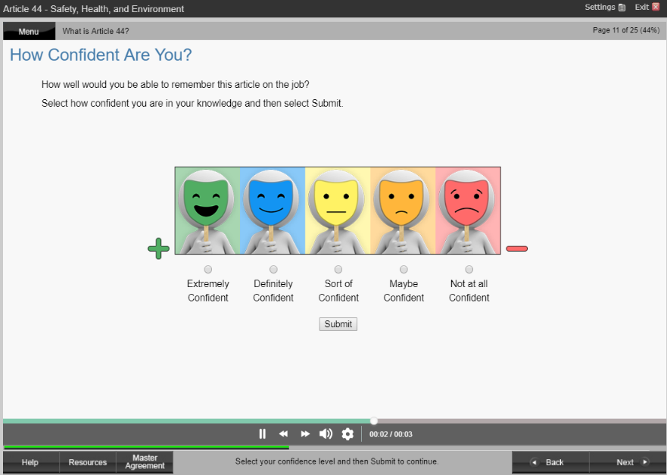

Modifying Feedback Text
The feedback text for the “How Confident Are You” exercise is located in the “js>confidence_script.js” file. Here you can modify the text for each value.

Master Agreement Reference Tool
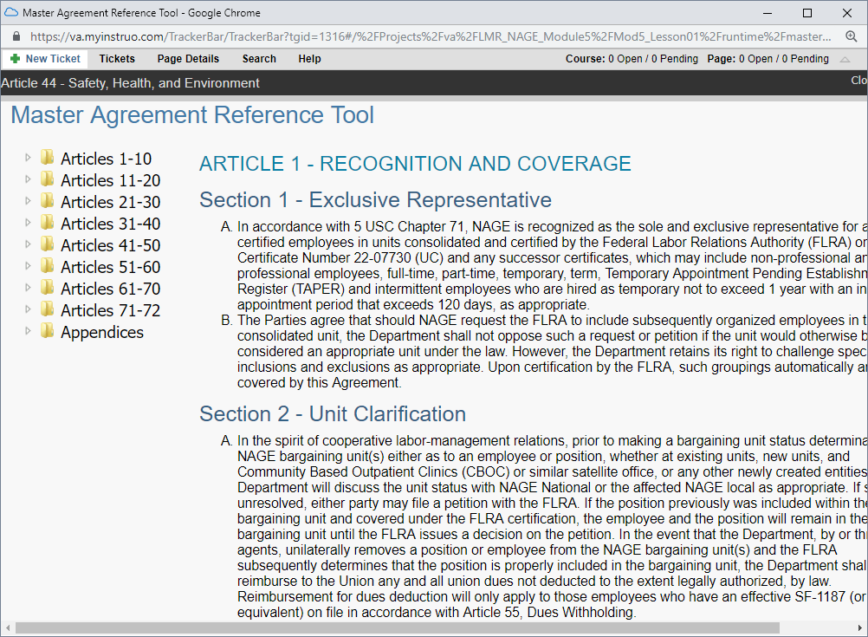

Standards
The Master Agreement Reference Tool has several standards to which the content was created, which should be noted if edits are to be made. The tool contains the entirety of the content within the Master Agreement and learners can access it by selecting the “Master Agreement” button on the bottom of the graphical user interface (or GUI).
The text in this tool, as well as the “Read the Contract!” exercise page, were copied directly from the Master Agreement document provided to OGT as Government Furnished Information (GFI). Any edits to this document were made solely for the purposes of formatting the text to work in an HTML version. Because this is a contract between and by the VA and NAGE, no content was changed, even though some typos were found in the Master Agreement. Even these were left in so as not to create a different version of the contract for the curriculum.
There were some links in the contract, but these were intentionally left as plain text rather than hyperlinks to encourage learners to stay within the lesson and because it is possible that links to websites controlled by other entities may be changed or modified.

Modifying the Master Agreement Text
The text that appears in the Master Agreement text box required modifying the article text in the appropriate HTML document in the “master_agreement>master_agreement” folder. These changes will also affect the contents of the “Read the Contract!” exercise as these two interactions draw the text from the same file.
Please note that changing this text will NOT affect the “What Do You Recall?” exercise pages. Any changes to the contract will require updates to individual exercises (only if the contract changes occur within the excerpts used for the exercise).

Modifying the Appendices
The Master Agreement Reference Tool also includes links to PDF copies of each page of the Master Agreement’s appendix. Each document in the appendix has been replaced with a Section 508-compliant version that was created by copying the individual pages into another PDF and then programming the PDF to be compliant. If updates must be made to these documents, please ensure that they meet Section 508-compliance requirements. To replace these documents, simply overwrite the corresponding PDF file in the “master_agreement>master_agreement” folder of each lesson.

Closed Captioning

Standards
To maximize onscreen text, the closed caption files have been intentionally programmed to be limited to one line of text. If edits to the closed caption files must be made, they can be found in the “media” folder and be identified by the “.vtt” file extension.

Naming Convention
Each closed caption file is identified by a number, such as 01_02_03_004. This naming convention identifies what page within the lesson the file corresponds to.
Filename  Component | OGT LCA Terms | Details
01_ | Module | The first number, 01 in the above example, corresponds to the “module.” This was the term used to identify which of the 5 major groupings of content that exists in the program.
02_ | Lesson | The second number, 02 in the above example, corresponds to the “lesson” in OGT terms.
03_ | Topic | The third number, 03 in the above example, corresponds to the “topic” in OGT terms. This is the subdivision of the above “lesson” and corresponds PAM use of the term “lesson.”
004 | Page | The fourth number, 004 in the above example, corresponds to the page. This is the subdivision of the above “topic” and corresponds an individual page within a lesson. Note that page numbering occurs at the lesson-level. In other words, page numbering does not start over at “Page 1” when the learner enters a new topic within a lesson.

Flow Charts and Other Images with Text

How to Edit
Editable versions of the images were included in the Source folder within each module’s “Final Source Package” Task Group in PAM. These editable files are in PSD (Adobe Photoshop) format in a zipped folder called “lca_m##_graphic_source_files.zip,” where “_m##_” indicates one of the five modules. Once edited, these can be republished with the same filetype and name as the original and used to overwrite existing image files in the “images” folder.

Glossary Links

Standards
When crafting these modules, the decision was made to include glossary links on many pages. A sweep was made of every lesson to capture the first time a term is used on each page of a lesson in order to then program the term to link to the appropriate section of the glossary when selected by the learner. Only the first instance of a term on a single page was linked.
Some glossary terms were not linked when they were accompanied by a definition on the same page. In addition, they were not linked when the words were part of an image or flowchart.
Finally, certain glossary terms were not linked because they were used so frequently. In these cases, it was decided that having so many links would distract from other, less frequently used glossary terms. These “nonlinked” terms were limited to:
- Employee
- Local or Local Union
- The Department
- The Party or Parties
- The Union

Adding New Terms
If adding new terms to the glossary is desired, the global list of glossary terms is available in the “LMR-NAGE Master Glossary” Project within the “Master Curriculum Glossary” Task Group.
Depending on a developer’s preference, there are probably other ways to add terms, but this document recommends adding them first to the “Master Curriculum Glossary” in PAM, and then exporting the updated “master code.”
This updated glossary code can then be manually copied and pasted into the resources folder within each lesson’s runtime.
Once new terms are added, each lesson should be searched to ensure any instances of the new terms are linked within the content following the standards outlined above.

