|  |
| --- |
| Team A |
| Movie Rental Application |
| Rapid Application Development Project |

|  |
| --- |
| Samuel Lee, Aashiyan Singh, Joshua Macaulay  6-3-2020 |

Table of Contents

**Sprint One** 3

Introduction: 3

Acme Entertainment Pty Ltd Requirements: 3

Meeting Agenda – Team A 4

Additional Information: 4

Source Control: 5

Project Management Plan: 6

Software Testing Report: 7

CITE Business Analysis: 8

CITE Business Rules for software development 8

Comprehensive Approach to Quality 8

Multi-Platform Report: 9

Introduction 9

Web Design Methods 9

Adaptive Web Design 9

Responsive Web Design 10

Our Pick 10

Software Testing Plan: Sprint One: 11

Introduction 11

Scope 11

In Scope 11

Out of Scope 11

Quality Objective 11

Roles and Responsibilities 11

Test Methodology 12

Overview 12

Test Levels 12

Bug Triage 12

Test Completeness 13

Test Deliverables 14

Resource & Environment Needs 15

Test Environment and Tools 15

Terms/Acronyms 16

Test Results: 17

System Test Components: 17

1. MotoG4 Mobile Device: 17

2. iPad Device: 18

3. Laptop Device: 19

Acceptance Test: 20

Marking Guidelines Verification: 20

# **Sprint One**

## Introduction:

Team A – Members for first sprint:  
  
The roles for this sprint have been determined as follows.  
- Sam Lee: Scrum Master, Testing Manager   
- Aashiyan Singh: Platform Planner, QA Analyst  
- Joshua Macaulay: Software Developer, Source Control Manager

This was decided at the meeting we held on the 28th of May, 2020.  
  
On the following page is the meeting agenda, which summarises the outcome of the meeting and details the delegation of tasks.  
  
Evidence of Meeting taking place:

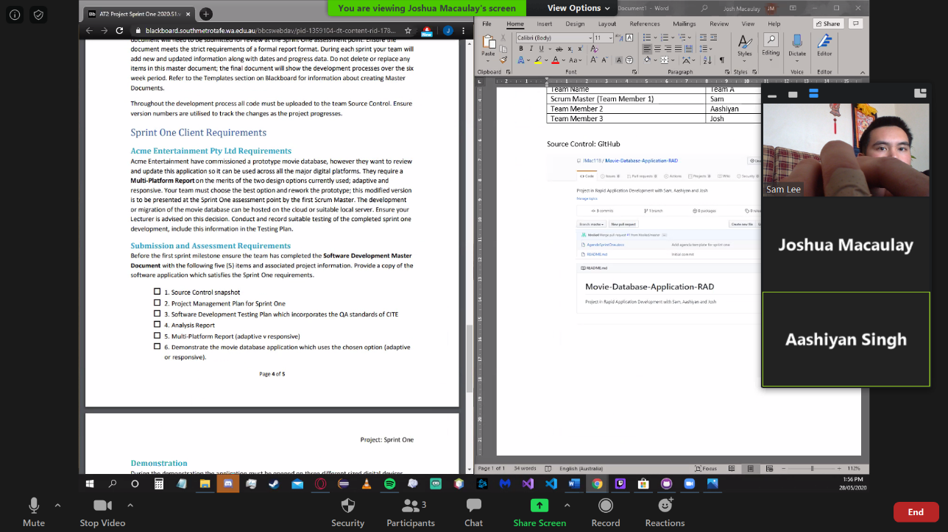

## Acme Entertainment Pty Ltd Requirements:

ACME Entertainment has commissioned a prototype movie database that allows users to search the database for movie information, using several different search options. The new prototype is required to take the existing application and modify it so that it fits on the major digital platforms (Desktop/Laptop, mobile, tablet). They have additionally requested a multi-platform report that outlines the advantages and disadvantages of the two major design options: responsive and adaptive. The development team must make a decision as to which option to use, implement it using the existing application, and produce a report explaining the differences between the two options.

## Meeting Agenda – Team A

Sprint One

28/05/2020

1:30

Meeting called by: Sam

Attendees: Sam, Aashiyan, Josh

Please read: Project Document

Please bring: Coffee  
Platform: Zoom

|  |  |  |
| --- | --- | --- |
| Time | Event Heading | Location |
| 1:30 -3:00 | Scrum Meeting | Zoom |

## Additional Information:

During these meeting we discussed which team member will be working on each aspect of the project.

At 1:35 we decided to use GitHub as our means of source control.

At 1:45 the Software Development Testing Plan was designated to Sam and since he is he scrum master for sprint one, he will also do the Project Management Plan.

Aashiyan was designated to do the Analysis Report at 2:10 and shortly afterwards was also given the Multi-Platform Report to complete.

At 2:25 it was decided that Josh would do the implementation of the Responsive update for the website.

The rest of the meeting was just to ensure each team member knew what they needed to complete with a short questions and answers session.

## Source Control:

We have chosen as our source control tool, Git. To host our repository, we are using GitHub.

Joshua was responsible for the creation and maintenance of our source control repository, so the repository is hosted on his GitHub account.

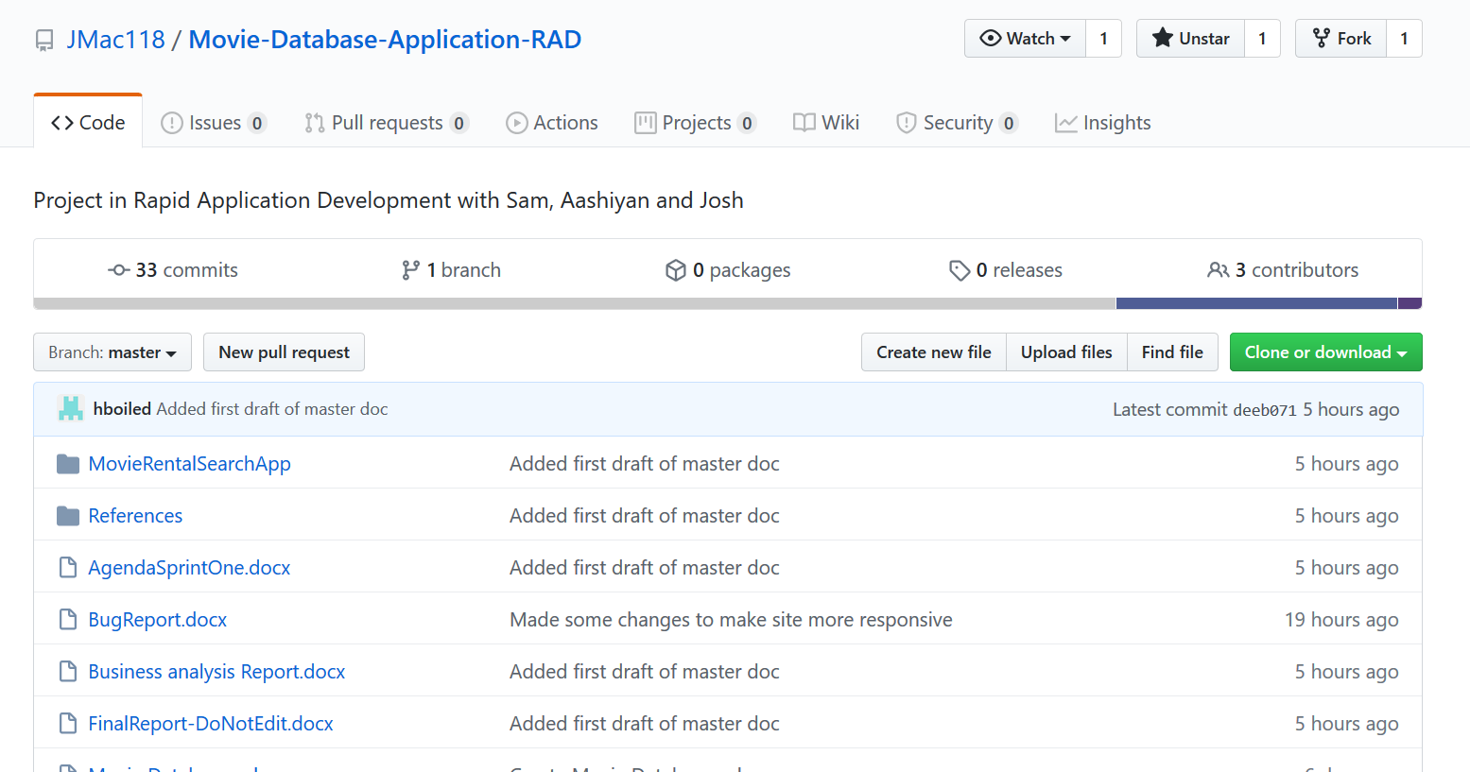

It can be found here:

<https://github.com/JMac118/Movie-Database-Application-RAD>

## Project Management Plan:

**Sam was responsible for planning out the project management plan. Our working progress mirrors that of what was set out in the following Gantt chart. The overlap in tasks reflects a period of collaboration.**

**While Joshua was implementing the responsive design, Sam was verifying the application against responsive design guidelines and the marking criteria, as can be seen in tasks 6 to 7.**

**Start Date: 28/05/2020  
Estimated Finish Date: 03/06/2020  
Actual Finish Date: 03/06/2020**

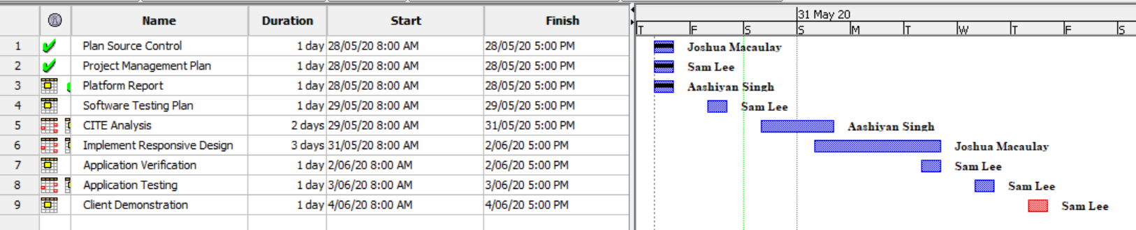

## Software Testing Report:

**The way we conduct the testing of our software will be detailed specifically in Testing Plan Documents for each sprint. The following pages will include a copy of the testing plan Sam has prepared for the first sprint.**

**Our testing and quality assurance practices will closely follow those specified by CITE Managed Services. Aashiyan has prepared a business analysis document detailing the software development, quality control and quality assurance practices of CITE to support our testing plans.**

**The criteria detailed in this testing report will be applied to all subsequent testing plans for each sprint.**

* **On the most fundamental level, all existing components of the application must be functional, which in the case of this project, are:  
  - the basic searching operations using the movie database are available and working  
  - GUI and elements are fully legible**
* **Any bugs and issues must be identified and reported so that they can be fixed during the following sprint.**
* **ACME ltd. Development Requirements are satisfied:  
  - Website has responsive or adaptive design  
  - Tests based on design choice have been run using the 3 major platforms (Desktop/Laptop, mobile, tablet) and are successful**
* **Client is satisfied with the delivered test results and application and signs off on it.**

## **CITE Business Analysis:**

### CITE Business Rules for software development

CITE Managed Services has implemented a Quality Management System (QMS) which provides and ensures the highest quality when it come to comprising a complex set of engineering and managerial activities.

#### QMS Tasks and Objectives

* To implement the procedures and regulations based on the industry standards for software deployment.
* To verify and validate the product to that it complies with clients’ business needs and expectations;
* To monitor the product lifecycle to ensure compliance with established processes and guidelines
* To establish a heathy and friendly environment between all project team members.

### Comprehensive Approach to Quality

#### Quality Planning

CITE Managed Services starts with planning applicable set of standards, regulations, procedures, guidelines and tools in each project’s development lifecycle.

#### Quality Assurance

To assure that quality standards are being followed and customer requirements are being met, CITE Managed Services have established processes that evaluate project performance.

#### Quality Control

To identify defective pieces of code, CITE Managed Services measure performance trends to verify that product is of high quality, complete and correct.

## **Multi-Platform Report:**

## Introduction

Acme Entertainment Pty Ltd has assigned our team with the task of implementing a movie database. Our team needs to create a multi-platform report and choose one of the two design options currently used, which are adaptive and responsive. In this report, we will be explaining the two web designs and will also be comparing the two to figure out the advantages and disadvantages of the two design methods. In the end, we will choose either adaptive or responsive method to rework our prototype.

## Web Design Methods

### Adaptive Web Design

Adaptive web design was first introduced by a web designer named Aaron Gustafson in 2011. In adaptive approach, the sites are designed to have multiple fixed layout sizes. Depending on the amount of space available, the site detects and picks one of the prefixed layouts that fits the screen. For example, if the site is opened on a desktop browser, it will pick the layout best suited for a desktop screen, resizing the browser won’t affect the layout of the web page.

Many websites use adaptive design. Some of which are Amazon, USA today, About.com and Apple. They mostly use six prefixed screen widths; 320, 480, 760, 960, 1200, 1600.

Adaptive design has the best user experience on all the devices because unlike responsive design, where the desktop design works into the smaller devices, adaptive design offers to have custom designs for desktop, mobile, tablet and any other devices that the site can be opened. Designers can design different buttons, navigation tools and other interface tools based on users’ needs for a particular device. Adaptive websites often outperform websites with responsive design. They are usually 2-3 times faster than the responsive ones as it gives less data to the user for it to deliver a better user experience. In adaptive design, there is also the option to create mobile only websites which is denoted with “m.” in the URL bar.

Adaptive design has some strong advantages, but it also comes with some drawbacks. Firstly, it requires a lot more work to create an adaptive design than responsive design. So many designers try to retrofit the existing websites to make them more accessible. It requires a lot of work, which means it needs a large team to maintain, which make the cost of creating adaptive design more expensive than of responsive. Adaptive design is also less flexible as if a new device is launched with a screen size different than the existing one, that could create problems. Which means the designer either have to create a new layout or edit the existing ones. They require much more maintenance in the long run than responsive design.

### Responsive Web Design

Responsive web design was first introduced by a web designer and developer named Ethan Marcotte. In responsive approach, the site uses just one layout for the site and adjusts to better fit the screen of the user’s device. It uses flexible grids and layout to present the information of the website. For example, If you open a responsive website on the desktop browser and try to adjust the size of the browser, the website will try to arrange the contents to fit the browser window. For smaller devices such as phones, the website checks for the available space and fits the content to the size.

Many websites such as Dropbox, GitHub, Shopify etc use responsive web design.

Responsive design is much easier and requires much less work to implement and maintain than adaptive design. It will cut down the time and cost to maintain and update the website. Designers mainly need to create a single design for the website that can be used on all devices. It can also be more user friendly as its mostly the same on all devices and users will get the same experience on different devices. Responsive websites are also much more search engine friendly as they have the same URL that serves all devices.

Responsive designs drawback could be that the websites might be slower on different devices. Images on the website could affect the loading times of a website. The same website that opens up quickly on a desktop might take much longer on mobile device or a tablet. Putting ads on the website could also be big challenge. As the website will flow on different devices, ads might not configure properly and adjust to the screen.

## Our Pick

**We picked Responsive web design as our approach.**

# **Software Testing Plan: Sprint One:**

## Introduction

## Scope

### In Scope

* Basic website functionality to render site through webhost and connect to DB.
* CITE Quality Assuances practices.
* Application responsiveness to different devices.
* Application responsiveness to window resizing.
* Runtime bugs and issues fixed.

### Out of Scope

* All components and issues not included in the marking guide.

## Quality Objective

**Objectives:**

* Ensure the Application Under Test (AUT) conforms to both functional and non-functional requirements
* Ensure the AUT meets the quality standards defined by the client
* Bugs and issues are identified and fixed before deployment

## Roles and Responsibilities

Detail description of the Roles and responsibilities of different team members like

* Sam Lee – Test manager, Tester, Project Management.
* Aashiyan Singh – QA Analyst, Platform Planning.
* Joshua Macaulay – Software Developer, Source Control Manager.

## Test Methodology

## Overview

The software development methodology we have chosen for this project is Rapid Application Development. The main strengths of this methodology is the speed at which the product can be developed, combined with its flexibility in adapting to changing requirements. Being an agile-like methodology, makes it suitable to handle projects where the client can request new requirements at any time during the development process.

The quicker the application is developed, the quicker we can move on and test existing components.

## Test Levels

For the first sprint, we will be testing the visual responsiveness of our application and how it performs on different devices. To achieve this, the testing methods employed will be the following:

System Testing: A form of black box testing where the tester will go through the application as a whole and test the various functionalities presented in the application. The tester does not know the implementation, to simulate an end user trying the application for the first time. For this project, a test table will be used to record the actual result of each test case.

Acceptance Testing: The formal validation test, where the criteria set out by the client is compared against the application. In RAD, the goal is to make sure the client is satisfied with the product. In this case, when the project satisfies the marking criteria, it will have passed the Acceptance phase.

## Bug Triage

The goal of the triage is to document all bugs and issues encountered, set out a plan to solve them, and to assign a team member to implement a solution.

## Test Completeness

* System Testing – Responsiveness with windows resizing and rendering on different devices is achieved and verified.
* Acceptance Testing – Tests are validated against marking criteria.
* All documentation is completed and verified, then put into the Master Document.

## Test Deliverables

|  |
| --- |
| * Test Report (For whole project) * Test Plan * System Testing Table * Validation Test Against Marking Criteria * Client Sign Off |

The following will be delivered as part of the completed testing phase, and added to the master document.

## Resource & Environment Needs

## Test Environment and Tools

Test System Specifications:

Processor: Intel® Core™ i5-8250U @ 1.60 GHz, 1.80 GHz  
RAM: 8.00 GB

System Type: 64-bit Operating System, x64-based processor

Required Software:

1. Windows 7 and above
2. Office 2013 and above
3. Google Chrome or Mozilla Firefox
4. Text editor – Visual Studio Code recommended
5. XAMPP – For hosting web server and database

## Terms/Acronyms

|  |  |
| --- | --- |
| **TERM/ACRONYM** | **DEFINITION** |
| API | Application Program Interface |
| AUT | Application Under Test |
| RAD | Rapid Application Development |

## Test Results:

Screenshots are provided in the directory “TestEvidence”. For each entry in the table, an id number will prefix its corresponding screenshot. Screenshots have been provided outside this document to make it more neat and organised.

### System Test Components:

- Go over main.css file and examine all statements relevant to website responsiveness.   
- Such code has been marked with comments to identify which ones should be tested.

### 1. MotoG4 Mobile Device:

|  |  |  |  |
| --- | --- | --- | --- |
| Subject | Expected | Actual | Reference |
| Home page, scaled 100%, vertical view | Responds to mobile device and renders mobile friendly view. | Meets expectation. | TestEvidence/1.1 |
| Home page, scaled 60% (to fit), vertical view | Whole screen renders to mobile friendly view and footer is fixed at bottom. | Meets expectation. | TestEvidence/1.2 |
| Home page, scaled 95% horizontal view | Whole screen renders to mobile friendly view horizontally, footer fixed at bottom. | Meets expectation. | TestEvidence/1.3 |
| Search result, scaled 100%, vertical view | Results table clearly visible with responsive design detecting mobile device and not rendering extra columns so all fits. | Meets expectation. | TestEvidence/1.4 |
| Browse results, scaled 60% (to fit) vertical view | Results table visible, footer fixed at bottom but not obscuring results. | Meets expectation. | TestEvidence/1.5 |
| Browse results, scaled 95%, horizontal view | Results table visible, wider horizontal dimension detected and adjusted column display to include more columns. | Meets expectation. | TestEvidence/1.6 |
| Top 10 graph, scaled 95%, horizontal view | Graph image is scaled to device and alignment. | Meets expectation. | TestEvidence/1.7 |
| Top 10 graph, scaled 60% (to fit), vertical view | Graph image is scaled to device and alignment. | Meets expectation. | TestEvidence/1.8 |

### 2. iPad Device:

|  |  |  |  |
| --- | --- | --- | --- |
| Subject | Expected | Actual | Reference |
| Home page, scaled 100%, vertical view | Whole screen renders to iPad friendly view and footer is fixed at bottom. | Meets expectation. | TestEvidence/2.1 |
| Home page, scaled 40% (to fit), vertical view | Responds to iPad device and renders iPad friendly view. | Meets expectation. | TestEvidence/2.2 |
| Home page, scaled 50% horizontal view | Whole screen renders to iPad friendly view horizontally, footer fixed at bottom. | Meets expectation. | TestEvidence/2.3 |
| Search result, scaled 100%, vertical view | Results table clearly visible with responsive design detecting iPad device and not rendering the extra column so all fits. | Meets expectation. | TestEvidence/2.4 |
| Browse results, scaled 40% (to fit) vertical view | Results table visible, footer fixed at bottom but not obscuring results. | Meets expectation. | TestEvidence/2.5 |
| Browse results, scaled 75%, horizontal view | Results table visible, wider horizontal dimension detected and adjusted column display to include one more column. | Meets expectation. | TestEvidence/2.6 |
| Top 10 graph, scaled 95%, horizontal view | Graph image is scaled to device and alignment. | Meets expectation. | TestEvidence/2.7 |
| Top 10 graph, scaled 60% (to fit), vertical view | Graph image is scaled to device and alignment. | Meets expectation. | TestEvidence/2.8 |

### 3. Laptop Device:

|  |  |  |  |
| --- | --- | --- | --- |
| Subject | Expected | Actual | Reference |
| Home page standard view | Displays full website, fit into single view. | Meets expectation. | TestEvidence/3.1 |
| Search results standard view | Displays all columns for search query. | Meets expectation. | TestEvidence/3.2 |
| Browse results standard view | Table of results fits view, footer does not obscure bottom results. | Meets expectation. | TestEvidence/3.3 |
| Top 10 graph standard view | Graph enlarged to reflect larger device, still viewable and scales well. | Meets expectation. | TestEvidence/3.4 |
| Top 10 graph resized window | Graph and other elements resize dynamically against changing window size. | Meets expectation. | TestEvidence/3.5 |

## Acceptance Test:

### Marking Guidelines Verification:

* Application functions correctly on multiple platforms:  
    
  This has been demonstrated in the test documentation, “Test Results”. Screenshots which serve as reference and proof of functionality are supplied in the directory “TestEvidence”. The screenshots have been labelled and with a descriptive name and are prefixed with a corresponding number identified in the test table.
* All documentation is properly formatted:  
    
  The master documented has been formatted so that each heading is on a new page. Headers, footers, table of contents and a cover page are included to assist with the organisation of the document. The master document feature was not used because of its tendency to corrupt and make the file unusable.
* Ensure all topics are adequately covered using common terminology:  
    
  The documents “MultiPlatform Report” and “Business Analysis Report” have been included in the master document. The former covers responsive versus adaptive web design and makes a choice as to which design we have utilised. The latter covers software development, quality control and quality assurance practices relating to CITE Managed Services. These practices are integrated into our testing and quality assurance plan.
* All testing has been documented:  
    
  A test table has been constructed for the various platforms with various test cases. Each test case was carried out, an expectation was set for the outcome, and then verified against a screenshot provided in the TestEvidence directory which shows the actual outcome. This document is included in the master document.