# Develop and Design Environments

## Prototype UI

I will be using FluidUI.com for an easy browser-based UI design.

## Develop Environment

### Run environment

The website will be tested, run, and hosted by using Apache XAMPP through localhost. For the database, XAMPP has database management through MySQL PhpMyAdmin.

#### Coding Environment

The actual website development will be done using Visual Studio Code IDE

## Website Hierarchy

The pages available will be:

Home, Search, Browse, Top 10 and a Contacts page.

# Prototypes

# Database Design

Database name: movie_rental

Table name: movies

Movies structure:

ID

Title

Studio

Status

Sound

Versions

RecRetPrice

Rating

Year

Genre

Aspect

TimesSearched

# Test Documentation

## PEAR Code Standard – CodeSniffer Results

The following errors are unremovable false flags from codesniffer.

The following warnings are to reduce the length of some of the lines of code. However they are usually sql statements and breaking them up actually decreases readability.

\browse.php

----------------------------------------------------------------------

FOUND 6 ERRORS AND 3 WARNINGS AFFECTING 9 LINES

----------------------------------------------------------------------

71 | ERROR | Expected "if (...) {\n"; found "if(...) {\n"

72 | ERROR | Expected "while (...) {\n"; found "while(...){\n"

73 | WARNING | Line exceeds 85 characters; contains 88 characters

93 | ERROR | Expected "if (...) {\n"; found "if(...) {\n"

94 | ERROR | Expected "while (...) {\n"; found "while(...){\n"

95 | WARNING | Line exceeds 85 characters; contains 90 characters

115 | ERROR | Expected "if (...) {\n"; found "if(...) {\n"

116 | ERROR | Expected "while (...) {\n"; found "while(...){\n"

117 | WARNING | Line exceeds 85 characters; contains 86 characters

----------------------------------------------------------------------

browse_function.php

----------------------------------------------------------------------

FOUND 4 ERRORS AND 1 WARNING AFFECTING 5 LINES

----------------------------------------------------------------------

32 | ERROR | Expected "if (...) {\n"; found "if(...) {\n"

50 | ERROR | Expected "while (...) {\n"; found "while(...){\n"

68 | ERROR | Expected "} else {\n"; found "}\n \n else{\n"

72 | ERROR | Expected "while (...) {\n"; found "while(...){\n"

73 | WARNING | Line exceeds 85 characters; contains 87 characters

----------------------------------------------------------------------

GenerateChart.php

----------------------------------------------------------------------

FOUND 5 ERRORS AND 4 WARNINGS AFFECTING 9 LINES

----------------------------------------------------------------------

27 | ERROR | Expected "if (...) {\n"; found "if(...) {\n"

28 | ERROR | Expected "for (...) {\n"; found "for(...){\n"

34 | ERROR | Expected "if (...) {\n"; found "if(...) {\n"

97 | ERROR | Expected "for (...) {\n"; found "for(...) {\n"

111 | WARNING | Line exceeds 85 characters; contains 96 characters

112 | WARNING | Line exceeds 85 characters; contains 93 characters

122 | ERROR | Expected "foreach (...) {\n"; found "foreach(...)

| | {\n"

140 | WARNING | Line exceeds 85 characters; contains 89 characters

141 | WARNING | Line exceeds 85 characters; contains 98 characters

----------------------------------------------------------------------

inc_database.php

----------------------------------------------------------------------

FOUND 2 ERRORS AFFECTING 2 LINES

----------------------------------------------------------------------

34 | ERROR | Expected "if (...) {\n"; found "if(...) {\n"

57 | ERROR | Expected "if (...) {\n"; found "if(...) {\n"

----------------------------------------------------------------------

inc_functions.php

----------------------------------------------------------------------

FOUND 5 ERRORS AFFECTING 5 LINES

----------------------------------------------------------------------

25 | ERROR | Expected "if (...) {\n"; found "if(...) {\n"

100 | ERROR | Function name "Error_404" is invalid; consider

| | "Error_404" instead

110 | ERROR | Function name "Error_500" is invalid; consider

| | "Error_500" instead

127 | ERROR | Expected "if (...) {\n"; found "if(...) {\n"

132 | ERROR | Expected "foreach (...) {\n"; found "foreach(...) {\n"

----------------------------------------------------------------------

inc_query_functions.php

----------------------------------------------------------------------

FOUND 0 ERRORS AND 2 WARNINGS AFFECTING 2 LINES

----------------------------------------------------------------------

156 | WARNING | Line exceeds 85 characters; contains 95 characters

190 | WARNING | Line exceeds 85 characters; contains 91 characters

----------------------------------------------------------------------

inc_validation_functions.php

----------------------------------------------------------------------

FOUND 1 ERROR AFFECTING 1 LINE

----------------------------------------------------------------------

257 | ERROR | Expected "} else {\n"; found "}\n else {\n"

----------------------------------------------------------------------

search.php

----------------------------------------------------------------------

FOUND 2 ERRORS AND 1 WARNING AFFECTING 3 LINES

----------------------------------------------------------------------

64 | ERROR | Expected "if (...) {\n"; found "if(...) {\n"

65 | ERROR | Expected "while (...) {\n"; found "while(...){\n"

66 | WARNING | Line exceeds 85 characters; contains 88 characters

----------------------------------------------------------------------

search_function.php

----------------------------------------------------------------------

FOUND 4 ERRORS AND 2 WARNINGS AFFECTING 6 LINES

----------------------------------------------------------------------

29 | ERROR | Expected "if (...) {\n"; found "if(...) {\n"

47 | ERROR | Expected "while (...) {\n"; found "while(...){\n"

65 | ERROR | Expected "} else {\n"; found "}\n \n else{\n"

66 | WARNING | Line exceeds 85 characters; contains 109 characters

69 | ERROR | Expected "while (...) {\n"; found "while(...){\n"

70 | WARNING | Line exceeds 85 characters; contains 87 characters

----------------------------------------------------------------------

Time: 200ms; Memory: 6MB

# Security

There could be invalid inputs using a different encoding format, but that would just display that there is no search result using that search term.

# Screenshots of use

## Home

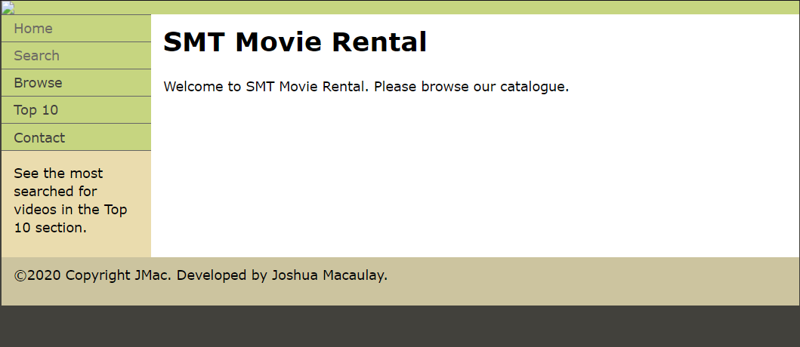

## Search



Can search using a title term and a genre

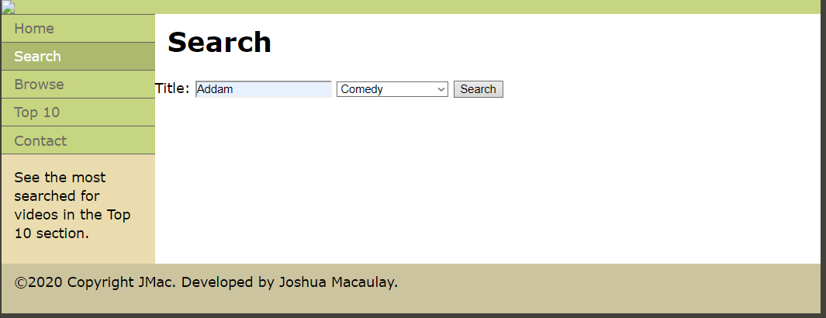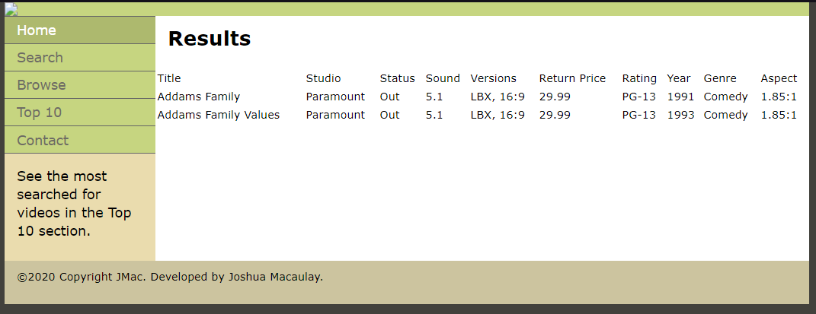

Or can search using just a title with no genre



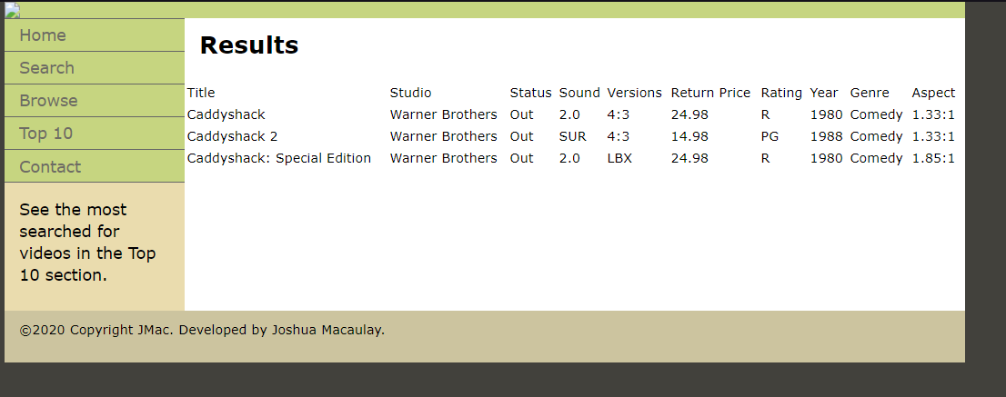

## Browse

Can search with browse with nothing input or any combination of Genre/Rating/Year

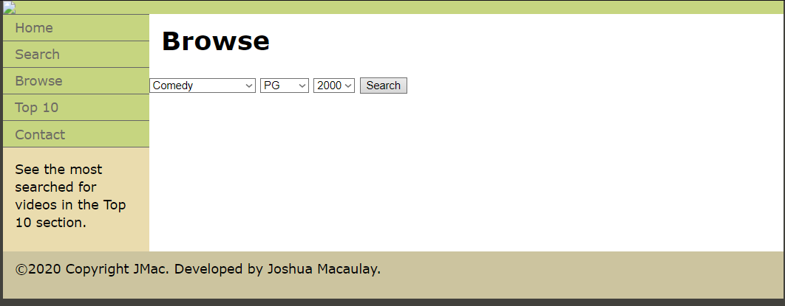

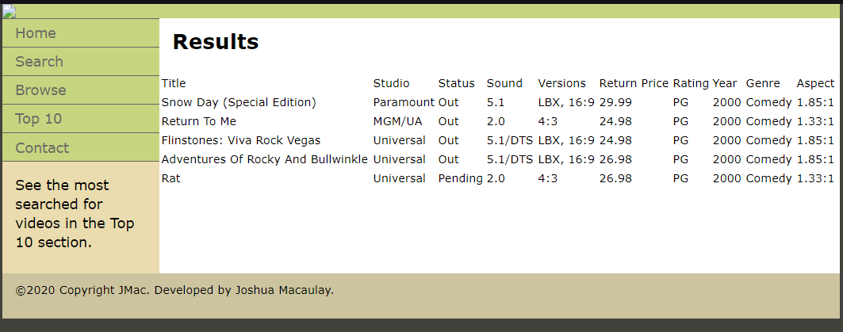

## Top Ten

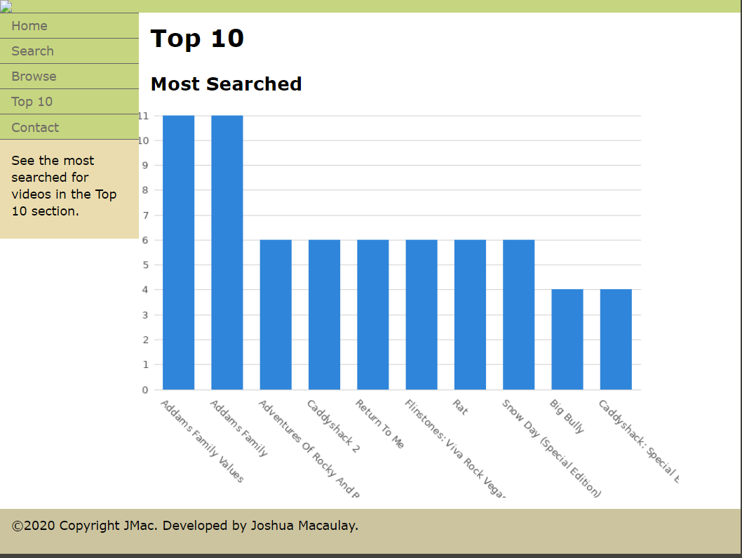

## Contact

