Installation Package Report

Software Deployment

Josh Macaulay 30008704

2020

Table of Contents

Target System Requirements 1

Operating System 1

Processor 1

RAM 1

Hard Drive Space 1

Graphics Card 1

Display 1

Installation 2

Chosen Method of Installation 2

Installation Plan 2

Installer Creation 2

Demonstration of Installation 3

Demonstration of Uninstallation 5

Database Deployment 6

Application Configuration 6

# Target System Requirements

The application has been tested on a Windows 10 environment, so the minimum requirements are at least the minimum requirements of Windows 10. The program uses under 26MB of ram as shown in the java profiler which if using minimum Win10 requirements is well over the needed amount. The Hard drive space is just how much is needed after installation is complete.

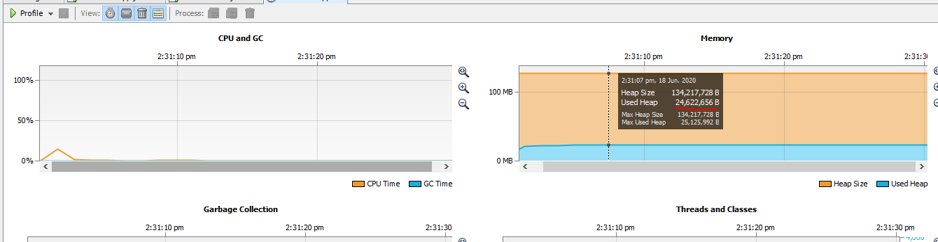

## Operating System

Windows 10

## Processor

1 GHz or faster.

## RAM

1 gigabyte for 32-bit or 2GB for 64-bit

## Hard Drive Space

5 MB spare storage for application after installation

## Graphics Card

DirectX 9 or later

## Display

800x600

# Installation

## Chosen Method of Installation

The method of installation for this program is a .exe Microsoft installer. This will only allow the application to be installed on Windows operating systems so if other operating systems are needed it will have to be made into a separate installer.

## Installation Plan

The .exe file will be made available, either to download or by physical data transfer (USB), to the client. They shall run the installer file and install the software locally. Then using a database hosting service (XAMPP) to run MySQL, they will upload the .sql file ‘dvd.sql’. Once this set-up is complete, they can run the software and search the titles of the movies in the database.

## Installer Creation

The installer was created using some software called “NullSoft scriptable install system” (NSIS), which used a .zip file to create the installer.

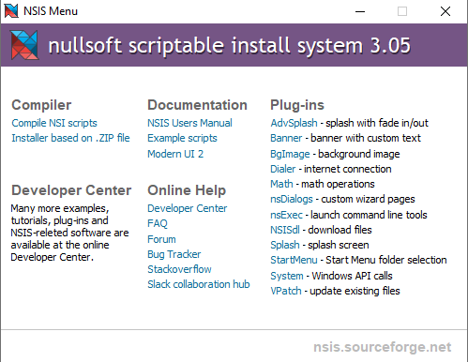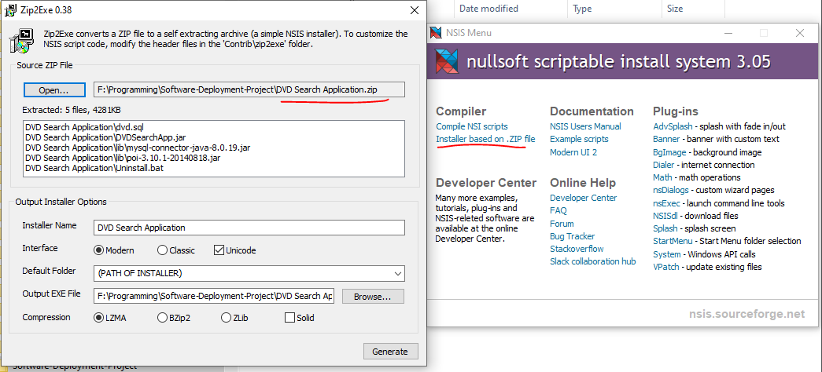

Result:

## Demonstration of Installation

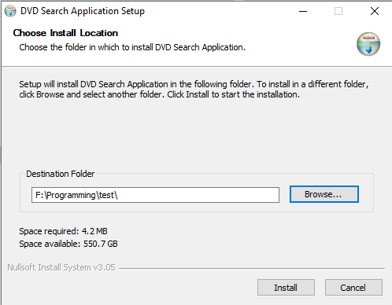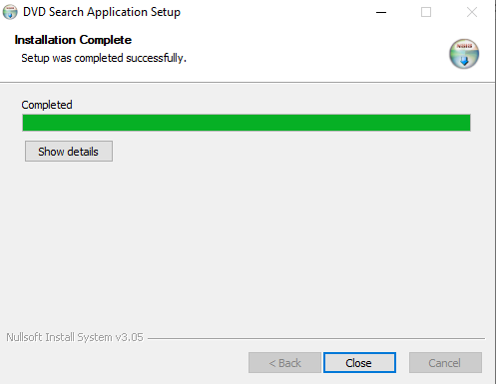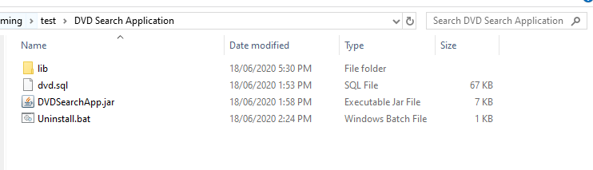

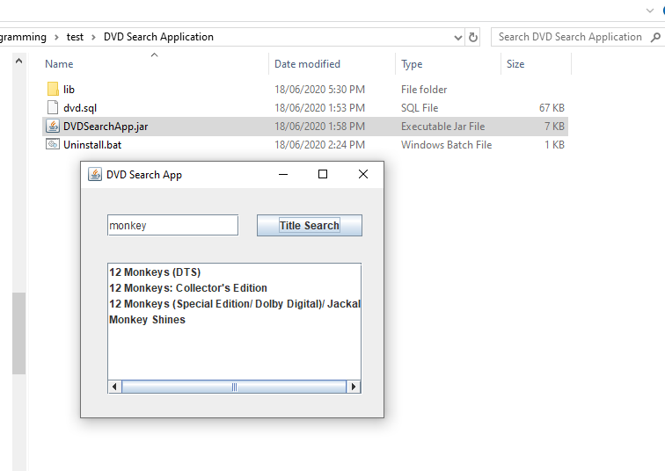

## Demonstration of Uninstallation

Running the Uninstall.bat file removes all files in the directory only leaving an empty file.

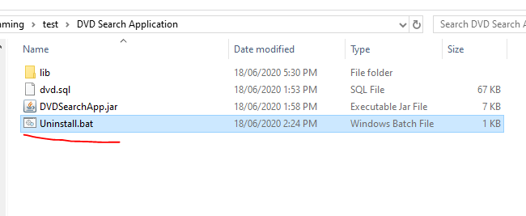

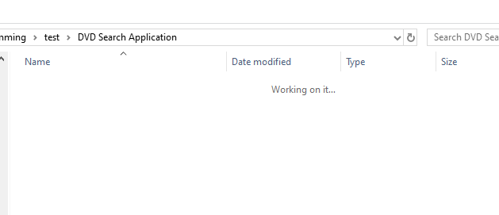

## Database Deployment

The database is deployed in MySQL by using XAMPP, and the .sql file is imported using PhpMyAdmin. The connection string is used in the java application 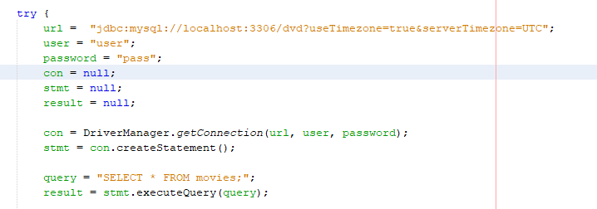

## Application Configuration

There is no application configuration used in this software except the choosing the location of the installation. Some variations of properties files are the customisation of database properties in the config file. This would allow the user to change the database in use but would not guarantee that the chosen database would be applicable to the software.