Evaluating PWM signals using Arduino NANO

This is a brief guide to the program and device for detecting and analyzing the #70197494 MB15-F33X-PWM-AMP sensor with PWM output. The device is based on the Arduino Nano board. Inputs and outputs are optically separated. The input signal must be in the range of 5-60 V / min 10mA.
The outputs are handled via opto-relay #70120618 OCPL S AQY210KSX SO4 a (350V/120mA). Current limitation is reliably handled by a 1k/5W series resistor for the range of 5-60V.
The program is primarily designed to detect a PWM signal with a frequency of 50Hz and two different duty cycles. A duty cycle of 30% corresponds to Log_0 and a duty cycle of 70% corresponds to Log_1. Settings can be called up or edited via serial line.
The delay after a short pulse is approximately 230 us, after a long pulse approximately 600 us.

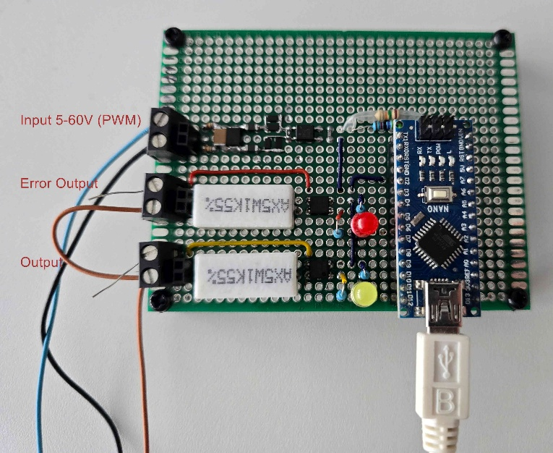

Commands: (the command must be terminated by a terminal char '\n')
command | parameter | factory setting | description
-h or ? or HELP |  |  | prints a brief help
show |  |  | lists the current settings values
-t | [number1] [number2] | 8000  12000 | setting the lower and upper pulse limit of the PWM signal on pin2 in us (500-20000) for changing pin12
-i | [number] | 0 | inverts the logic of the evaluation output pin12 (0/1 - yes/no)
-p | [number1] [number2] | 18000  22000 | limits of the correct period of the PWM signal in us (100-65000)
-s | [number1] [number2] | 280  330 | setting the correct duty cycle of the PWM signal in per mille for log0 (it is assumed that for log1 these values are mirrored (1-499)
-e | [number] | 2 | setting the number of consecutive PWM period or duty cycle errors to evaluate the pin6 error output (0-255)
-te | [number] | 800 | minimum error signaling time in ms on pin6 (10-65000)
-b | [number] | 96 | serial buat rate 96 -> 9600, 144 -> 14400, 192 -> 19200, 288 -> 28800, 384 -> 38400, 576 -> 57600, 1152 -> 115200
-l | [number] | 0 | output of currently measured values to the serial line (0-No; 1-Yes error; 2- Yes periodic)
-ds | [char] | ',' | decimal separator
-cs | [char] | ';' | columns separator
*IDN? |  |  | returns the device IDN. (Arduino NANO for measuring PWM signal duty cycle. Version: 1.4)
*RST |  |  | sets all parameters to factory settings
*CLS |  |  | clear error counter
:FETCh? |  |  | returns the duty cycle values of the PWM signal in per mille
:MEASure:WIDth? |  |  | returns the length value of the HIGH signal
:MEASure:PERiod? |  |  | returns the signal period value
SYSTem:ERRor:COUNt? |  |  | returns the number of errors since start or *CLS

Recommendation for detection on EMC 61000-4-6 set '-e 0\n'

Wiring diagram:
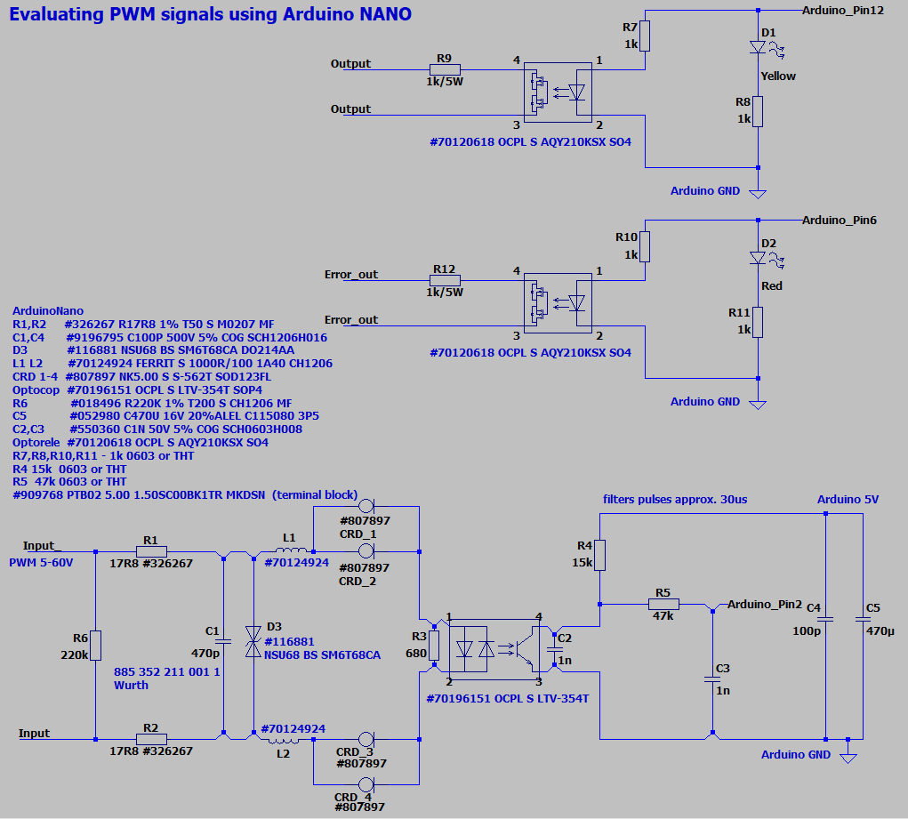

PWM duty cycle 70% to 30% (short) delay 230us, purple - input PWM signal, blue - output (yellow LED)
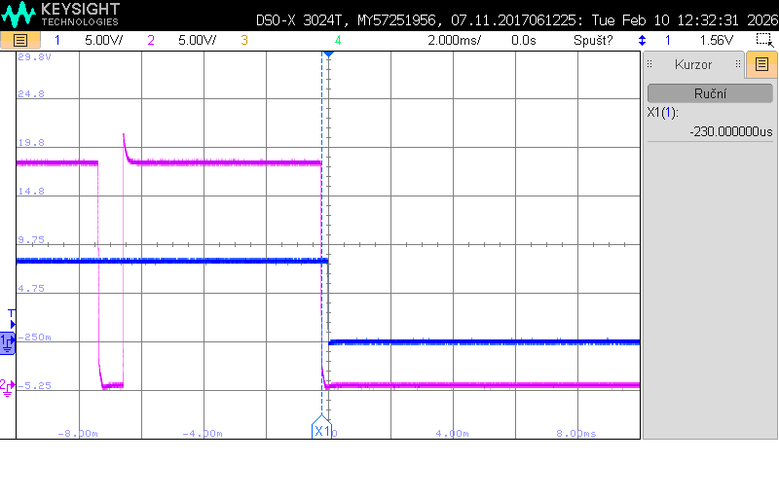
PWM duty cycle 30% to 70% (long) delay 600us, purple - input PWM signal, blue - output (yellow LED)
