Wildfly Server on LAN: By John Mark  
Using the TicketMonster Tutorial:  
  
**REST URL:**We want to have a URL like this,   
where any computer on the LAN can access our instance of the wildfly server.  
<http://172.22.5.81:8080/jboss-javaee6-webapp/rest/events>  
Where: 172.22.5.81 is my IP.  
  
**HOW TO FIND IP:**  
WindowsKey+R --> Run Dialog: “cmd”   
In Command Prompt: “IpConfig” --> [ENTER]  
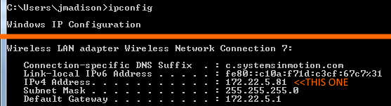

**EDIT STANDALONE.XML:**  
GOTO: **%WHERE_WILDFLY_IS%\ standalone\configuration\standalone.xml**In my case: C:\DEV\SDK\JAVA_TECH\JBOSSWILDFLY\wildfly-9.0.1.Final\standalone\configuration\standalone.xml  
Set the ip-address in **<interface name=”public”>** to your IPv4 Address.   
In my case: 172.22.5.81  
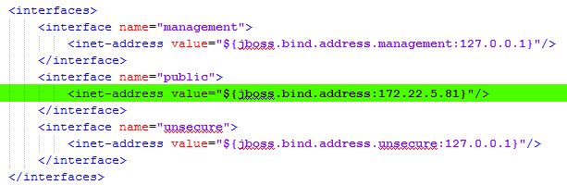  
  
**RUN SERVER IN CORRECT CONFIGURATION:**  
ON COMMAND LINE:  
**%WHERE_WILDFLY_IS% /bin/standalone.bat –b 0.0.0.0**  
//This will boot up on server to be listening on all ports.

**When ready to stop sever:**  
Because you started the server on the command line, you need to stop it on the command line. Failure to do so will confuse whatever IDE you are using.  
ON COMMAND LINE:  
**CTRL + C**  
when asked “Terminate batch job?”,   
Hit “**Y**” and then “**ENTER**”

Notes:  
You would think you’d be able to run on command line:  
%WHERE_WILDFLY_IS%\bin\standalone.bat –b <Your IP Address>  
But alas, no you cannot. You need to use 0.0.0.0  
And make sure your IP address is set in the public area of  
standAlone.xml