Computer Communications and Networks (COMN)
2019/20, Semester 2

Assignment Part 2 Results Sheet

Forename and Surname: | Joao Maio
Matriculation Number: | s1621503

Question 1 – Experimentation with Go-Back-N. For each value of window size, run the experiments for 5 times and write down average throughput.
 | Average throughput (Kilobytes per second)
Window Size | Delay = 5ms | Delay = 25ms | Delay = 100ms
1 | 30.99 | 7.57 | 2.03
2 | 45.83 | 10.95 | 2.77
4 | 62.93 | 15.26 | 3.94
8 | 84.32 | 18.38 | 4.75
16 | 84.03 | 19.35 | 5.52
32 | 101.13 | 21.52 | 5.21
64 | 80.45 | 20.21 | 5.17
128 | 71.17 | 20.46 | 4.86
256 | 76.81 | 21.51 | 5.77

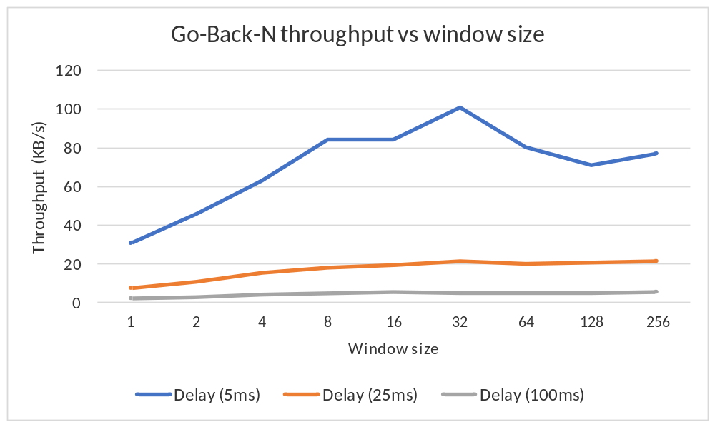

Question 2 – Discuss your results from Question 1.

Question 3 – Experimentation with Selective Repeat. For each value of window size, run the experiments for 5 times and write down average throughput.
 | Average throughput (Kilobytes per second)
Window Size | Delay = 25ms
1
2
4
8
16
32

Question 4 - Compare the throughput obtained when using “Selective Repeat” with the corresponding results you got from the “Go Back N” experiment and explain the reasons behind any differences.

Question 5 – Experimentation with iperf. For each value of window size, run the experiments for 5 times and write down average throughput.
 | Average throughput (Kilobytes per second)
Window Size (KB) | Delay = 25ms
1
2
4
8
16
32

Question 6 - Compare the throughput obtained when using “Selective Repeat” and “Go Back N” with the corresponding results you got from the iperf experiment and explain the reasons behind any differences.

