Game Plan

Jahn Makim Ramjahn 101095903

# Plan

## Genre

Simple Turn Based Multiplayer Game – Tic Tac Toe.

## Gameplay Description

2 players battle for supremacy in a game of wits, to align 3 symbols in a single row.

## Multiplayer Description

2 players take turns in making moves

## Flow Diagrams

### Connection Flow

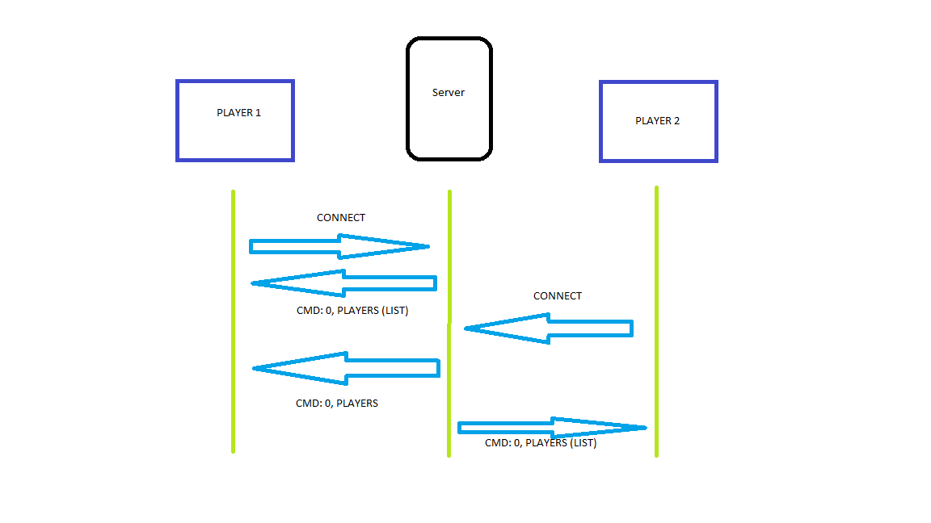

### Heart Beat

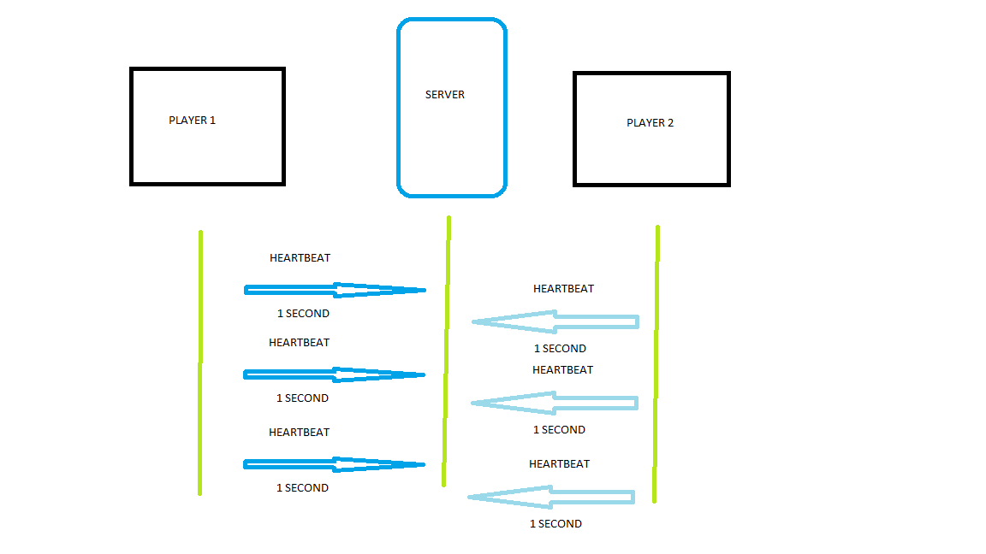

### Game Flow

