Individual report

1. Created the ‘Maze’ floor layout using ProBuilder and baked on a NavMesh for the ‘Monster’.

1. Designed interactables that show up on the UIOverlay with triggers and button inputs.

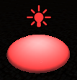

1. Designed the sound triggers.
2. Designed Scenes (“Maze”, “Ball”, “3Bricks”, “Golem”, “Menu”, “ExplodingBrick”)

“3Brick” Scene and all animations.

“Maze” Scene, positioning, ideas and structure.

“Ball” Scene and scripting.

“ExplodingBrick” Scene, camera animation and scripting.

“Golem” Scene, buttons and flip animation.  
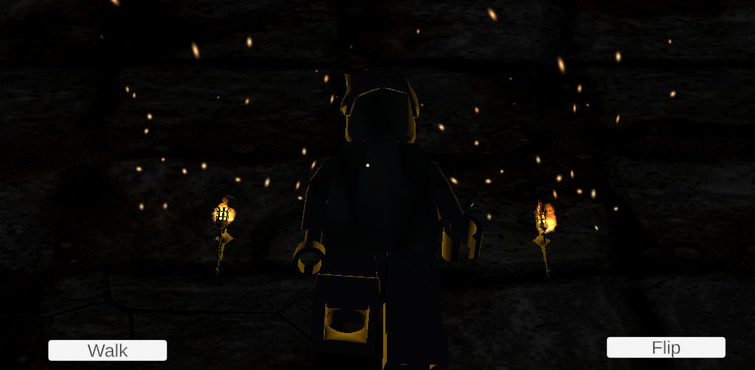  
  
“Menu” Scene, camera animation and buttons.

1. Designed these Animations and Animation ControllersText

   Description automatically generated
2. Designed these Images and Materials

7) Designed these scripts

