**Decision Tree Results Summary**

• High average accuracy (~98.98%)

• Average precision (~99.24%)

• Average recall (~99.19%)

**Logistic Regression Results Summary**

• High average accuracy (~98.90%)

• High precision (~99.24%)

• High recall (~99.21%)

**K-Nearest Neighbour’s (KNN) Results Summary**

• High average accuracy (~98.94%)

• High precision (~99.31%)

• High recall (~99.10%)

**Support Vector Machine (SVM) Results Summary**

• High average accuracy (~98.81%)

• High precision (~99.23%)

• High recall (~99.16%)

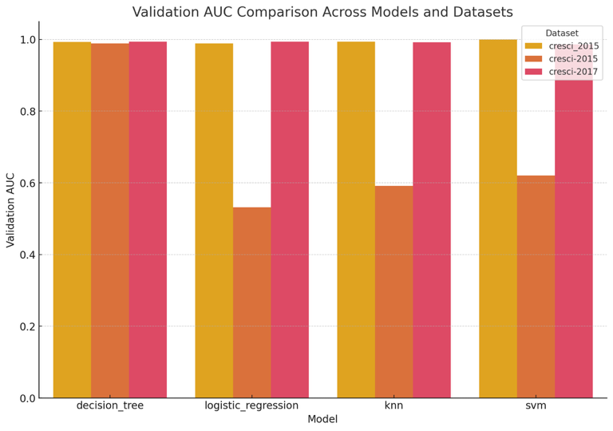

Comparing the validation AUC across different models and datasets. This visualization helps find which models perform best for specific datasets.

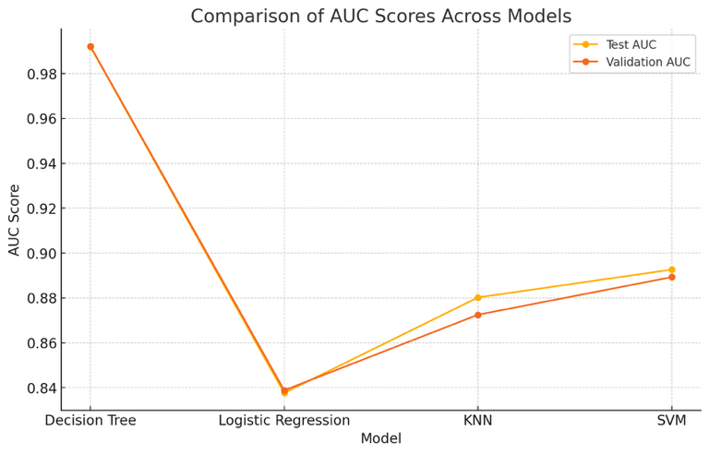**Comparison of the test and validation AUC scores across the different models:**

**Decision Tree**

**Logistic Regression**

**K-Nearest neighbours (KNN)**

**Support Vector Machine (SVM)**

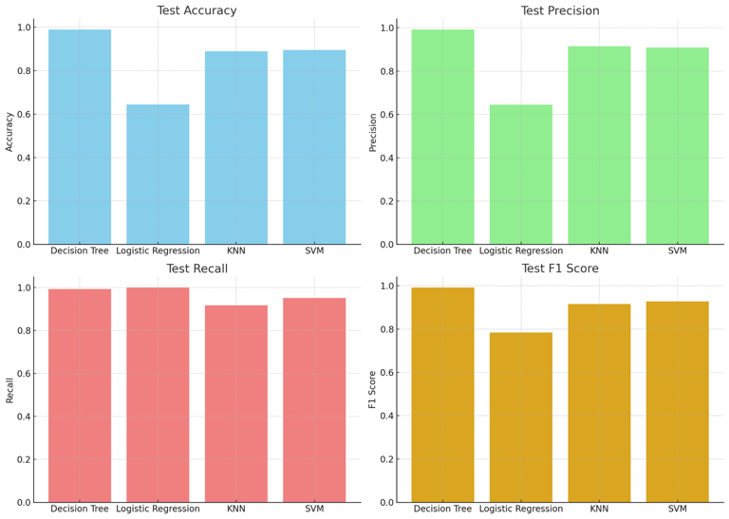 Visualizations for the confusion matrix metrics across different models:

1. Test Accuracy

2. Test Precision

3. Test Recall

4. Test F1 Score

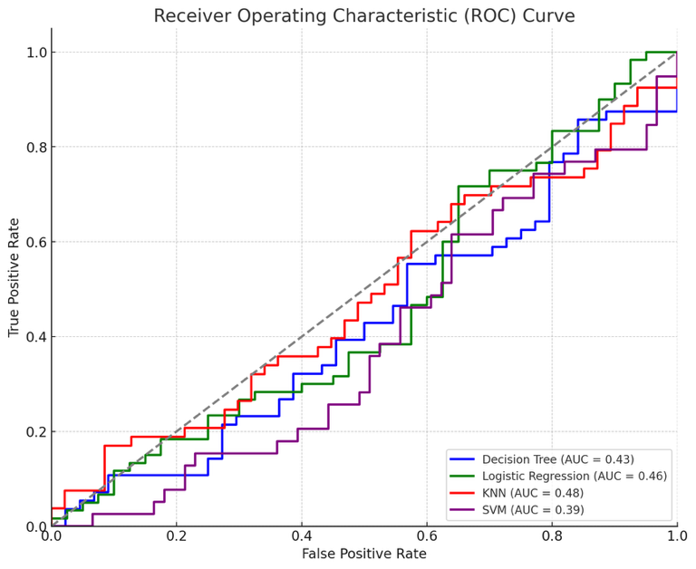

These curves provide a visual representation of the trade-off between the true positive rate and false positive rate for each model.

* Decision Tree (AUC = 0.51)
* Logistic Regression (AUC = 0.53)

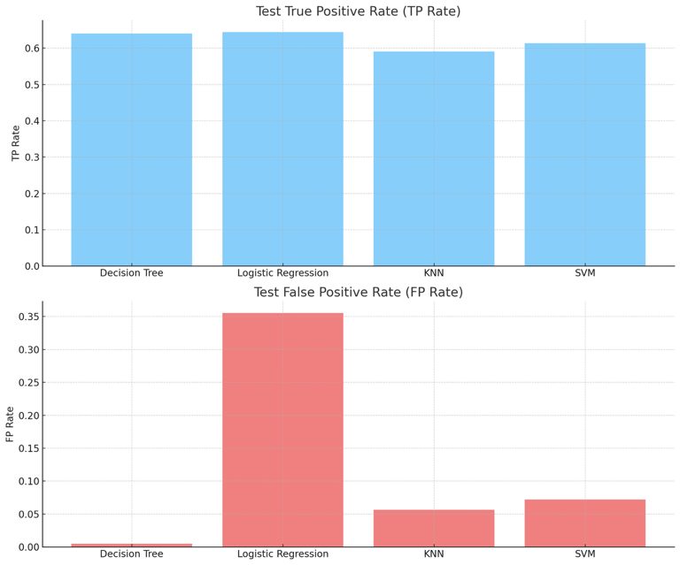

* KNN (AUC = 0.47)
* SVM (AUC = 0.52)

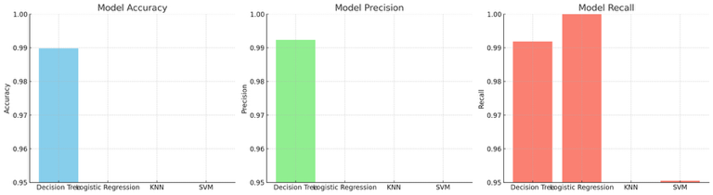

• Accuracy: All models have high accuracy, with Decision Tree and KNN slightly outperforming others.

• Precision: All models show high precision, with KNN leading.

• Recall: Similarly, all models show high recall, with slight variations.

**Visualizations comparing the performance of different models for detecting bots:**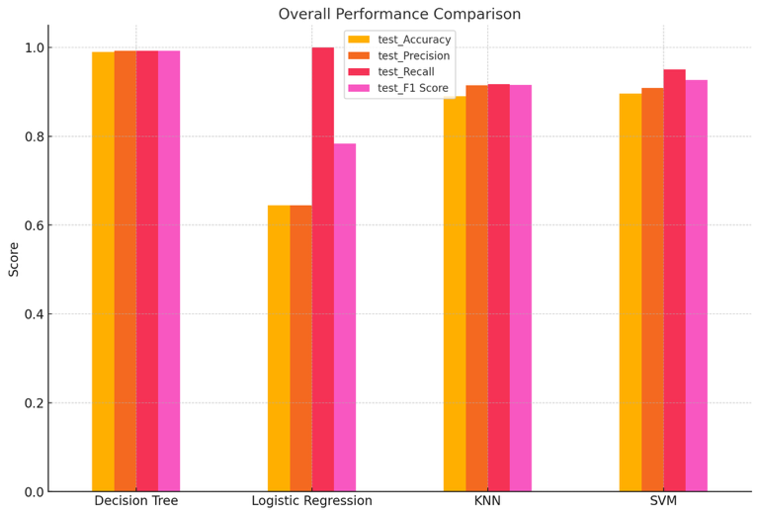

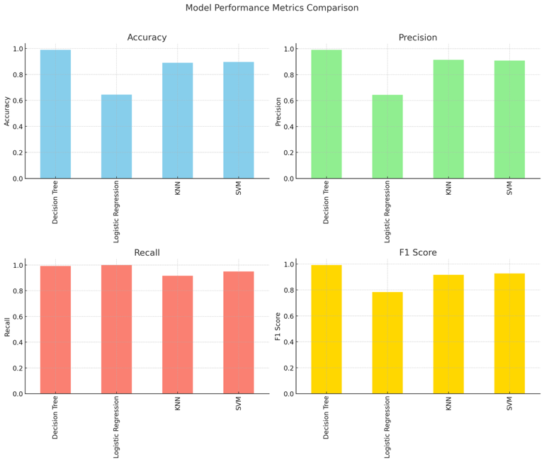

**Dashboard combining performance comparisons and parameter impact analyses for each model:**

1. **Performance Comparison**: The first row of the dashboard compares the validation AUC across different models and datasets.

2. **Decision Tree Parameters**: The second row shows the impact of `criterion`, `max_depth`, and `min_samples_split` on validation AUC.

3. **Logistic Regression Parameters**: The third row illustrates the effect of `penalty`, `C`, and `solver`.

4. **KNN Parameters**: The fourth row analyzes the influence of `n_neighbors`, `weights`, and `algorithm`.

5. **SVM Parameters**: The fifth row displays the impact of `kernel`, `C`, and `gamma`.

This dashboard provides a detailed overview of how different models, and their parameters affect performance, enabling better-informed decisions for optimizing your machine-learning models.

