# **Decision log**

# **SageMaker Instance**

The selected notebook instance type is the ml.t3.medium.   
We don‘t need much processing power to run this notebook  
as we run the compute intenstive training on dedicated instances.

The instance has 4GiB and 2vCPU, fast launch speed, and is part of free-trier initially

with the ongoing cost of ~$1.2/day | $0.05/h in us-east-1 region.

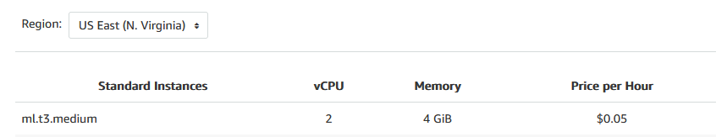

# **EC2 Training Instance**

The selected EC2 instance type is the ml.m5.xlarge  
which is the same we used for the training with the SageMaker Notebook  
where training took around 20 minutes in addition to 2 minutes launch time.  
The instance have 16GiB and 4vCPU with the ongoing cost of   
~$5.52/day | $0.23/h in us-east-1 region.

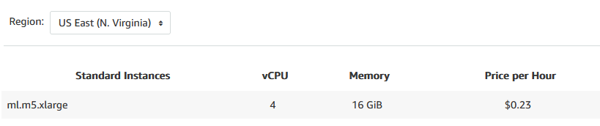

# **Differences between code for SageMaker and EC2 Training Instance**

On SageMaker instance we utilize SageMaker SDK with its functionalities  
as is creating of a training instance with SageMaker‘s PyTorch Estimator  
and passing the PyTorch training code as the entry point together with hyperparameters.

In contrast, when we use EC2 instance to start and execute the training instead of SageMaker SDK  
we run there the PyTorch training code directly while defining hyperparameters as part of the code.

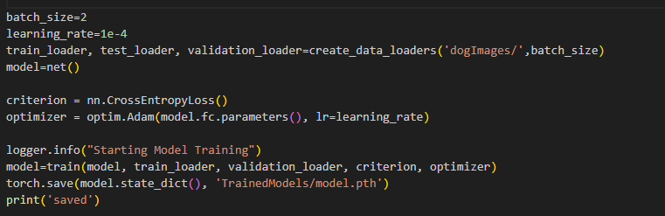*Argparse arguments required in SageMaker but not on EC2 instance*

With SageMaker we use CloudWatch   
to log important metrics as validation metric which it then used for hyperparameters tuning  
and the training instance is turned off automatically after the training  
Contrary, the code that runs on EC2 stores the metrics and model locally  
and one needs to turn off the instance manually after the training.

# **Lambda function for inference**

The lambda function serves here as a proxy we can call from the internet  
to reach the private sagemaker inference endpoint and get back the prediction.  
The SageMaker endpoints themselfs are not publicly exposed to the internet.

**Lambda input format**

The lambda function expects url to the image as an input  
{ "url": "https://s3.amazonaws.com/cdn-origin-etr.akc.org/wp-content/uploads/2017/11/20113314/Carolina-Dog-standing-outdoors.jpg" }  
  
**Lambda response format**

*Response  
{  
 "statusCode": 200,  
 "headers": {  
 "Content-Type": "text/plain",  
 "Access-Control-Allow-Origin": "*"  
 },  
 "type-result": "<class 'str'>",  
 "COntent-Type-In": "LambdaContext([aws_request_id=4fabc3a1-67aa-4642-8b3d-646a2fca0091,log_group_name=/aws/lambda/lambda-classifier-inference,log_stream_name=2023/08/05/[$LATEST]66377a4b0223437188a51e54ef36c0bc,function_name=lambda-classifier-inference,memory_limit_in_mb=128,function_version=$LATEST,invoked_function_arn=arn:aws:lambda:us-east-1:342422827189:function:lambda-classifier-inference,client_context=None,identity=CognitoIdentity([cognito_identity_id=None,cognito_identity_pool_id=None])])",  
 "body": "[[-10.411001205444336, -3.359707832336426, -0.8716796040534973, -0.806928277015686, -4.352297782897949, -5.186327934265137, -1.495664358139038, 0.8672809600830078, -5.380954742431641, 1.8454653024673462, 0.4312936067581177, -3.658811330795288, -2.8765857219696045, 0.8555495142936707, -3.514918327331543, -2.7837865352630615, -3.0496015548706055, -0.40549755096435547, -3.7292232513427734, 2.481992244720459, -3.8871142864227295, -0.23016999661922455, -4.7074055671691895, -4.1295390129089355, -1.7130252122879028, -7.174082279205322, -0.8516669273376465, -3.8094027042388916, -6.795691013336182, -1.4744735956192017, -3.0278568267822266, -3.00732421875, -3.488715887069702, -2.308708906173706, -4.75553035736084, -3.2217209339141846, -5.662548542022705, -3.37078595161438, -1.3833039999008179, -3.1248347759246826, -0.4696883261203766, -4.379352569580078, -0.6068338751792908, -1.7910823822021484, -2.007514238357544, -7.800812244415283, -0.7701671719551086, -0.2863987386226654, -2.760631561279297, 1.4280922412872314, -0.8542321920394897, -3.884108304977417, -7.310881614685059, -0.4031883776187897, -7.083492279052734, -0.9902368783950806, -2.8704679012298584, -5.145750045776367, 1.2012884616851807, -0.9694129824638367, -4.938790798187256, -7.690269470214844, -8.024537086486816, -8.33481216430664, -0.7291134595870972, -4.421416282653809, 1.974891185760498, -3.7833690643310547, 0.42422670125961304, 0.04445834457874298, 1.4988248348236084, -4.184320449829102, -6.3427019119262695, -3.1247105598449707, -4.442811965942383, 0.2801550626754761, -4.49869966506958, -1.0993596315383911, -4.876307010650635, -5.119265079498291, -0.48293337225914, -7.715047836303711, 1.818647027015686, -1.0500093698501587, -6.889594554901123, -4.097452163696289, -0.9937998652458191, -4.184472560882568, -1.842955231666565, 0.07524902373552322, -6.111001014709473, -3.8210742473602295, -4.455970764160156, -4.266619682312012, -1.588929295539856, -0.21372069418430328, -3.720984935760498, -2.2540969848632812, -4.282245635986328, -3.6666383743286133, -5.490141868591309, 1.640966534614563, -1.159744143486023, -2.869694709777832, -3.370785713195801, -4.364036560058594, -1.3472678661346436, 0.28569215536117554, -0.7098796963691711, -1.6858900785446167, -1.6024034023284912, 0.3240872025489807, -4.126656532287598, -2.1658661365509033, -4.123987674713135, 0.5662287473678589, -8.372995376586914, -0.7134520411491394, -5.814210414886475, 0.7786624431610107, -2.9264795780181885, -3.000781774520874, -4.719344139099121, -5.324817180633545, -5.956800937652588, -1.7227917909622192, -2.3081328868865967, 0.5590783953666687, -2.500715970993042, -7.0961127281188965, -4.543877124786377, -0.22000989317893982, -2.8665199279785156]]"  
}*

**Security and vulnerabilities of the IAM configuration for the Lambda**

The lambda is provisioned with IAM permission to invoke a sagemaker endpoint  
rather than SagemakerFullAccess thus limiting the attacker‘s scope to triggering endpoints.  
For convenience, the lambda can now trigger any endpoint in the account but this could be limited to a specific endpoint if the account would contain multiple endpoints.

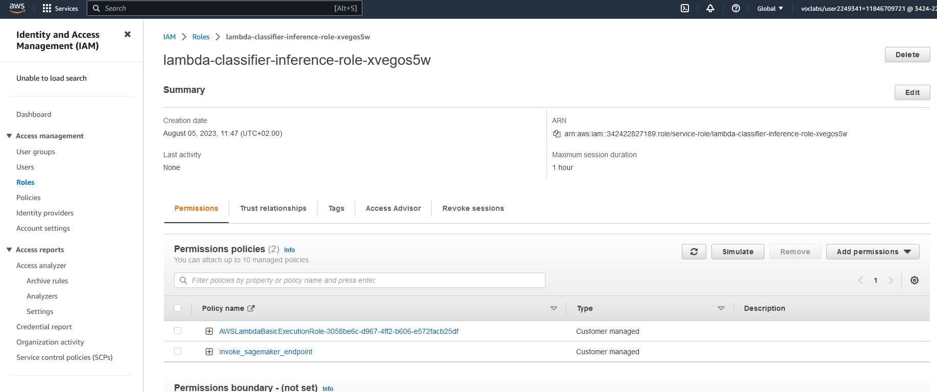

**Lambda Concurrency Configuration**

By default, the account has a concurrency limit of 1,000 across all functions in a region.  
Here we make sure that at least 3 concurrent calls get always processed by this lambda function  
before relying on shared account concurrency pool of 997. If the inference would be latency-sensitive we could configure even provisioned concurrency to minimize lambda cold-starts.

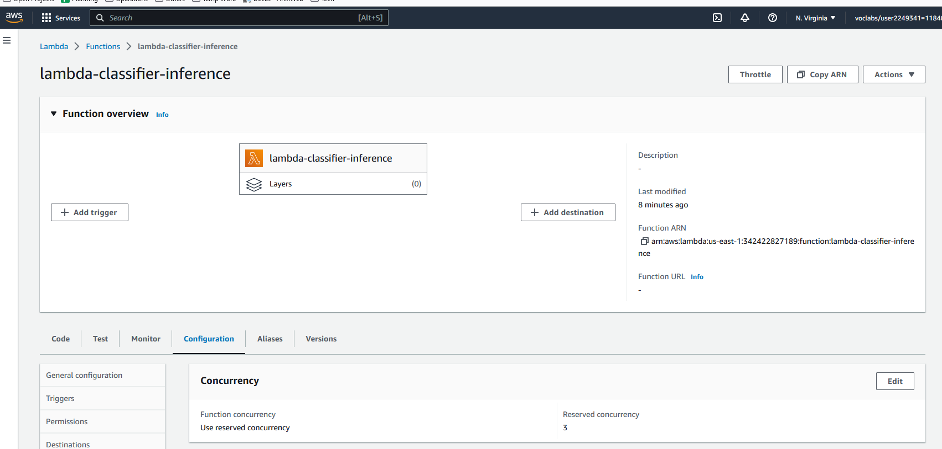

**Endpoint Autoscaling Configuration**

To handle the low, but potentially variable traffic, the inference endpoint configuration was extended to allow scaling to up to 3 inference endpoints to handle peak periods with minimal latency while scaling back when the peak is over.

