# Title

A sound check on compliance: Acoustically detected vessel presence indicates variation in compliance across marine protected areas

# Abstract

Managers of marine protected areas (MPAs) rely on consistent monitoring to effectively combat noncompliance. National Park Zones within Australian Marine Parks prohibit fishing and other extractive activities, but some are located in remote areas and present a variety of challenges to monitoring, including increased time and costs to maintain regular patrols. In this study, acoustic recorders were deployed in nine National Park Zones, with recording lengths between 19 and 84 days, providing a continuous archival record of vessel presence within each NPZ. Models of acoustic transmission loss were estimated for each NPZ to determine the likelihood of acoustically detected vessels occurring within NPZ boundaries, and those vessels determined to occur within the NPZs were further classified by acoustic characteristics to identify maneuvering vessels potentially exhibiting noncompliant behaviors. Inshore NPZs generally showed higher proportions of maneuvering vessels compared to areas farther offshore. Analysis of weekday and diel patterns showed increased presence later in the week and during daylight hours, particularly in NPZs closer to shore, consistent with recreational boating activity. NPZs farther offshore showed lower presence overall and less consistent temporal patterns in activity, but the detection of maneuvering vessels in these NPZs indicates the value of acoustic monitoring to capture infrequently occurring events indicative of noncompliance. The results from this study highlight the benefits of using passive acoustic monitoring to complement existing survey methods for managers to obtain a more complete assessment of activities within protected areas.

# Introduction

Marine protected areas (MPAs) are key to ensuring ocean conservation, however their success can be undermined by noncompliance (Icarella et al. 2021). Noncompliance activities include pollution (e.g., Jameson et al. 2002) or unauthorized extractive activities such as illegal fishing (Mangubhai et al., 2011). Detection of noncompliant activities is crucial for effective enforcement of regulations and eventual success of the MPA as a tool for recovery or conservation (Rossiter and Levine 2014). Understanding and addressing non-compliance is critical to ensure the success of MPA management. However, MPAs are often located in remote areas and may cover large areas of the ocean, presenting logistical challenges for consistent monitoring.

Autonomous monitoring tools include systems such as automatic identification systems (AIS) and vessel monitoring systems (VMS) which transmit data on vessel location, course, and speed, providing real time information to managers that can be used for compliance purposes. Both of these systems send signals from vessels at regular intervals and can help bridge gaps in survey effort, although they are each mandatory only for certain vessel size classes and categories (Read et al. 2019, Robards et al. 2016). Additionally, operators engaging in noncompliant activities may turn off or disable AIS transponders to conceal their location (Dunn et al., 2018; Welch et al., 2022).VMS is considered the gold standard for monitoring compliance with fishing regulations, and tools such as geo-fencing have been successfully used to avert noncompliant fishing in MPAs (Read et al. 2017); however, due to the cost of implementing and maintaining VMS systems, VMS is only mandated for commercial fishing vessels and is not universally implemented across fisheries (Birchenough et al. 2021, Read et al. 2017).

Since all motorized vessels generate a distinctive acoustic signal as a byproduct of operation, autonomous passive acoustic monitoring (PAM) has been used to assess patterns of vessel use (e.g., Barlett and Wilson, 2002; Hatch et al., 2008; Kline et al., 2020; Kendall et al., 2021) and provides a cost-effective solution for monitoring remote or inaccessible marine habitats. When comparing multiple methods of remote monitoring, Kendall et al. (2021) found that acoustic monitoring outperformed visual and satellite methods in terms of ability to detect simulated changes in the number of vessels over time. PAM recorders can be deployed for months at a time, providing a continuous acoustic recording which can be analyzed for patterns in the presence of any signals of interest (Mellinger et al., 2007). The primary advantages of this approach for monitoring noncompliance are (1) a more continuous record, eliminating the ‘snapshot’ nature of discrete patrols and enabling data collection through all light and weather conditions (Mellinger et al. 2007) and (2) the ability for compliance programs to target their surveillance from known patterns of activity.

Autonomous PAM does not enable confirmation of specific vessel activity, but it has been used extensively in MPAs to remotely monitor vessel presence and activity patterns (Kendall et al. 2021). Measurements of ambient sound levels in Glacier Bay National Marine Sanctuary show the impact of scheduled cruise ship passages on diel patterns in the local soundscape (Fournet et al. 2018). In other U.S. National Marine Sanctuaries, acoustic monitoring has been used to determine not only noise impacts of vessels (e.g., Hatch et al. 2008) but also temporal patterns in presence (McKenna et al. 2017, Fournet et al. 2018, Kendall et al. 2021). Beyond patterns in vessel presence, PAM can be used to detect noncompliant activities that have distinctive acoustic features (Braulik et al. 2017, Astaras et al. 2020, Kline et al. 2020). In MPAs where fishing is prohibited, abrupt changes in amplitude and frequency within a vessel’s acoustic signature indicate maneuvering vessels that would warrant further investigation (Kline et al., 2020).

Australian Marine Parks cover 3.8 million km2 of Australia’s ocean ecosystems, representing over 43 per cent of Australia’s oceans. These parks comprise an enormous range and quantity of socio-economic, cultural, heritage and nationally significant marine conservation values. Zoning within Australian Marine Parks follows the International Union for the Conservation of Nature (IUCN) protected area category or categories. The six IUCN categories are defined under the *Environmental Protection and Biodiversity Conservation Regulations 2000* and differ in the level and type of protection they afford, ranging from ‘multiple use’ to ‘sanctuary’[1]. The focus of this study is National Park Zones (NPZ; IUCN Category II). NPZs permit general use of the area (e.g., vessel transiting, viewing wildlife) but prohibits extractive activities such as fishing, aquaculture, or mining.

The most common methods of monitoring the NPZs are manned surface patrols or aerial surveillance (Director of National Parks 2018), although the vast nature of the AMP system creates difficulties in maintaining consistent, cost-effective coverage of these areas (Read et al. 2017). This creates an information gap regarding the activities conducted by small vessels that may be engaging in unauthorised tourism and illegal recreational fishing activities in AMPs. In the 2022/23 financial year, 27.5% of domestic compliance incidents in AMPs were attributed to illegal recreational fishing[2]. Smaller recreational fishing vessels are not required to use either AIS or VMS (e.g., Director of National Parks 2018) and may be too small to be reliably detected using satellite imagery methods (Paolo et al., 2024), making them difficult to detect using those remote monitoring technologies. Investigating the use of technologies to better understand activity from small recreational vessels is a key priority of the AMP compliance program.

In this study, we expand on the initial work carried out in Kline et al. (2020) by investigating patterns in acoustic vessel presence across nine NPZs located throughout three marine park networks: the Temperate East, North-west, and South-west.

Using empirical propagation modeling in each NPZ, we further estimate whether detected vessels are likely to be operating within the NPZ, therefore signaling potential non-compliance. These data are compiled to provide an overall understanding of compliance and human use patterns across a broad ranging set of Australian Marine Parks.

# Methods

## Site Descriptions and Acoustic Data Collection

Between 2018 and 2023, SoundTrap 300 STD acoustic recorders were deployed in nine NPZs across the three marine park networks (Fig. 1): Cod Grounds Marine Park (Cod Grounds) and Solitary Islands Marine Park (Solitary Islands) in the Temperate East network, Ningaloo Marine Park (Ninglaoo) and Dampier Marine Park (Dampier) in the North-west network, and Murat Marine Park (Murat), Two Rocks Marine Park (Two Rocks), South-west Corner Marine Park (South-west Corner), Geographe Marine Park (Geographe), and Jurien Marine Park (Jurien) in the South-west network.

The Temperate East network is characterized by temperate and subtropical waters in Queensland and New South Wales, Australia and provides a popular destination for snorkeling, scuba diving, and other ecotourism opportunities (Director of National Parks 2018a). Within this network, Cod Grounds Marine Park is located approximately 5.5 km from shore and provides critical habitat for grey nurse sharks. Although the park itself is fairly small–four square kilometers–the entirety of the park is classified as a National Park Zone (NPZ). Solitary Islands Marine Park is located approximately 5.5 km from shore and covers roughly 150 square kilometers along the coastline on either side of North Solitary Island and South Solitary Island in New South Wales. The focal NPZ for this study surrounds Pimpernel Rock, a submerged reef structure which provides habitat for a variety of marine life (Director of National Parks 2018a) (Fig. 1).

The North-west network covers over 1 million km2 and represents key tropical and subtropical habitats including shallow reefs, continental shelf and slope, and areas of abyssal plain (Director of National Parks 2018b). Ningaloo Marine Park extends approximately 300km along the west coast of the Cape Range peninsula and contains Ningaloo Reef, a common destination for tourism and a known seasonal aggregation site for whale sharks. The NPZ area within Ningaloo Marine Park is centrally located along the north-south axis of the park. The second NPZ analyzed in this study is located within Dampier Marine Park, northeast of Cape Lambert, Western Australia. This park contains offshore habitats including multiple submerged coral reefs and supports a high biodiversity of sponges. The NPZ covers approximately 73 km2 and is situated north of Delambre Island (Director of National Parks 2018b) (Fig. 1) .

The South-west network extends from subtropical waters of the Indian Ocean to temperate habitats of the Great Australian Bight, encompassing waters in Western Australia and South Australia (Director of National Parks 2018c). The network covers approximately 1.3 million km2 and includes 14 marine parks established to protect a wide array of marine species and habitats. Five parks in the South-west network were included in the present study: South-west Corner, Murat, Two Rocks, Jurien, and Geographe. South-west Corner Marine Park and Murat Marine Park both represent offshore marine habitats. The NPZ selected within South-west Corner Marine Park is located approximately 45 km from the nearest coastline and contains habitat representative of the Cape Mentelle upwelling, which encourages high productivity and biodiversity. Murat Marine Park is located south of the Nuyts Archipelago in South Australia and contains a detached reef structure which is a hotspot of local biodiversity and supports feeding aggregations of marine mammals, seabirds, and sharks (Director of National Parks 2018c). The remaining three marine parks used in this study are located much closer to shore, with Geographe and Two Rocks located adjacent to state waters approximately 5.5 km from the coastline. Jurien Marine Park is similarly situated; however, the NPZ within the larger marine park is located approximately 40 km from shore (Director of National Parks 2018c) (Fig. 1).

Timing of each deployment was determined by managers to monitor priority areas previously demonstrated to be at risk of noncompliant fishing activity while maximizing use of limited recording equipment. While most recordings were continuous, two deployments each in Cod Grounds and Solitary Islands were duty-cycled to record continuously for 30 minutes before turning off for 30 minutes each hour. In a previous report to Parks Australia using these deployments (McCordic et al. 2020), imposing an artificial 30-minute duty-cycle to the continuous acoustic data indicated that duty-cycled deployments had lower overall counts but comparable patterns of temporal presence.

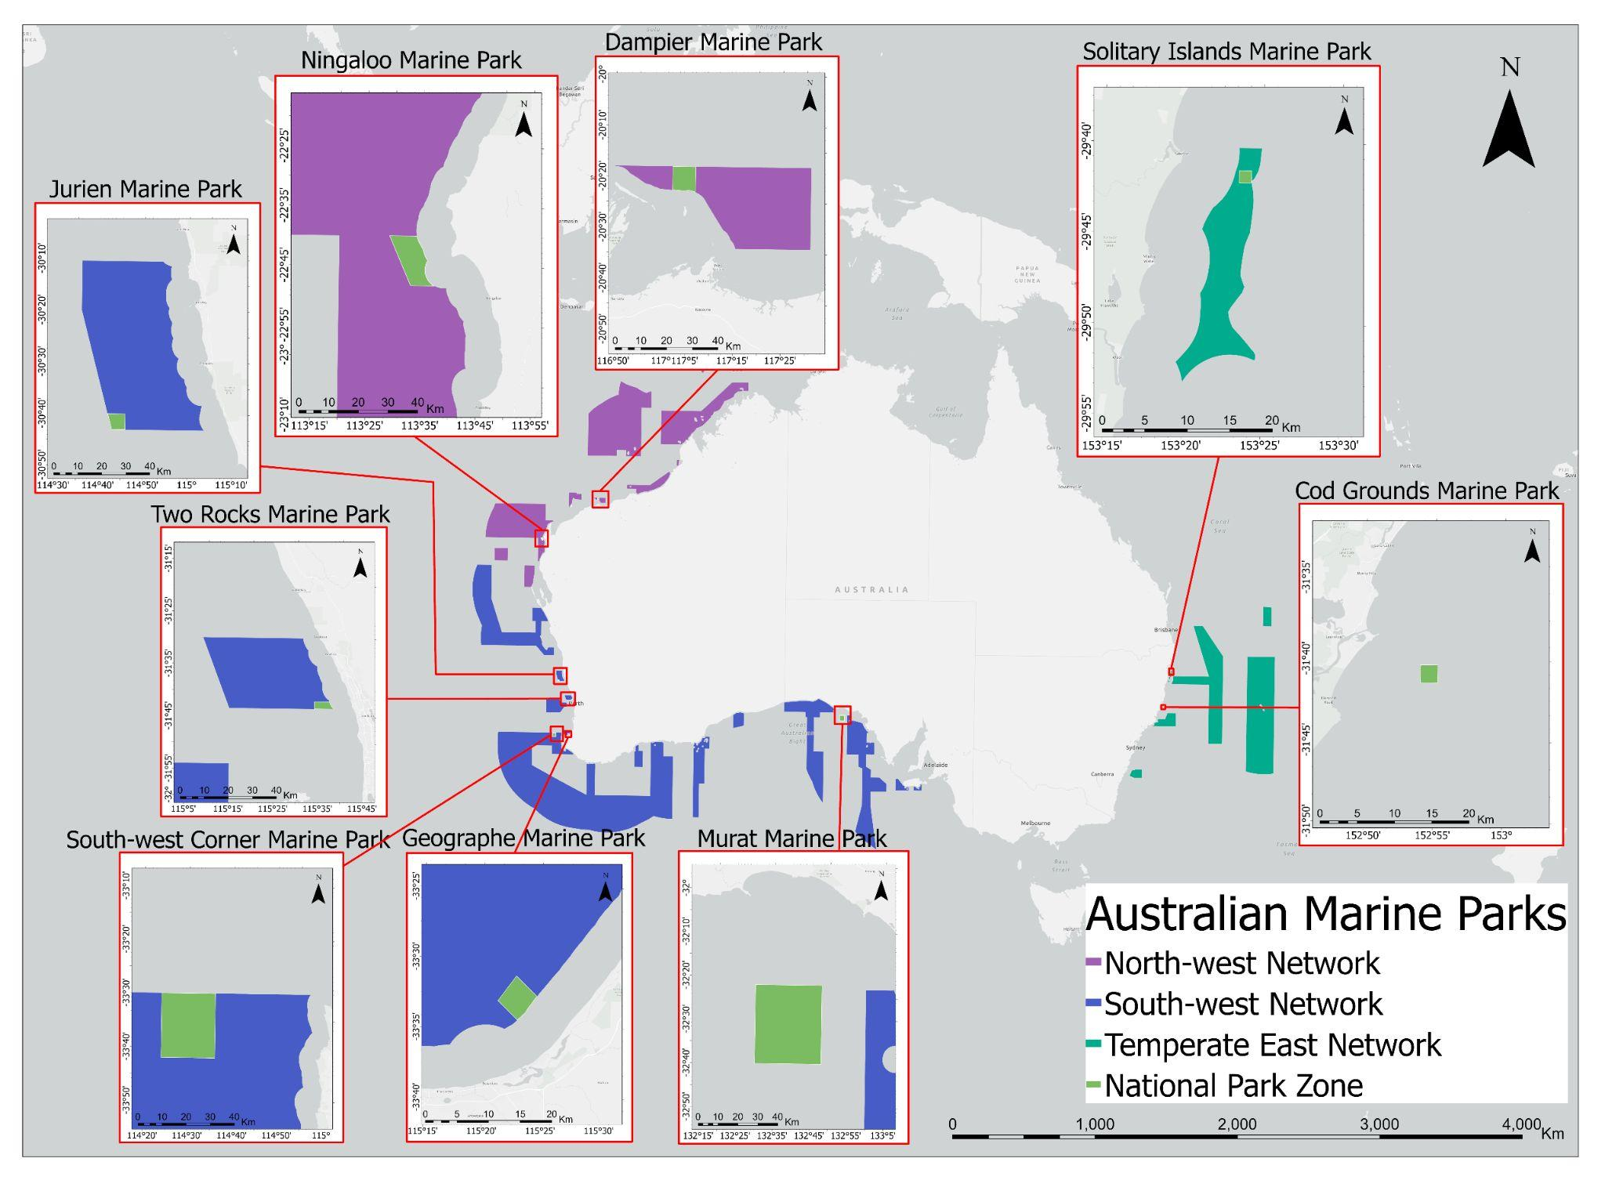

**Figure 1:** Australian Marine Park system, highlighting marine park networks (purple: North-west network, blue: South-west network, dark green: Temperate East network) with acoustic sampling effort in selected National Park Zones (light green) within nine parks: Cod Grounds Marine Park and Solitary Islands Marine Park in the Temperate East network, Ningaloo Marine Park and Dampier Marine Park in the North-west network, and Jurien Marine Park, Two Rocks Marine Park, South-west Corner Marine Park, Geographe Marine Park, and Murat Marine Park in the South-west network.

## Acoustic vessel presence

A combination of manual and automated methods were used to detect the presence of vessel passages in each acoustic dataset. For earlier deployments (Cod Grounds, Solitary Islands), spectrograms were browsed manually by an analyst (LK or JM) using RavenPro software to obtain counts of vessel passages per hour. For remaining deployments, a long-term spectral average (LTSA) with 5-second, 48-Hz bins was created in order to run an automated ship detector (Ship Detector Remora) within the Triton analysis software (Solsona-Berga et al. 2020). All automated detections were then manually reviewed by an analyst (RG or JM) to correctly classify detections as “Ship” or “Ambient” as well as to ensure the correct start and end times of each passage. The entire LTSA was additionally reviewed manually to include any ships missed by the detector. To allow for comparisons of total vessel presence across NPZs with varying effort in terms of number of recording sites and length of recordings, total counts for a given deployment period were pooled together by deployment period for each NPZ and normalized by the sum of recording days in each NPZ during that period.

## Modelling transmission loss

Due to their high source levels (125–180+ dB re 1µPa) (Hatch et al. 2008, Parsons et al. 2021), vessels are typically loud enough to be detected several kilometers from the source, resulting in acoustic detections of distant vessels that may not be operating within the geographic area of interest for managers of MPAs (Kline et al. 2020, Hildebrand 2009). Transmission loss (TL) for each NPZ was empirically modelled following methods in Kline et al. (2020). Measurements of the peak frequency received level (*RL*) of the deployment vessel at known distances in meters (*r*) from the hydrophone were fitted to a modified passive sonar equation (Eq. 1) using generalized linear model (GLM) regressions. Source level (*SL*), the geometric spreading loss coefficient (*b*), and the absorption coefficient (*a*) were unknowns.

**Equation 1**: *RL* = *SL* - (*b*\*log10(*r*) + *a*\**r*)

The transmission loss equation was then used to estimate an approximate maximum vessel detection range (km) for the hydrophone at each site based on local noise characteristics. To represent noise in the relevant frequency range for vessel detections, the median noise level (NL50) was calculated as the median value of one-minute third-octave level (TOL) bands containing median peak frequency values (Hz) for detected vessels. To account for NPZs with irregular shapes or non-central placement of the acoustic recorder within the NPZ, the representative distance between the recorder and NPZ boundary was calculated using a distance-weighted average (Dodonova and Dodonova 2013) of 8 distance measurements (km) between the recorder and the park boundary taken at 45-degree increments (Eq. 2). The distance-weighted average () was calculated as the sum of the products of each distance measurement (*xi*) and its respective weighting factor (*wi*) divided by the sum of all weighting factors (Eq. 2a). The weighting factor itself divides the number of differences between measurements (*n* - 1) by the sum of differences between each measurement (*xi*) and the following measurement (*xj*) (Eq. 2b).

For vessel passages detected throughout the dataset (i.e., with unknown distance to recorder), peak frequency RLs were inserted into the modelled transmission loss equation to solve for plausible source levels (125 - 180 dB re 1µPa) at 10m intervals between 1m and the maximum detection range. Using these simulated ranges, vessels were assigned as likely to occur inside the NPZ if the ratio of simulated ranges within the representative park boundary distance to the total number of simulated ranges was > 0.75.

Vessel events determined to occur within the NPZ boundaries were further classified into “transit” and “maneuver” categories based on aural and visual inspection of spectrograms by an analyst (LK, JM, or RG) as in Kline et al. (2020). Transiting vessels are characterized by relatively constant harmonics over time with any changes to frequency or amplitude occurring gradually as a result of changing distance relative to the recorder. In contrast, vessel signatures classified as containing a maneuver contained at least one instance of an abrupt change in frequency or amplitude, potentially indicating a change in engine operation or a rapid change in direction (e.g., Kline et al. 2020, Trevorrow et al. 2018). Since maneuvering vessels may indicate fishing activity, proportions of each of these categories relative to total vessel counts within the park boundaries is presented as a proxy of noncompliance with NPZ regulations.

## Temporal patterns in vessel presence

To account for variation in overall vessel presence throughout each deployment and to facilitate comparisons among NPZs with variation in total vessel presence, temporal trends were assessed for each deployment period using mean-adjusted counts of vessels in each hour of the day as well as for each day of the week. For diel patterns, only full days (24 hours) with at least one vessel present were included. The daily mean of hourly vessel presence was subtracted from the count of vessel signatures for each hour of the day (00:00–23:00 local time). Positive values of mean-adjusted counts indicate hourly or daily counts greater than the daily or weekly means, respectively; negative values indicate hourly or daily counts less than the respective daily or weekly means. For weekday patterns, a similar approach was used: the weekly mean of daily counts for each week including at least one vessel signature was subtracted from vessel signature counts per weekday. Mean-adjusted counts were calculated for total vessels present as well as vessels estimated to occur within the NPZ boundaries. For the latter case, only days and weeks with at least one vessel signature within the NPZ boundaries were included for diel and weekday patterns, respectively.

# Results

## Overall vessel presence across NPZs

Recordings ranged from 19–86 days (median = 57 days) with a sample rate of 48 kHz and a flat frequency response (+/- 3 dB) of 20 Hz–24 kHz (Table 1, Fig. 2).Vessel presence across all sites comprises all vessel signatures, whether inside or outside of the NPZ boundaries and ranged from 0.024–10.40 vessels per day (mean = 5.09 vessels/day), with the winter deployment at Cod Grounds in the Temperate East network representing the highest daily average vessel count and Murat in the South-west network showing the lowest vessel presence. With the exception of Murat, all deployments in both the Temperate East and South-west networks had over four vessels per day on average, while the North-west network was characterized by relatively lower vessel presence (Dampier = 3.24 vessels/day, Ninglaoo = 1.14 vessels/day) (Table 2).

**Table 1**: Summary of recording effort in each National Park Zone. NPZ ID specifies the unique National Park Zone (NPZ) identifier within each marine park. N Sites = number of recorders deployed during each time period within each NPZ. Latitude and longitude are reported in decimal degrees.

|  |  |  |  |  |  |  |  |  |  |  |
| --- | --- | --- | --- | --- | --- | --- | --- | --- | --- | --- |
| **Park Name** | **NPZ ID** | **N Sites** | **Lat.** | **Long.** | **Depth (m)** | **Start Date (mm/dd/yy)** | **End Date (mm/dd/yy)** | **N Days** | **Recording Schedule** | **Habitat** |
| Cod Grounds  Marine Park | tecodnpz01 | 1 | -31.681 | 152.91 | 37 | 07/01/18 | 08/04/18 | 34 | Continuous | Temperate reef |
| 12/12/18 | 02/20/19 | 70 | 30-min duty cycle | Temperate reef |
| 04/11/19 | 06/24/19 | 74 | 30-min duty cycle | Temperate reef |
| Solitary Islands  Marine Park | tesolnpz02 | 2 | -29.698  -29.698 | 153.397  153.398 | 42  42 | 08/10/18  08/10/18 | 09/11/18  09/12/18 | 32  33 | Continuous | Temperate reef |
| 12/12/18  12/12/18 | 01/15/19  01/15/19 | 34  34 | 30-min duty cycle | Temperate reef |
| 06/10/19  06/11/19 | 08/09/19  06/30/19 | 60  19 | 30-min duty cycle  Continuous | Temperate reef |
| Ningaloo  Marine Park | nwninnpz02 | 2 | -22.705  -22.738 | 113.546  113.557 | 97  54 | 09/25/19  09/25/19 | 11/18/19  11/17/19 | 55  54 | Continuous | Sand/shell substrate |
| Murat  Marine Park | swmutnpz01 | 2 | -32.584  -32.633 | 132.630  132.564 | 60  56 | 02/08/20  02/08/20 | 05/03/20  04/25/20 | 86  78 | Continuous | Sand/shell substrate |
| Dampier  Marine Park | nwdamnpz01 | 2 | -20.197  -20.210 | 117.054  117.044 | 32  30 | 09/09/20  09/09/20 | 11/04/20  11/04/20 | 57  57 | Continuous | Calcareous sand, gravel, and silt |
| Two Rocks  Marine Park | swtwonpz02 | 2 | -31.712  -31.711 | 115.614  115.583 | 31  33 | 05/10/21  05/10/21 | 07/25/21  08/02/21 | 76  84 | Continuous | Calcareous sand, gravel, and silt |
| Jurien  Marine Park | swjurnpz02 | 2 | -30.678  -30.706 | 114.753  114.753 | 164  168 | 01/05/22  01/05/22 | 03/10/22  02/12/22 | 65  39 | Continuous | Calcareous sand, gravel, and silt |
| Geographe  Marine Park | swgeonpz04 | 1 | -33.576 | 115.424 | 12 | 01/12/22 | 04/03/22 | 82 | Continuous | Seagrass bed/macroalgae |
| South-west Corner  Marine Park | swswcnpz04 | 1 | -33.675 | 114.579 | 143 | 01/18/22 | 04/11/22 | 83 | Continuous | Calcareous sand, gravel, and silt |

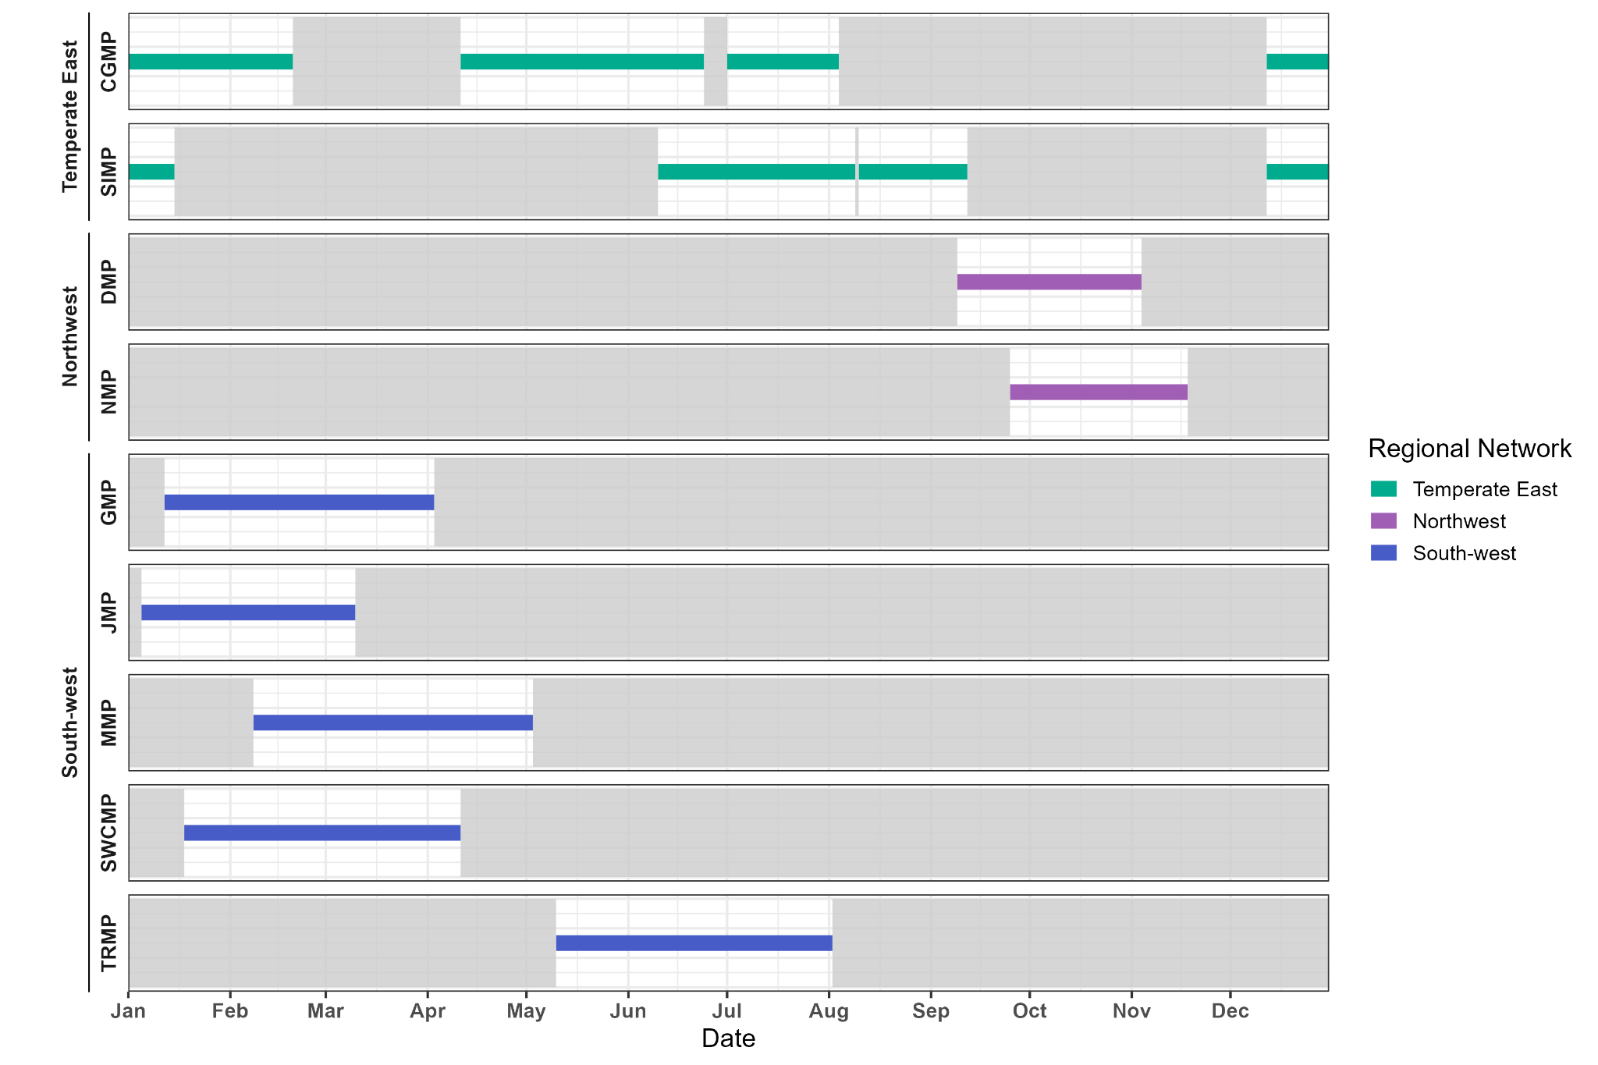

**Figure 2**: Recording effort for each of nine National Park Zone (NPZ) during a representative calendar year. The nine NPZs are Cod Grounds Marine Park (CGMP) and Solitary Islands Marine Park (SIMP) in the Temperate East network, Ningaloo Marine Park (NMP) and Dampier Marine Park (DMP) in the North-west network, and Jurien Marine Park (JMP), Two Rocks Marine Park (TRMP), South-west Corner Marine Park (SWCMP), Geographe Marine Park (GMP), and Murat Marine Park (MMP) in the South-west network. Horizontal lines are colored by regional network (green = Temperate East network, purple = North-west network, blue = South-west network) and indicate time periods during a calendar year with recording effort in the NPZ. Grey shaded areas represent times of the calendar year that were not sampled for a given NPZ.

**Table 2**: Summary of vessel presence across all National Park Zones (NPZs). The nine NPZs are Cod Grounds Marine Park (CGMP) and Solitary Islands Marine Park (SIMP) in the Temperate East network, Dampier Marine Park (DMP) and Ningaloo Marine Park (NMP) in the North-west network, and Geographe Marine Park (GMP), Jurien Marine Park (JMP), Murat Marine Park (MMP), Two Rocks Marine Park (TRMP), and South-west Corner Marine Park (SWCMP) in the South-west network.

|  |  |  |  |  |  |
| --- | --- | --- | --- | --- | --- |
| **Network** | **NPZ** | **Deployment start  (mm/yyyy)** | **N recording days** | **N vessels total** | **N vessels / day** |
| **Temperate East** | **CGMP** | 07/2018 | 35 | 364 | 10.4 |
| 12/2018 | 71 | 395 | 5.56 |
| 04/2019 | 75 | 473 | 6.31 |
| **SIMP** | 08/2018 | 67 | 523 | 7.81 |
| 12/2018 | 70 | 443 | 6.33 |
| 06/2019 | 81 | 343 | 4.23 |
| **Northwest** | **DMP** | 09/2020 | 116 | 376 | 3.24 |
| **NMP** | 09/2019 | 111 | 126 | 1.14 |
| **South-west** | **GMP** | 01/2022 | 91 | 575 | 6.32 |
| **JMP** | 01/2022 | 106 | 425 | 4.01 |
| **MMP** | 02/2020 | 164 | 4 | 0.02 |
| **SWCMP** | 01/2022 | 85 | 343 | 4.04 |
| **TRMP** | 05/2021 | 164 | 1109 | 6.76 |

## 

## Empirical transmission loss models

Empirical models of sound propagation in each NPZ revealed transmission loss coefficients largely agreeing with theoretical values of spherical or hybrid geometric spreading loss (e.g., Urick 2013) for most NPZs. The exception to this pattern occurred in the shallowest recording location, Geographe, where the fitted transmission loss value was 10.9, more closely approximating a cylindrical spreading model (Table 2). Murat and South-west Corner Marine Parks in the South-west network were excluded from further propagation analysis due to unreasonable fitted values for coefficients, potentially indicating more complex local propagation characteristics that cannot be approximated using a basic sonar equation.

**Table 3**: Transmission loss modeling parameters and detection distance for each National Park Zone (NPZ). The NPZs suitable for propagation modeling and included in this table are Cod Grounds Marine Park (CGMP) and Solitary Islands Marine Park (SIMP) in the Temperate East network, Dampier Marine Park (DMP) and Ningaloo Marine Park (NMP) in the North-west network, and Geographe Marine Park (GMP), Jurien Marine Park (JMP), and Two Rocks Marine Park (TRMP) in the South-west network. For TRMP, the transmission loss model was estimated separately for each recording location.

|  |  |  |  |  |  |  |
| --- | --- | --- | --- | --- | --- | --- |
| **NPZ** | **Deployment start (mm/yyyy)** | **Distance to NPZ boundary (km)** | **Transmission Loss** | **TOL band center frequency (Hz)** | **NL50 (dB re 1μPa)** | **Maximum detection distance (km)** |
| **CGMP** | 07/2018 | 1.22 |  | 250 | 87.7 | 1.63 |
| 12/2018 | 250 | 84.1 | 1.89 |
| 04/2019 | 250 | 86.4 | 1.73 |
| **SIMP** | 08/2018 | 0.76 |  | 200 | 91.3 | 1.39 |
| 12/2018 | 200 | 83.4 | 1.84 |
| 06/2019 | 200 | 92.7 | 1.32 |
| **DMP** | 09/2020 | 5.24, 5.28 |  | 200 | 85.9, 89.9 | 25.2,  16.6 |
| **NMP** | 09/2019 | 8.25, 8.09 |  | 500 | 83.9, 84.8 | 16.8,  16.2 |
| **GMP** | 01/2022 | 2.13 |  | 160 | 75.6 | 39.5 |
| **JMP** | 01/2022 | 2.89, 2.47 |  | 100 | 79.2, 79.1 | 21.1,  21.2 |
| **TRMP** | 05/2021 | 1.68, 1.71 |  | 250 | 81.9, 82.0 | 11.5,  11.4 |

## Vessel presence inside NPZ boundaries

When considering vessels inside the park boundaries, NPZs in the Temperate East network showed the highest proportions of vessels inside the NPZs, with pooled proportions approximately twice as high as in the South-west network (Cod Grounds = 17.5%; Solitary Islands = 25.6%) (Table 4). The August 2018 deployment at Solitary Islands represented the single deployment with the highest proportion of vessels within the NPZ boundaries relative to vessel signatures used for propagation analysis (36.6% of vessels). The two NPZs in the North-west network showed a low overall proportion of vessels inside the NPZs (Dampier = 5.6%; Ninglaoo = 3.7%). The South-west network varied, with only a single vessel estimated within Geographe (0.3%) and Jurien and Two Rocks showing similar proportions (Jurien = 6.1%; Two Rocks = 7.3%).

**Table 4**: Presence of vessels estimated to occur within the boundaries of each National Park Zone (NPZ). The NPZs suitable for propagation modeling and included in this table are Cod Grounds Marine Park (CGMP) and Solitary Islands Marine Park (SIMP) in the Temperate East network, Dampier Marine Park (DMP) and Ningaloo Marine Park (NMP) in the North-west network, and Geographe Marine Park (GMP), Jurien Marine Park (JMP), and Two Rocks Marine Park (TRMP) in the South-west network.

|  |  |  |  |  |  |  |  |
| --- | --- | --- | --- | --- | --- | --- | --- |
| **Network** | **NPZ** | **Deployment start (mm/yyyy)** | **N vessels suitable for propagation analysis** | **N vessels inside** | **N maneuvers** | **% Inside** | **% Maneuvers** |
| **Temperate East** | **CGMP** | 07/2018 | 208 | 41 | 14 | 19.7% | 36.6% |
| 12/2018 | 216 | 33 | 0 | 15.3% | 66.7% |
| 04/2019 | 326 | 57 | 31 | 17.5% | 57.9% |
| **SIMP** | 08/2018 | 112 | 41 | 8 | 36.6% | 29.3% |
| 12/2018 | 265 | 42 | 29 | 15.8% | 71.4% |
| 06/2019 | 241 | 75 | 65 | 31.1% | 90.7% |
| **Northwest** | **DMP** | 09/2020 | 125 | 7 | 3 | 5.6% | 42.9% |
| **NMP** | 09/2019 | 109 | 4 | 2 | 3.7% | 50.0% |
| **South-west** | **GMP** | 01/2022 | 390 | 1 | 0 | 0.3% | 0.0% |
| **JMP** | 01/2022 | 345 | 21 | 3 | 6.1% | 14.3% |
| **TRMP** | 05/2021 | 831 | 61 | 52 | 7.3% | 85.3% |

**Figure 3**: (a) Total counts of vessels estimated as likely to occur inside (colored bars) and outside (grey bars) the NPZ boundaries for each deployment period. For deployment periods with two concurrent recording sites, totals represent the pooled sum of all vessel signatures suitable for propagation analysis. (b) Counts of vessels estimated to occur inside each NPZ that were maneuvering (darker areas) or transiting (lighter areas) based on visual and aural review of each vessel signature. Colors indicate marine park network: green = Temperate East, purple = North-west, blue = South-west. CGMP = Cod Grounds Marine Park, SIMP = Solitary Islands Marine Park, DMP = Dampier Marine Park, NMP = Ningaloo Marine Park, GMP = Geographe Marine Park, MMP = Murat Marine Park, SWCMP = South-west Corner Marine Park, TRMP = Two Rocks Marine Park.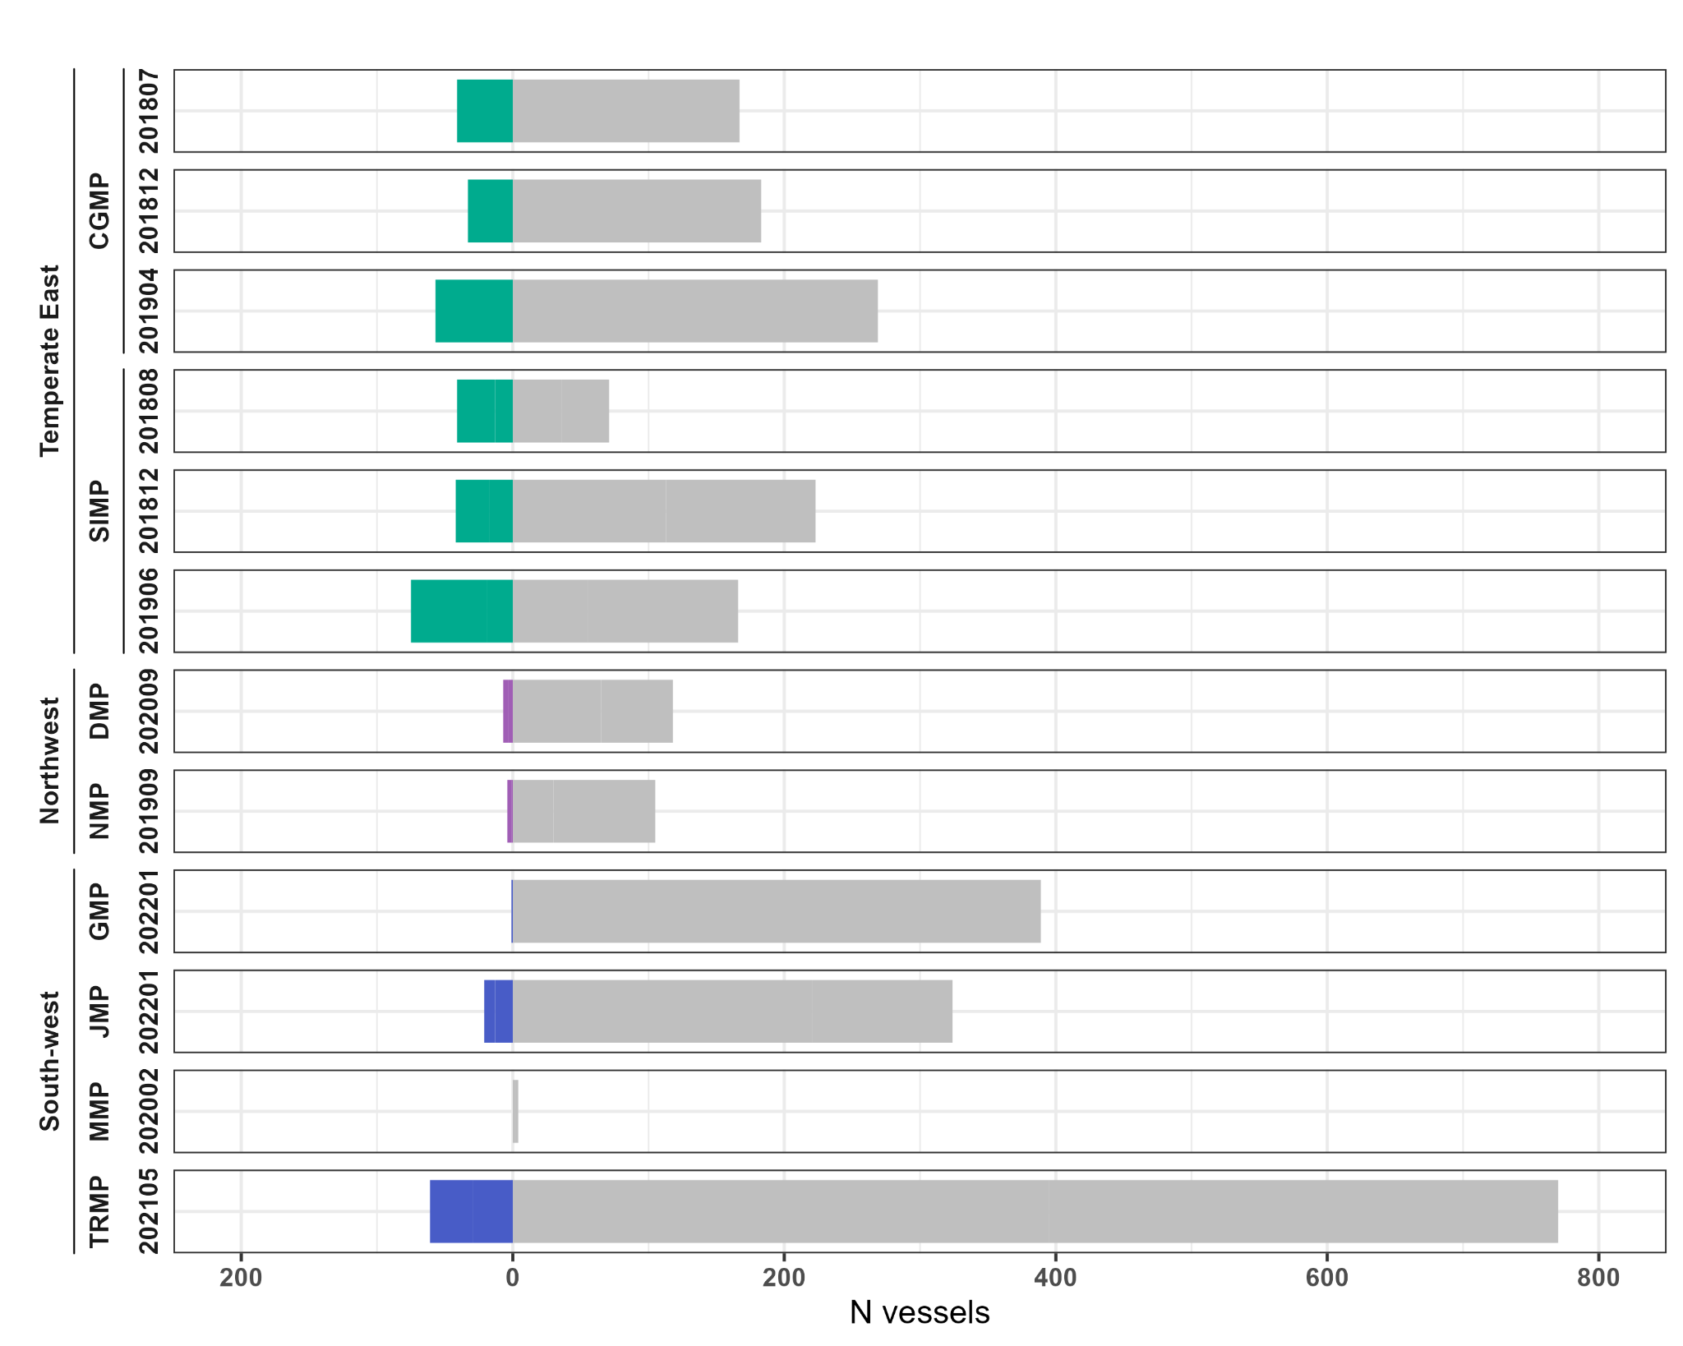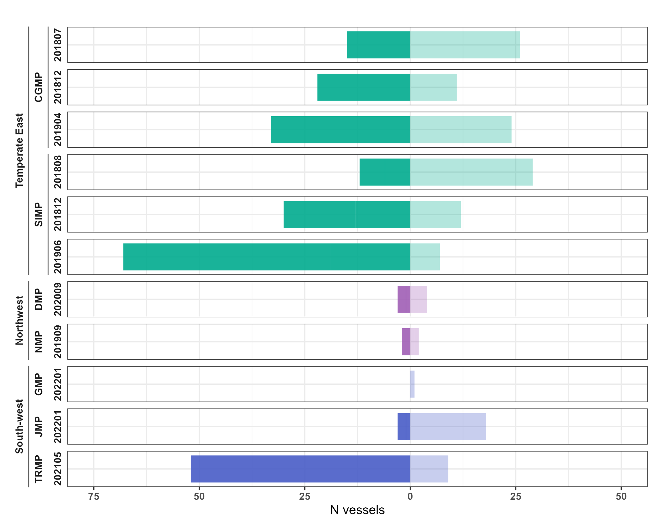

Of the vessels that were within the NPZ boundaries in the Temperate East network, the highest proportions of maneuvering vessels occurred during the June 2019 deployment at Solitary Islands (90.7% of vessels inside the NPZ) (Table 3). In the North-west network, Dampier and Ninglaoo showed similar proportions of maneuvering vessels despite relatively low counts of vessels occurring within the NPZs (Dampier = 3/7 vessels, 42.9%; Ninglaoo = 2/4 vessels, 50.0%). In the South-west network, Two Rocks showed one of the highest proportions of maneuvering vessels across the study (85.3% of vessels inside the NPZ), but the other NPZs in the South-west network were characterized by much lower percentages (Jurien = 3/21 vessels, 14.3%; Geographe = 0/1 vessel, 0%).

## Temporal patterns in vessel presence

### Weekday presence

Mean-adjusted rate of total vessel presence was higher towards the end of the week (Thursdays - Saturdays) for most NPZs, although specific weekdays with peaks in presence varied across NPZs and networks (Fig. 4). The majority of deployments showed peak mean-adjusted rates on Thursdays or Saturdays, particularly in the Temperate East network–Cod Grounds December 2018 and April 2019 deployments, Solitary Islands August 2018 and June 2019 deployments. In the North-west network, peak activity above weekly mean levels occurred on Thursdays in Dampier and Sundays in Ninglaoo. With the exception of Murat, vessels in the South-west network showed similar patterns as the Temperate East NPZs with peaks on Saturdays–Geographe, Jurien, South-west Corner, and Two Rocks. Several deployments also exhibited a pattern of higher rates on Thursdays and Saturdays and lower rates on Fridays (Fig. 4).

Weekday patterns of vessels within the park boundaries diverged from total vessel presence in multiple NPZs, occasionally showing values in the opposite directions relative to weekly means (Fig. 4). For example in the Temperate East network, the July 2018 deployment in Cod Grounds exhibited a Saturday peak in mean-adjusted rates of presence inside the NPZ despite negative rates for total vessels on Saturdays in that deployment. Similarly, in the December 2018 and June 2019 deployment in Solitary Islands, peaks in vessel presence within the NPZ that were not reflected in total presence occurred on Sundays and Thursdays, respectively. For the subset of maneuvering vessels, patterns of presence generally followed patterns of presence for vessels within the NPZs.

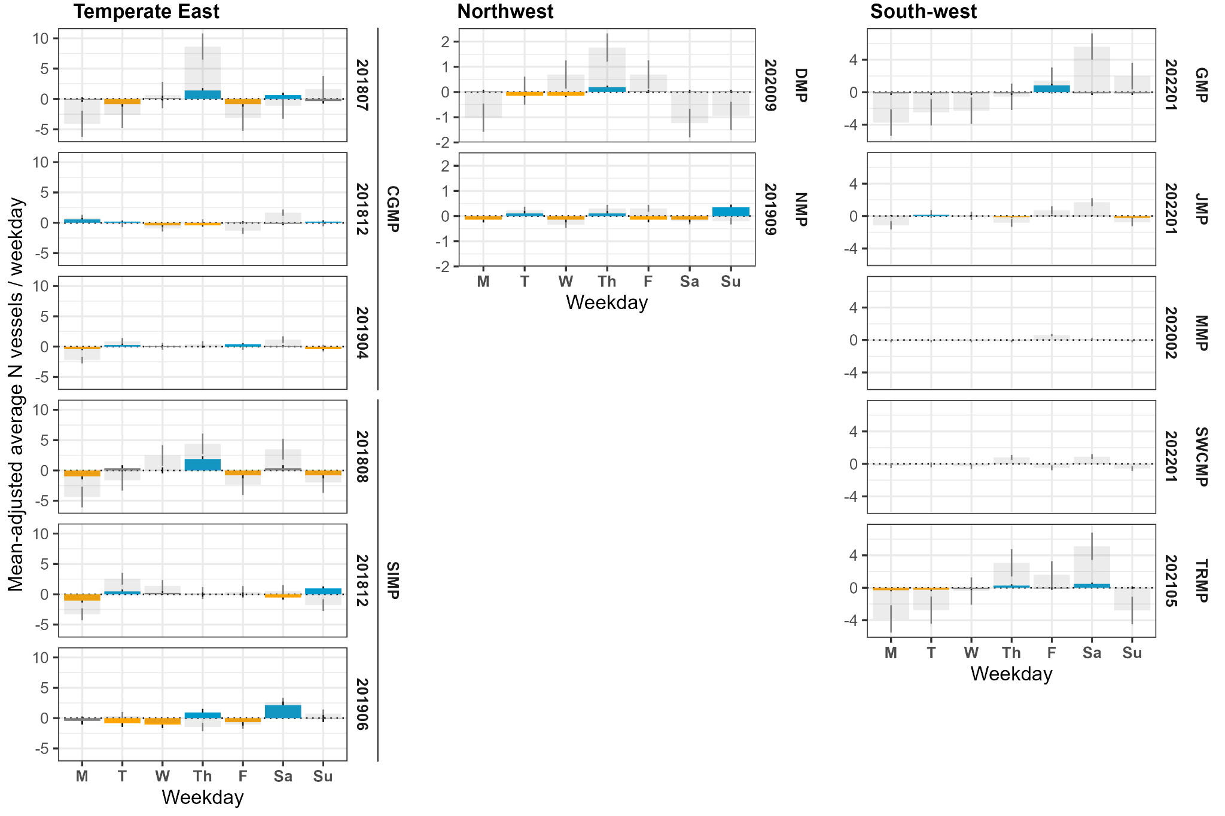

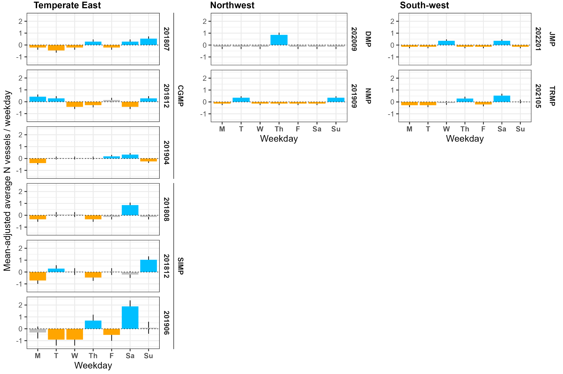

**Figure 4**: (a) Weekly mean-adjusted counts of all vessels (light grey bars) and vessels estimated to occur within the National Park Zone (NPZ) boundaries (dark colored bars) per hour. (b) Weekly mean-adjusted counts of vessels within the NPZ boundaries that contained maneuvers. (blue bars: mean +/- SD > 0, orange bars: mean +/- SD < 0, dark grey bars: mean +/- SD includes 0). Bars represent mean values of adjusted counts for each weekday across the deployment period, and error bars indicate standard deviation around the mean. CGMP = Cod Grounds Marine Park, SIMP = Solitary Islands Marine Park, DMP = Dampier Marine Park, NMP = Ningaloo Marine Park, GMP = Geographe Marine Park, MMP = Murat Marine Park, SWCMP = South-west Corner Marine Park, TRMP = Two Rocks Marine Park. Note MMP and SWCMP were not analyzed for vessels within the NPZ boundaries; those parks are displayed with total vessel presence only and are not included in (b). GMP did not contain any maneuvers and is not included in (b). Deployment labels indicate the start month of each deployment period (yyyymm).

### Diel presence

Mean-adjusted hourly rates of total vessel presence showed positive values between 06:00 and 17:00 local time with highest rates occurring earlier in the day in the majority of NPZs (Fig. 5). Exceptions included Ninglaoo with peak presence at 18:00 and Murat with peak presence at 04:00. South-west Corner did not exhibit a clear diel pattern in mean-adjusted rates, although the highest rate occurred at 11:00 in that NPZ.

Overall, vessels estimated to occur within the NPZ boundaries exhibited similar diel patterns in mean-adjusted hourly rates compared to total vessel presence. In all 3 deployments in Solitary Islands, the rate of vessel occurrence within the NPZ boundaries showed a peak later in the day (August 2018: 15:00–18:00; December 2018: 11:00–16:00; June 2019: 18:00–21:00). Some NPZs had more sporadic diel patterns, including Dampier with similar rates occurring at 03:00, 06:00, 08:00–09:00, 11:00, and 17:00–18:00 and Geographe with a single vessel estimated inside the NPZ at 19:00. As with weekday patterns, diel patterns in maneuvering vessels largely followed diel patterns in vessel presence within the NPZ for the majority of deployments.

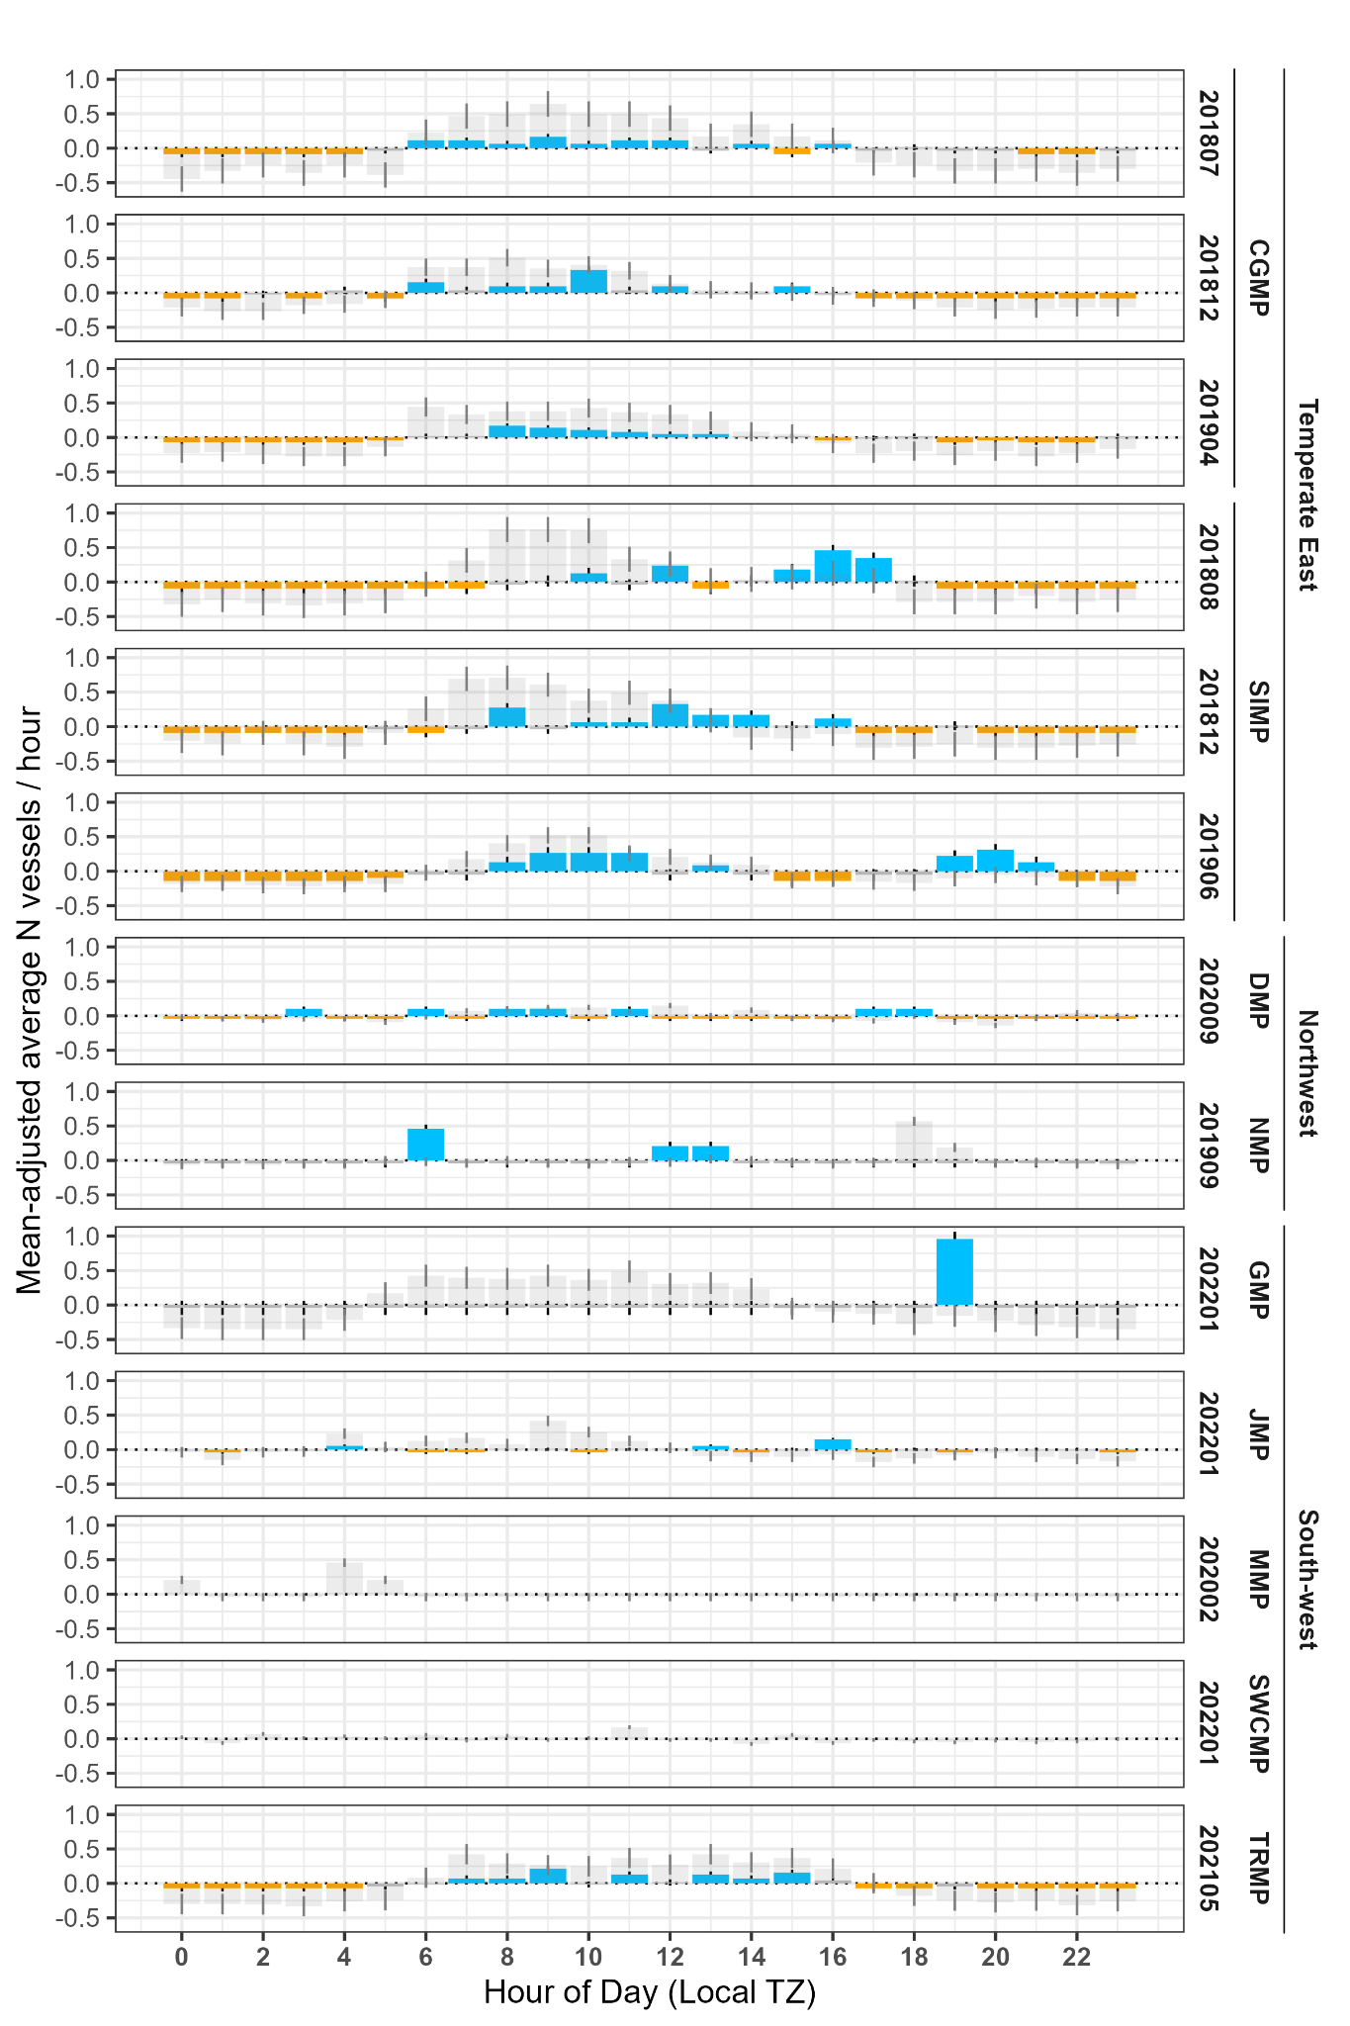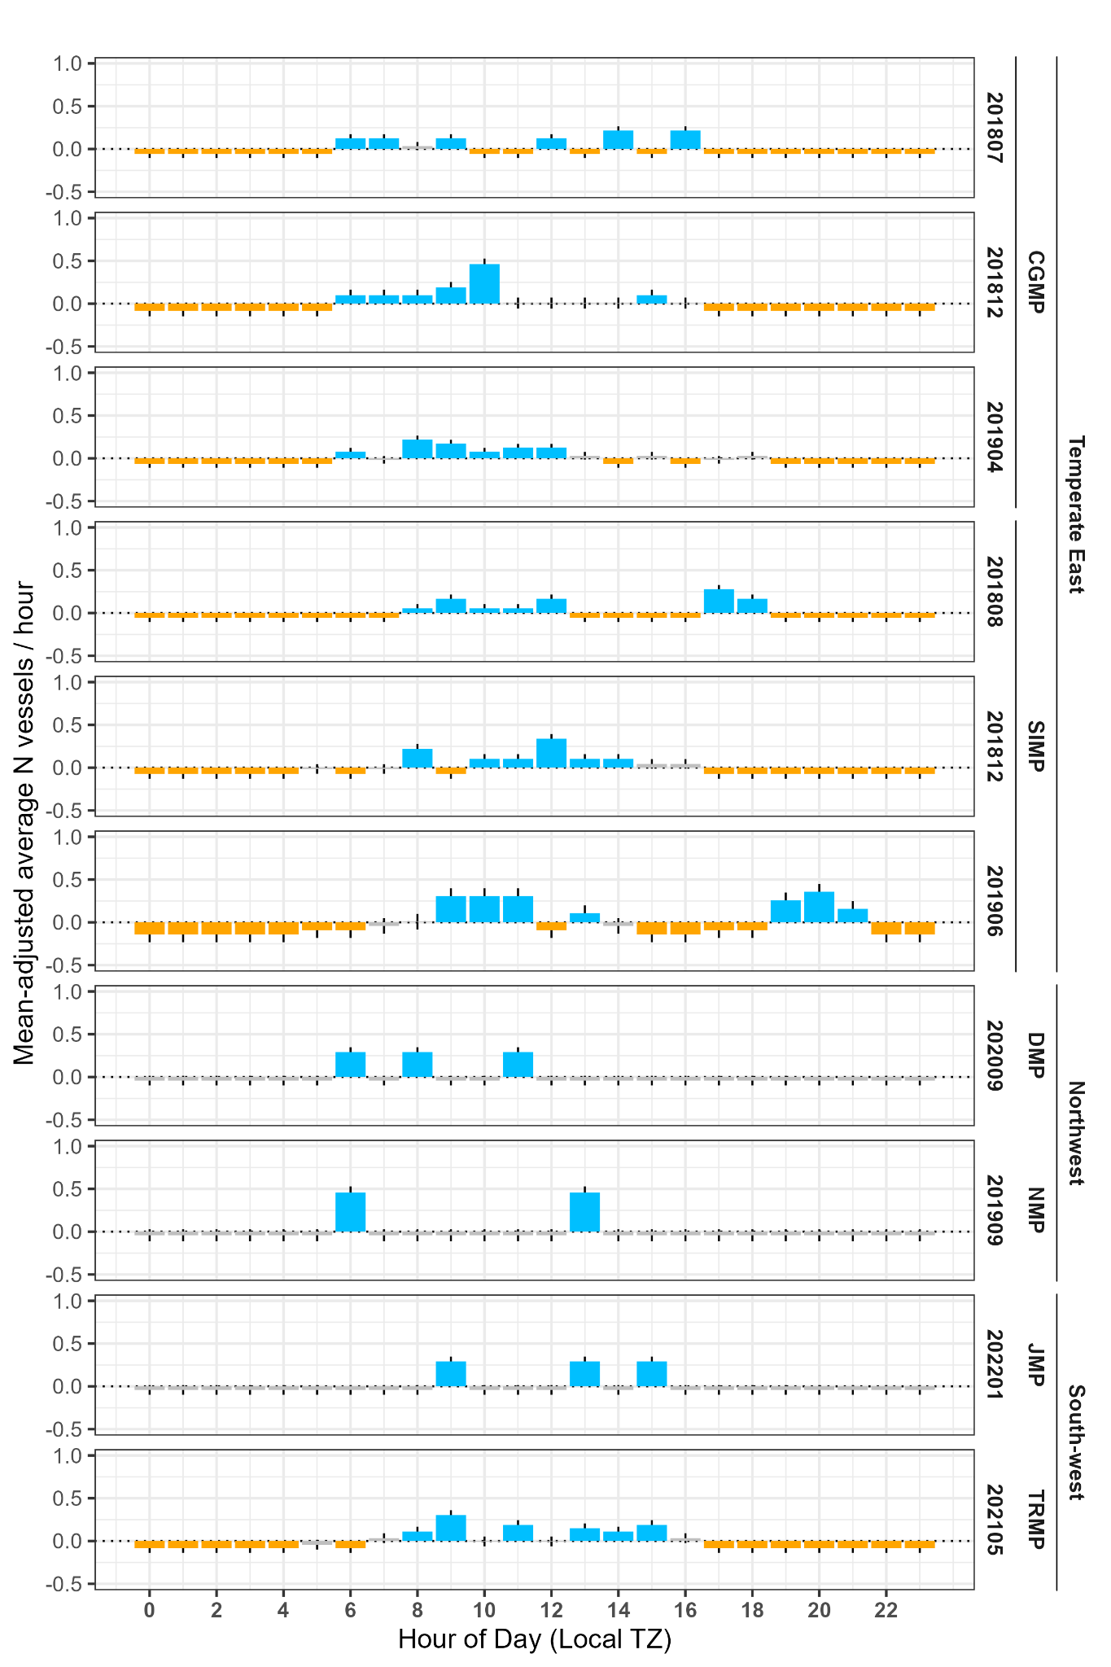

**Figure 5**: (a) Daily mean-adjusted counts of all vessels (light grey bars) and vessels estimated to occur within the National Park Zone (NPZ) boundaries (dark colored bars) per hour. (b) Daily mean-adjusted counts of vessels within the NPZ boundaries that contained maneuvers. (blue bars: mean +/- SD > 0, orange bars: mean +/- SD < 0, dark grey bars: mean +/- SD includes 0). Bars represent mean values of adjusted counts for each hour across the deployment period, and error bars indicate standard deviation around the mean. CGMP = Cod Grounds Marine Park, SIMP = Solitary Islands Marine Park, DMP = Dampier Marine Park, NMP = Ningaloo Marine Park, GMP = Geographe Marine Park, MMP = Murat Marine Park, SWCMP = South-west Corner Marine Park, TRMP = Two Rocks Marine Park. Note MMP and SWCMP were not analyzed for vessels within the NPZ boundaries; those parks are displayed with total vessel presence only and are not included in (b). GMP did not contain any maneuvers and is not included in (b). Deployment labels indicate the start month of each deployment period (yyyymm).

# Discussion

The high variability in vessel activity within each marine park network is not surprising given that marine park networks span large regions from easily accessible inshore areas to remote offshore habitats. This study further develops the pilot study conducted by Kline et al. (2020) by expanding the spatial and temporal scope from two to nine Australian Marine Parks recorded over a four-year study period in order to improve understanding of human use patterns and vessel activity across an expansive network of MPAs. Consistent with Kline et al. (2020), the percentage of vessels estimated to occur within boundaries of the nine NPZs (0.3%–36.6% of the total vessels) was low overall; the majority of recorded vessel signatures were estimated to occur outside of the NPZ boundaries and therefore not of concern with regards to potential illegal activity within the NPZs. Of the vessels inside the NPZ boundaries, those containing acoustic indicators of maneuvers varied widely in prevalence across the different parks and networks (range 0.0%–90.7% of vessels within the NPZs).

Both parks in the Temperate East network–Cod Grounds and Solitary Islands–had deployments with a high proportion of maneuvering vessels, including the highest proportion throughout the study occurring during the June 2019 deployment at Solitary Islands Marine Park. Two Rocks Marine Park in the South-west network showed a similarly high proportion of maneuvering vessels within the NPZ boundaries. Vessel signatures containing an acoustically identifiable maneuver may indicate fishing activities (Kline et al. 2020). All three of these NPZs represent inshore areas with close proximity to populated areas (Coffs Harbour and Port Macquarie, NSW; Perth, WA) and public boat ramps. In other locations, proximity to boat ramps was shown to be an important predictor of illegal fishing in no-take MPAs (Weekers et al. 2019, Weekers and Zahnow 2018). Although proximity to boat ramps was not quantitatively assessed for this study, the patterns of vessel activity in these three NPZs suggest an association between accessibility and prevalence of potential illegal fishing. Geographe, however, which is situated nearshore and represents a relatively accessible destination with several opportunities for eco-tourism (Galadiuk et al. 2018), did not fit this pattern of high presence of vessels within the NPZ. Geographe exhibited similar total vessel presence as other nearshore NPZs, but there was only a single vessel estimated to occur within the NPZ boundaries. This seemingly anomalous finding may result from the nature of the transmission loss model for the NPZ. Likely due to the shallow habitat, the cylindrical approximation of the geometric component of spreading loss indicates a maximum detection distance over twice as far as other NPZs; combined with the relatively small size of the NPZ, these conditions may underestimate the likelihood of a vessel occurring with the NPZ boundaries. With the exception of the NPZ in Geographe Marine Park, the remaining NPZs in the study are more difficult to access either due to a lack of available boat ramps or the offshore location of the NPZ.

An additional piece of valuable information for understanding human use patterns relies on identifying temporal patterns of vessels both inside and outside of the NPZs. Across the majority of the NPZs, temporal patterns of vessels (inside and outside) show peaks toward the latter half of the week (Thursdays - Saturdays) and during the morning and early afternoon. These results suggest that peak levels in potential noncompliance follow peak overall vessel presence and likely represent days and times that are convenient for operators and suitable for recreational boating in general (Davis and Harasti 2020). Although most NPZs showed a pattern of increased activity early in the day, Solitary Islands was an exception to this, with the August 2018 and June 2019 deployments showing peaks in mean-adjusted rates of diel vessel presence within the NPZ boundaries that were several hours later than the peak activity indicated by total vessel presence. Maneuvering vessels showed a similar secondary peak, indicating potential noncompliance during the early evening time period. An analysis of biological sound sources in the Temperate East NPZs concurrent with the present study found consistent fish chorusing with peak presence in the early evening (McCordic et al. 2021) which could indicate aggregations of fish during that time (e.g., Rowell et al. 2017) that may represent target species for illegal fishing.

The deployment lengths in this study provide over a month of continuous sampling for each NPZ throughout all weather conditions and daylight regimes. In Cod Grounds and Solitary Islands, multiple deployments throughout the calendar year provided a more nuanced understanding of seasonal variation in patterns of vessel use at those sites. One of the major limitations of the present study, however, is that most NPZs are represented by a single recording period. Given limited equipment availability and funds, this strategy maximized spatial coverage throughout the AMP system and suited the management objectives for acoustically monitoring vessels. However, it is important to acknowledge that single deployments may not be wholly representative of human use in an area and results should be interpreted in the context of the recording period. As an extreme example, Murat Marine Park was the only NPZ sampled during the Covid-19 pandemic, which the World Health Organization declared as a “public health emergency of international concern” on 30 January 2020 (recording effort 20 Feb 2020 - 03 May 2020) (Jee 2020). Over the time period covered by the deployment, Australia experienced a sharp decline in total vessel traffic (March et al. 2021). Although Murat represents a relatively inaccessible area on the south coast of Australia and would likely not exhibit a high prevalence of vessels, it is possible that the low vessel presence observed here was confounded by the global reduction in vessel presence in response to the pandemic (March et al. 2021) and that conducting additional deployments in this NPZ would provide a more representative understanding of vessel activity.

Several recommendations for monitoring and managing vessel activity in MPAs emerge from the results of this study. We demonstrate that incorporating local propagation characteristics provides a more spatially relevant subset of vessel presence compared to all acoustically detected vessels, improving the quality of information available to managers from passive acoustic recordings. Since vessel sound can travel several kilometers (Hildebrand 2009, Hatch et al. 2008, Erbe et al. 2021), the measure of total acoustic vessel presence is likely to overestimate the number of vessels inside the target MPAs and, as shown in this study, may provide false indicators of peak activity times. By including empirical models of transmission loss in each NPZ, we were able to estimate relative distance of vessels from the recorder without the need for acoustic localization. Localizing acoustic sources is possible with PAM, but it requires deploying three or more acoustic recorders, careful documentation to reduce localization errors, and time-consuming analysis, all of which can add cost to the overall effort (Van Parijs et al. 2021). Generating the models requires knowledge of at least one vessel with known distances to the recorder, preferably in the absence of other vessels in the area. Although such calibration passes could theoretically occur at any point during the recording, measuring the received levels of the vessel used for deploying the receiver allows for a large improvement in relevant information with a relatively low added cost of vessel time and effort. In some areas, such as shallow-water habitats (e.g., Geographe) or areas with potentially complex acoustic propagation conditions (e.g., South-west Corner, Murat), the empirical model based on the basic sonar equation may not be sufficient to determine vessels occurring within the NPZ boundaries. While beyond the scope of the present study, more detailed propagation modeling (e.g., parabolic range-dependent acoustic model used in Erbe et al. 2021) in these instances may provide additional insight into the spatial component of vessel presence. However, it is important to weigh where there is a clear need for detailed propagation information as opposed to whether a more rudimentary estimate is sufficient to inform basic management needs and patrolling efforts.

NPZs with a high prevalence of maneuvering vessels indicate areas where additional surveillance may be valuable. In order to prioritize monitoring effort across NPZs more effectively, it may be worth further dividing each marine park network into levels of urban development or accessibility to recreational boaters. Existing monitoring strategies in AMPs rely on intermittent patrols—vessel and aerial patrols—as well as VMS alerts for commercial fishing vessels traveling under 5 knots in an NPZ (Director of National Parks 2023). The primary advantage of patrols is the ability to visually confirm active or suspected recent fishing activity in protected areas, but patrols may be infrequent for a given NPZ depending on several logistical factors including prior risk assessments, personnel and vessel availability, and weather conditions. Adding a continuous passive acoustic monitoring component to MPA management allows for a robust long-term assessment of variation in seasonal and temporal presence of vessels to be created within a given NPZ. This information in turn can help to direct and improve the timing and focus of AMP vessel and aerial patrols.

The proportion of maneuvering vessels among vessels estimated to occur within the NPZ boundaries provides an additional indication of compliance across the NPZs. Vessels engaging in simple transit through an NPZ will typically be represented by acoustic signatures lacking abrupt frequency or amplitude changes that would occur, for example, if the operator shifts to a different gear, changes speed or direction, or starts and stops the engine (Trevorrow et al. 2008). While any of these maneuvers may indicate noncompliant activities such as illegal fishing since they indicate a diversion from consistent transit, it is important to recognize that they serve as a proxy indicator rather than a confirmation of noncompliant activities. Such maneuvers can also occur during compliant activities including watching wildlife, so we suggest that NPZs with increased prevalence of acoustically detected maneuvers be targeted by other enforcement strategies such as vessel-based or aerial patrols in order to confirm compliance with local regulations. Additionally, the presence of vessels maneuvering within the NPZ at times (e.g., after sunset) or in locations (e.g., remote offshore habitat) that would not otherwise be suitable for non-extractive recreational activities may more reliably indicate noncompliant behavior.

# Conclusions

Using acoustic recorders to monitor vessel presence improves monitoring and can better inform risk assessments used to determine priority areas for enforcement patrols in NPZs within Australian Marine Parks. Unlike other remote monitoring methods, PAM captures passages of all motorized vessels in all light regimes regardless of vessel class or size. Using basic modeling of sound propagation and discrimination of vessel behavior using acoustic signatures can reveal important information regarding vessel location and potential activity, highlighting areas and time periods that are most likely to contain noncompliant activities such as illegal fishing. The prevalence of maneuvering vessels can be used as a proxy for potential illegal activity which is likely tied to accessibility of NPZs to the general public and recreational boaters. In addition to high-use inshore areas, PAM additionally provides a cost-effective way to capture rare occasions of potential illegal activity in remote areas. We suggest that regularly incorporating acoustic monitoring will maximize the benefit of existing management efforts aimed at reducing noncompliant activities within protected areas.

1. AMP 2023, Proposal to expand Macquarie Island Marine Park – Public consultation paper, Australian Marine Parks, Canberra, March. CC BY 4.0.
2. Director of National Parks 2024, Commercial Fishing Vessel Monitoring Systems in Australian Marine Parks: Impact analysis, Department of Climate Change, Energy, the Environment and Water, Canberra, March. CC BY 4.0.