How do time, gender, air quality, temperature and coaching affect distance running performance in California adolescents?
John McIntire
2026-04-30

Abstract
Data on California high-school cross-country running times for female and male runners were compiled from the Mount San Antonio College (Mt SAC) invitational (4,715 meters, final 10 days of October, 2002-2023); and the California state high-school cross-country championships (Woodward Park, near Fresno, 5,000 meters, final Saturday in November, 1987-2023).
Findings in the 1987-2023 Woodward Park sample were: (1) times of female athletes fell at a slightly faster rate than those for male athletes (-1.18 seconds year⁻¹ ± 0.194) over the period 1987-2023 using a daily air quality indicator (AQI) as a covariate; (2) from grade 9 to grade 12, times for female runners fell more slowly than those for male runners in the 1987-2023 sample (31.5 seconds ± 3); and (3) times of female runners were not more affected than times of male runners (0.32 seconds ± 0.224) by higher daily AQI levels (P = 0.149).
Findings in the 2000-2023 Woodward Park sample were: (1) female times fell at a slightly faster rate than did male (-0.1 seconds year⁻¹ ± 0.377) using hourly ozone and hourly temperature as covariates (P = 0.849); (2) female times fell at slower rates from grade 9 to grade 12 than did male (29.3 seconds ± 3.209); (3) hourly temperature had significant effects on male times (P = 1.9) but not on female times (P = 1.3) ; and (4) hourly ozone had no significant effect on male times (0 seconds ± 0.2) or on female times (0.3 seconds ± 0.29).
Findings for Mt SAC (2002 - 2023) were: (1) female times fell at the same rates (0.021) seconds year⁻¹ ± (0.718) as male times at Mt SAC over the period 2002-2023 (P = 0.977) taking hourly air quality into account; (2) hourly ozone affected female times (1.5846625, (P = 4.4030739^{-9}) with greater force than it did male (1.1088354; P = 8.3618824^{-8}) seconds PPB⁻¹ ± 0.337; P = 0.158); (3) a shock of 1 standard deviation in hourly ozone would have raised mean male times by 17.1 seconds and would have raised mean female times by 24.3 seconds; (4) race-time temperature did not affect females or males significantly; (5) mean finish time in females improved by about 63 seconds from grade 9 to grade 12, compared to 122 seconds for males (P < 0.001); and (6) in the sub-sample from the top quintile of runners from large schools: (a) year effects were smaller than in the all-schools sample and did not differ between male and female (P = 0.775); (b) hourly ozone affected finish times among females more strongly than among male but with much less force than in the all-schools sample(0.08; P = 0.551); and (c) a positive shock of 1 standard deviation in hourly ozone would have raised mean male times by 1.5 seconds and would have raised mean female times by about 2.7 seconds.

Introduction
Distance running requires little equipment beyond shoes and cheap clothing. It demands no expensive facilities and can be practiced alone or in groups, outdoors or indoors, at any time. The numbers of runners have increased greatly across the US since the 1970s, spurred by the low cost, independence, and potential health benefits of running. The growth in numbers of runners has the advantage of generating large sample sizes for studies of running performance under ambient environmental conditions which do not require costly laboratory measurements, but where dose (daily or hourly air quality and temperature) and response (running speed) can be adequately matched.
Research on distance running has involved physiology and genetics, notably the heritability of running speed¹, the effects of aging on maximum speed in males². The impacts of air pollution^{3–5} are well known, yet understudied questions remain about interactions with factors–gender, age, changes in air quality on race day, air quality in the training environment, temperature, and coaching–determining running speeds in conditions of open competition involving large samples.
This paper evaluates hypotheses about the determinants of running speeds in female and male adolescents (ages 14-18) in California. Using data from two long-established cross-country races of around 5 km, at which athletes competed between 1987 and 2023, I estimate those determinants with respect to: (1) gender; (2) school grade, as a proxy for age; (3) hourly ozone, hourly temperature, and daily PM 2.5 levels on race days for two sites between 2002 and 2023; (4) daily air quality (AQI) at one site from 1987-2023; (5) AQI measured near competing schools in the 14 days before the races; (5) school traditions of successful running programs, which may indicate coaching, peer (teammate), and location (school air quality and training site quality) effects; and (6) school size, which determines the potential absolute numbers of elite runners at a given school.
Public data were compiled from two races: (1) the Mount San Antonio College Cross-country Invitational (Mt SAC, altitude 222 masl), in Walnut, California, east of Los Angeles, which was run at the distance of 4,715 meters at the same site since 1978; and (2) the California state high school championships, which has been run at a distance of 5,000 meters at Woodward Park (mean altitude, 110 masl) near Fresno since 1987. These datasets have the advantage of containing data on thousands of female and male runners; a recent paper in this field (⁴) studied only male runners in a much smaller sample of 334 athletes.

The running environment in central and southern California
Three changes in the environmental and social contexts of distance running have occurred over the past half-century in southern and central California⁶. First, the air is warmer (Figure 1a and Figure 1b), making conditions less favorable for distance running which requires hundreds of hours of outdoor training annually. Second, September and October ozone levels have fallen sharply. Using data from Fresno County measuring sites near Woodward Park (Figure 2b) shows daily AQI. Figure 2b shows corresponding values for Los Angeles County sites near Mt San Antonio College; those data suggest that cleaner air has improved training conditions since 1987.
A third change has been in demography. California’s population grew from 23.8 million in 1980 to 39.0 million in 2020, causing an increase in the absolute numbers of runners with elite ability. Over the same period, the state’s population became more diverse, allowing the possibility that new sub-populations within California schools have higher, or lower, relative frequencies of individuals with elite ability.⁷ estimated the heritability of VO2 max, a determinant of running ability, to be in the range of 0.40-0.50), though we do not know the distribution of this parameter in California populations over time or for sub-groups within that population.

Methods

Woodward Park races
California has run state high school cross-country championship races annually since 1987 at Woodward Park near Fresno. The course is 5,000 meters and is moderately difficult. The Köppen climate class for Fresno is Csb/BSk (semi-arid). Race dates at Woodward Park (final Saturday in November) have daytime temperatures in the range of 9 to 19 degrees C with only 2 days of expected precipitation. Figure 2c shows ozone levels generally rise from 8 AM to 2 PM.
There are four Woodward Park samples: (i) one female and one male from 1987-2023 with daily AQI; and (ii) one female and one male from 2000-2023 with hourly ozone, hourly temperature, and daily PM values matched to race starting times between 8:30 AM and 1:30 PM.
The 1987-2023 WP races included 29,033 valid observations for females in 168 races, including 17714 unique competitors. The 1987-2023 WP competitions included 29,467 valid observations for males across 168 individual races, with 18,913 unique athletes.
The 2000-2023 Woodward Park female sample (excluding 2020 when the race was not run because of the COVID pandemic) included 21,672 runners in 115 races, of whom 13,309 were unique. The Woodward Park male sample (2000-2023, excluding 2020) included 21,972 in 115 unique races involving 14,311 unique runners.
Because Woodward Park is a championship race for which schools and individual competitors must meet qualify standards, average finish times are faster for both genders and for larger schools.

Mount San Antonio College races
The Mt SAC all schools sample included individual observations from the years 2002-2023, excluding 2020⁸. The Mt SAC races included 87,693 valid observations for females in 828 races, including 53,353 unique competitors.
The Mt SAC all schools competitions included 130,144 valid observations for males across 976 individual races, including 74,345 unique athletes. Most participating schools at Mt SAC are in southern California — Los Angeles, Orange, Riverside, Ventura, San Bernardino, and San Diego counties — with some from Kern, San Joaquin, Santa Barbara, and San Luis Obispo counties in central California.
The Köppen climate classification for Walnut, California is Mediterranean (Csb). The region receives most of its rain during the winter months (November through February) and has little to no rain outside those months. The Mt SAC race has, with rare and minor exceptions, been run on the same course every year on the 3rd or 4th Friday and Saturday in October under warm and dry conditions. Some exceptions, such as race cancellations or shortening from 2.93 miles to 2 miles, have occurred because of rain, heat, or poor air quality.
The ozone and temperature data for Mt SAC were measured at the Azusa weather station which is about 17 km NW of the course. In the years (2002-2023) for which we have race information the average daily AQI near Mt San Antonio College rose as did hourly ozone values (Figure 2b).
Most of the Friday Mt SAC races were run from 12 noon through 5 PM. Most of the Saturday races were run between 8 AM and 6 PM. Ozone levels typically rose from 7 AM through 6 PM with the weekend (F-Su) maximum at 2 PM being typically 87.7 PPB and the weekday (M-Th) maximum being 77 compared to a weekend 7 AM minimum of 12.6 and a weekday minimum of 10 at 7 AM.

Estimation procedures
Separate functions by gender were estimated for Woodward Park (1987-2023) by equation (1), using year, division (a proxy for school size), grade (a prozy for runner age), and average daily AQI readings on race day at Woodward Park.
$$R_{isy}=K+Y_{y}+D_{sy}+G_{isy}+AQI_{y}(1)$$
Separate functions by gender were estimated for Woodward Park (2000-2023) by equation (2), using hourly ozone (O3), temperature, and PM 2.5 readings at start time.
$$R_{isy}=K+Y_{y}+O3_{hy}+Temp_{hy}+PM{2.5}_{dy}+G_{isy}+D_{sy}(2)$$
A third function was estimated for Mt SAC using hourly environmental data for in which the program score variable was added as a proxy for coaching quality.
$$R_{isy}=K+Y+O3_{hy}+Temp_{hy}+PM{2.5}_{dy}+G_{isy}+D_{sy}+Program_{sy}(3)$$
The term ‘K’ is an intercept and ‘Y’ indicates year. The term R_{isy} is the time of an individual runner ‘i’ at school ‘s’ in year ‘y’, O₃ indicates the ozone content of the atmosphere in parts per billion (PPB), subscripted in equation (2) by ‘h’ for hourly; G_{isy} is the school grade (9-12) of runner ‘i’ in school ‘s’ where grade ‘G’ is a proxy for age in year ‘y’; Temp_{hy} is degrees C at racetime at hour ‘h’ in year ‘y’; Program_{sy} is a measure of coaching quality at school ‘s’ in year ‘y’, as constructed from team times in the annual California state championships at Woodward Park; and ‘school AQI_{sy}’ is the average air quality index in the 14 days preceding the race as measured at the sites nearest each competing school. The “Program” variable was excluded from the Woodward Park regressions to avoid endogeneity problems because, by definition, only schools with strong running programs are eligible to compete.A threshold model was not used for ozone, temperature, or PM 2.5 particulates given that continuous hourly data on those factors was available for large samples over many years.
High school cross-country running in California is organized by ‘division’ to achieve greater competitive equity within groups of similar enrolment. Divisions 1 and 2 (labelled D1 and D2) include the largest schools; enrolment at Division 1 schools was > 2400. Divisions 4 and 5 are the smallest schools, including most private institutions; where enrolment at Division 5 schools was usually < 600. The five divisions at Mt SAC were re-grouped into D1 & D2 (Divisions 1 and 2), D3, and D4 & D5 to allow for the fact that invitational races often mix divisions. The divisions at Woodward Park were left unchanged as D1, D2, D3, D4, and D5.

Results

Determinants of running times at Woodward Park

1987-2023
Table 1 reports results from Woodward Park for the years 1987-2023 and Figure 3 depicts finish times by grade and division. Table 1, presenting estimates from all divisions and using daily AQI, shows that female times fell in at an annual rate of -2.31 seconds (P < 0.001). Male times in all divisions fell at an annual rate of -1.13 seconds (P < 0.001). Table 2a and Table 2b give results from female and male runners, respectively by division (a proxy for school size). Models with PM 2.5 as a treatment are not reported given that they had no P values < 0.2 in any of the 4 models in which they were included for the period 1987-2023.
Age progressions in the all-divisions model for females were:
Grade 9 to Grade 10, -6.6 seconds (P < 0.001);
Grade 9 to Grade 11, -11.8 seconds (P < 0.001);
and Grade 9 to Grade 12, -16.8 seconds (P < 0.001)

2000-2023
Table 3 presents estimates from pooled school divisions. It shows that female times fell in all schools at an annual rate of -1.7 (P < 0.001). Hourly temperature, hourly ozone, and daily PM2.5 had no significant effects on female times. Male times fell in all schools at an annual rate of -1.6 (P < 0.001). Hourly temperature had significant effects on male times (P < 0.001), though hourly ozone and daily PM25 levels did not.
Table 4a and Table 4b show results for female and male runners at Woodward Park using hourly environmental data and with separate estimates by school division. Hourly temperature effects (warmer days meant slower times) were stronger on females than on males. Hourly ozone effects were small.
Small atmospheric particulates (PM 2.5) reduce running speed^{9,10}. The effects of PM2.5 were of the expected positive sign for female athletes in one of two estimates (Table 4a); p-values were always > 0.127. Effects of PM 2.5 were also > 0 in one of two estimates for males with p-values were always > 0.652.

Determinants of running times at Mt San Antonio College
Table 4c (female) and Table 4b (male) and Figure 5, Figure 6a, and Figure 6b report results from Mt SAC. The hourly ozone (P < 0.001) and temperature (P < 0.001) variables had significant effects on female times. An increase in 1 standard deviation of hourly ozone would raise the median time of 1400 seconds by about 24.3 seconds. Male runners showed the expected adverse effects of ozone and temperature in all divisions and in the pooled sample with 7 of the 10 coefficients having p < 0.01. The adverse effects of ozone on female runners’ times were always higher in absolute value those observed among male runners; all four estimates for females had p-values < 0.05 and three of four estimates for males had p-values < 0.001.
Age progressions in the all-divisions model for females were:
Grade 9 to Grade 10, -27.4 seconds (P < 0.001);
Grade 9 to Grade 11, -42.5 seconds (P < 0.001);
and Grade 9 to Grade 12, -62.8 seconds (P < 0.001)
Age progressions in the all-divisions model for males were:
Grade 9 to Grade 10, -57.9 seconds (P < 0.001);
Grade 9 to Grade 11, -98.1 seconds (P < 0.001);
and Grade 9 to Grade 12, -123.3 seconds (P < 0.001)

Comparing Woodward Park results to Mt San Antonio College results in a fixed effects model
Subsets of data were drawn to make fixed effect (runner) estimates for the years 2002-2023 at Mt SAC and at Woodward Park. All runners having competed in both races in a given year were included. The functional form was a difference-in-difference (D-in-D) model as given in equation (4), with separate estimates for females and males.
$$dR_{iyw−m}=K+R_{iym}+Y+dO3_{hyw−m}+dTemp_{hyw−m}+G_{isy}+D_{sy}(4)$$
The subscript ‘w-m’ indicates the difference between a Woodward Park value and a Mt SAC value in the same year. The dependent value dR is calculated as the finish time of a given runner at Woodward Park minus the time of the same runner at Mt SAC in the same year.The sub-samples require the runner to have qualified, individually or in a team, for the state championships at Woodward Park and hence are drawn from faster runners, female and male alike. The term R_{iym} is the time for the runner ‘i’ in year ‘y’ at Mt Sac.

Discussion

How did the running environment change from 1987-2023 ?
We use five measures of environmental effects on running speed: (i) daily air quality index (AQI) on race day, in which higher values indicate poorer air quality and which are expected to lower running speeds; (ii) daily PM 2.5 in micrograms per cubic meter, in which higher values indicate poorer air quality with adverse effects on running speed; (iii) ozone levels at start time in PPB; (iv) temperature at race-time in degrees C, with ambiguous effects on running speed; and (vi) PM 2.5 at start time.
Daily AQI in Fresno County near Woodward Park followed this pattern: sharp improvements in September and October before 2005 with weekends converging more closely to workdays in the colder months of November and December. Daily PM 2.5 near Woodward Park was stable in September and October, fell over the years 1999-2023 in November and December, and did not show a consistent difference between weekends and weekdays over time. Daily AQI near Mt SAC fell sharply from 1980 to about 2003 in September and October, an indicator of the long-term improvement in air quality in Los Angeles County, with some degradation in air quality after about 2005 in all months shown in (NA); the Mt SAC readings have consistently shown worse AQI on weekends than on weekdays before December in the years measures.
Hourly ozone readings near Woodward Park (Figure 2a) and Mt SAC (Figure 2c) followed a common pattern, with the lowest values in the colder early-morning hours and with the highest values between 1 PM and 3 PM. Month effects on hourly ozone over the period 1980 to 2023 were important, with major declines in September, smaller declines in October, and little change in the colder months. Hourly temperatures rose slightly (Figure 2b) at Woodward Park and somewhat more at Mt SAC (Figure 2d).

Did female times converge to male ?
Female times converged to male in the 1987-2023 sample (all divisions) at Woodward Park at an annual rate of 0.32 seconds year⁻¹; similar effects were observed in the five divisional races. There were no significant differences between the year coefficients for male and female in any grade or across grades. All division female times converged to male in the 2000-2023 samples from Woodward Park at an annual of -0.07 seconds year⁻¹.
Another way of looking at convergence at Woodward Park is to sample among elite times, as measured by the fastest quintiles in D1 and D2 schools, which have the largest enrolment. Elite female times progressed toward male at Woodward Park over the period 1987-2023 at an annual rate of about 1.2 seconds.
The rate of female to male convergence at Mt SAC was negative, with female athletes losing some 0.14 seconds annually over the period 2002-2023. The contrast between Woodward Park and Mt Sac allows the conclusion that elite female times converged slowly to elite male times in the better environmental conditions (cooler temperatures and lower daily AQI) observed at Woodward Park.

Did daily AQI levels affect running times at Woodward Park ?
Daily AQI had greater effects at Woodward Park in the 1987-2023 sample on females (P = 0.149 than on males (0.2). An increase from the first quintile to the third quintile in AQI (higher numbers indicate poorer air quality) would have raised female times by about 21.3 seconds and male times by about 29 seconds.

Did hourly ozone and temperature have different effects on males and females ?
Hourly ozone levels had faintly positive (higher ozone leading to slower times), though not significant, impacts on female and male times at Woodward Park (Table 3). The low hourly ozone levels at Woodward Park—-when all races were run in the cooler final week of November and started before 1:30 PM—have contributed to the weak ozone effect for male and female runners on that course. It is also possible that the occasional rises in hourly ozone levels at Woodward Park in late November were due to warmer temperatures, which in turn allowed faster times.
Hourly ozone levels had strong adverse (higher ozone leading to slower times) effects for males and females at Mt SAC. A one standard deviation increase in the 10 AM ozone value would have raised female times by about 1.7 % in the pooled divisions model; the same shock would have raised male times by about 2.1 % in the pooled divisions model.
It is possible that the rise in ozone levels at Mt San Antonio in this century has contributed to the failure to see convergence between male and female times on that course, given the slightly stronger effect of ozone levels on female times.

Did school air quality affect running times ?
School AQI is a measure of training conditions, as given by average AQI near the competing schools in the 14 days before the races. One expects school AQI to have a modest positive effect (higher school AQI stimulating higher [slower] times) on male and female runners at Woodward Park and at Mt SAC. The opposite effect was found though the estimates were never significant–school AQI had negative effects (school AQI encouraging faster times).

Did age progression vary between females and males ?
Age progression differed sharply between females (Table 5a) and males at Mt SAC (Table 5b). Mean female age progression from grade 9 to grade 12 at Mt SAC was about -62.8 seconds. Age progression in males from grade 9 to grade 12 was -123.3, giving a mean difference in 9th to 12th grade progression of 60.4 seconds (P < 0.001).
The Woodward Park data from the state championships have faster average times for female and male athletes compared to the Mt SAC open invitational, reflect better coaching, and generally include schools with lower (healthier) AQI levels in the training season. Therefore, estimates of age progression at Woodward Park sampled the top quintile only and within the larger schools (Division 1 and Division 2). For the long data series at Woodward Park (1987-2023), the differences in female - male progressions from 9th to 12th grade were 0.5 seconds (Table 7). For the short series at Woodward Park (2000-2023), the differences in female - male grade progressions from 9th to 12th grade were 4.8 seconds.

Did fixed runner effects change the results ?
The FE models allowed much better fit in the equations for females and males (Table 8). Differences in ozone impact from Mt Sac to Woodward Park between the DnD model and the DnD/FE were smaller for women and for men, suggesting that the runner fixed effects picked up most of what appeared to be ozone effects in the simpler DnD model. Temperature effects were significant in all models, with weaker effects seen for females in moving from the ‘Females, DnD’ estimate to the ‘Females, DnD and FE’ estimate. The estimates for males in “Males, DnD” and in “Males, DnD and FE” were similar in magnitude and in significance, indicating different site-temperature interactions in male and females.

Table 1: Female times converged to male times at about 1.2 second yr^-1^, Woodward Park, 1987 - 2023
 | Female pooled divisions | Male pooled divisions
(Intercept) | 1253.220*** | 1060.715***
 | (7.622) | (4.221)
Year | -2.311*** | -1.129***
 | (0.160) | (0.109)
Daily AQI | 0.528** | 0.204+
 | (0.193) | (0.115)
Grade 10 | -6.603*** | -23.876***
 | (1.662) | (1.722)
Grade 11 | -11.780*** | -38.334***
 | (1.960) | (1.946)
Grade 12 | -16.797*** | -48.271***
 | (2.256) | (1.906)
Division 2 | 4.652 | 6.739**
 | (3.991) | (2.248)
Division 3 | 31.791*** | 24.493***
 | (5.483) | (2.630)
Division 4 | 59.377*** | 47.066***
 | (4.248) | (2.519)
Division 5 | 113.947*** | 83.386***
 | (4.618) | (4.460)
Num.Obs. | 29033 | 29467
R2 | 0.162 | 0.224
R2 Adj. | 0.162 | 0.224
RMSE | 95.83 | 62.49

Table 2a: Female times by division, Woodward Park, 1987 - 2023
 | Division 1 | Division 2 | Division 3 | Division 4 | Division 5
(Intercept) | 1257.731*** | 1264.091*** | 1284.313*** | 1294.490*** | 1367.870***
 | (11.322) | (9.992) | (25.124) | (11.723) | (20.591)
Year | -2.772*** | -2.384*** | -2.195*** | -1.780*** | -2.286***
 | (0.244) | (0.302) | (0.487) | (0.268) | (0.404)
Daily AQI | 0.562* | 0.400 | 0.265 | 0.749* | 0.835
 | (0.239) | (0.293) | (0.649) | (0.297) | (0.615)
Grade 10 | -3.290 | -5.982+ | -2.281 | -5.580 | -17.765***
 | (3.446) | (3.304) | (3.594) | (3.371) | (4.728)
Grade 11 | -7.842* | -12.607*** | -7.158 | -11.683* | -21.335**
 | (3.845) | (3.115) | (4.492) | (4.507) | (5.947)
Grade 12 | -12.691*** | -20.876*** | -6.150 | -16.078** | -32.564***
 | (3.539) | (3.829) | (5.946) | (4.622) | (6.911)
Num.Obs. | 7173 | 5991 | 5977 | 5551 | 4341
R2 | 0.093 | 0.091 | 0.057 | 0.034 | 0.025
R2 Adj. | 0.092 | 0.090 | 0.057 | 0.033 | 0.024
RMSE | 87.02 | 82.02 | 93.51 | 100.57 | 120.43

Table 2b: Male times by division, Woodward Park, 1987 - 2023
 | Division 1 | Division 2 | Division 3 | Division 4 | Division 5
(Intercept) | 1050.601*** | 1058.463*** | 1081.102*** | 1108.231*** | 1165.297***
 | (6.506) | (6.490) | (11.420) | (8.073) | (15.623)
Year | -1.202*** | -0.893*** | -1.208*** | -0.846*** | -1.919**
 | (0.164) | (0.145) | (0.265) | (0.192) | (0.661)
Daily AQI | 0.415* | 0.237 | 0.166 | 0.016 | 0.406
 | (0.159) | (0.205) | (0.296) | (0.211) | (0.587)
Grade 10 | -20.187*** | -20.195*** | -17.181*** | -26.147*** | -28.272***
 | (3.171) | (3.572) | (3.458) | (3.189) | (4.354)
Grade 11 | -31.655*** | -35.975*** | -31.728*** | -38.304*** | -47.322***
 | (3.232) | (4.077) | (3.646) | (3.051) | (5.667)
Grade 12 | -41.873*** | -43.925*** | -40.482*** | -50.738*** | -58.865***
 | (2.760) | (3.991) | (3.681) | (2.774) | (5.611)
Num.Obs. | 6552 | 6188 | 6232 | 5768 | 4727
R2 | 0.086 | 0.077 | 0.082 | 0.061 | 0.071
R2 Adj. | 0.085 | 0.076 | 0.081 | 0.061 | 0.070
RMSE | 53.75 | 50.67 | 57.15 | 66.01 | 85.29

Table 3: Female times converged to male times by about 0.07 second yr^-1^, Woodward Park 2000 - 2023
 | Female pooled divisions | Male pooled divisions
(Intercept) | 1198.469*** | 1035.034***
 | (8.564) | (5.227)
Year | -1.698*** | -1.627***
 | (0.303) | (0.225)
Hourly ozone | 0.323 | 0.040
 | (0.295) | (0.200)
Hourly temperature | 1.350 | 1.899***
 | (0.886) | (0.527)
Daily PM 2.5 | 0.252 | -0.096
 | (0.155) | (0.110)
Grade 10 | -7.430*** | -22.868***
 | (1.974) | (1.893)
Grade 11 | -12.371*** | -37.542***
 | (2.309) | (2.207)
Grade 12 | -19.032*** | -48.309***
 | (2.351) | (2.185)
Division 2 | 3.612 | 9.210***
 | (4.875) | (2.225)
Division 3 | 32.233*** | 25.392***
 | (6.234) | (2.401)
Division 4 | 62.668*** | 51.263***
 | (4.967) | (2.562)
Division 5 | 113.155*** | 85.242***
 | (5.107) | (4.233)
Num.Obs. | 21672 | 21972
R2 | 0.173 | 0.253
R2 Adj. | 0.173 | 0.252
RMSE | 94.70 | 62.80

Table 4a: Female times by division, Woodward Park, 2000 - 2023
 | Division 1 | Division 2 | Division 3 | Division 4 | Division 5
(Intercept) | 1193.417*** | 1212.630*** | 1205.100*** | 1254.408*** | 1335.031***
 | (21.300) | (15.174) | (15.371) | (13.421) | (17.153)
Year | -2.854*** | -1.736* | -0.519 | -1.199* | -1.618**
 | (0.701) | (0.762) | (0.584) | (0.520) | (0.480)
Hourly ozone | 0.472 | 0.307 | -0.839 | 0.072 | 0.864
 | (0.388) | (0.345) | (1.383) | (0.398) | (0.719)
Hourly temperature | 2.040 | 1.103 | 4.226 | 1.630 | -0.219
 | (1.704) | (1.304) | (2.850) | (1.061) | (2.428)
Daily PM 2.5 | 0.293 | -0.010 | 0.241 | 0.250 | -0.015
 | (0.292) | (0.271) | (0.311) | (0.222) | (0.249)
Grade 10 | -1.882 | -4.625 | -3.898 | -6.335 | -19.183**
 | (4.341) | (3.162) | (3.579) | (3.765) | (5.128)
Grade 11 | -7.233 | -10.732** | -8.748+ | -9.876+ | -24.224***
 | (4.691) | (3.734) | (4.538) | (5.006) | (6.176)
Grade 12 | -14.670*** | -22.138*** | -10.185* | -11.443* | -35.835***
 | (3.861) | (3.239) | (3.864) | (5.134) | (7.497)
Num.Obs. | 5073 | 4211 | 4246 | 4231 | 3911
R2 | 0.079 | 0.031 | 0.022 | 0.014 | 0.021
R2 Adj. | 0.078 | 0.030 | 0.021 | 0.012 | 0.019
RMSE | 83.68 | 78.34 | 89.51 | 101.76 | 117.43

Table 4b: Male times by division, Woodward Park, 2000 - 2023
 | Division 1 | Division 2 | Division 3 | Division 4 | Division 5
(Intercept) | 1027.740*** | 1037.629*** | 1051.438*** | 1088.357*** | 1129.618***
 | (8.304) | (9.327) | (8.220) | (8.261) | (18.148)
Year | -1.868*** | -1.477** | -1.229** | -1.119** | -2.701***
 | (0.228) | (0.411) | (0.408) | (0.297) | (0.566)
Hourly ozone | 0.192 | 0.086 | 0.349 | -0.173 | -0.575
 | (0.157) | (0.157) | (0.256) | (0.306) | (0.672)
Hourly temperature | 1.957* | 1.778** | 0.895* | 0.899 | 4.984***
 | (0.712) | (0.560) | (0.427) | (0.872) | (1.287)
Daily PM 2.5 | -0.095 | -0.130 | 0.017 | 0.281 | -0.576
 | (0.092) | (0.146) | (0.122) | (0.194) | (0.369)
Grade 10 | -18.815*** | -16.296*** | -18.850*** | -25.026*** | -25.887***
 | (4.236) | (3.166) | (3.654) | (3.613) | (4.248)
Grade 11 | -31.448*** | -32.839*** | -30.702*** | -38.508*** | -43.907***
 | (4.502) | (4.795) | (3.661) | (3.255) | (5.332)
Grade 12 | -41.686*** | -40.758*** | -42.203*** | -51.024*** | -56.220***
 | (3.404) | (4.407) | (3.891) | (2.999) | (5.651)
Num.Obs. | 4412 | 4359 | 4515 | 4422 | 4264
R2 | 0.096 | 0.084 | 0.066 | 0.075 | 0.093
R2 Adj. | 0.095 | 0.083 | 0.065 | 0.074 | 0.092
RMSE | 50.98 | 49.69 | 55.85 | 65.83 | 84.34

Table 4c: Top quintile times, D1 & D2, Woodward Park, 1987 - 2023
 | Female, 1987-2023 | Male, 1987-2023 | Female, 2000-2023 | Male, 2000-2023
(Intercept) | 1122.195*** | 951.708*** | 1113.164*** | 947.493***
 | (2.624) | (2.766) | (2.433) | (3.064)
Year | -0.283*** | -0.236*** | -0.480*** | -0.321***
 | (0.078) | (0.038) | (0.109) | (0.085)
Daily AQI | -0.041 | 0.108*
 | (0.062) | (0.045)
Grade 10 | -2.469 | -1.820 | 0.023 | -4.821*
 | (1.577) | (2.210) | (1.757) | (2.192)
Grade 11 | -6.752*** | -5.676* | -3.958* | -8.855***
 | (1.611) | (2.454) | (1.525) | (2.429)
Grade 12 | -7.866*** | -8.409*** | -6.321*** | -11.695***
 | (1.867) | (2.395) | (1.803) | (2.341)
Division 2 | 1.591 | 1.070 | 2.469* | 0.844
 | (1.074) | (0.768) | (1.219) | (0.941)
Hourly ozone |  |  | 0.007 | 0.008
 |  |  | (0.061) | (0.054)
Hourly temperature |  |  | -0.037 | 0.467**
 |  |  | (0.089) | (0.142)
Daily PM 2.5 |  |  | -0.046 | -0.008
 |  |  | (0.029) | (0.031)
Num.Obs. | 2633 | 2584 | 1869 | 1767
R2 | 0.021 | 0.037 | 0.024 | 0.040
R2 Adj. | 0.019 | 0.035 | 0.020 | 0.036
RMSE | 26.62 | 16.24 | 25.14 | 15.81

Table 5a: Female times by division, Mt SAC, 2000 - 2023
 | Pooled divisions | Divisions 1 & 2 | Division 3 | Divisions 4 & 5
(Intercept) | 1371.935*** | 1373.732*** | 1420.570*** | 1414.860***
 | (15.912) | (20.189) | (38.157) | (34.972)
Year | -1.746** | -1.260+ | -1.257 | -6.610***
 | (0.577) | (0.696) | (1.345) | (1.552)
Hourly ozone | 1.585*** | 1.198*** | 2.023** | 3.266***
 | (0.267) | (0.317) | (0.708) | (0.605)
Hourly temperature | 0.888 | 1.369 | -0.091 | 0.568
 | (0.820) | (1.061) | (1.729) | (1.584)
Program score | -4.276*** | -4.119*** | -4.026*** | -4.879***
 | (0.295) | (0.373) | (0.537) | (0.713)
Grade 10 | -27.408*** | -32.404*** | -25.637** | -10.178
 | (4.493) | (5.744) | (8.721) | (10.884)
Grade 11 | -42.511*** | -47.980*** | -45.589*** | -23.552*
 | (4.816) | (6.099) | (10.128) | (10.215)
Grade 12 | -62.806*** | -72.412*** | -66.235*** | -30.601**
 | (4.706) | (6.028) | (9.803) | (10.109)
Division 3 | 45.374***
 | (7.801)
Divisions 4 & 5 | 64.246***
 | (7.969)
Num.Obs. | 87693 | 52644 | 19235 | 15814
R2 | 0.115 | 0.090 | 0.066 | 0.104
R2 Adj. | 0.115 | 0.090 | 0.066 | 0.103
RMSE | 151.18 | 149.00 | 154.16 | 152.22

Table 5b: Male times by division, Mt SAC, 2000 - 2023
 | Pooled divisions | Divisions 1 & 2 | Division 3 | Division 4 & 5
(Intercept) | 1187.762*** | 1195.761*** | 1225.588*** | 1228.315***
 | (11.448) | (13.562) | (28.869) | (27.392)
Year | -1.767*** | -1.589*** | -0.914 | -6.238***
 | (0.427) | (0.474) | (1.129) | (1.225)
Hourly ozone | 1.109*** | 0.751** | 1.151* | 3.037***
 | (0.205) | (0.231) | (0.570) | (0.550)
Hourly temperature | 1.010+ | 1.083 | 0.958 | 1.155
 | (0.593) | (0.736) | (1.358) | (1.226)
Program score | -3.487*** | -2.802*** | -3.930*** | -4.648***
 | (0.274) | (0.349) | (0.450) | (0.412)
Grade 10 | -57.919*** | -56.562*** | -59.473*** | -56.788***
 | (3.453) | (4.203) | (7.251) | (8.660)
Grade 11 | -98.149*** | -98.939*** | -99.359*** | -98.659***
 | (4.087) | (4.932) | (8.927) | (9.267)
Grade 12 | -123.255*** | -125.560*** | -122.939*** | -118.127***
 | (3.956) | (4.884) | (8.702) | (8.781)
Division 3 | 46.431***
 | (5.946)
Divisions 4 & 5 | 72.165***
 | (6.334)
Num.Obs. | 130144 | 76759 | 30172 | 23213
R2 | 0.193 | 0.169 | 0.123 | 0.186
R2 Adj. | 0.193 | 0.169 | 0.123 | 0.186
RMSE | 132.70 | 123.76 | 141.77 | 145.39

Table 6: Top quintile times, D1 & D2, Mt SAC, 2000 - 2023
 | Female | Male
(Intercept) | 1190.500*** | 1010.635***
 | (7.373) | (4.563)
Year | -0.404+ | -0.321+
 | (0.241) | (0.165)
Hourly ozone | 0.175 | 0.094
 | (0.112) | (0.077)
Hourly temperature | 0.029 | 0.097
 | (0.420) | (0.276)
Program score | -1.027*** | -0.946***
 | (0.161) | (0.133)
Grade 10 | -3.035+ | -8.870***
 | (1.555) | (1.293)
Grade 11 | -4.076** | -16.128***
 | (1.563) | (1.387)
Grade 12 | -10.528*** | -23.583***
 | (1.615) | (1.489)
Num.Obs. | 10597 | 15432
R2 | 0.048 | 0.076
R2 Adj. | 0.047 | 0.076
RMSE | 45.79 | 32.29

Table 7: Pooled MTSAC and WP, female and male, 2002-2023
 | pooled MTSAC WP with interactions | pooled MTSAC WP without interactions
(Intercept) | 1358.558*** | 1384.486***
 | (14.035) | (9.481)
Woodward Park | -158.879*** | -156.178***
 | (8.340) | (6.253)
Male | -177.100*** | -229.747***
 | (18.215) | (3.956)
Year | -1.709*** | -1.863***
 | (0.404) | (0.299)
Hourly ozone | 1.512*** | 1.416***
 | (0.239) | (0.158)
Hourly temper | 0.892 | 0.898+
 | (0.728) | (0.469)
Grade 10 | -22.627*** | -41.203***
 | (3.558) | (2.616)
Grade 11 | -34.894*** | -66.404***
 | (3.657) | (2.902)
Grade 12 | -50.122*** | -86.691***
 | (3.576) | (2.935)
Division D3 | 41.113*** | 43.675***
 | (5.890) | (4.237)
Division D4 D5 | 74.976*** | 72.258***
 | (5.358) | (4.182)
Male x year | -0.213
 | (0.591)
Male x ozone | -0.262
 | (0.316)
Male x temperature | 0.001
 | (0.941)
Male x Grade 10 | -35.023***
 | (4.981)
Male x Grade 11 | -61.779***
 | (5.517)
Male x Grade 12 | -71.880***
 | (5.373)
Male x D3 | 5.172
 | (8.454)
Male x D4-D5 | -4.732
 | (8.360)
Num.Obs. | 257921 | 257921
R2 | 0.429 | 0.423
R2 Adj. | 0.429 | 0.423
RMSE | 135.97 | 136.63

Table 8: Comparing Mt SAC and Woodward Park, 2002 - 2023
 | Females, DnD | Females, DnD and FE | Males, DnD | Males, DnD and FE
(Intercept) | -309.891*** |  | -273.665***
 | (18.009) |  | (17.428)
Finish time at Mt SAC | 0.244*** | 0.565*** | 0.247*** | 0.649***
 | (0.014) | (0.033) | (0.018) | (0.038)
Year | 0.173 | 4.585* | 0.152 | -2.334
 | (0.381) | (2.159) | (0.211) | (1.430)
Grade 10 | -3.631* | 0.612 | 0.758 | 15.027***
 | (1.680) | (3.722) | (1.958) | (3.060)
Grade 11 | -3.150* | -1.641 | 2.923 | 31.141***
 | (1.554) | (5.087) | (2.092) | (3.984)
Grade 12 | -2.251 | -2.382 | 5.364* | 42.606***
 | (2.008) | (6.873) | (2.267) | (5.754)
Delta ozone | 0.204 | 0.164+ | 0.248*** | 0.069
 | (0.128) | (0.100) | (0.060) | (0.069)
Delta temperature | 1.885*** | 1.073** | 0.998*** | 0.952***
 | (0.297) | (0.365) | (0.197) | (0.256)
Num.Obs. | 6257 | 6257 | 7370 | 7370
R2 | 0.344 | 0.871 | 0.312 | 0.884
R2 Adj. | 0.343 | 0.605 | 0.312 | 0.590
RMSE | 41.72 | 18.50 | 30.60 | 12.58
Std.Errors | by: year_MTSAC | by: year_MTSAC | by: year_MTSAC | by: year_MTSAC

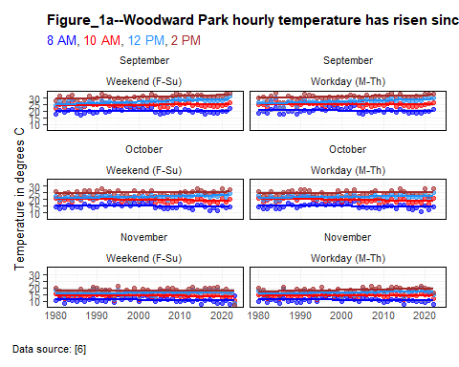

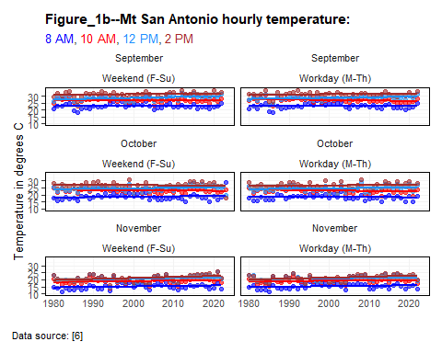

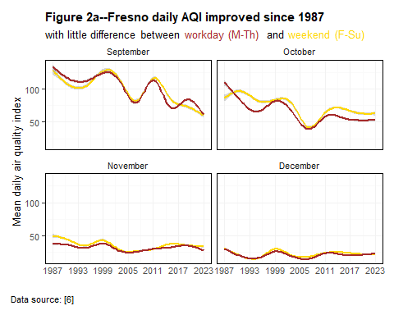

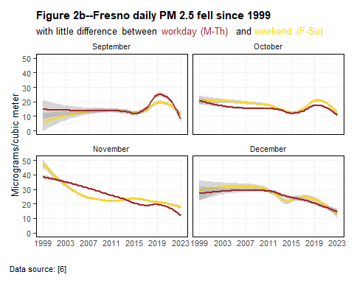

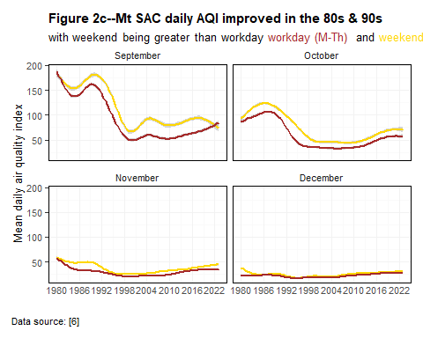

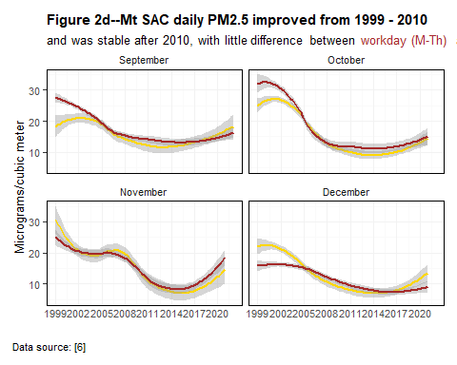

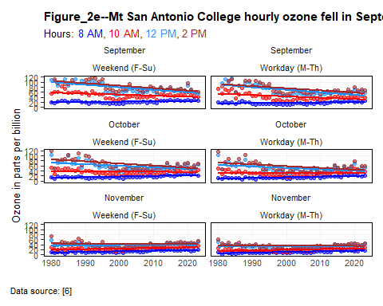

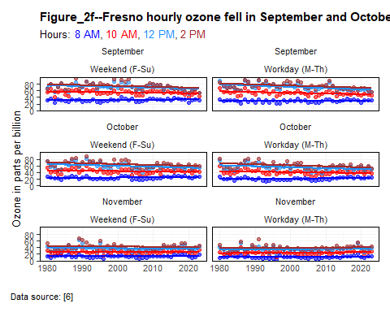

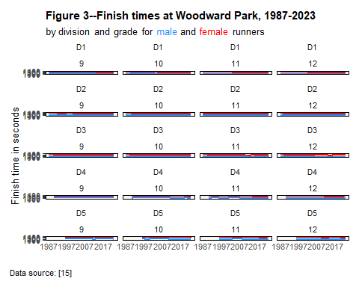

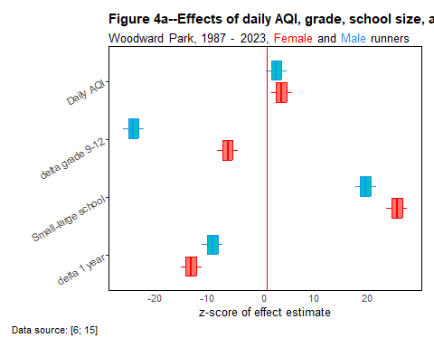

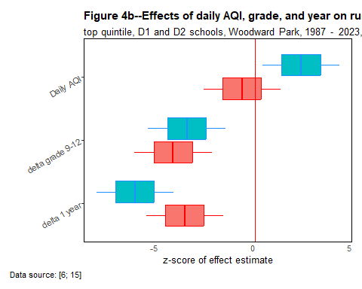

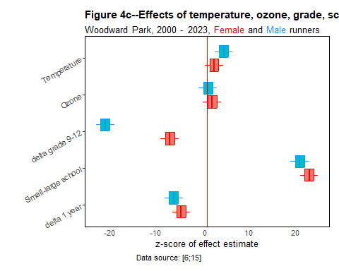

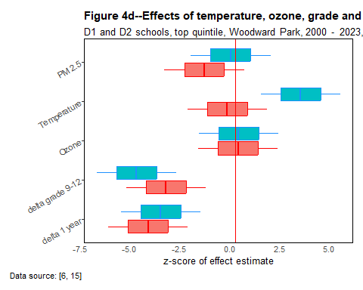

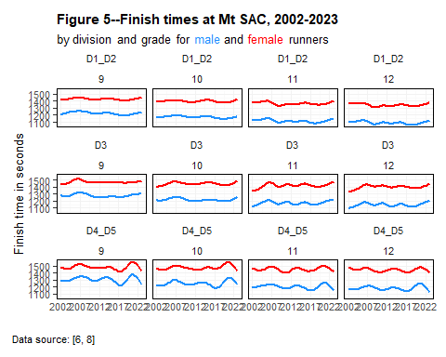

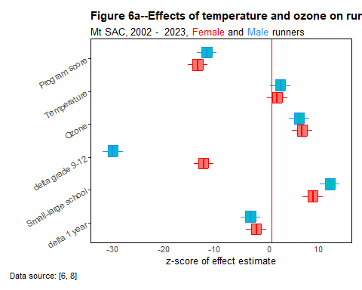

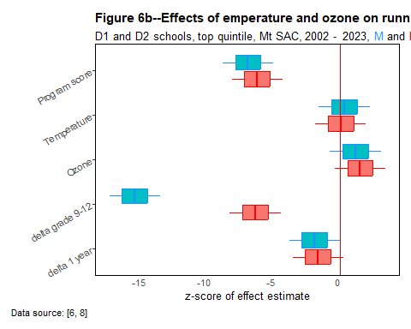

Supplementary information
Valid observations. A valid observation is one in which the finish time, school grade, runner name, and school name could be verified from the online race data and the school websites. Ambiguities in names for the same individual (“Bill”, ”Will”,”William”; “Zach”,”Zack”; “Megan”,”Meghan”) or apparent errors in school grade (e.g., repeating a grade for the same runner in different years) were checked against school websites or the California Mile Split web site¹¹. Many school names contained the strings “Academy”, “Christian”, “Foothill”,” Prep” or “Valley” which had to be disambiguated. School names were forced to be unique; that is, even if the same school name occurred in two different areas of California scholastic athletics (such areas are known as sections) the name was edited to be unique even without the attached section name. Observations that could not be verified or were missing values in the original data for finish time, school grade, runner name, and school name were dropped.
Mt San Antonio College. Course managers at Mt Sac limited race distance on occasional hot days; races shorter than the standard 4,715 meters were dropped from the analysis. Race organizers made small adjustments in the course in the period 2016-2019 to allow construction near the College; those adjustments did not change the distance, which remained at 4,715 m, but may have affected the course’s difficulty. The course was extended to 4,828 m in 2024, a year that is not in the sample.
The original Mt Sac female sample was 96,507 observations before validation. After dropping short races, observations with missing data on finish time, school grade, runner name, and school name, and observations from schools outside California, the validated Mt Sac female sample was 89,332. Further adjustments were to drop individual runners with finish times > 1,800 seconds, and to drop one race where the runners’ names could not be disambiguated, resulting in a valid female sample of 87,693.
The original Mt Sac male sample had 139,266 observations before validation. After dropping short races, observations with missing data on finish time, school grade, runner name, and school name, and observations from schools outside California, the validated Mt Sac male sample was 130,226. Further adjustments were to drop individual runners with finish times > 1,800 seconds, and to drop two races where the runners’ names could not be disambiguated, resulting in a valid male sample of 130,144.
Woodward Park. There were no observations from outside of California in the Woodward Park samples¹². The Woodward Park state championship has always been run at 5,000 m so it was unnecessary to drop races at non-standard distances. At Woodward Park, 35 observations were dropped from the original female sample of 29,068 and 2 were dropped from the orginal male sample of 29,469 because some runner names could not be disambiguated.
Program scores at Woodward Park were used as a proxy for coaching quality in the Mt SAC races. Scores were calculated as the total finishing places of the top five runners in each school having at least five runners at Woodward Park to create ‘team gross points’. The value for team gross points was divided into a constant (1,500) to derive a team score. The sum of team scores for the two years before a given year ‘t’ were summed to return a ‘program score’ in year ‘t’. The highest program score for males was 57.7 was achieved by a D2 school in 2022.The program scores were used as regressors at Mt SAC, but not at Woodward Park, given the high expected serial correlation in the latter race between team gross points and individual times.
The 14-day average AQI was used as a regressor to test for the effects of training in varying air conditions. The 14-day average AQI was constructed as the mean of readings at EPA sites within 25 km of each high school represented in the Mt SAC and Woodward Park databases. (Very few runners competed with masks¹³).
PM 2.5 values could only be used as a regressor to test for the effects of training in varying air conditions.

Estimation procedures and strategy
Estimation procedures. The R package ‘fixest’^{14,15} was used to make robust s.e. estimates using the function feols(). Tests to refine the estimation strategy were done for goodness-of-fit, heteroscedascity, and linearity|non-linearity of covariates such as school grade (a proxy for runner age).These led to choice of a linear dependent variable, not log, because goodness-of-fit did not vary between linear and log specifications; grade as a factor, not as a numeric, and to the exclusion of possible confounders (notably lagged AQI indicators at the school level and measures of PM 2.5 because of weak relations between those variables and the dependent variable).
A number of diagnostic models were run to define an estimation strategy. The steps in the estimation strategy were:
Step 1 Model to test for linear or log dependent variables as shown in the plot for Test_1a; model choice is to use linear values, not logs; goodness of fit was similar in the log and linear models; while heteroscedasticity in Test_1b and Test_1c was higher in the linear models, notably in the Mt SAc data for male runners, linear values do allow easier interpretation of the regression coefficients.
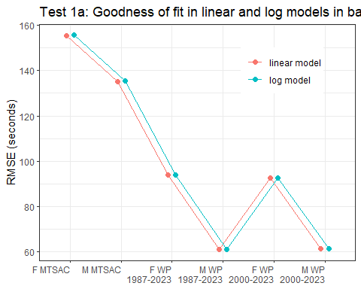

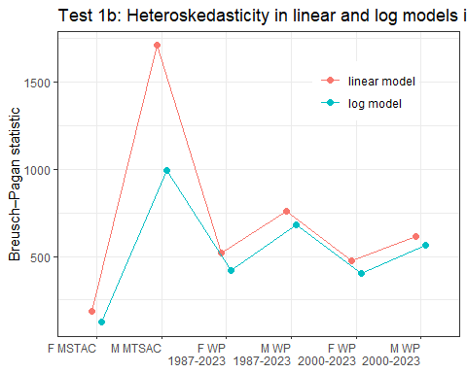

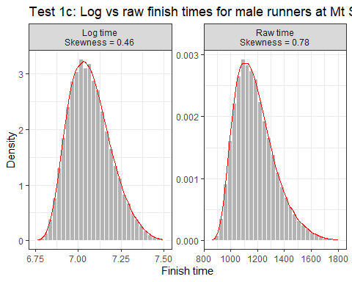

Step 2 Model to test for direct and indirect effects of temperature. Figure Test_2 shows modest direct effects of temperature on running times at Woodward park and null indirect of temperature via ozone levels on times.
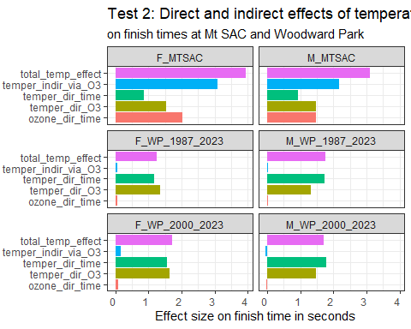

Step 3 The PM 2.5 data for Mt SAC could not be used because there were more than 50 % missing values in hourly and daily measurements for the entire Mt SAC dataset (2002-2023 as given in Test_3. The PM 2.5 data could not be used at Woodward Park for the complete 1987-2023 datasets (male or female) because of missing values before 1999. The sole use of PM 2.5 was at Woodward Park for the period 2000-2023; daily PM2.5 was not significant for females at Woodward Park (0.107 or for males(`r round(reg_M_WP_2000_2023$coeftable[“PM25_daily_on_race_day”,“Pr(>|t|)”],3).
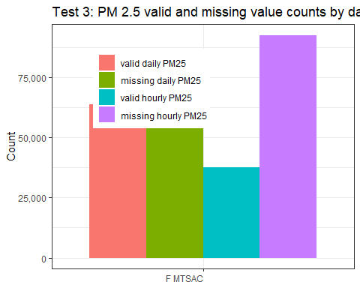

Step 4 Four models compared AIC values between linear lagged 14 day AQI or knotted lagged 14 day AQI as shown in Test_4a through Test_4d. There were many missing AQI 14 spline values at Woodward Park before 2000. The AIC values for Woodward Park Test_4b were low and differed little between the linear and spline AQI 14 models. AICs were much higher at Mt Sac with somewhat higher values for linear AQI 14 compared to spline AQI 14.
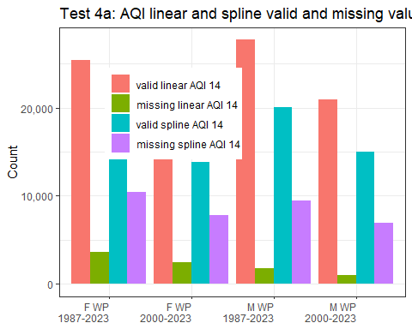

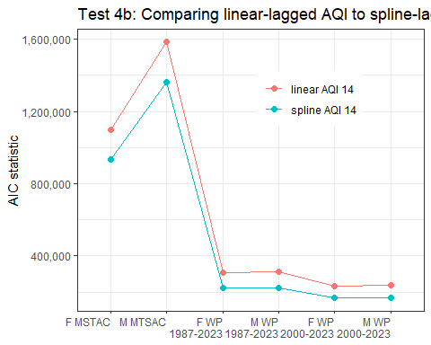
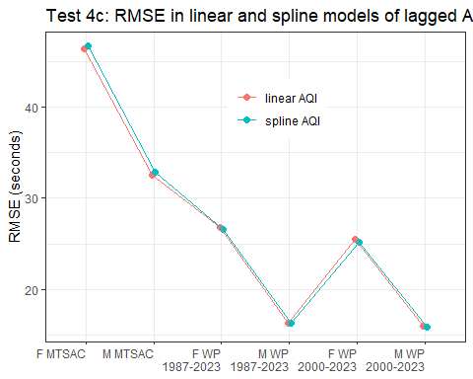
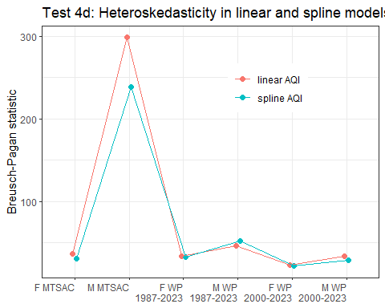

Step 5 Four models tested–grade as factor with (without) interactions between grade and year and between year and division. Use of grade as a factor (or as a numeric) with (or without) interactions made little difference within race sites (Test_5). There were no material differences between models within datasets, though the 8 Mt SAC values were always much larger than any of the 16 WP values.
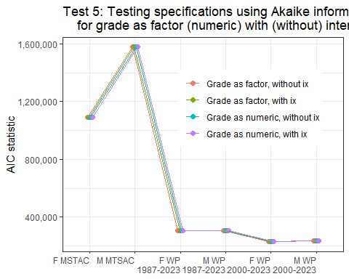

Step 6 Diagnostic models were run on the Mt SAC data to compare linear AQI 14 and spline AQI 14 for male runners as shown in Test_6a and for female runners as shown in Test_6b. The diagnostic models were used only to inform the choice of linear or spline functions in the paper.
Test 6a: Male times, treatments linear and spline AQI, MT SAC
 | linear M AQI 14 | spline M AQI 14
(Intercept) | 1172.055*** | 1198.403***
 | (13.928) | (25.349)
Year | -1.444** | -0.904+
 | (0.475) | (0.499)
Hourly ozone | 1.110*** | 1.144***
 | (0.216) | (0.217)
Hourly temper | 2.704*** | 2.537***
 | (0.612) | (0.617)
School AQI | -0.264+
 | (0.159)
Grade 10 | -57.966*** | -58.245***
 | (4.322) | (4.219)
Grade 11 | -94.225*** | -95.094***
 | (4.823) | (4.750)
Grade 12 | -119.408*** | -120.883***
 | (4.744) | (4.662)
AQI lag 1 |  | -13.411**
 |  | (4.877)
AQI lag 2 |  | 9.265+
 |  | (5.098)
AQI lag 3 |  | 3.483
 |  | (4.088)
AQI lag 4 |  | -4.440
 |  | (4.017)
Num.Obs. | 124762 | 107356
R2 | 0.145 | 0.145
R2 Adj. | 0.145 | 0.145
RMSE | 136.57 | 136.47

Test 6b: Female times, treatments linear and spline AQI, MT SAC
 | linear F AQI 14 | spline F AQI 14
(Intercept) | 1353.360*** | 1398.099***
 | (18.493) | (32.063)
Year | -1.588** | -0.991
 | (0.610) | (0.636)
Hourly ozone | 1.589*** | 1.559***
 | (0.276) | (0.278)
Hourly temper | 2.527** | 2.462**
 | (0.835) | (0.833)
School AQI | -0.264
 | (0.205)
Grade 10 | -25.736*** | -25.933***
 | (4.760) | (4.689)
Grade 11 | -38.652*** | -39.394***
 | (5.054) | (5.047)
Grade 12 | -59.056*** | -60.659***
 | (5.030) | (5.014)
AQI lag 1 |  | -12.710*
 |  | (6.439)
AQI lag 2 |  | 8.564
 |  | (6.829)
AQI lag 3 |  | -1.085
 |  | (5.394)
AQI lag 4 |  | 2.537
 |  | (5.275)
Num.Obs. | 84538 | 72003
R2 | 0.065 | 0.065
R2 Adj. | 0.065 | 0.065
RMSE | 155.41 | 155.15

Data availability
Data and code are available from
$$linktobeinserted$$

References
1. Moir, H. J. et al. Genes and Elite Marathon Running Performance: A Systematic Review. Journal of Sports Science & Medicine 18, 559–568 (2019).
2. Fair, R. C. & Kaplan, E. H. Estimating Aging Effects in Running Events The Review of Economics and Statistics MIT Press. (2018).
3. Carlisle, A. J. & Sharp, N. C. C. Exercise and outdoor ambient air pollution. British Journal of Sports Medicine 35, 214–222 (2001).
4. Cusick, M., Rowland, S. T. & DeFelice, N. Impact of air pollution on running performance. Scientific Reports 13, 1832 (2023).
5. Hodgson, J. R., Elliott, S., Chapman, L., Hudson, C. & Pope, F. D. The influence of meteorology and air quality on parkrun athletic performance. https://scholar.archive.org/work/ge5obqmfgrd2xcmurmrxd6d5ha/access/wayback/https://assets.researchsquare.com/files/rs-30113/v2/65481a03-d33b-4360-9ba6-f113b7d62cad.pdf (2020).
6. United States Environmental Protection Agency. AirData website File Download page. Pre-generated data files (2024).
7. Bouchard, C. et al. Familial aggregation ofV˙\textlessspan style="font-variant:small-caps;"\textgreatero\textless/span\textgreater $​_{\text{2 max}}$ response to exercise training: Results from the HERITAGE Family Study. Journal of Applied Physiology 87, 1003–1008 (1999).
8. Mount San Antonio College. 75th Annual Mt. SAC Cross Country Invitational - Meet Info - Cross Country Meet. 75th Annual Mt. SAC Cross Country Invitational (2023).
9. Fleury, E. S., Bittker, G. S., Just, A. C. & Braun, J. M. Running on Fumes: An Analysis of Fine Particulate Matter’s Impact on Finish Times in Nine Major US Marathons, 2003–2019. Sports Medicine 55, 1505–1514 (2025).
10. Mullins, J. T. Ambient air pollution and human performance: Contemporaneous and acclimatization effects of ozone exposure on athletic performance - Mullins - 2018 - Health Economics - Wiley Online Library. (2018).
11. MileSplitCA_2024. CIF State XC Championships Meet Manager. California MileSplit (2024).
12. MileSplitCA_1987-2023. CIF State Cross Country Championship 1987 - Meet Information. California MileSplit (1987).
13. Mengmeng, G. & Shihe, F. Running With a Mask? The Effect of Air Pollution on Marathon Runners’ Performance. (2019).
14. Blair, G., Cooper, J., Coppock, A., Humphreys, M. & Sonnet, L. Estimatr: Fast Estimators for Design-Based Inference. (CRAN, 2025). doi:10.32614/CRAN.package.estimatr.
15. R Core Team. R: A Language and Environment for Statistical Computing. (R Foundation for Statistical Computing, Vienna, Austria, 2025).

