TaxiTimes
Operating Manual

Login Page
At the login page you have one of two options, login to your account, or apply for a new account.
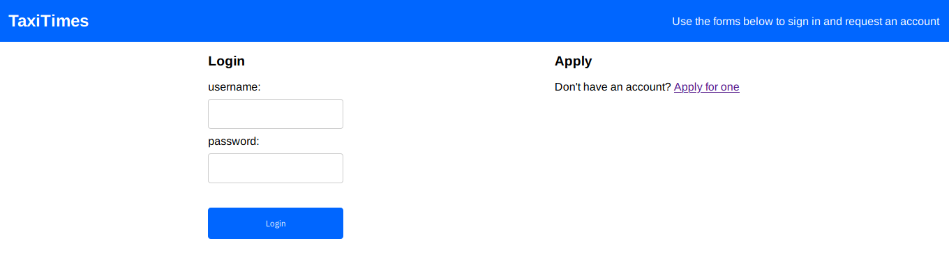

Apply For an Account
To get access to the system, you must apply for an account first. Fill in your name and email for the admin to review your application and create an account for you.

Home Page
The home page gives you the option to change your password, and has links to the rest of the program.
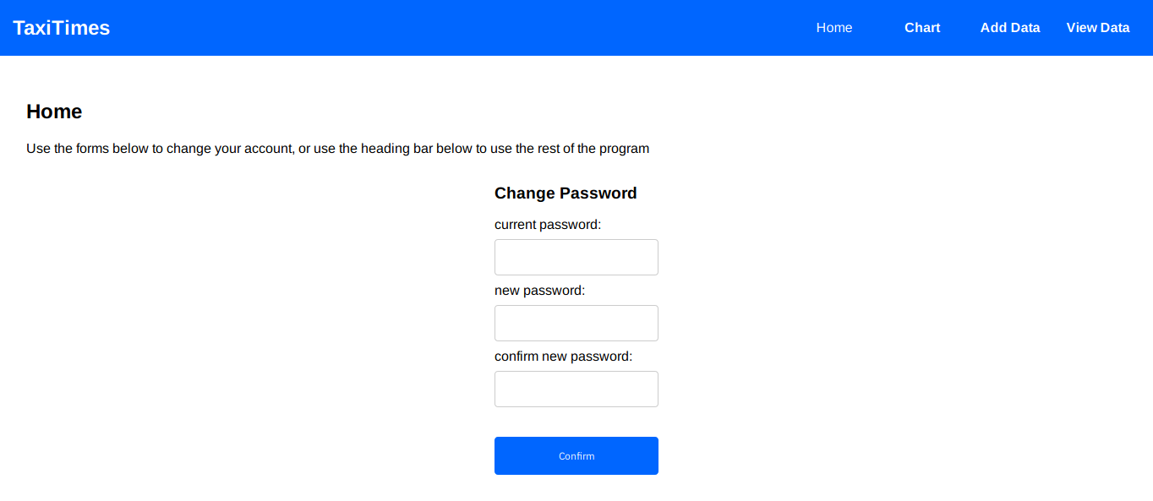

Change Password
Enter your current password, your new password and your new password again to confirm it, then press ‘confirm’ to change your password.
It is recommended you change your password on account creation as the admin created your password in the first place.

Admin Account
The account with the username ‘admin’ has access to the administrator section of the website, and therefore is able to create the rest of the accounts in the system.
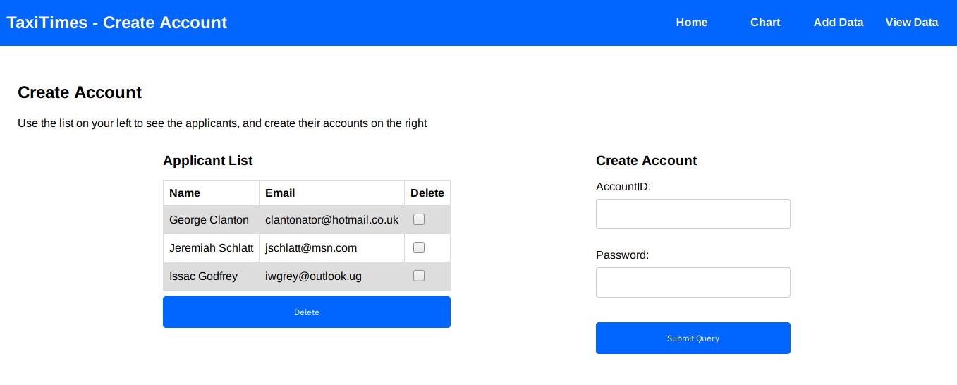

Admin Page
The administrator page allows you to see and delete information about the applicants. You also have the option to create accounts.

Applicant List
This shows you the list of people who have applied for the system. To delete an applicant from the list, tick the ‘delete’ box and press the delete button.

Create Account
This form allows you to create a new account. Type in the accountID and password, and press ‘Submit Query’, the account will then be created.

Log Feature
It is assumed that the admin knows how to access the log system in the database.
- To do this, enter phpmyadmin
- Click on the ‘taxidb’ section in the left hand column
- Then select the log table from the list of tables
As the admin account, you are also expected to keep the hashed passwords safe. You are not able to see anyone’s password.

Chart
This page allows you to create a chart of how much time a school on a course misses within a date range. Fill out the form and click ‘create chart’ to see the chart.
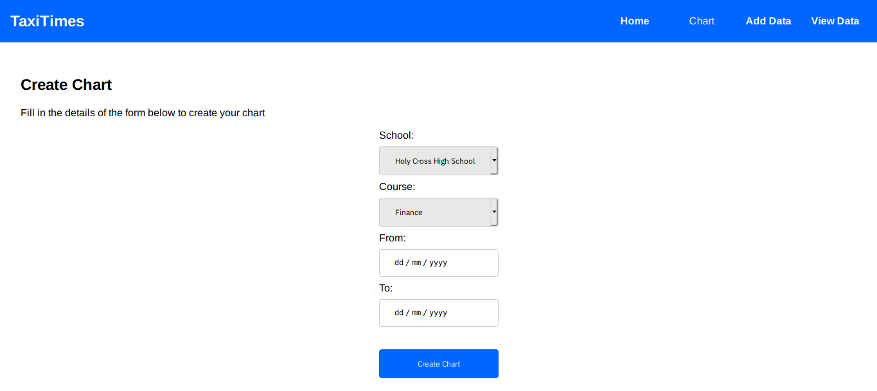

Add Data
This page allows you to create courses and classes that belong to you. Use these to indicate when students leave and show up to class.
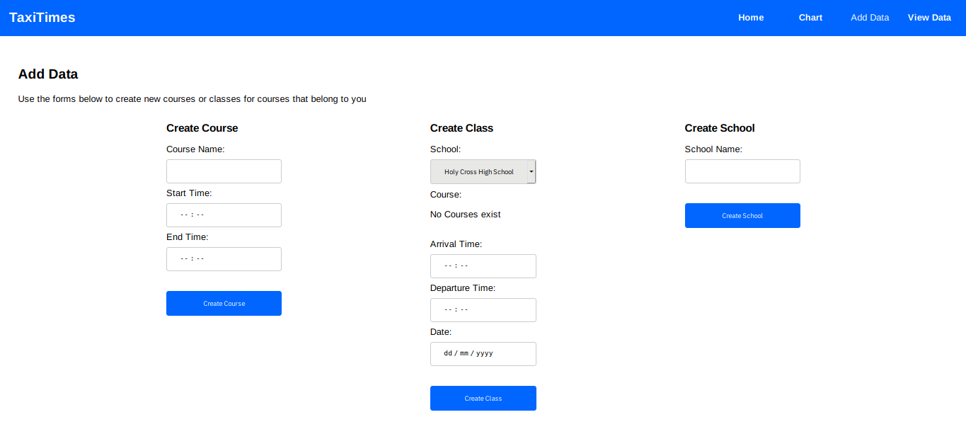
You also have the option to create a school but be weary that if you create a school, it can have the same name as another school.

View Data
This page allows you to view your data.
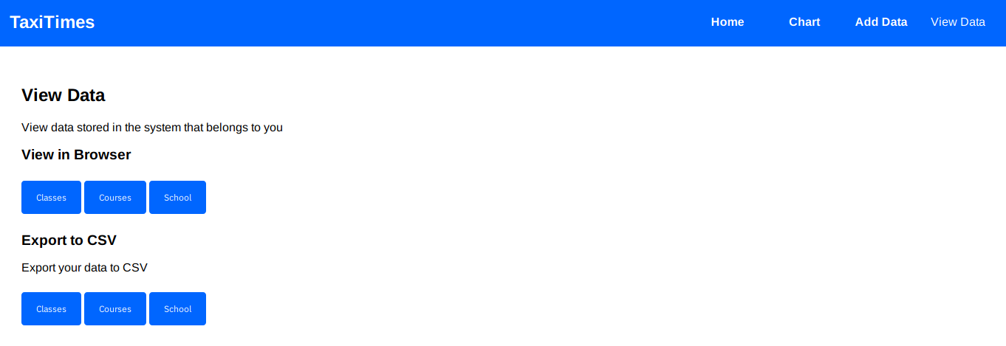

View in Browser
This will display a page showing you either your classes, your courses, or all schools depending on which button you press.

Export to CSV
This will download a CSV file to your computer detailing either your classes, your courses, or all schools depending on which button you press.

