Heavy Duty Modular Belt Grinder

Outside of my professional life, I love to build things. This was of my favorite projects!

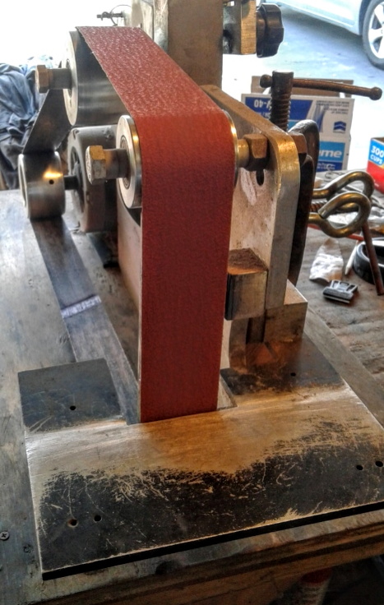 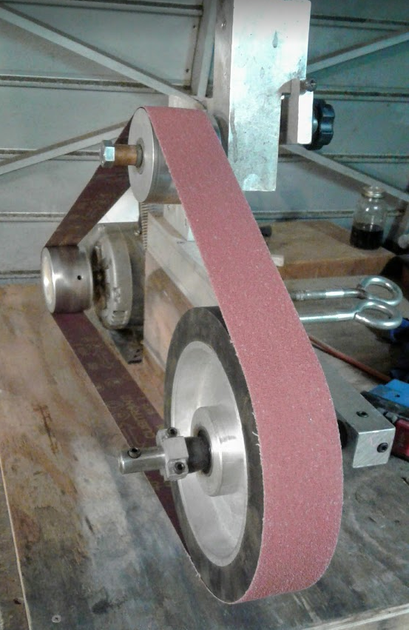

This is a 2x72” belt grinder I designed and built. It features a tilting tracking wheel (adjusted with the black knob), a belt tensioning arm, and interchangeable tool arms for various applications. Its powered by a 1.5 HP AC motor

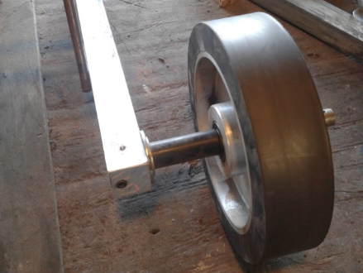 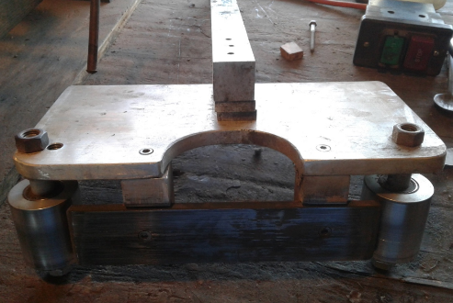 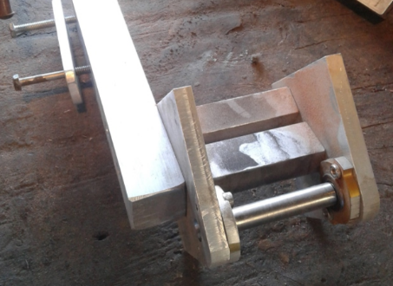

Here are some of the tooling arms I’ve made. From left to right: 10” contact wheel, Flat platen, Small wheel attachment.