# Novel Automatic screw feeder: UC Davis Senior Design Project

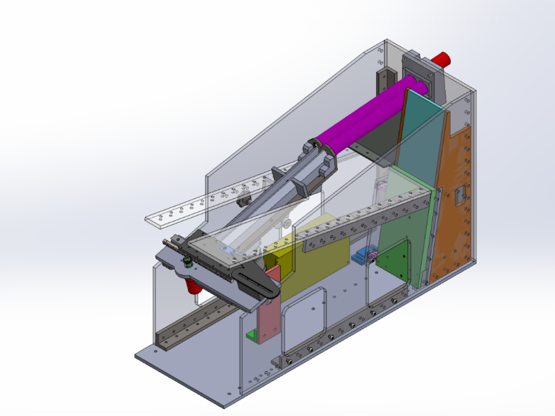 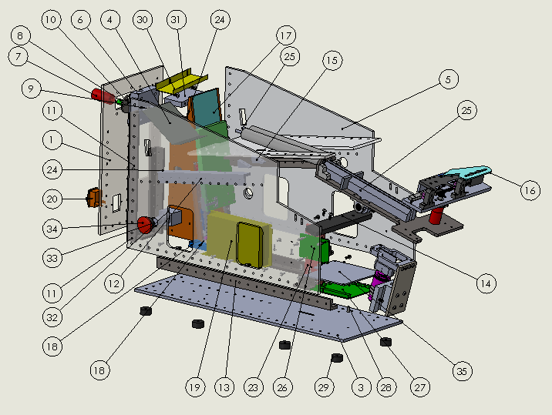

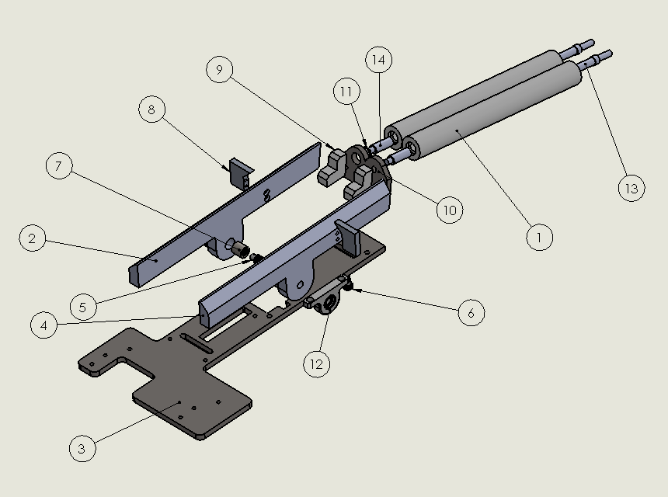 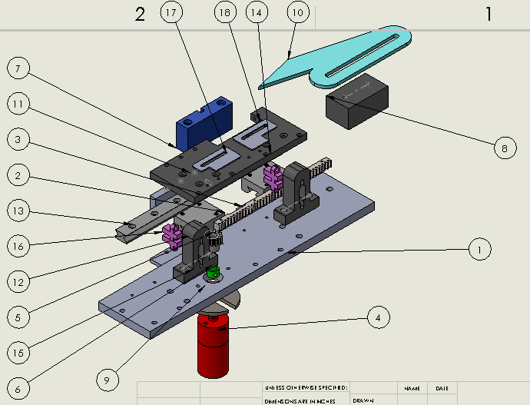

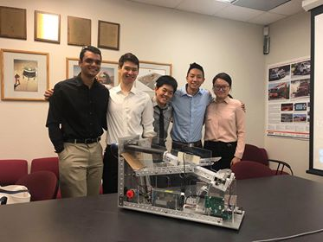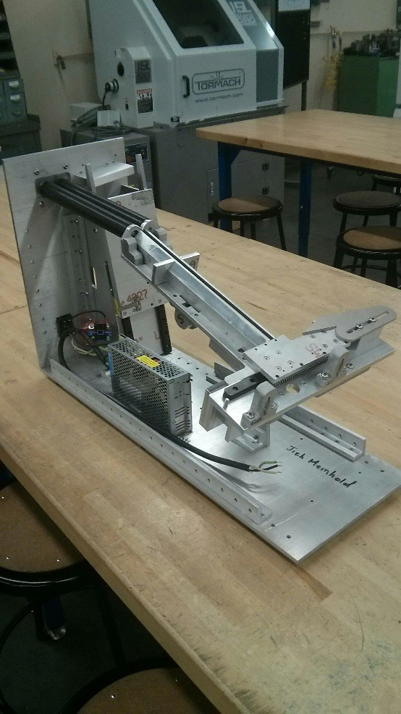

Existing assembly processes often use screw feeding technologies that are loud, bulky, and prone to jamming. Many of these existing technologies are built use a vibrating hopper to align the screws. The hopper tosses the screws around randomly until they become aligned on a track. The problem with these existing aligners is that alignment is by chance and unreliable.

Our industry sponsor tasked us with designing and prototyping a novel automated screw feeder. My 5 person design group conceptualized, designed and fabricated and tested the proof of concept for delivery to our sponsor by the end of the academic year.

Our design replaced vibration alignment with slanted rollers which direct the screws into the track. I was responsible for the majority of the mechanical design, as well as aroud 35% of the machining/fabrication. My design work included main enclosure, as well as the 2 subassemblies shown above and integration of the other subassemblies. In addition to this, the use of tangential rollers for screw alignment was my invention.