# CS 255 Business Requirements Document Template

Complete this template by replacing the bracketed text with the relevant information.

This template lays out all the different sections that you need to complete for Project One. Each section has guiding questions to prompt your thinking. These questions are meant to guide your initial responses to each area. You are encouraged to go beyond these questions using what you have learned in your readings. You will need to continually reference the interview transcript as you work to make sure that you are addressing your client’s needs. There is no required length for the final document. Instead, the goal is to complete each section based on your client’s needs.

**Tip:** You should respond in a bulleted list for each section. This will make your thoughts easier to reference when you move into the design phase for Project Two. One starter bullet has been provided for you in each section, but you will need to add more.

### Purpose

*What is the purpose of this project? Who is the client and what do they want their system to be able to do?*

* Our client’s name is DriverPass and their system is used to help students prepare for their test at the DMV.
* They will be using a web application to allow students to take advantage of online test prep resources.
* Additionally, they want to allow student to connect with local resources to help prepare for their driver’s test.

### System Background

*What does DriverPass want the system to do? What is the problem they want to fix? What are the different components needed for this system?*

* The User needs to have access to practice tests and online classes.
* The web app will also allow users to preform CRUD operations for appointment to meet with local instructors at the DMV.
* The application will be web based with cloud data storage.
* The users will be able to download data and preform CRUD operations when not connected to the web. Later when the user reconnects to the database their updates will be pushed to the data service.

### Objectives and Goals

*What should this system be able to do when it is completed? What measurable tasks need to be included in the system design to achieve this?*

* Ability to perform CRUD operations stored locally when not connected to the database. Then when connection is reestablished pushing updates to the database.
* Make a database with different privileges based on login credentials and roles.
* Allow users to schedule and perform CRUD operations on appointments to meet with instructors locally for training.
* Give users access to a catalog on online practice tests and resources to help the user prepare for their driver’s test.
* The Client wants to be able to make simple changes such as disabling or altering packages if needed with minimal technical experience.

## Requirements

### Nonfunctional Requirements

*In this section, you will detail the different nonfunctional requirements for the DriverPass system. You will need to think about the different things that the system needs to function properly.*

#### Performance Requirements

*What environments (web-based, application, etc.) does this system need to run in? How fast should the system run? How often should the system be updated?*

* A web-based application will be used to allow the maximum amount of users access to the program.
* The application should be able to get and send data almost immediately to the users.

#### Platform Constraints

*What platforms (Windows, Unix, etc.) should the system run on? Does the back end require any tools, such as a database, to support this application?*

* With the client’s employees being in different locations, a cloud-based database would be best to store their data such as Azure.
* For the client utilizing PaaS model to minimize their involvement in maintaining the servers required.
* Since the program will be web-based only frameworks that are compliant for any modern browser will be appropriate.

#### Accuracy and Precision

*How will you distinguish between different users?* *Is the input case-sensitive? When should the system inform the admin of a problem?*

* The database will have tables to determine different user roles permissions within the application.
* We will use different a table with a row for each user to verify login.

#### Adaptability

*Can you make changes to the user (add/remove/modify) without changing code? How will the system adapt to platform updates? What type of access does the IT admin need?*

* We will use SQL to preform CRUD operations to the user’s data as need with the tables.
* Since we are using the PaaS model will allow for the most flexibility in scaling their requirement in the future.
* We will allow administrator additional privileges to alter the UI as needed and alter some user data to facilitate their user base.

#### Security

*What is required for the user to log in? How can you secure the connection or the data exchange between the client and the server? What should happen to the account if there is a “brute force” hacking attempt? What happens if the user forgets their password?*

* Since the servers will be cloud based the cloud service provider will manage direct security to the server.
* Abstraction will prevent data to be altered depending on user privileges.
* If a user attempts too many logins within a brief time we will lock out their account to prevent brute force attacks.
* We will use captcha authentication to prevent bots from accessing user data.

### Functional Requirements

*Using the information from the scenario, think about the different functions the system needs to provide. Each of your bullets should start with “The system shall . . .” For example, one functional requirement might be, “The system shall validate user credentials when logging in.”*

* The system shall allow users to create and change some data within their account.
* The system shall allow users to take practice tests and check their results.
* The system shall allow users to schedule driving appointments.
* The system shall allow users to make purchases on their account and verify payment.
* The system shall allow driving instructors to create data while offline and sync their data when they are able to access the internet again.

### User Interface

*What are the needs of the interface? Who are the different users for this interface? What will each user need to be able to do through the interface? How will the user interact with the interface (mobile, browser, etc.)?*

* The Application will be web based and accessible through any browser.
* The Application will serve a container with the home page that will display limited high volume data to the user.
* The Application will have a page for account management, test-taking, appointment scheduling, driver status, login, and a landing page for advertising purposes.
* We will also have a App and portal for employee to use on mobile tablets and phone to enter data while offline during the driving tests that will update once they have reestablished connection to the server.

### Assumptions

*What things were not specifically addressed in your design above? What assumptions are you making in your design about the users or the technology they have?*

* The client will be responsible for updating their data on the website and keeping their tests up to date.
* The cloud service provider will replicate and store our data as securely as possible in the event of a natural disaster or network outages.
* Leveraging cloud infrastructure, we will have 24/7 accesses to the data being stored and the client will be able to freely expand or shrink their cloud service requirements depending on their needs.

### Limitations

*Any system you build will naturally have limitations. What limitations do you see in your system design? What limitations do you have as far as resources, time, budget, or technology?*

* Users will have a powered device that is capable of connecting the web application.
* The client will be responsible for determining their budget for data replication and capabilities of their cloud service provider.
* The client will provide technical service personal to solve support issues among their userbase.
* The client will provide the infrastructure of driving instructors for their appointment scheduled by their users.

### Gantt Chart

*Please include a screenshot of the GANTT chart that you created with Lucidchart. Be sure to check that it meets the plan described by the characters in the interview.*

[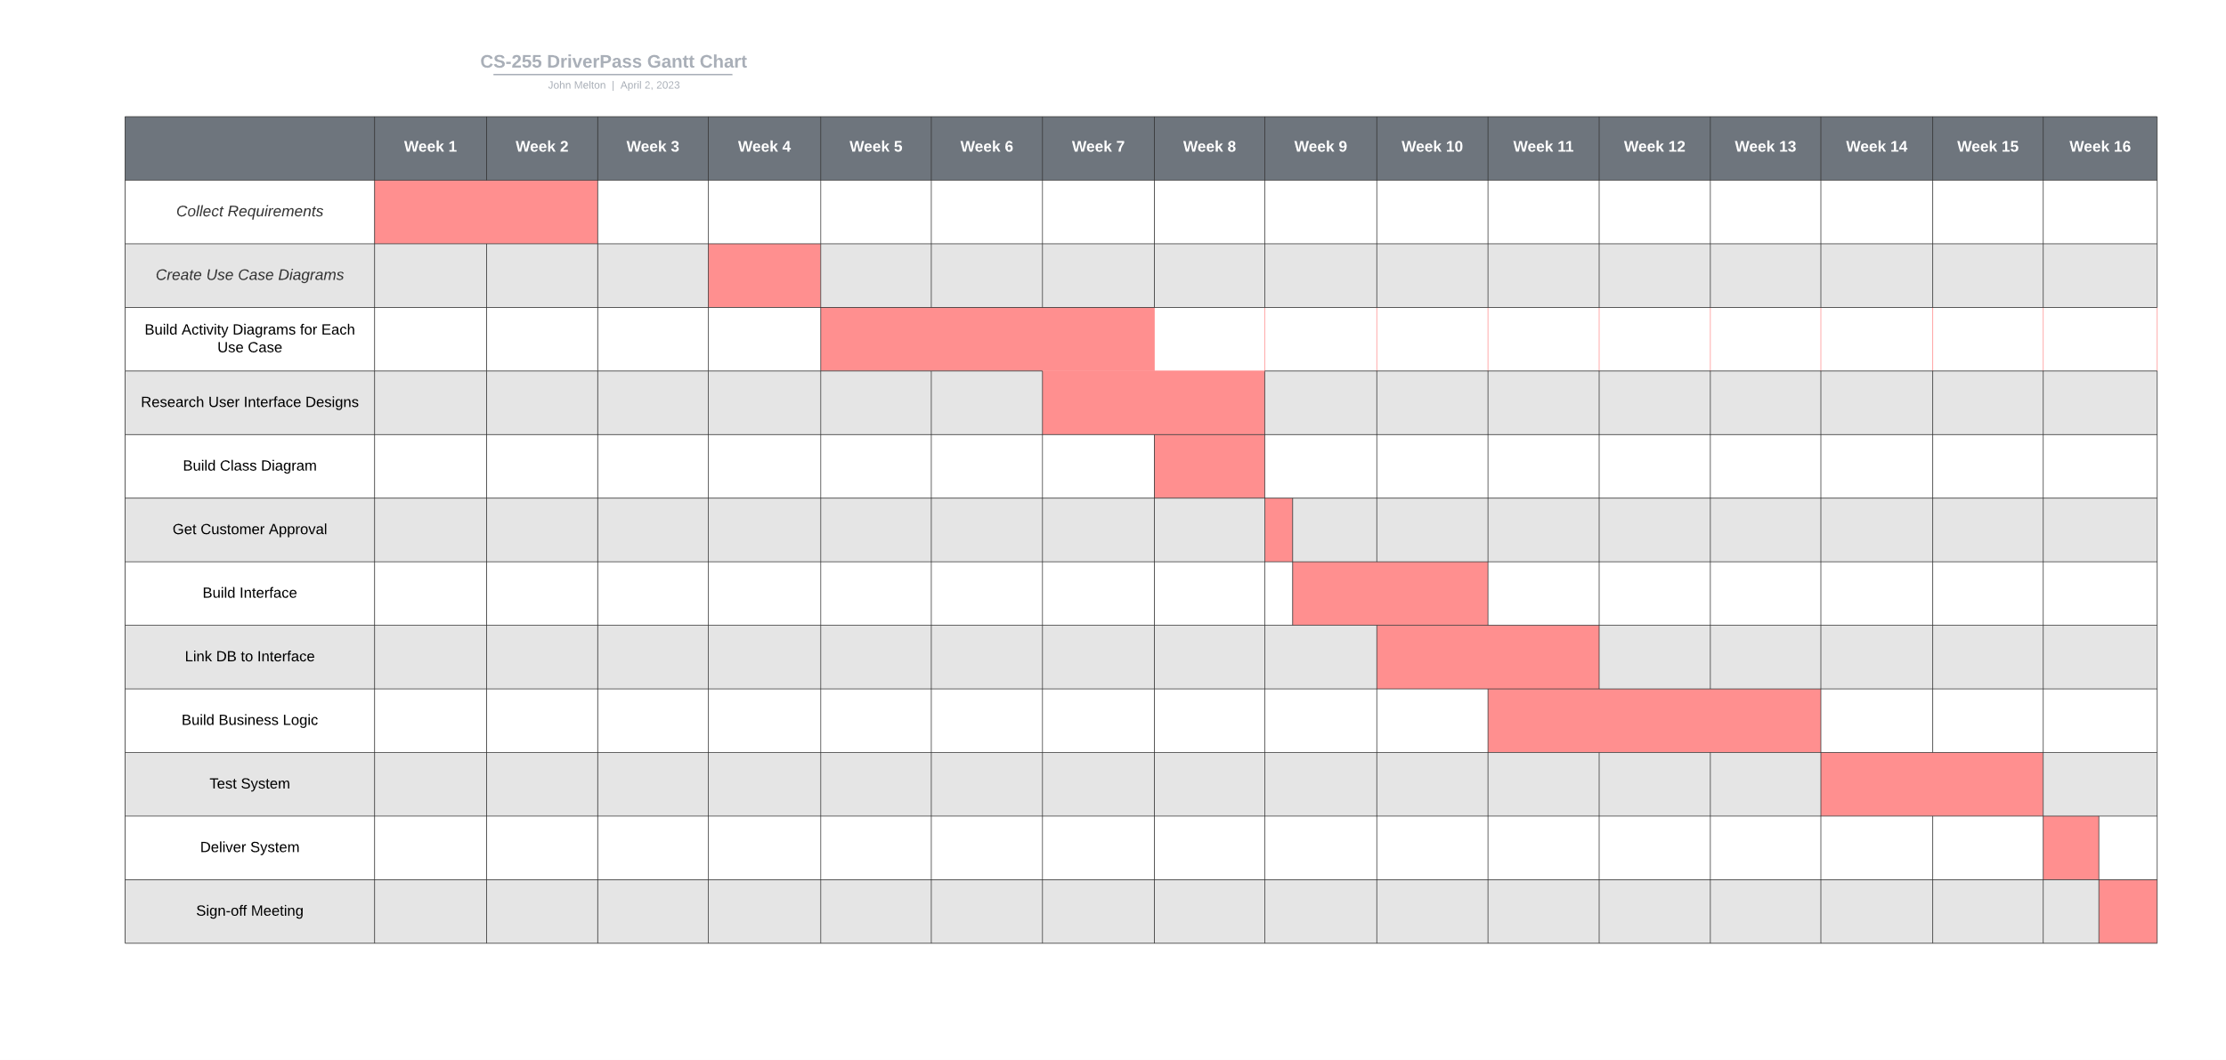](https://lucid.app/lucidchart/a4626acc-0d24-473b-b920-254c1146f3a9/edit?viewport_loc=-1242%2C-846%2C6912%2C3306%2CuDe-dIt-NWfS&invitationId=inv_9e29b37b-f449-4e62-84e5-367c6b81f57b)