# CS 255 System Design Document Template

This template lays out all the different sections that you need to complete for Project Two. Each section has guidance to prompt your thinking. You will need to continually reference the interview transcript as you work to make sure that you are addressing your client’s needs. There is no required length for the final document. Instead the goal is to complete each section based on what your client’s needs are. Remove this note when you are finished, and replace all bracketed text with the relevant information.

## UML Diagrams

### UML Use Case Diagram:

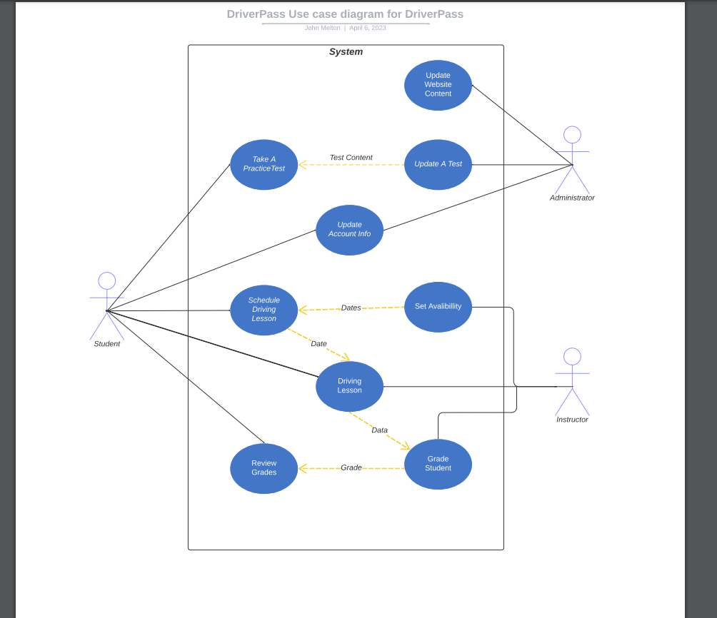

### UML Activity Diagrams:

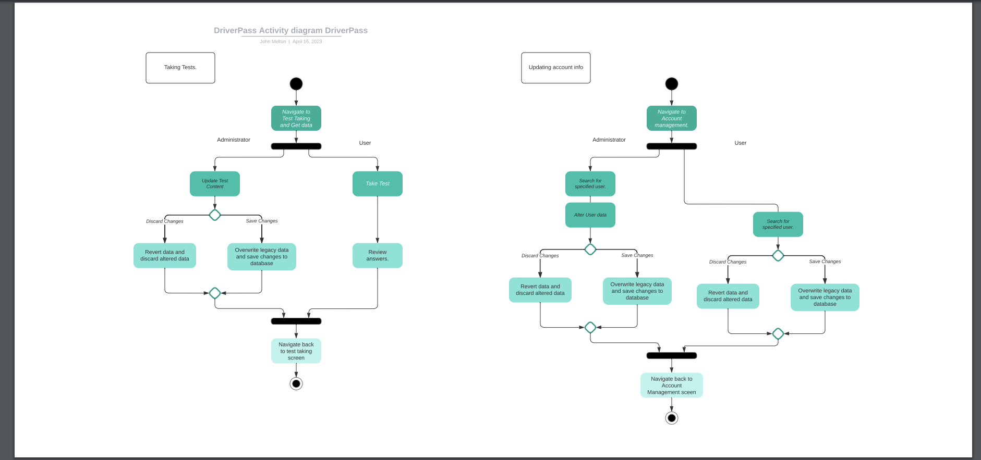

### UML Sequence Diagram:

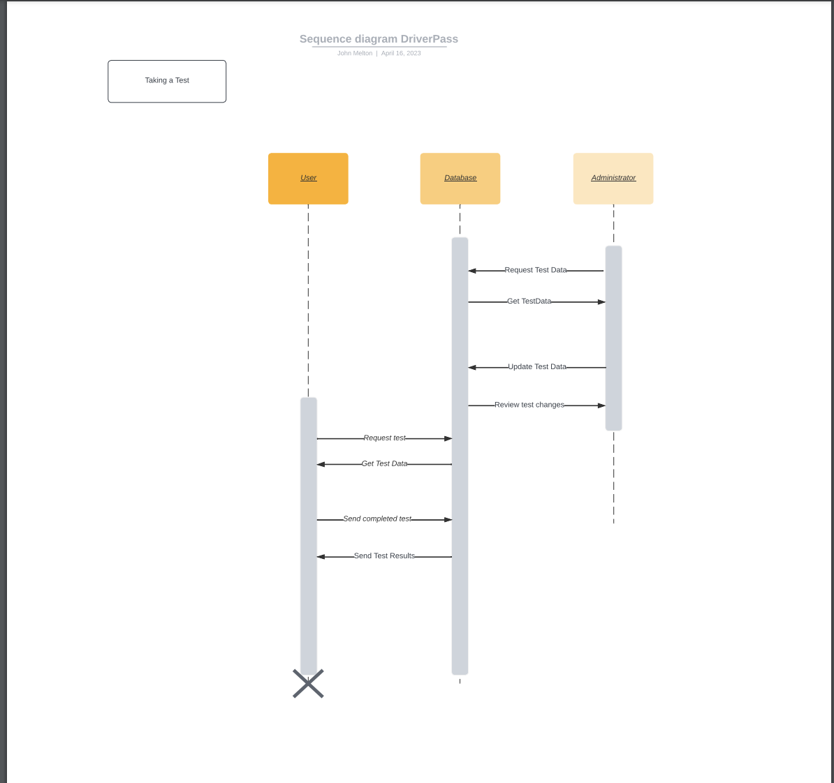

### UML Class Diagram:

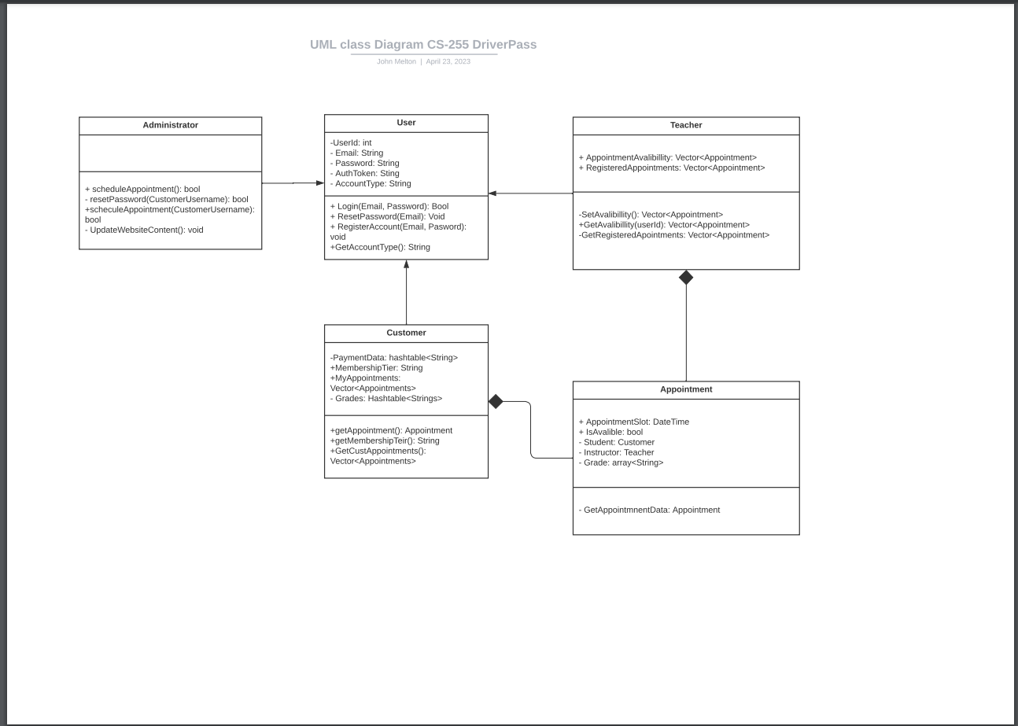

## Technical Requirements

For DriverPass the technical requirements will be fairly minimal. The user will only need a device capable of accessing their website. The instructor will need access to a tablet or some other mobile computer to access and hold changes locally when not connected to the database. This will allow them to update their database when reconnecting to the internet. The client will also some sort of database to store user data. Based on their infrastructure needs I would recommend a cloud provided database. Using a cloud provider such as azure will reduce upfront cost to the client and will allow them to have the redundancy and accessibility to their data that they will require throughout the life of their product. A cloud provider will also allow them to easily scale their infrastructure as needed while incurring minimal costs.