MATH6010-M02 Assignment02

Jia Mian Tan 120033990001

Find the dominating set using greedy approach

|  |  |
| --- | --- |
| **Algorithm** findDominatingSetGreedy | |
| **Input:** A graph $G$ with $n$ vertices and $e$ edges | |
| **Output:** A set $U$, the dominating set of vertices | |
|  | $E←$ adjacency matrix; $U←$ [] |
|  | $coveredV[1…n]←$ array used to tell if the vertex is already covered: 1 if covered, 0 otherwise. Initialized as 0 for all vertices. |
|  | $uncovNB[1…n]←$ array used to store the number of uncovered neighbors for each vertex. Initialized as the number of neighbors + 1(itself) |
|  | **while** sum($coveredV$) **is not $n$**  **do** *(meaning there is still vertex(vertices) uncovered)* |
|  | $maxV←$ the vertex with largest number of uncovered neighbors |
|  | add $maxV$ to tail of $U$ |
|  | $E\left[maxV\right]\left[maxV\right]←0$ |
|  | **if $maxV$**  has never been covered |
|  | $uncovNB\left[maxV\right]←uncovNB\left[maxV\right]-1$*(minus itself)* |
|  | **for $i$**  from $1$**to $n$** |
|  | **if $i$**  is an uncovered neighbor of $maxV$ |
|  | remove the edge between $i$ and $maxV$ |
|  | **if $maxV$**  has never been covered |
|  | $uncovNB\left[i\right]←uncovNB\left[i\right]-1$ |
|  | **if $i$**  has never been covered |
|  | $uncovNB\left[maxV\right]←uncovNB\left[maxV\right]-1$ |
|  | **for $j$**  from $1$**to $n$** |
|  | **if** there is still edge between $i$ and $j$ |
|  | $uncovNB\left[j\right]←uncovNB\left[j\right]-1$ |
|  | **if $j$**  has been covered before *(so now both $i$ and $j$ are covered)* |
|  | remove the edge between $i$ and $j$ |
|  | mark $i$ as covered |
|  | mark $maxV$ as covered |
|  | **return $U$** |

p/s: the vertices which have been covered but not yet in the dominating set are still eligible to be picked into the dominating set

Driver code

Sample 1: randomly generated 100x100 adjacency matrix, the number of minimum neighbor $\left(δ\right)$ for each vertex is 3.

n = 100; $δ$ = 3

Sample 2:

n = 6; $δ$ = 1

Greedy Approach should be 2 🡪 3;

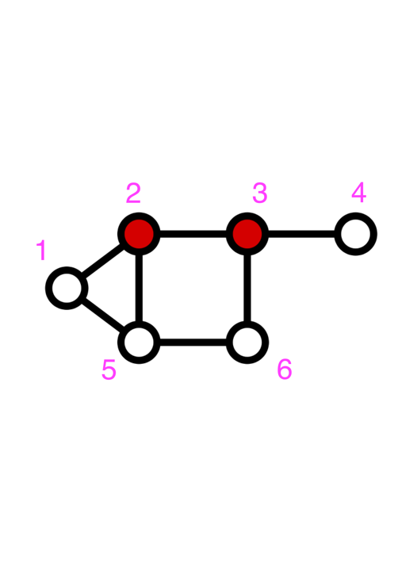output in Python (index from 0): 1 🡪 2

Sample 3:

n = 10; $δ$ = 3

Greedy Approach should be 1 🡪 2 🡪 9;

output in Python (index from 0): 0 🡪 1 🡪 8

