**RUFit**



User’s Manual

Document

**James Dadson, Jonathan Miller, Colin Newton, Michael Yilma**

**teammapletree.weebly.com**

**04/22/19**

**USER'S MANUAL**

**TABLE OF CONTENTS**

Page #

1.1 System Overview 3

1.3 Authorized Use Permission 3

1.4 Points of Contact 4

*1.4.1* *Information 4*

*1.4.2* *Coordination 4*

**SYSTEM SUMMARY 5**

2.1 System Configuration 5

2.2 Information Flow 5

2.3 User Access Levels 5

3.1 Logging On (Gaining Access to the System) 6

3.2 System Menu 6

*3.2.x* *[System Function Name] 6*

3.4 Exiting the System 6

3.5 Special Instructions for Error Correction 6

3.6 Caveats and Exceptions 6

3.7 Maintenance Capabilities 7

**1.0 GENERAL INFORMATION**

***NOTE TO AUTHOR:*** *highlighted, italicized text throughout this template is provided solely as background information to assist you in creating this document. Please delete all such text, as well as the instructions in each section, prior to submitting this document.* ***ONLY YOUR PROJECT-SPECIFIC INFORMATION SHOULD APPEAR IN THE FINAL VERSION OF THIS DOCUMENT.***

*The User’s Manual provides the information necessary for the user to effectively use the automated information system.*

## 1.1 System Overview

* Major functions performed by the system
* Register for an Account
* Login into the System
* Add, Edit, and Delete Exercises
* Add Exercises to Create a Workout
* Add, Edit, and Goals
* Complete, Uncomplete Goals
* Earn and Claim Rewards
* Complete Workouts

* Describe the architecture of the system in non-technical terms, (e.g., client/server, Web-based, etc.)
* The architecture of our system is a Web-based application, but ultimately will be incorporated in the Radford University mobile app.

* User access mode, (e.g., graphical user interface)
* The user can access and use the application using the graphical user interface.

* Responsible organization
* Team Maple Tree
* System name or title
* RUFit
* System code
* The application uses PHP, Javascript, HTML, and CSS.
* System category:
* The application is a major application, as it is stand alone and the functions performed only affect said application.
* Operational status:
* The application is currently operational.
* General description
* RU Fit is a fitness application that allows Radford University students and staff to track their workouts, reach their goals, and eventually earn rewards. RU Fit will not only cater to beginners, by providing built-in workouts, but allows allow more advanced users to create and customize their own workouts. RU Fit will also allow users to create fitness goals, which can motivate users to exercise more often. Lastly, RU Fit will allow users to work towards certain milestones, giving them the opportunity to earn rewards from the fitness center, such as a water bottle.
* System environment or special conditions

## 1.3 Authorized Use Permission

Provide a warning regarding unauthorized usage of the system and making unauthorized copies of data, software, reports, and documents, if applicable. If waiver use or copy permissions need to be obtained, describe the process.

* Unauthorized use of the RUFit system will result in blocking and the loss of privilege of using the system in any way or form.

## 1.4 Points of Contact

### 1.4.1 Information

Provide a list of the points of organizational contact (POCs) that may be needed by the document user for informational and troubleshooting purposes. Include type of contact, contact name, department, telephone number, and e-mail address (if applicable). Points of contact may include, but are not limited to, help desk POC, development/maintenance POC, and operations POC.

* IT services of Radford University.

### 1.4.2 Coordination

Provide a list of organizations that require coordination between the project and its specific support function (e.g., installation coordination, security, etc.). Include a schedule for coordination activities.

* Radford University Division of Information Technology
* Radford University Recreation and Wellness System

# 

# SYSTEM SUMMARY

*This section provides a general overview of the system written in non-technical terminology. The summary should outline the uses of the system in supporting the activities of the user and staff.*

## 2.1 System Configuration

Briefly describe and depict graphically the equipment, communications, and networks used by the system. Include the type of computer input and output devices.

* In order to access the RUFit system, you must first obtain either a mobile device with a touchscreen or a computer with a mouse and keyboard. Next, you must connect to the internet, as the system is a web-based application. Current the system is hosted on Infinityfree.net, at the address: rufit.epizy.com. The database used to house the information for this application is phpMyAdmin.

## 2.2 Information Flow

Briefly describe or depict graphically, the overall flow of information in the system. Include a user-oriented description of the method used to store and maintain data.

## 

## 2.3 User Access Levels

Describe the different users and/or user groups and the restrictions placed on system accessibility or use for each.

* An example of a standard user that has no administrative abilities and simply uses the system to track their workouts. A standard user can create an account, create, edit, and delete their workouts, create, edit, delete, complete, and uncomplete their goals, complete their workouts, and earn rewards. An example of an administrative user is a user that has the ability to monitor users usage and add new rewards to the system.

**QUICK START GUIDE**

*This section provides a general walkthrough of the system from initiation through exit. The logical arrangement of the information shall enable the functional personnel to understand the sequence and flow of the system. Use screen prints to depict examples of text under each heading.*

## 3.1 Logging On (Gaining Access to the System)

Describe the procedures necessary to access the system, including how to get a user ID and log on. If applicable, identify job request forms or control statements and the input, frequency, reason, origin, and medium for each type of output.

The first step to accessing the RUFit system is to obtain a computer or mobile device that has web browsing capabilities. The next step is to open a web browser and navigate to the web address rufit.epizy.com/Login1.php. The third step is to register for an account if you have not already done so. Once you have registered for an account, you can then login and start using the system.

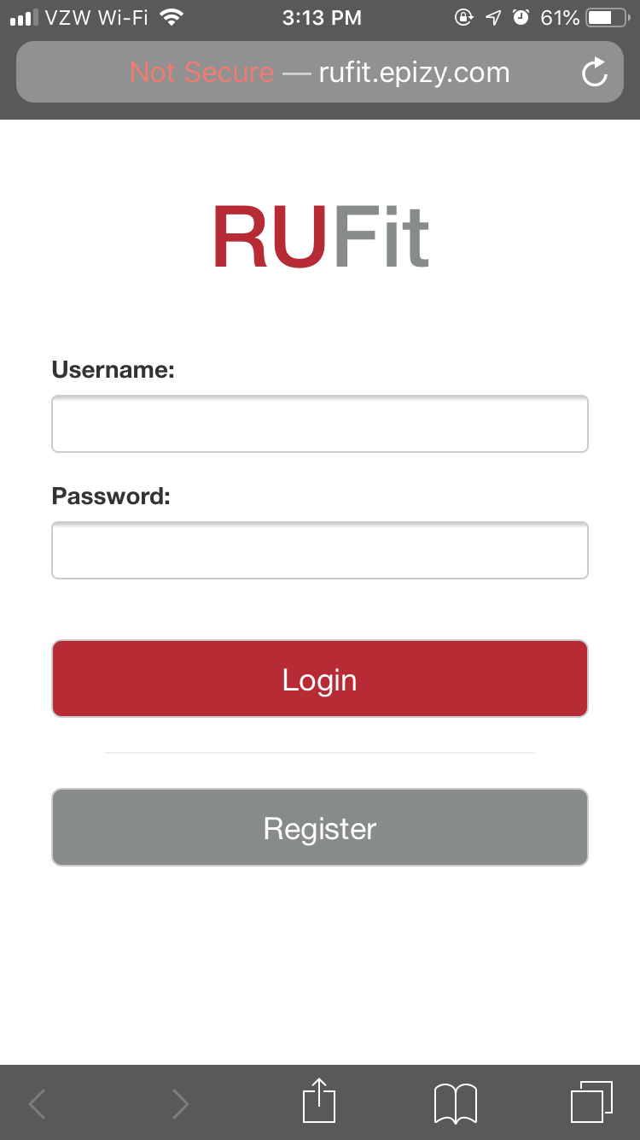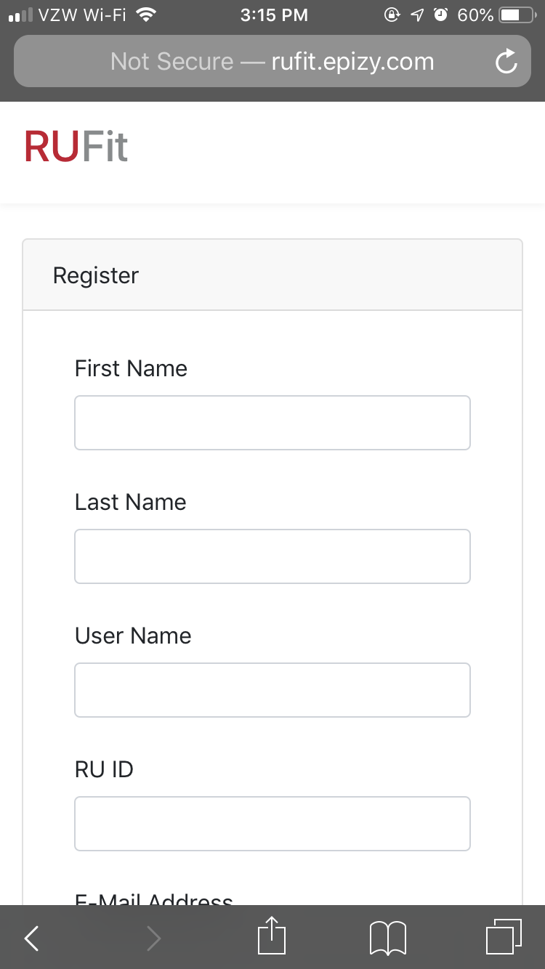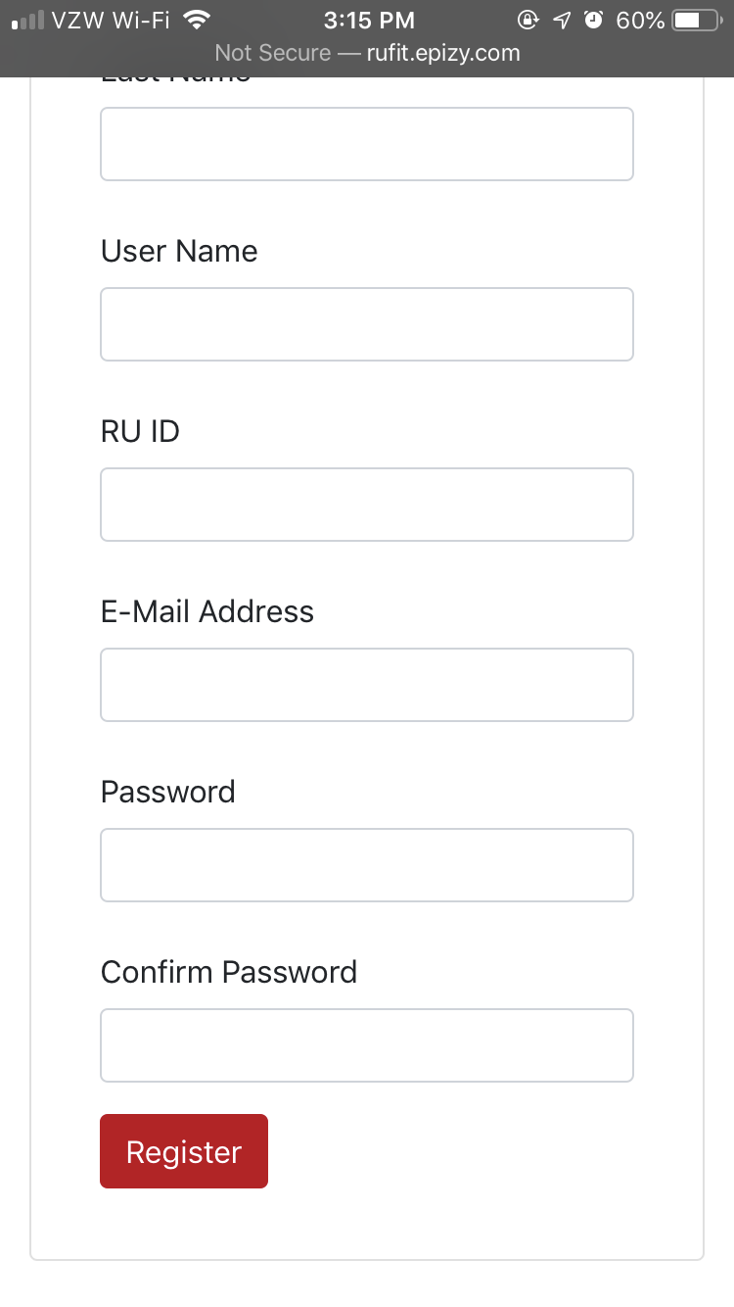

## 

## 3.2 System Menu

*This section describes in general terms the system menu first encountered by the user, as well as the navigation paths to functions noted on the screen. Each system function should be under a separate section header, 3.2.1 - 3.2.x.*

### 3.2.1 View Menu

Provide a system function name and identifier here for reference in the remainder of the subsection. Describe the function and pathway of the menu item. Provide an average response time to use the function.

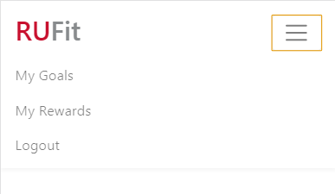

### 

### 

### 

### 

### 

### 

### 3.2.2 Add Exercise

Provide a system function name and identifier here for reference in the remainder of the subsection. Describe the function and pathway of the menu item. Provide an average response time to use the function.

* To add an exercise, a user has to click on the Add Exercise button located on the homepage that they are redirected to on a successful login and filling out data about an exercise.

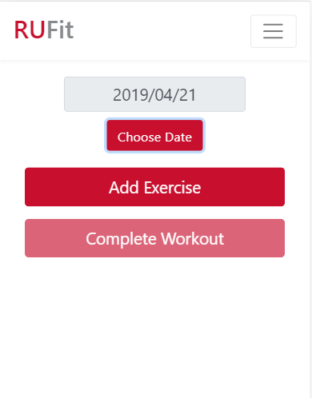

### 

### 3.2.3 Complete Workout

Provide a system function name and identifier here for reference in the remainder of the subsection. Describe the function and pathway of the menu item. Provide an average response time to use the function.

* The user can click on Complete Workout button once they are done logging their workouts for a day. This in turn will give them points towards a reward.

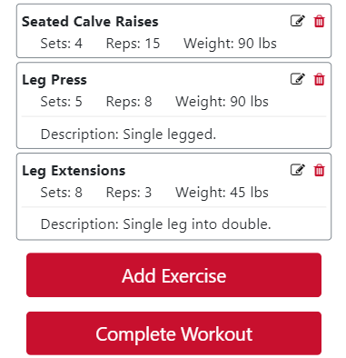

### 

### 

### 

### 

### 3.2.4 Create a Goal

Provide a system function name and identifier here for reference in the remainder of the subsection. Describe the function and pathway of the menu item. Provide an average response time to use the function.

* The user can go to the main menu on the top right of the screen and click on My Goal which will redirect to the goals page where Create Goal button is located.

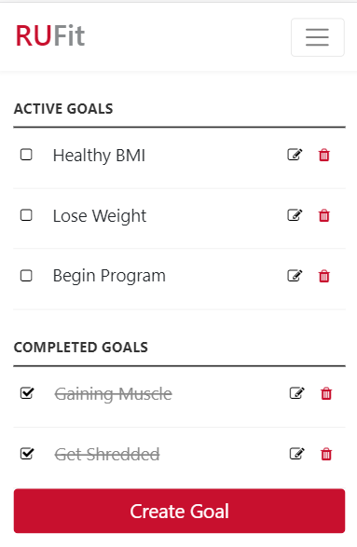

### 

### 3.2.5 Complete a Goal

Provide a system function name and identifier here for reference in the remainder of the subsection. Describe the function and pathway of the menu item. Provide an average response time to use the function.

* Once the user creates a goal, it is displayed on the goals page where they can mark it complete by clicking on the checkbox, after they have completed the goal.





### 3.2.6 Edit a Goal

Provide a system function name and identifier here for reference in the remainder of the subsection. Describe the function and pathway of the menu item. Provide an average response time to use the function.

* Once the user creates a goal, it is displayed on the goals page where they can edit by clicking on the edit icon, if they want to modify any data about the goal.





### 3.2.7 Delete a Goal

Provide a system function name and identifier here for reference in the remainder of the subsection. Describe the function and pathway of the menu item. Provide an average response time to use the function.

* Once the user creates a goal, it is displayed on the goals page where they can delete it by clicking on the trash icon.





### 3.2.8 Edit a Workout

Provide a system function name and identifier here for reference in the remainder of the subsection. Describe the function and pathway of the menu item. Provide an average response time to use the function.

* Once the user creates an exercise, it is displayed on the home page where they can edit it by clicking on the edit icon, if they want to modify any data about the exercise.



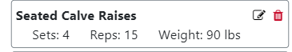

### 3.2.9 Delete a Workout

Provide a system function name and identifier here for reference in the remainder of the subsection. Describe the function and pathway of the menu item. Provide an average response time to use the function.

* Once the user creates an exercise, it is displayed on the home page where they can mark it complete when they have achieved the achieved goal.





### 3.3.0 Claim a Reward

Provide a system function name and identifier here for reference in the remainder of the subsection. Describe the function and pathway of the menu item. Provide an average response time to use the function.

* As the user complete workouts, they earn rewards. Once the reach certain milestones they can claim them by clicking on the My Rewards button located on the Main Menu.

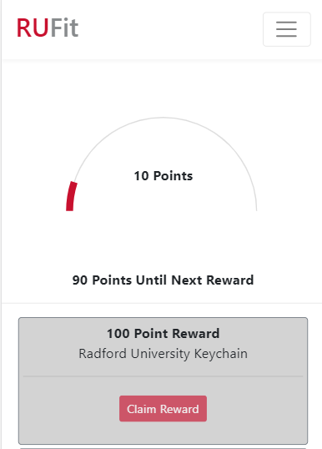

## 3.4 Exiting the System

Describe the actions necessary to properly exit the system.

* To exit, a user has to go to the menu and click on logout to exit the system.

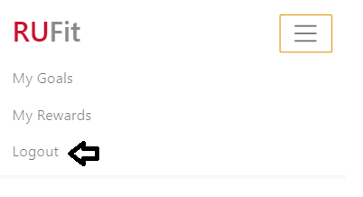

## 

## 3.5 Special Instructions for Error Correction

Describe all recovery and error correction procedures, including error conditions that may be generated and corrective actions that may need to be taken.

* The user simply needs to follow the prompts that inform of ongoing errors.

## 3.6 Caveats and Exceptions

If there are special actions the user must take to insure that data is properly saved or that some other function executes properly, describe those actions here. Include screen captures and descriptive narratives, if applicable.

* The user has to click on the choose date button in order for the date to be chosen for any day that is not today.

## 3.7 Maintenance Capabilities

Describe all how future maintenance of the system should happen.

* In order to keep the RUFit system running in the future there will need to be various types of updates administered. First, there will need regular updates to keep the system running and performing, as it should. Next, there will need to be security updates that will correct and patch security issues. Next, there needs to be regular updates to fix any bugs that are reported by users of the system. Last, there will need to be updates that will introduce new features to the system.