Homework 4 INF503

Jiaming Chen

Part 1: Needleman Wunsch

The result:

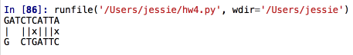

Part 2: Smith Waterman

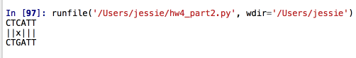

The following is the running time for Needleman Wunsch and Smith Waterman. In hw4.sh, Needleman Wunsch is executed first and Smith Waterman is executed subsequently. The running time for these two algorithm is quite same here. Smith Waterman is slightly fatser.

1000:

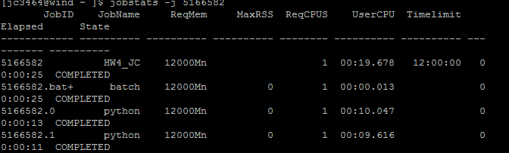  
10000:

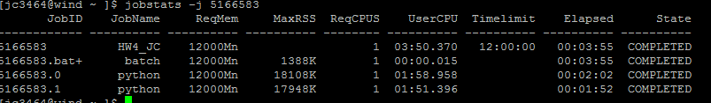

100000:

