Introduction
As part of our Human-Computer Interaction Course at Macalester College, our group was tasked with adapting an electric water gun to be able to use a button switch to fire in addition to the trigger. This adaptation allows people with limited hand function to more easily use the water gun, as they might struggle with pulling the trigger or holding the gun. The button switch negates the need to pull the trigger and allows more variety in the placement and holding of the gun. Additionally, we were tasked with designing a stand for the gun in order to provide a stable and usable platform, such that people with limited motor function could more easily aim and use the gun.

Research

Commercial Alternatives:

Water Gun with Lights Switch Adapted - $51.69
Switch-Adapted Powerful Water Gun - $70.00

DIY Alternatives:
Adaptions 4 Kidz: Switch Adapted Water Gun Fun
Switch Adapted Water Gun - Makers Making Change

Requirements

Goals
G01 | Switch adapt the water gun
G02 | Design a 3D printed stand for the water gun
G03

Functional Requirements
F01 | That the water gun can be adapted to work with a 3.5mm switch.
F02 | It can be placed in a wheelchair or other vehicle.
F03

Non-functional Requirement
NF01 | The adaptation is easy enough so other volunteer makers can do it themselves.
NF02
NF03

Constraints
C01 | We had a time restraint of 3 weeks to make our switches and adapt the water gun.
C02
C03

Ideation
The water gun planned to be used in this project is shown below. It is a battery-operated water gun that requires no pumping to squirt water. It was purchased from Walmart. The idea is to add a jack in parallel with the existing switch in the water gun.
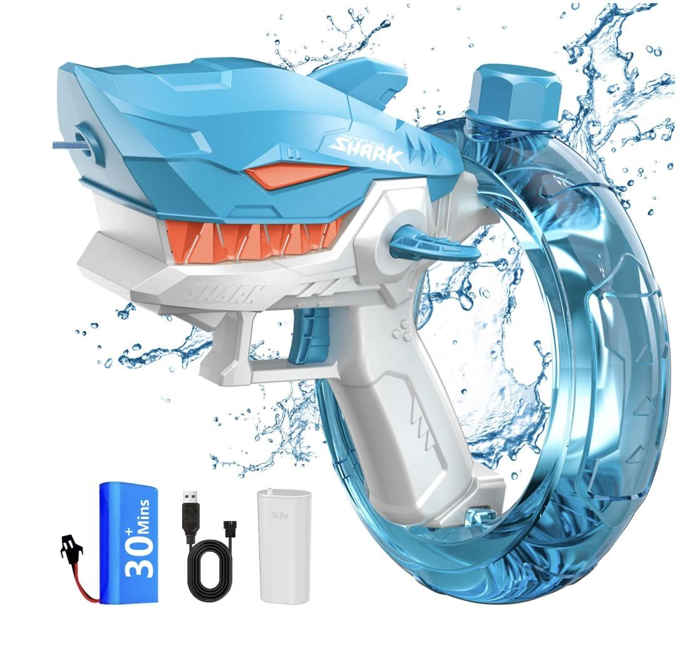
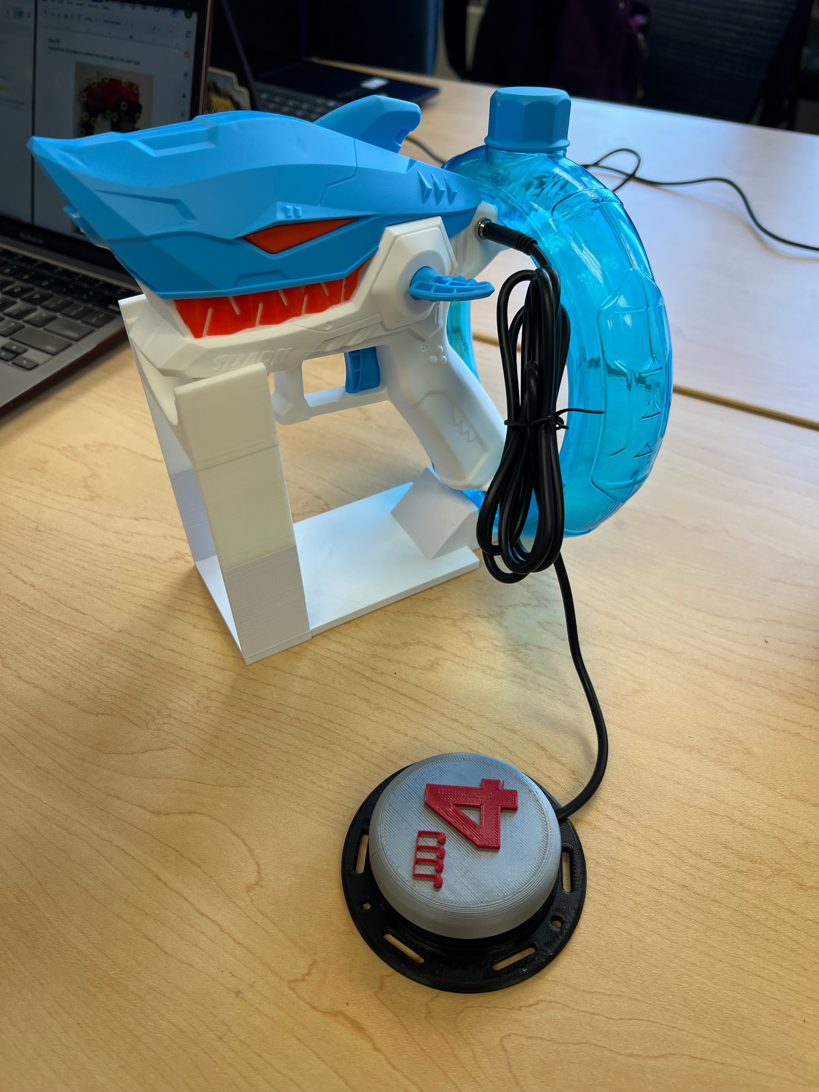

Conceptual Design

Concept 1 – Adding the Assistive Switch in Parallel
The original concept for the water gun adaptation was to be able to add an assistive switch in parallel with the existing switch. This allows for either the original trigger or the assistive switch to operate the toy. This would be done by drilling a hole in the plastic shark mold of the water gun for the mono jack to sit. The jack would then be added in parallel to the existing trigger for the water gun using new wiring. The button and the original trigger were soldered together and worked independently. Implementing this design means the user can choose to either utilize the original button to trigger the water gun or attach an assistive switch to trigger the water gun. Below is a visual of the process of soldering the mono jack in parallel with the original trigger.
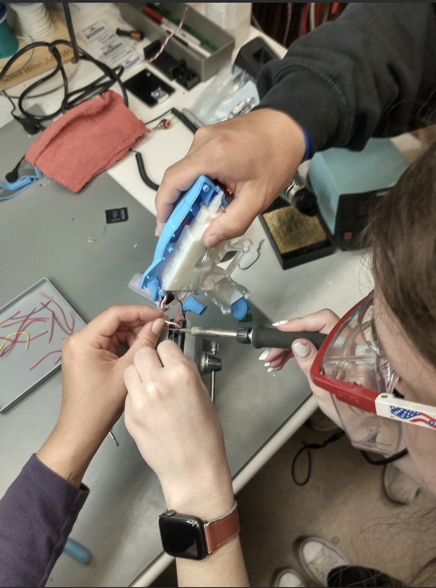

Concept 2 - Designing a Stand for the Water Gun
For our water gun stand, we focused on creating a simple, easy-to-print design that held the water gun in place but allowed for some freedom of movement, so that the user could rotate the gun on the stand. Our design is pictured below.
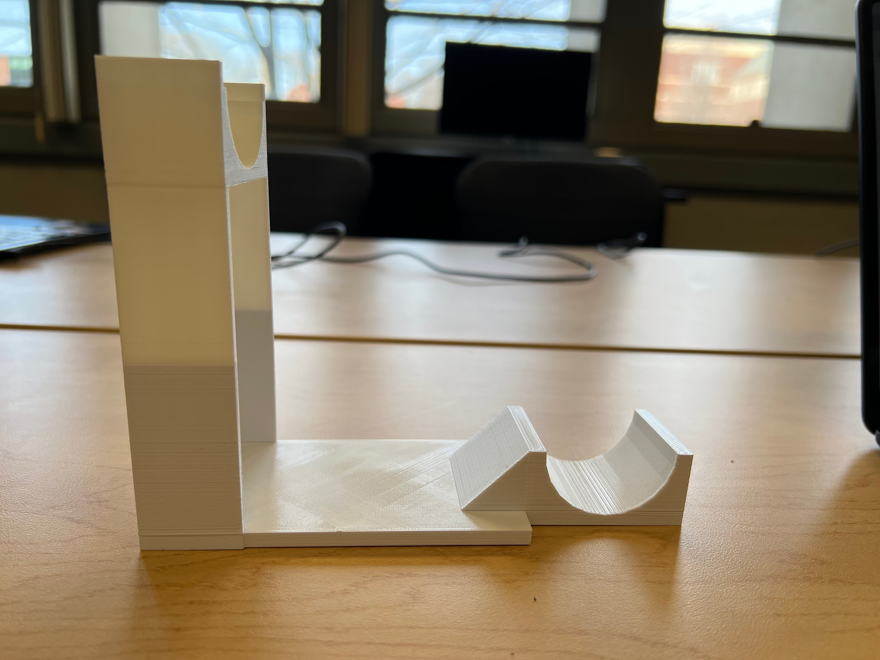
The semi-circle in the back (the right side of this photo) is sized such that the reservoir for the water gun fits into it, and is held stationary, but it is loose enough that the gun can be removed easily and be rotated in place. The semi-circle in the front (the left side of this photo) holds the front end of the water gun securely. Our stand is also designed to use a quite limited amount of filament to print, making it economical to produce. We also ensured that it was lightweight and quite compact, making it easy to transport and able to be used on many surfaces of different sizes.

Detailed Design

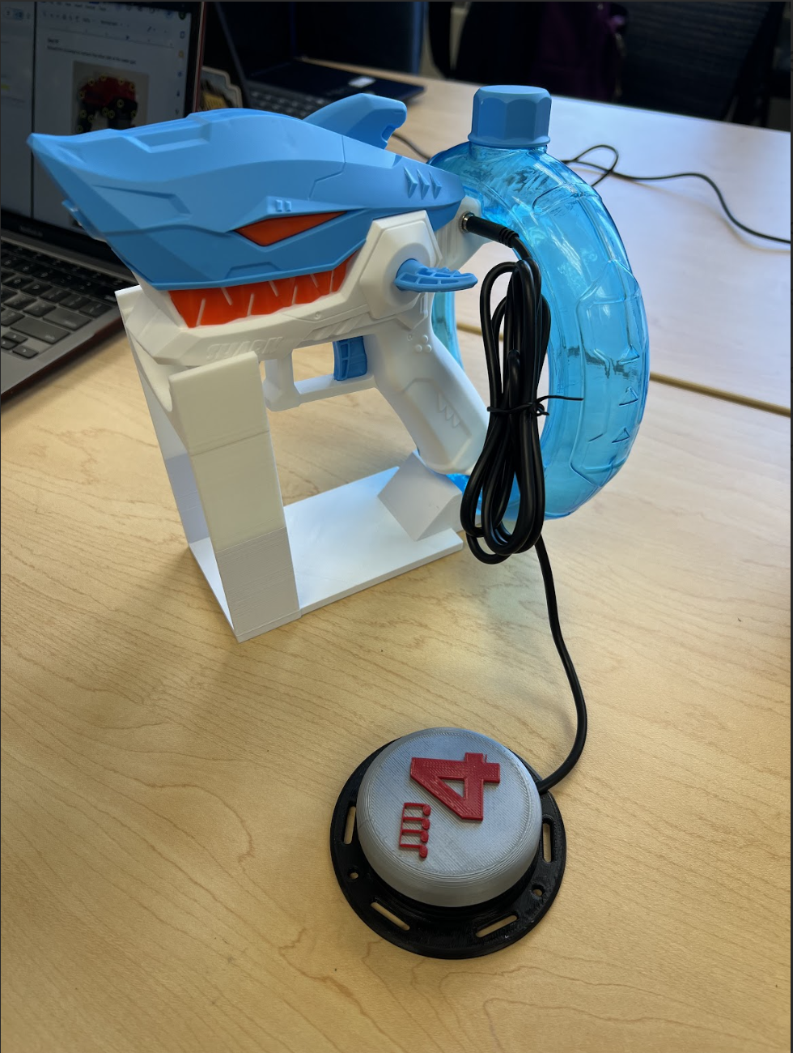
This is the switch-adapted water gun. You can see that the trigger is still there and the button is connected to the jack that we created. We can press the button and the water gun works.
Testing
We tested our water gun by attaching a button switch through the 3.5mm jack and pushing the button, which successfully fired the water gun. We made sure that the original trigger on the water gun continued to function as well. Our class also put on a little competition in which we tested the water guns with the stands. We were successful as we got positive feedback from our classmates about our switch design and our stand.

Opportunities for Improvement
- Design the stand to rotate to allow for more adaptability and creativity when using the water gun.
- Find a simple way to redesign the stand such that the gun can optionally be locked into place.

