# 3D Printing Summary (Prusa MK4)

|  |  |
| --- | --- |
| **Metrics** | **Servo Base** |
| Total Print Time (min) | 610min |
| Total Number of Components | 1 |
| Typical Total Mass (g) | 261.84g |
| Typical Number of Print Setups | 1 |

# 3D Printing Summary (Prusa MK3S)

|  |  |
| --- | --- |
| **Metrics** | **Adapted Phone Mount** |
| Total Print Time (min) | 616min |
| Total Number of Components | 1 |
| Typical Total Mass (g) | 100.84 g |
| Typical Number of Print Setups | 1 |

# 3D Printing Settings (Prusa MK4)

|  |  |  |  |  |  |  |  |
| --- | --- | --- | --- | --- | --- | --- | --- |
| **Print File Name** | **Qty** | **Total Print Time (hr:min)** | **Mass (g)** | **Infill (%)** | **Support (Y/N)** | **Layer Height/ Nozzle Diameter (mm)** | **Notes (orientation, special settings, etc.)** |
| Servo_Base.stl | 1 | 10:10 | 261.84g | 15 | Y (on build plate only) | 0.3/0.4 | Print in orientation given in STL  Used 0.20mm STRUCTURAL rather than speed |

# 3D Printing Settings (Prusa MK3S)

|  |  |  |  |  |  |  |  |
| --- | --- | --- | --- | --- | --- | --- | --- |
| **Print File Name** | **Qty** | **Total Print Time (hr:min)** | **Mass (g)** | **Infill (%)** | **Support (Y/N)** | **Layer Height/ Nozzle Diameter (mm)** | **Notes (orientation, special settings, etc.)** |
| Phone Stand Parts.stl | 1 | 10:16 | 100.84g | 15 | Y (on build plate only) | 0.3/0.4 | Print in orientation given in STL  Used 0.20mm QUALITY rather than speed |

# Post-Processing

It is good to use supports for this device. I chose to let my slicer program, the Prusa slicer, automatically insert supports on the build plate only. I also chose to use 0.20mm structural/quality instead of speed, so that the build has a higher chance of being printed stably. I had access to two different printers, the MK4 and the MK3S, during this time. This is likely why the phone stand took so much longer, relatively, when comparing overall mass to the servo base. If printing using different printers, expect different speeds of printing.

# Customization Options

The user can request the color of the stand or any other custom markings they may want on the device.

# Examples of Quality Prints

Below are pictures of what the quality of the print is expected to look like:

Phone Stand:

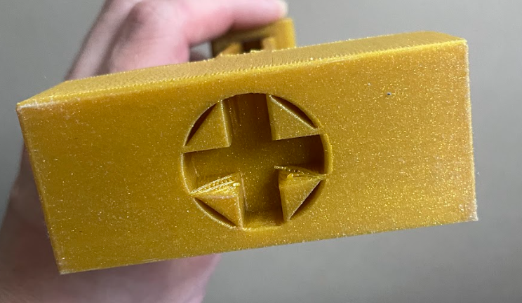.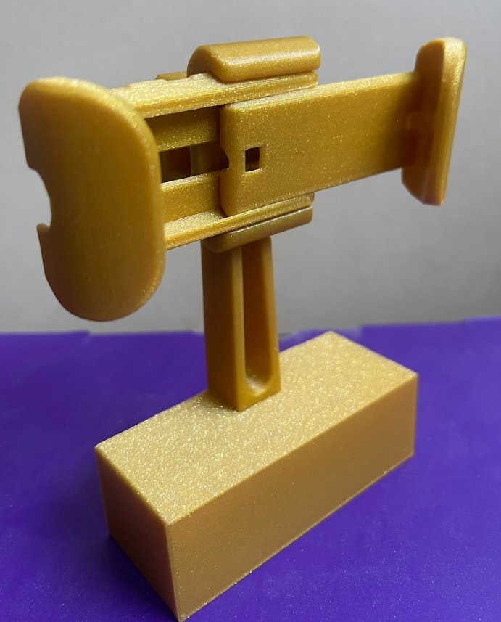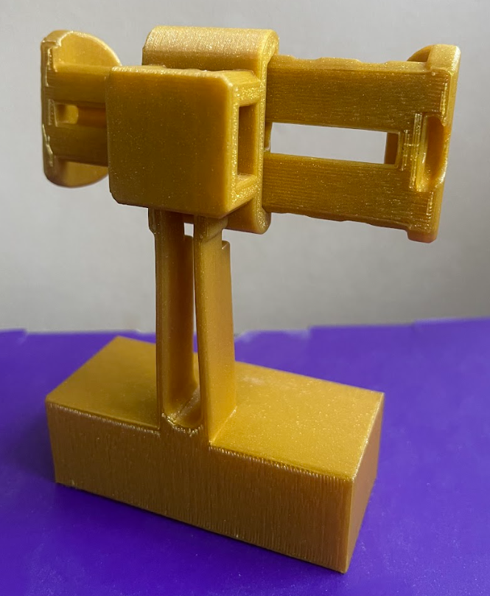

|  |  |
| --- | --- |
| Servo Base: |  |