# Required Components

|  | **BOM**   1. Electric Water Gun 2. 3.5mm mono jack and nut 3. 2 pieces of wire 100 mm long |
| --- | --- |

# Required Tools

* Drill with 15/64" (can also use a 6mm) plexiglass bit
* Small Phillips screwdriver (it must be skinny as the screws are in deep)
* Flush Cutters
* Wire Strippers
* Soldering Iron and Solder
* Scissors

# Required Personal Protective Equipment (PPE)

* Safety Glasses

# Assembly Instructions

## Step 1

Remove the 10 screws from the side of the water gun as pictured below (One screw can be found beneath the top blue half of the water gun).

| a picture of a red and black small water gun |
| --- |

## Step 2

Remove and set aside the top and bottom pieces of the half of the water gun that was held down by the screws.

|  |
| --- |

## Step 3

Using a drill with 15/64" (can also use a 6mm) plexiglass bit so as to not shatter the plastic, drill a hole through white plastic at the back of the water gun (see location below)

|  |
| --- |

## Step 4

Remove the nut from the mono jack and insert it through the hole to ensure it fits. Reinstall the nut and tighten to secure.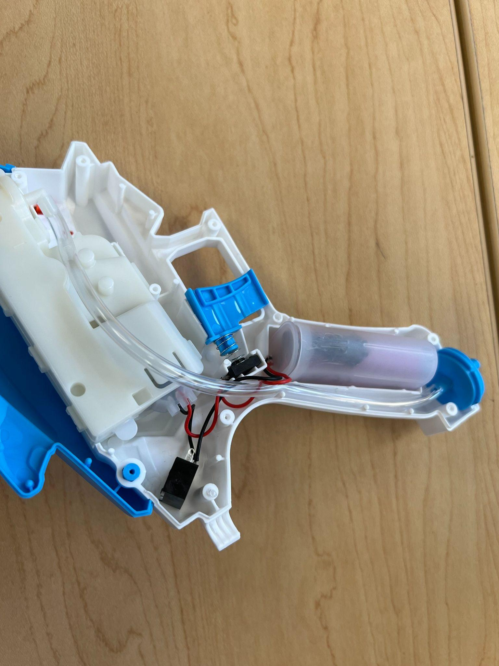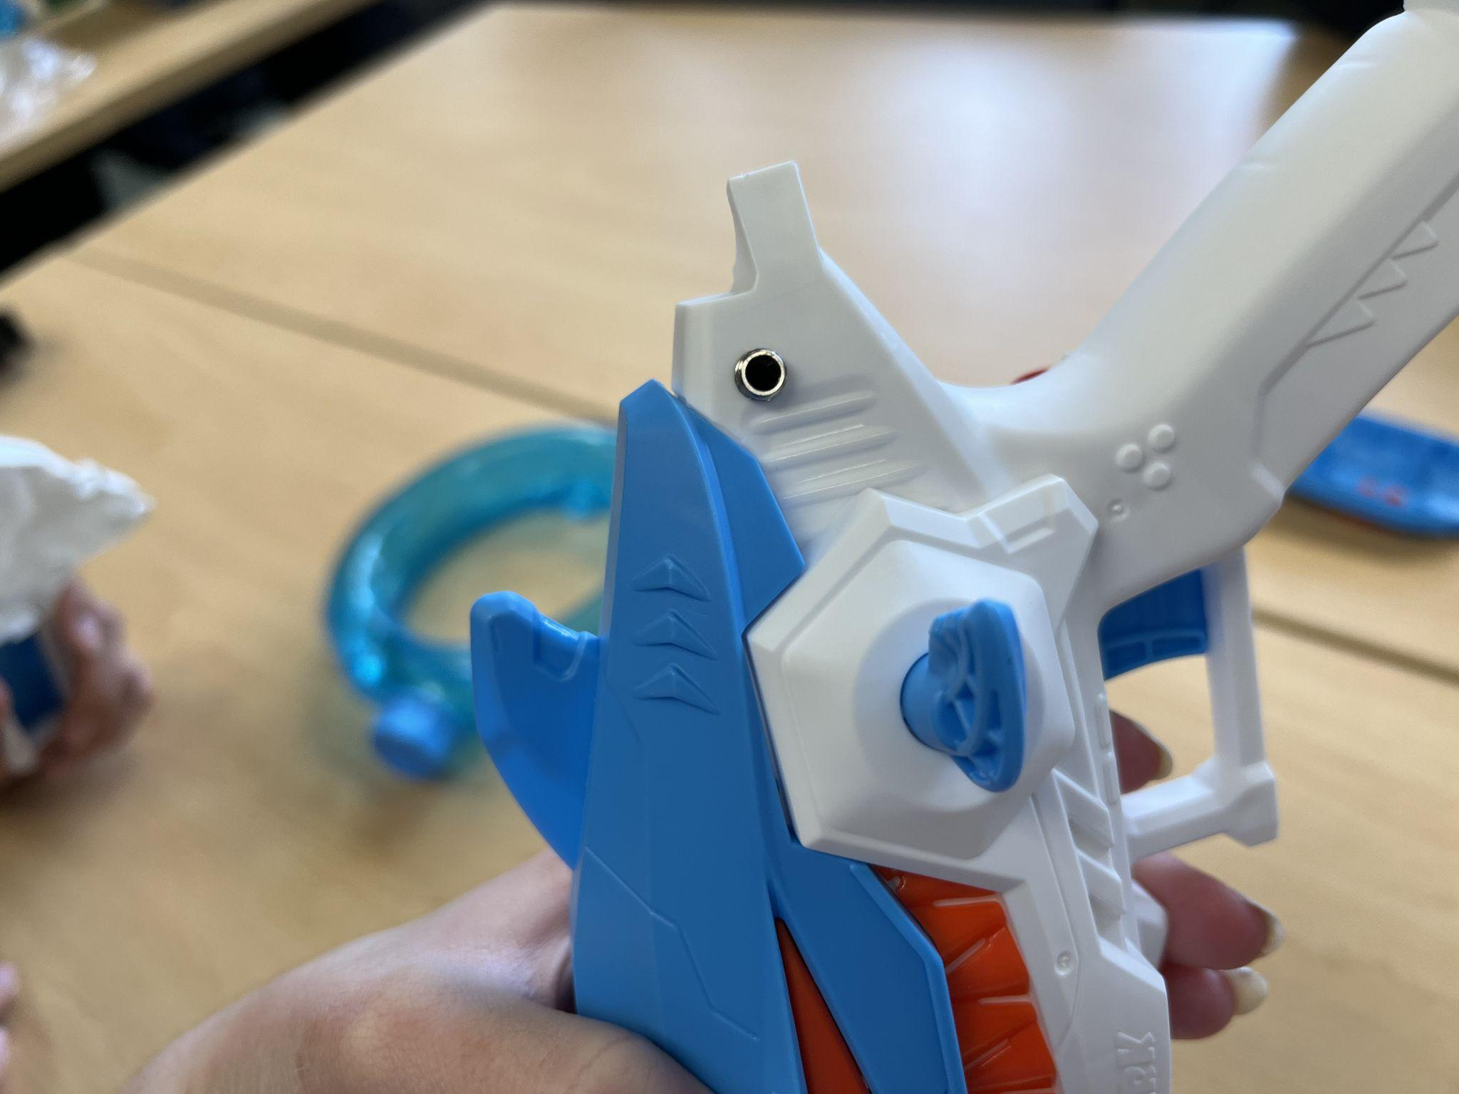

|  |
| --- |

## Step 5

Remove the mono jack after ensuring it fits in the hole. Cut 2 x 100mm pieces of wire and strip 5 mm off each end. Insert each of the 100 mm long pieces of wire into two of the terminal holes of the mono jack (see below). Fold over the excess exposed wire.

|  |
| --- |

## Step 6

Using the soldering iron, solder the wires to the mono jack. Ensure there is no wire insulation in the soldering area. Use the flush cutters to remove any excess exposed wire.

|  |
| --- |

## Step 7

Repeat step 4 to insert the mono jack back into the hole. 

|  |
| --- |

## Step 8

Remove the button from the trigger. To solder the mono jack in parallel with the original trigger for the water gun, solder the two new wires on top of the original soldered wires on the button. Use the flush cutters to remove any excess exposed wire. 

|  |
| --- |

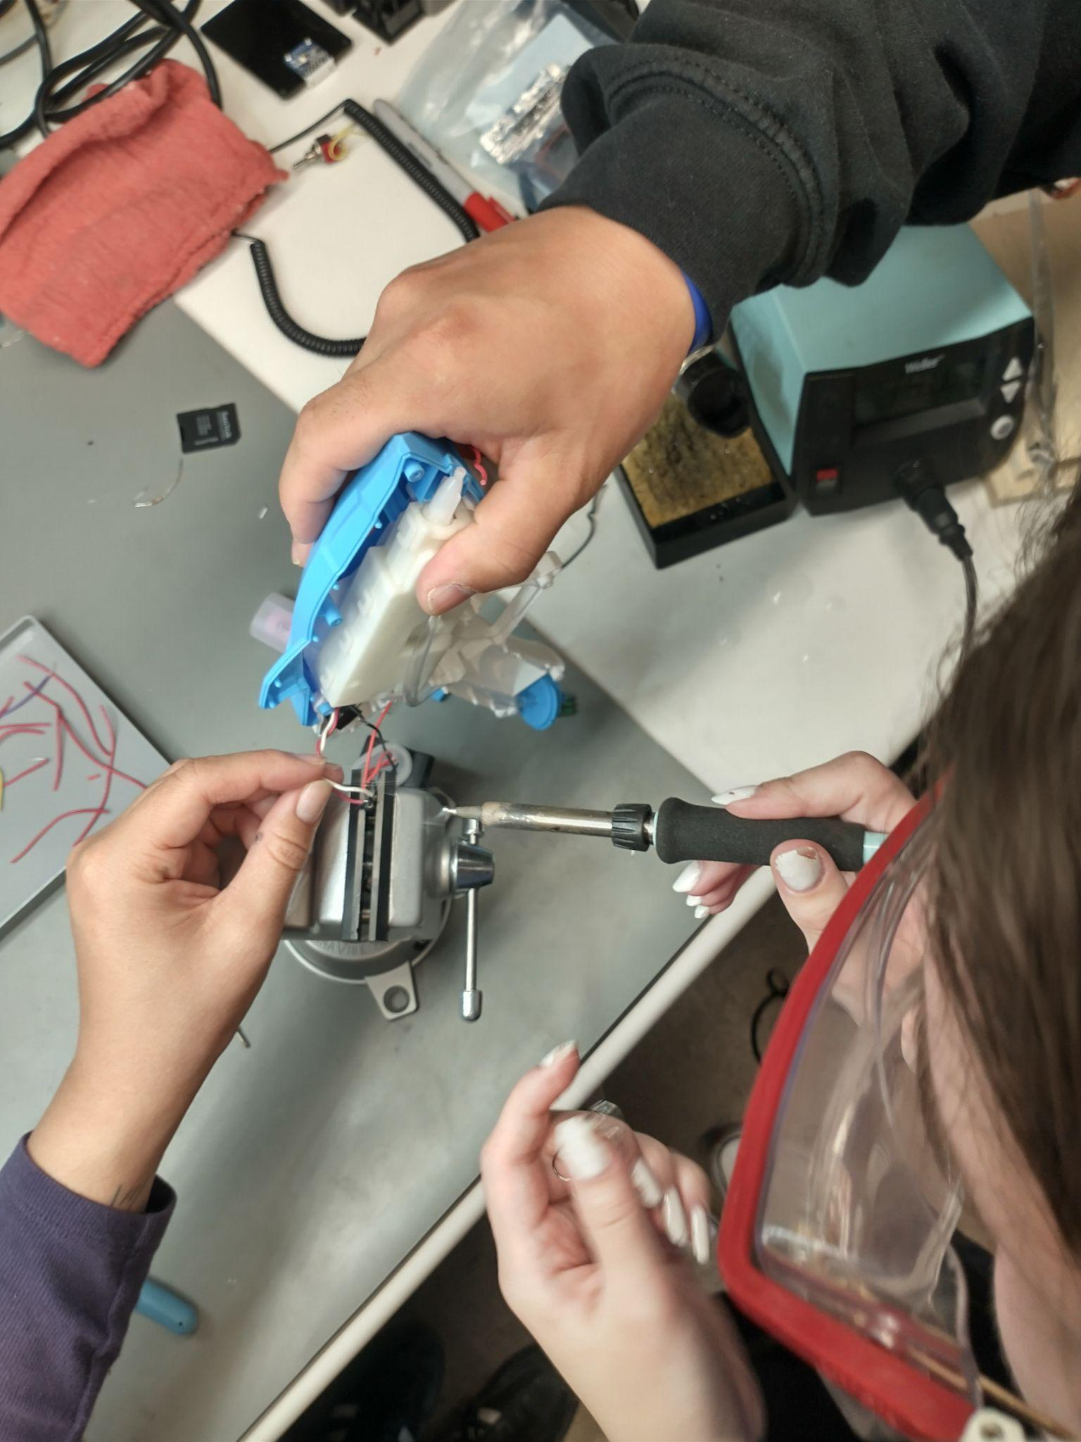

## Step 9

Reset the button in the trigger area and reinsert the 10 screws to reattach the other side of the water gun.

| a picture of a red and black small water gun |
| --- |

## Step 10

Place the water bottle of the water gun in the lower half-circle of the water gun stand and the shark head in the upper half-circle.

