## Introduction

## This is a switch-adapted water gun that is compatible with 3.5mm switches. The intention of this device is to assist someone with limited hand function who might be interested in using a water gun.

## Features

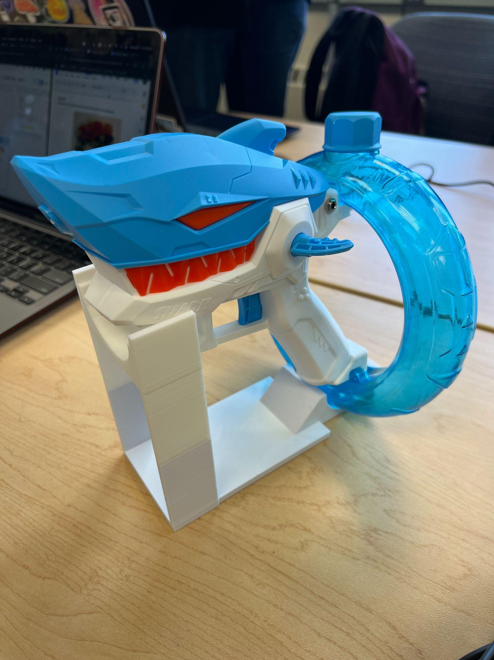

## Usage

The Switch Adapted Water Gun can be used by filling up the water bottle with water and plugging in a 3.5mm switch into the side of the water gun. The water gun can be activated by either pressing the switch or using the trigger included with the water gun.

## Compatibility

The Switch Adapted Water Gun should be compatible with any 3.5mm switch.

## Specifications

| **Length (mm)** | **Width (mm)** | **Height (mm)** |
| --- | --- | --- |
| 177.8 | 50.8 | 177.8 |

## Cleaning

The device can be cleaned using a damp cloth to wipe it down. The water bottle at the back of the water gun can be removed and emptied when not in use.

## Changing the Batteries

The battery pack can be accessed on the side of the handle of the water gun by removing the screw to the compartment. Inside the compartment is a translucent container. Open the container to find the battery pack attached to the wires by a black plastic clip. Disconnect the battery pack by unclipping it and replace it with the new battery. The device uses a 3.7V rechargeable lithium battery.



