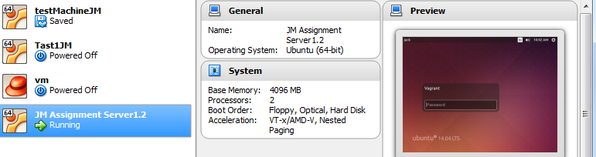Create new Vagrant environment

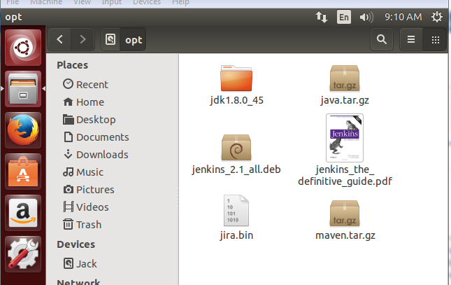Include install files in shared folders

Moved from shared folder to /opt

After extraction of java and maven files

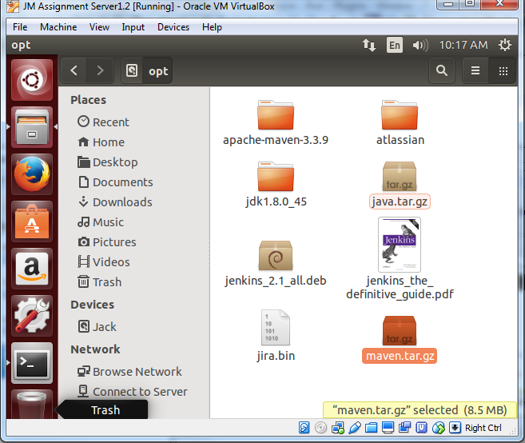

Run vagrant up

