Course Title: Wireless Networking
Date: 1/3/2024

Exercise 1: Plan a Small Office Network Report
clarification: network device info (SSID and such) can be found in the simulation files
1. Introduction
- Brief overview of the small office scenario.
In this small office scenario, we see an attempt to create a reliable network for daily use, fitting to different user needs.
- Objectives of the network plan.
- Provide reliable connection methods
- Cover all needed spots with signal
- Provide as much speed as possible, at a reasonable budget
2. Cisco Packet Tracer Simulation
- Network Layout: Include a screenshot of the overall network layout designed in Cisco Packet Tracer. Describe the rationale behind the placement of routers, APs, and other network devices.
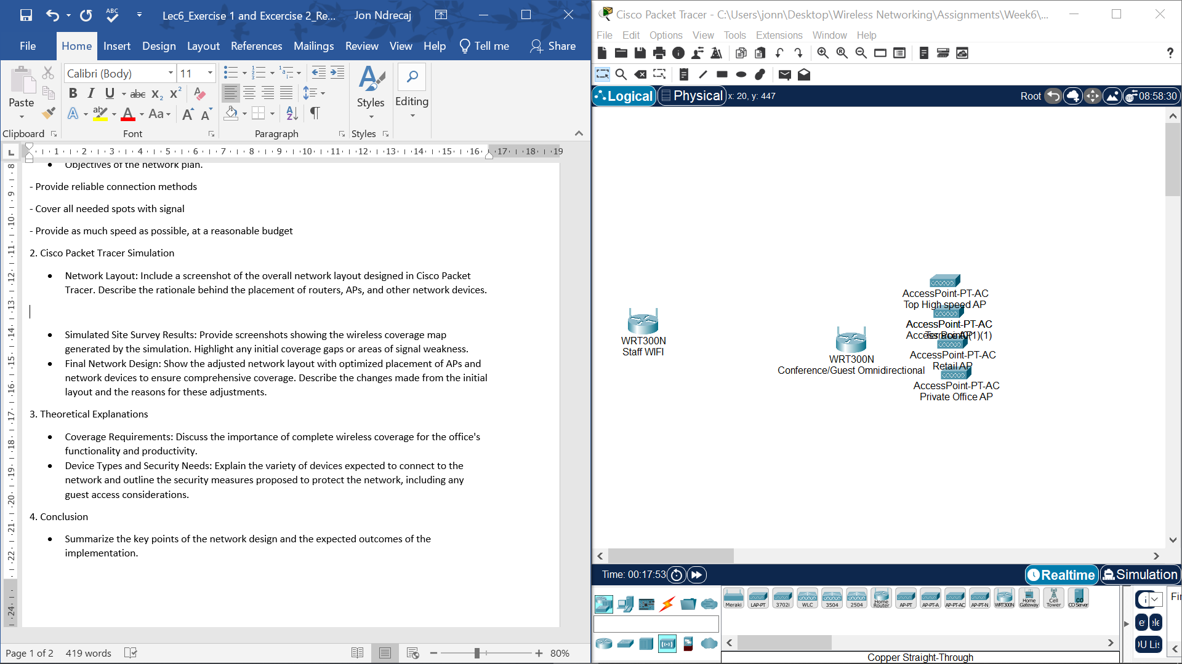 Fig. 1: Network devices
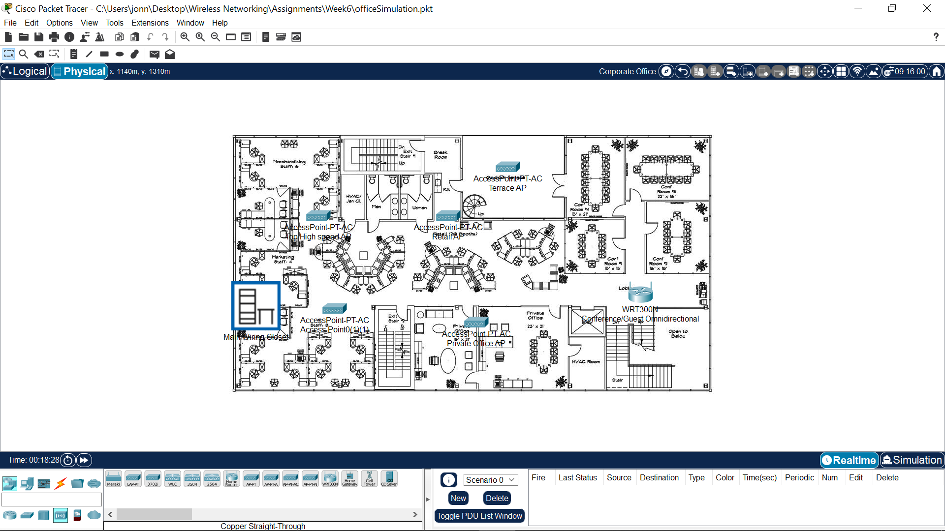 Fig. 2: Layout
As one can see, the overall network layout covers a small office using 2 omnidirectional antennas (represented by the WRT300N device), and 5 directional antennas from the APs. The network has been separated in these 5 groups:
- general Staff WIFI (in wiring rack, provides signal for 1 half of the building)
- conference, guest WIFI (in the lobby, covers the other half of the building)
- High speed AP, dedicated to merchandising, and marketing staff.
- 1 High speed AP needed for the IT Office
- 1 high speed access point for the central information room (called retail but that’s the role I assigned)
- 2 private offices share the same AP for higher bandwidth
- Terrace access point provides good speeds

The reason 2 omnidirectional antennas are used to cover the building is so each part of the building has good coverage of signal. It also adds redundancy, in case the access points in respective sections fail. Guests connect to the right side of the building, while staff has their own dedicated router. The directional access points give high bandwidth (in this case, WIFI 5 speeds) data rates to separate departments, and ensures network segregation.
- Simulated Site Survey Results: Provide screenshots showing the wireless coverage map generated by the simulation. Highlight any initial coverage gaps or areas of signal weakness.
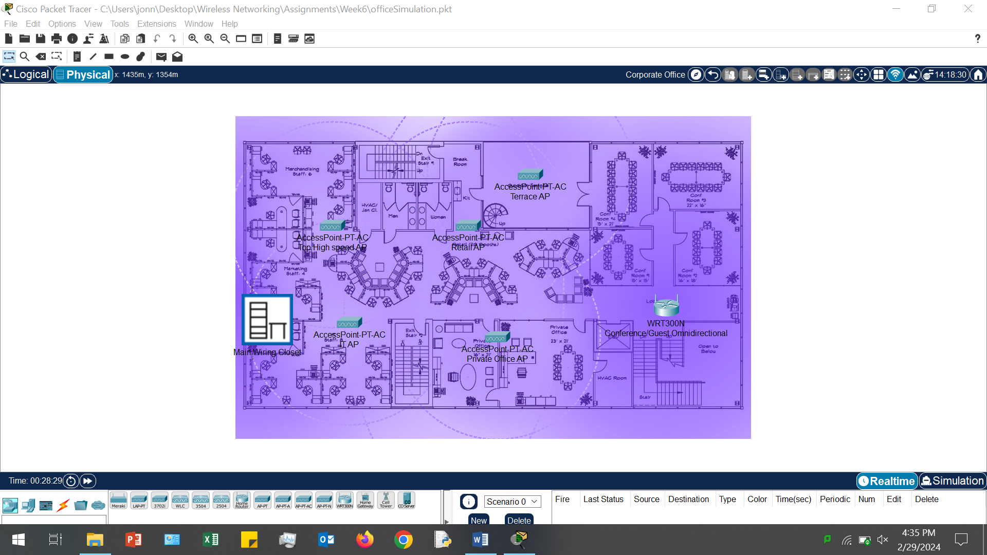 Fig. 3
Since this simulated site survey also shows the final network design, it has been ensured that the network covers all areas of the office plan, except the edges of the break room and exit stairs. This is intentional, and will be explained in the final section.
Ranges of devices:
Wireless routers (role of omnidirectional antennas) -> 125m coverage range
AP range -> 40m
Signal weaknesses exist when considering also that the omnidirectional antennas have weaker signal, however this is also intentional since they’re specialized in covering the building.
- Final Network Design: Show the adjusted network layout with optimized placement of APs and network devices to ensure comprehensive coverage. Describe the changes made from the initial layout and the reasons for these adjustments.
The final network design is shown in figure 3. The optimized placement of APs is displayed by the placement in respective departments. The wireless routers ensure coverage of the whole building. Each office worker has 2 options when connecting:
- redundant, but lasting signal from the routers (acting as omnidirectional antennas)
- tailored access points, which are placed and separated in separate departments, based on needs.

Why are the secondary exits break rooms not as well covered? Because of budgetary constraints. In this case it’s more reasonable to leave the signal of the left wireless router reach there, since it’s a point of exit.
3. Theoretical Explanations
- Coverage Requirements: Discuss the importance of complete wireless coverage for the office's functionality and productivity.
Coverage is most essential in office functionality: reliable, 24/7 connection is needed for staff productivity. However, coverage must also ensure that the correct bandwidth is given to needing areas. Ideally these areas would be segregated places in a WLAN. We can see this being the case in my WLAN design, since there are 5 APs separating each part of the office plan, and 2 routers separating staff from guests or conference calls.
- Device Types and Security Needs: Explain the variety of devices expected to connect to the network and outline the security measures proposed to protect the network, including any guest access considerations.
In a small office environment, you can expect about 50 – 100 people to be using the WLAN plan daily. In my plan there’s a lot of variety in terms of ways you can connect to a network. This ensures all sorts of different devices (with WIFI functionality) can connect to the office without much problem. Guest access is essential when there’s other people entering this building. That’s why guest access has been segregated into the right path of the office, separating from staff. However, due to budgetary constraints, 1 router also covers the conference room, leaving 1 vulnerability. In this case, it’s important to inform staff of security problems that could happen by connecting to the conference/ guest WIFI. Regardless, the security of each network device is encrypted with WPA2/PSK encryption, so only trusted people can use the network.
4. Conclusion
- Summarize the key points of the network design and the expected outcomes of the implementation.
Main takeaway of my network design:
- cover area using omnidirectional antennas
- use directional antennas not only to provide higher speed (in this case 5Ghz WIFI) in areas which need it, but also to segregate the network
- use different channels for antennas operation in the same radio band, to reduce interference. Place devices in line of sight connections ideally, or in open areas where the signal can proliferate.
- Secure the network with 802.1 X, and with WPA2 for AES encryption (if available WPA3 for SAE)
- Inform staff only of networks they can use and prevent the interchange of authentication info between different networks. Ensure ACL rules to prevent untrusted actors.

Exercise 2: Capacity Planning Simulation Report

1. Introduction
- Overview of the high-density event venue scenario.
A high-density venue would be a place where many people would gather in a specific spot. Use of network is temporary, lasting as long as the event. Due to a fixed location, the network design is centered around covering signal on the main event spaces. The event takes place on top of a roof.
- Objectives of the capacity planning exercise.
- coverage: cover all users who will be in event with good WIFI speeds.
- security: ensure only people who are entering the event have internet access, leave little vulnerabilities.
- speed/budget: cover the event space with the best balance of speed/coverage.
2. Cisco Packet Tracer Simulation
- Venue Layout with Network Devices: Include a screenshot of the event venue layout in Cisco Packet Tracer, showing the placement of network hardware. Describe how the layout was designed to manage high-density environments.
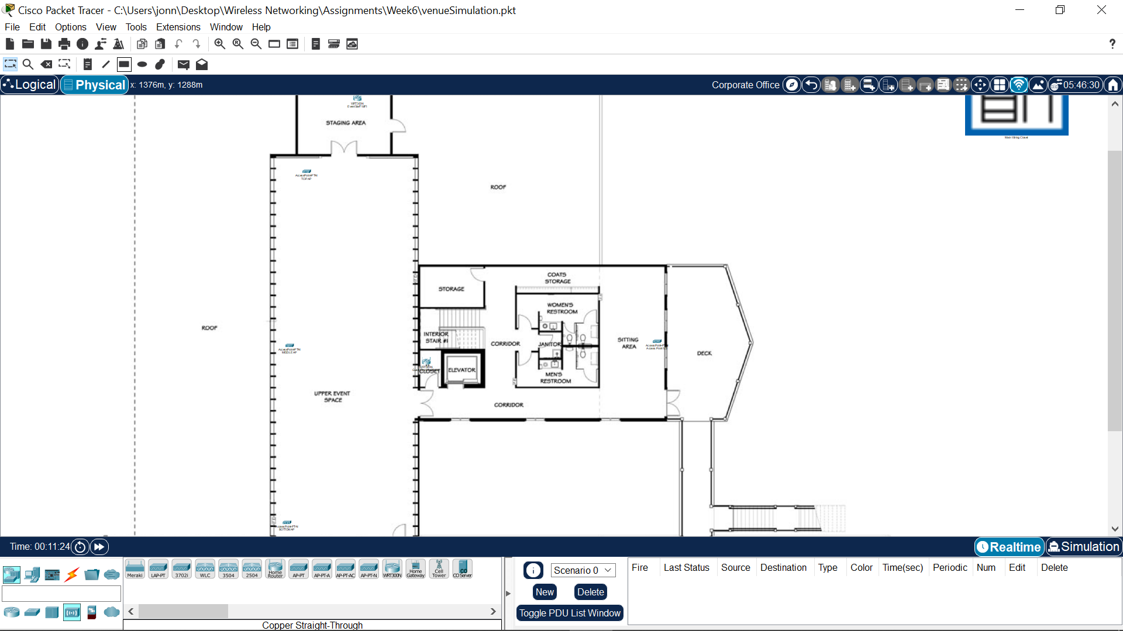 Fig. 4
In this case, we can see the event layout is big. This leaves the need to cover the area with many directional antennas. However, it’s clear that in this case the access points have to be of higher power than traditional antennas.
Network devices:
1. Staff WI-FI: located in the staging area, it ensures the staff working on the even has access to their own separate connection. This separates staff and guests.
2. Four directional antennas, covering the top, middle, bottom of the event space and covering the sitting area/deck. All of these antennas have the same SSID, ensuring easier connection. It’s important to note that these need to be set up in different channels to reduce interference. These directional antennas try to separate the high-density area into smaller parts.
3. Guest Router covers the space before the event venue. Gives general guest access to slower connections. An omnidirectional antenna acting as fallback in case of bandwidth increase, and as an additional connection point.
- Hardware Selection: Provide details and screenshots of the different routers and APs tested in the simulation. Discuss why certain hardware was chosen based on its performance in the simulated environment.
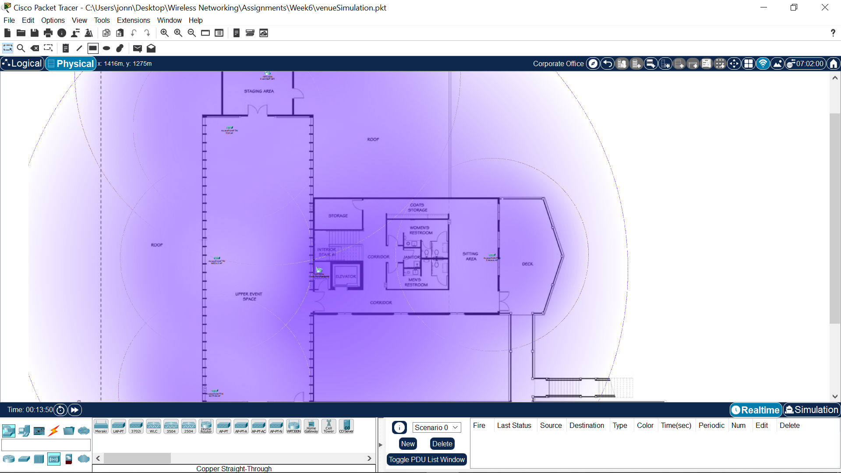 Fig. 5
As for the hardware choice, the wireless routers represent omnidirectional APs. The staff Wireless router is used by all staff, but it is located further from the venue. The guest router, also an omnidirectional antenna, covers areas before the venue and acts as fallback. The 4 APs provide higher speed WIFI for all the event goers.
3. Theoretical Explanations
- Capacity Planning Approach: Elaborate on the methods used to estimate capacity needs, considering attendee numbers, device usage, and application demands.

capacity needs: the upper event space needs bandwidth to cover 200 people (standard venue size, depending on event, requirements could be even larger).
device usage: ensure devices can connect to the internet throughout different points of the event space.
application demands: High gain Directional antennas ensure application demands could be met.
- Visualization Tools: Briefly mention the types of advanced tools that could further aid in capacity planning, acknowledging their potential for more detailed analysis beyond Packet Tracer's capabilities.
Network traffic analyzers are essential to ensuring that capacity planning is accurate. Cisco packet tracer can show area requirements, but monitoring tools show type of data such as:
bandwidth usage, traffic patterns and resource use. [1]
- Capacity Planning Report Insights: Summarize the theoretical aspects of compiling capacity planning findings, emphasizing the justification for network design decisions and hardware choices.

To ensure proper capacity planning, network analyzers are needed to be continuously used to know proper insights needed for placement and hardware choice. Other things to consider in capacity planning is the type of environment. This can be simulated in cisco packet tracer by imagining areas that need special coverage. In my case, the even venue was separated into 3 parts to make the high-density area have stronger signals and coverage. This adds an expense by adding more directional access points, with likely higher gain than usual. In this type of area, capacity planning also needs to ensure how long data is going to be sent/received for budget concerns.
4. Conclusion
- Recap the planning process, highlighting how the chosen network design and hardware meet the anticipated needs of the event venue.
The planning process involves doing a careful site survey, which evaluates the area (high-density, low-density, temporary/permanent (daily use), size of area, bandwidth requirements, how the network should be segregated, interference, and so on.) on general insights for network planning. Then, traffic analyzers give accurate, numerical information over where pain points in the network are, and how to solve them.
sources:
- https://obkio.com/blog/network-capacity-monitoring-and-planning/

END OF WORK

