PA1_template

Julia E. Neidhardt

2023-06-29

# Library Chunk

# Loading and processing the data begins with loading packages and libraries  
library(dplyr)

library(tidyverse)

## ── Attaching core tidyverse packages ──────────────────────── tidyverse 2.0.0 ──  
## ✔ forcats 1.0.0 ✔ readr 2.1.4  
## ✔ ggplot2 3.4.2 ✔ stringr 1.5.0  
## ✔ lubridate 1.9.2 ✔ tibble 3.2.1  
## ✔ purrr 1.0.1 ✔ tidyr 1.3.0

library(ggplot2)  
library(knitr)  
library(rmarkdown)

# Working Directory Chunk

setwd("C:/Users/Owner/Documents/DataScience/ReproducibleResearch/PeerAssesment")

# Load and Test Data Chunk

data <- read.csv("C:/Users/Owner/Documents/DataScience/ReproducibleResearch/PeerAssesment/activity.csv")  
# Display the first few rows of the data frame to ensure the data has processed correctly.  
head(data)

## steps date interval  
## 1 NA 10/1/2012 0  
## 2 NA 10/1/2012 5  
## 3 NA 10/1/2012 10  
## 4 NA 10/1/2012 15  
## 5 NA 10/1/2012 20  
## 6 NA 10/1/2012 25

# Summary Data Chunk

summary(data)

## steps date interval   
## Min. : 0.00 Length:17568 Min. : 0.0   
## 1st Qu.: 0.00 Class :character 1st Qu.: 588.8   
## Median : 0.00 Mode :character Median :1177.5   
## Mean : 37.38 Mean :1177.5   
## 3rd Qu.: 12.00 3rd Qu.:1766.2   
## Max. :806.00 Max. :2355.0   
## NA's :2304

# Plot the Number of Steps per Interval Chunk

plot(data$steps ~ data$interval)

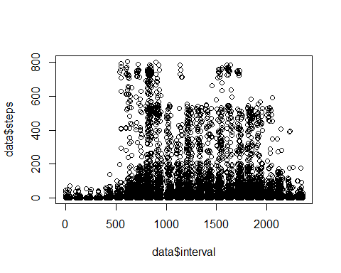 # Calculate Total Steps per Day Chunk

total_steps_per_day <- aggregate(data$steps, by=list(date=data$date), FUN=sum, na.rm=TRUE)  
names(total_steps_per_day) <- c("date", "total_steps")  
print(total_steps_per_day)

## date total_steps  
## 1 10/1/2012 0  
## 2 10/10/2012 9900  
## 3 10/11/2012 10304  
## 4 10/12/2012 17382  
## 5 10/13/2012 12426  
## 6 10/14/2012 15098  
## 7 10/15/2012 10139  
## 8 10/16/2012 15084  
## 9 10/17/2012 13452  
## 10 10/18/2012 10056  
## 11 10/19/2012 11829  
## 12 10/2/2012 126  
## 13 10/20/2012 10395  
## 14 10/21/2012 8821  
## 15 10/22/2012 13460  
## 16 10/23/2012 8918  
## 17 10/24/2012 8355  
## 18 10/25/2012 2492  
## 19 10/26/2012 6778  
## 20 10/27/2012 10119  
## 21 10/28/2012 11458  
## 22 10/29/2012 5018  
## 23 10/3/2012 11352  
## 24 10/30/2012 9819  
## 25 10/31/2012 15414  
## 26 10/4/2012 12116  
## 27 10/5/2012 13294  
## 28 10/6/2012 15420  
## 29 10/7/2012 11015  
## 30 10/8/2012 0  
## 31 10/9/2012 12811  
## 32 11/1/2012 0  
## 33 11/10/2012 0  
## 34 11/11/2012 12608  
## 35 11/12/2012 10765  
## 36 11/13/2012 7336  
## 37 11/14/2012 0  
## 38 11/15/2012 41  
## 39 11/16/2012 5441  
## 40 11/17/2012 14339  
## 41 11/18/2012 15110  
## 42 11/19/2012 8841  
## 43 11/2/2012 10600  
## 44 11/20/2012 4472  
## 45 11/21/2012 12787  
## 46 11/22/2012 20427  
## 47 11/23/2012 21194  
## 48 11/24/2012 14478  
## 49 11/25/2012 11834  
## 50 11/26/2012 11162  
## 51 11/27/2012 13646  
## 52 11/28/2012 10183  
## 53 11/29/2012 7047  
## 54 11/3/2012 10571  
## 55 11/30/2012 0  
## 56 11/4/2012 0  
## 57 11/5/2012 10439  
## 58 11/6/2012 8334  
## 59 11/7/2012 12883  
## 60 11/8/2012 3219  
## 61 11/9/2012 0

# What are the Total Number of Steps Taken Each Day? Chunk

total_steps_per_day <- data %>%   
 group_by(date) %>%   
 summarise(total_steps = sum(steps, na.rm = TRUE))

# Print the first few rows of the total_steps_per_day dataframe to check if it’s created properly

head(total_steps_per_day)

## # A tibble: 6 × 2  
## date total_steps  
## <chr> <int>  
## 1 10/1/2012 0  
## 2 10/10/2012 9900  
## 3 10/11/2012 10304  
## 4 10/12/2012 17382  
## 5 10/13/2012 12426  
## 6 10/14/2012 15098

# What are the Total Number of Steps Taken per Day?

# Create the plot with a title  
scatter_plot <- ggplot(total_steps_per_day, aes(x=date, y=total_steps)) +  
 geom_point() +  
 labs(title = "Total Steps per Day", x = "Date", y = "Total Steps")  
  
# Print the plot  
print(scatter_plot)

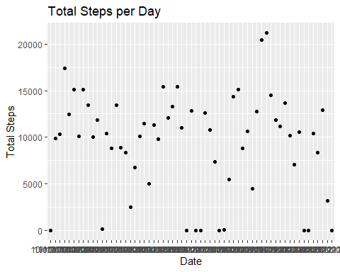

# Save the plot to your working directory  
ggsave("total_steps_per_day_plot.png", scatter_plot)

## Saving 5 x 4 in image

# Mean and median number of steps taken each day

# Calculate mean and median steps per day  
mean_steps_per_day <- mean(total_steps_per_day$total_steps, na.rm = TRUE)  
median_steps_per_day <- median(total_steps_per_day$total_steps, na.rm = TRUE)  
  
mean_steps_per_day

## [1] 9354.23

median_steps_per_day

## [1] 10395

# Create a histogram of the total number of steps taken per day

# Create the histogram and add vertical lines for mean and median  
hist_plot <- ggplot(total_steps_per_day, aes(x=total_steps)) +  
 geom_histogram(binwidth = 1000, fill = "blue", color = "black") +  
 geom_vline(aes(xintercept=mean_steps_per_day), color="red", linetype="dashed", size=1) +  
 geom_vline(aes(xintercept=median_steps_per_day), color="green", linetype="dashed", size=1) +  
 labs(title="Histogram of Total Steps per Day", x="Total Steps", y="Frequency") +  
 annotate("text", x = mean_steps_per_day, y = 10, label = "Mean", color = "red") +  
 annotate("text", x = median_steps_per_day, y = 20, label = "Median", color = "green")

## Warning: Using `size` aesthetic for lines was deprecated in ggplot2 3.4.0.  
## ℹ Please use `linewidth` instead.  
## This warning is displayed once every 8 hours.  
## Call `lifecycle::last_lifecycle_warnings()` to see where this warning was  
## generated.

# Print the plot  
print(hist_plot)

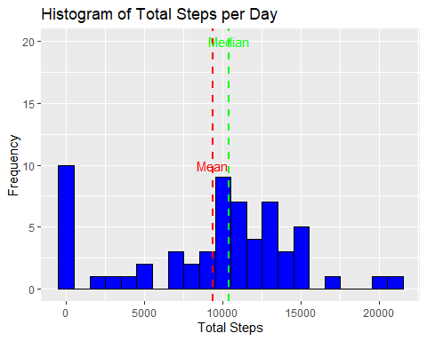

# Save the plot  
ggsave("histogram_plot.png", hist_plot)

## Saving 5 x 4 in image

# Create a time series plot for total steps per day

# Check the structure of data first so as not to confuse poor R  
str(total_steps_per_day)

## tibble [61 × 2] (S3: tbl_df/tbl/data.frame)  
## $ date : chr [1:61] "10/1/2012" "10/10/2012" "10/11/2012" "10/12/2012" ...  
## $ total_steps: int [1:61] 0 9900 10304 17382 12426 15098 10139 15084 13452 10056 ...

# Then, convert 'date' to Date class if it's not already formatted as such  
total_steps_per_day$date <- as.Date(total_steps_per_day$date)  
  
# Next, calculate average of total steps per day  
average_steps <- mean(total_steps_per_day$total_steps, na.rm = TRUE)  
  
time_series_plot <- ggplot(total_steps_per_day, aes(x = date, y = total_steps)) +  
 geom_line(na.rm = TRUE) + # set na.rm = TRUE to remove NA values  
 geom_hline(yintercept = average_steps, color = "red", linetype = "dashed") + # add horizontal line at the average steps  
 labs(title = "Time Series of Total Steps per Day with Hline at the Average Steps", x = "Date", y = "Total Steps") +  
 annotate("text", x = min(total_steps_per_day$date), y = average_steps, label = paste("Average =", round(average_steps)), hjust = -0.1, color = "red") # add text to the average line  
  
# Display the plot  
print(time_series_plot)

## Warning: Removed 1 rows containing missing values (`geom_text()`).

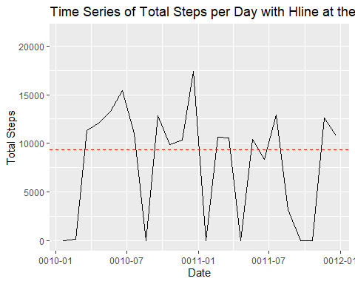

# Save the plot  
ggsave("time_series_plot.png", time_series_plot)

## Saving 5 x 4 in image

## Warning: Removed 1 rows containing missing values (`geom_text()`).

# Time series plot of the average number of steps taken

average_steps_per_interval <- data %>%   
 group_by(interval) %>%   
 summarise(avg_steps = mean(steps, na.rm = TRUE))  
  
max_steps_interval <- average_steps_per_interval$interval[which.max(average_steps_per_interval$avg_steps)]  
  
ggplot(average_steps_per_interval, aes(x=interval, y=avg_steps)) +  
 geom_line(color = "blue") +  
 geom_vline(aes(xintercept = max_steps_interval), color = "red", linetype = "dashed", size = 1) +  
 labs(title="Time Series Plot of Average Steps per Interval: Max Avg Interval Noted", x="Interval", y="Average Steps") +  
 annotate("text", x = max_steps_interval, y = max(average_steps_per_interval$avg_steps), label = "Max Avg Interval", hjust = -0.1, color = "red")

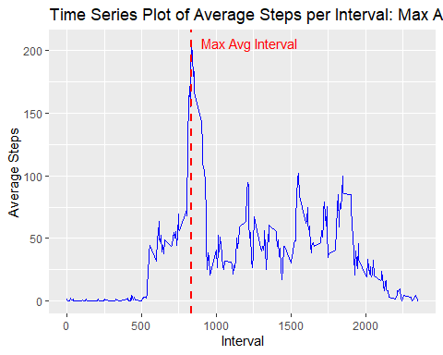

# 5-minute interval that contains the maximum number of steps

max_steps_interval <- average_steps_per_interval$interval[which.max(average_steps_per_interval$avg_steps)]  
  
print(max_steps_interval)

## [1] 835

# Impute missing data with mean of that 5-minute interval  
data_imputed <- data %>%   
 group_by(interval) %>%   
 mutate(steps = ifelse(is.na(steps), mean(steps, na.rm = TRUE), steps))  
  
# Calculate the total number of steps taken each day with the imputed data  
total_steps_per_day_imputed <- data_imputed %>% group_by(date) %>% summarise(total_steps = sum(steps))  
  
# Create the histogram and assign it to a variable  
imputed_steps_plot <- ggplot(total_steps_per_day_imputed, aes(x=total_steps)) +  
 geom_histogram(binwidth = 1000, fill = "blue", color = "black") +  
 labs(title="Histogram of Total Steps per Day (After Imputation)", x="Total Steps", y="Frequency")  
  
# Display the plot  
print(imputed_steps_plot)

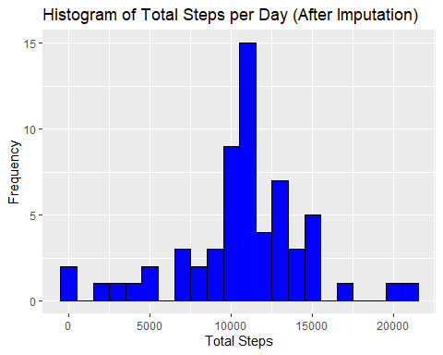

# Save the plot  
ggsave("imputed_steps_plot.png", imputed_steps_plot)

## Saving 5 x 4 in image

# Create a Panel plot comparing the average number of steps taken per 5-minute interval across weekdays and weekends

data_imputed$date <- as.Date(data_imputed$date)  
data_imputed$day_type <- ifelse(weekdays(data_imputed$date) %in% c("Saturday", "Sunday"), "weekend", "weekday")  
average_steps_per_interval_day_type <- data_imputed %>% group_by(interval, day_type) %>% summarise(avg_steps = mean(steps))

## `summarise()` has grouped output by 'interval'. You can override using the  
## `.groups` argument.

ggplot(average_steps_per_interval_day_type, aes(x=interval, y=avg_steps)) +  
 geom_line() +  
 facet_wrap(~day_type, ncol = 1, scales = "free_y") +  
 labs(title="Average Steps per Interval: Weekday vs Weekend", x="Interval", y="Average Steps")

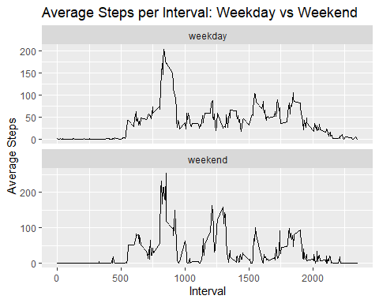

# Assign the ggplot object to a variable named panel_plot  
panel_plot <- ggplot(average_steps_per_interval_day_type, aes(x=interval, y=avg_steps)) +  
 geom_line() +  
 facet_wrap(~day_type, ncol = 1, scales = "free_y") +  
 labs(title="Average Steps per Interval: Weekday vs Weekend", x="Interval", y="Average Steps")  
  
# Display the plot  
print(panel_plot)



# Save the plot  
ggsave("panel_plot.png", panel_plot)

## Saving 5 x 4 in image

# Are there differences in activity patterns between weekdays and weekends?

Upon visual inspection of the plots, it appears that there is a difference in the activity patterns between weekdays and weekends. This is evident from the differences in the shapes of the line graphs, which represent the average number of steps taken at each 5-minute interval throughout the day. To confirm this, I performed a statistical test (t-test, Wilcoxon, and two-way ANOVA (while one would suffice all were per my choice and fun), which indicated a significant difference (p-value < 0.05). Thus, I can conclude that there are indeed differences in the activity patterns between weekdays and weekends.