Project Group 15

Lingxuan Gao , Enkai Ji , Huixiong Qin

We use d3.js in this project

**Uncolored drawing of the given graph**

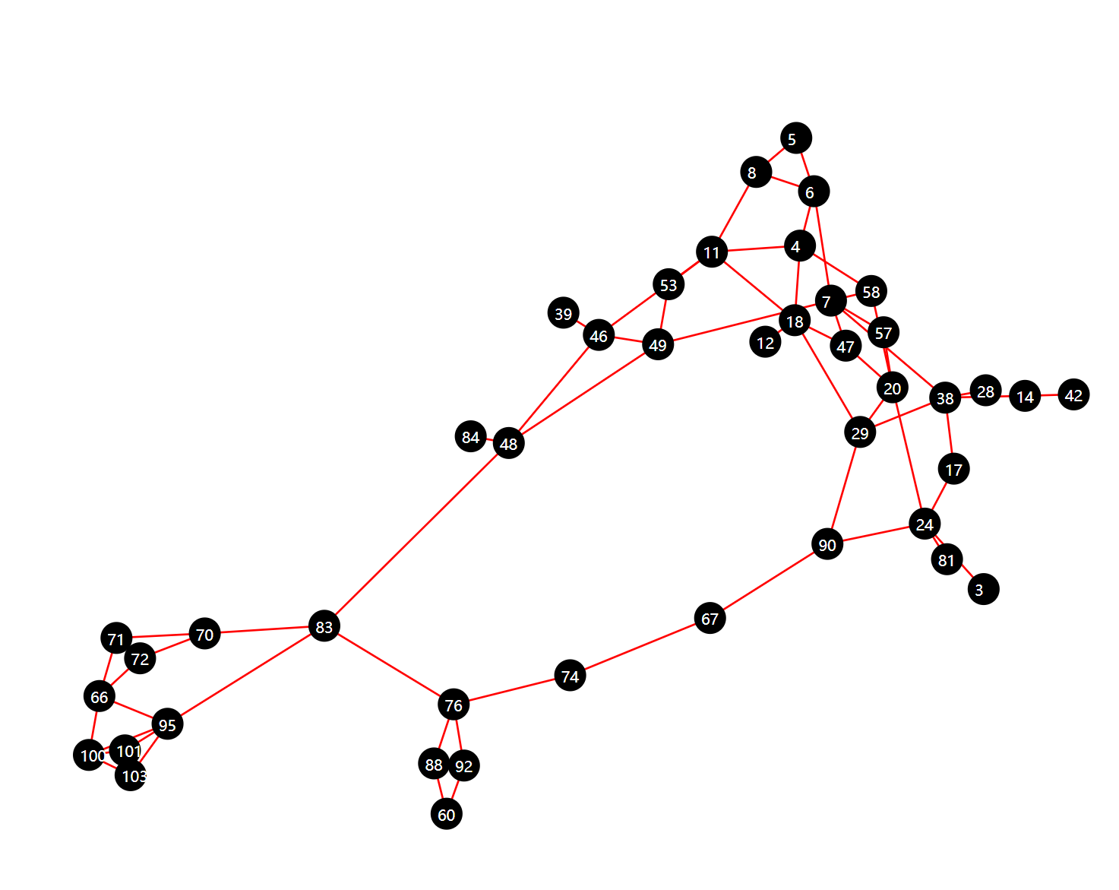

**The plot of the graph degree distribution**

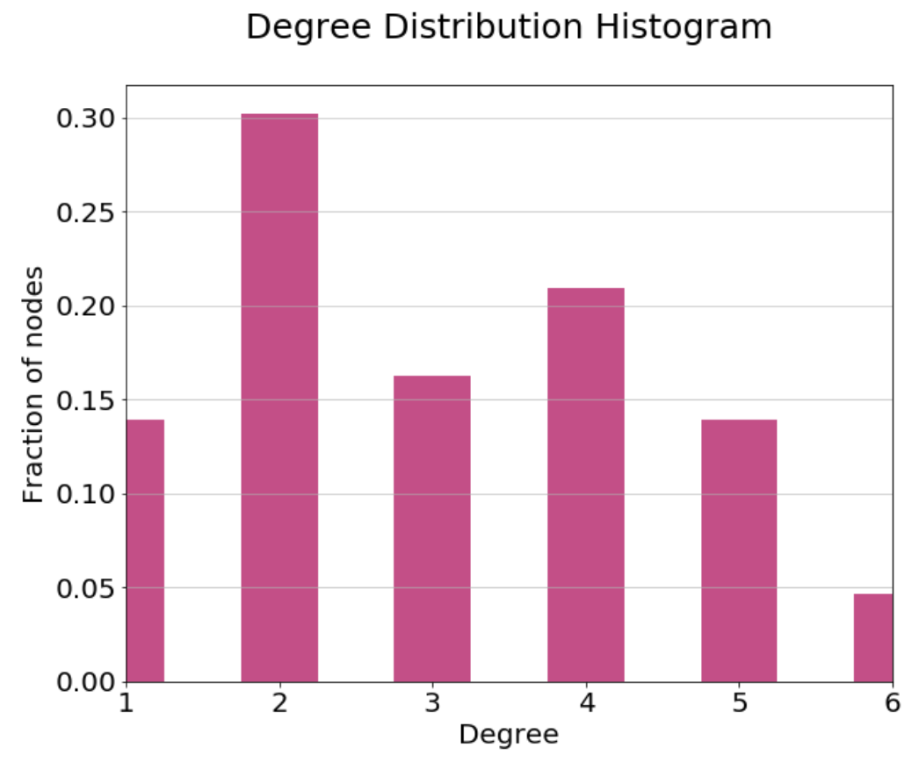

**Edges colored according to the biconnected components**

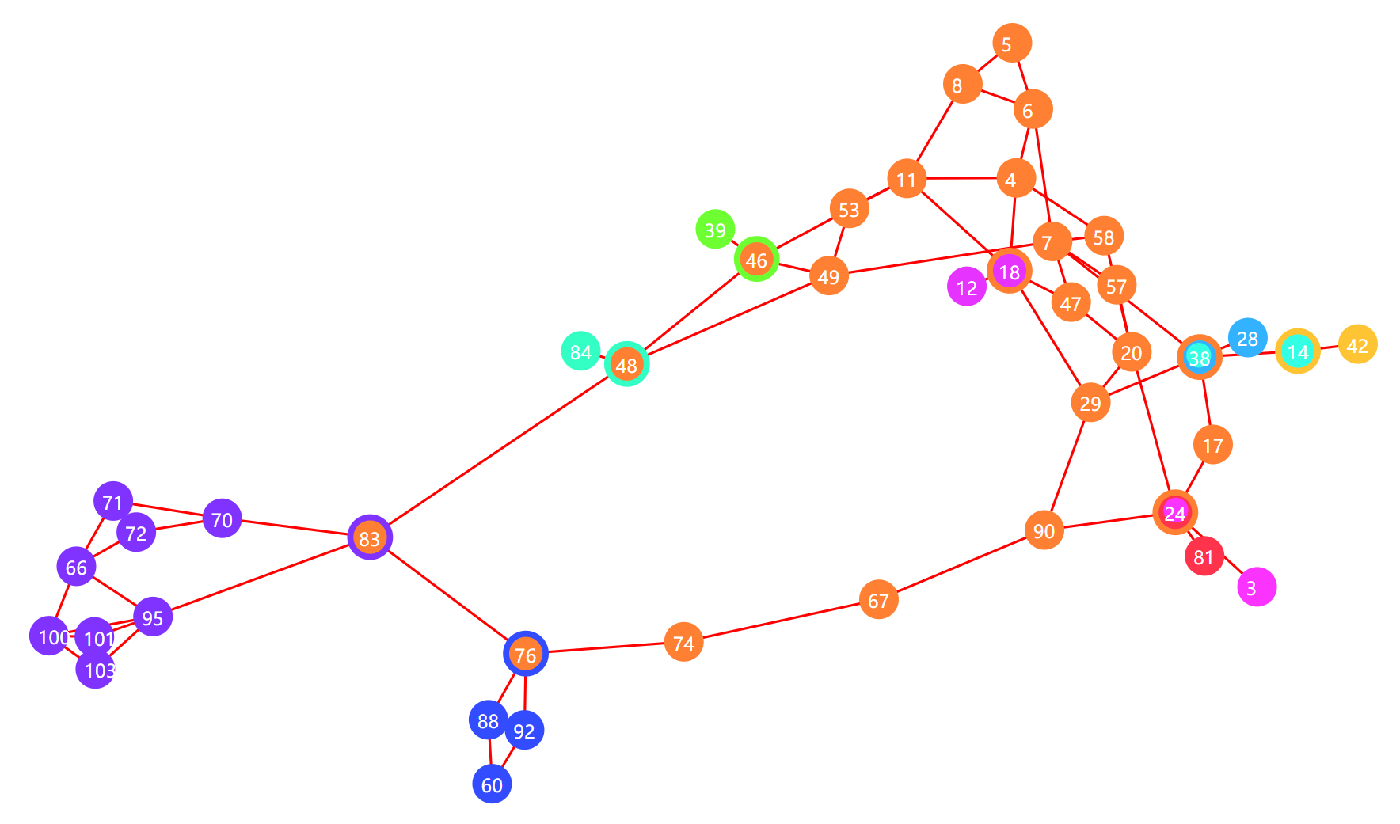

**Biconnected Metagraph**

