

**Activity Scheduler**

User’s Manual

|  |  |
| --- | --- |
| **Section** | G01 |
| **Team Members** | Fernandez, Ryan Austin  Poblete, Clarisse Felicia M. |
| **Date Submitted** | August 27, 2016 |

**Table of Contents**

Registering for, Logging into, Logging out of, and Editing an Account / 1

Adding, Editing, and Deleting Target Groups / 2

Adding, Editing, and Deleting Venues / 4

Creating, Editing, and Deleting a Session / 6

Adding, Editing, and Deleting Activities / 8

Generating a Schedule / 10

**Registering for, Logging into, Logging out of, and Editing an Account**

Accounts contain all information, sessions, activities and schedules associated with a user.

**Registering**

The user must register for an account on the Activity Scheduler before using the application.

1. Click the **Register** link



1. Fill out the necessary information
2. Click the **Submit** button

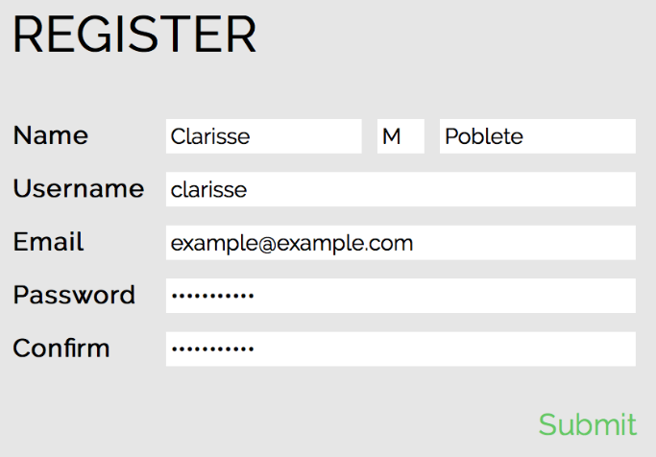

**Logging In**

The user must be logged in to use the Activity Scheduler.

1. Fill out username and password
2. Click the **Login** button

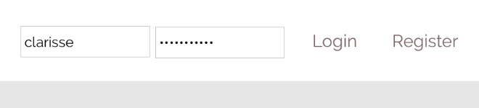

**Logging Out**

The user must log out of his/her account in order to prevent others from using his/her account.

1. Click the **Logout** button

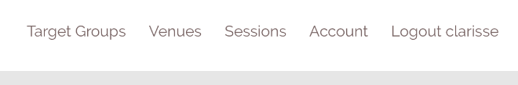

**Editing**

The user may edit his/her account information

1. While logged in, click the **Account** link



1. Fill out new account information
2. Click the **Submit** button to save changes

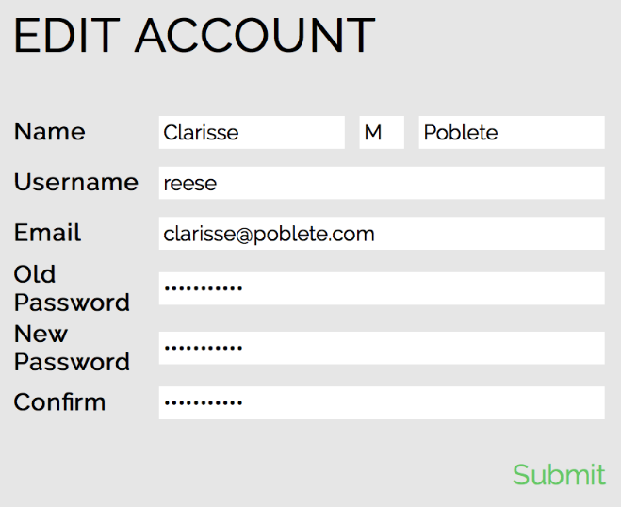

**Adding, Editing, and Deleting Target Groups**

Target groups represent the groups of people each activity is intended for. Activities may cater to similar or different or similar target groups, and may also cater to more than one target group.

**Adding**

The user must add target groups to his/her account before adding them to activities.

1. Click the **Target Groups** link



1. Click the **Add Target Group** button

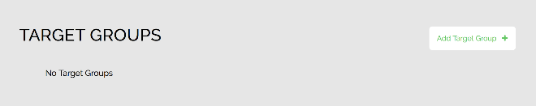

1. Fill out target group name
2. Click the **Confirm** button to add the target group

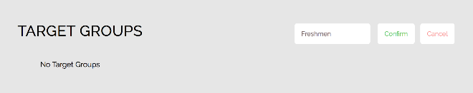

**Editing**

The user may edit a target group’s name.

1. Go to the list of target groups
2. Click the edit icon beside the name of the target group to be edited

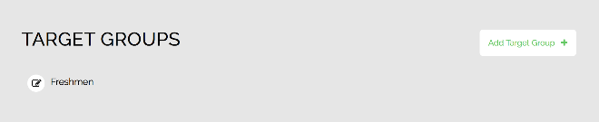

1. Fill out the new name for the selected target group
2. Click the **Confirm** button to save changes made to the target group

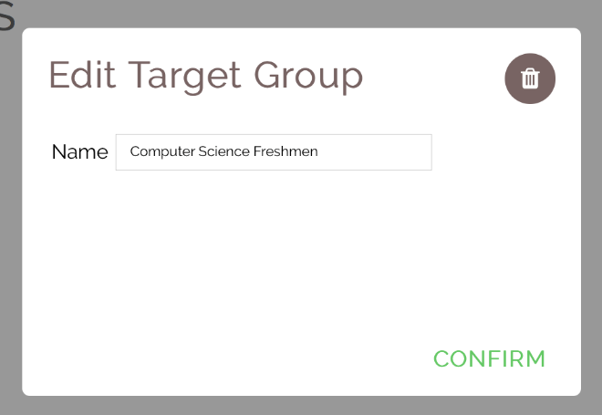

**Adding, Editing, and Deleting Target Groups**

**Deleting**

The user may delete a target group.

1. Go to the list of target groups
2. Click the edit icon beside the name of the target group to be deleted

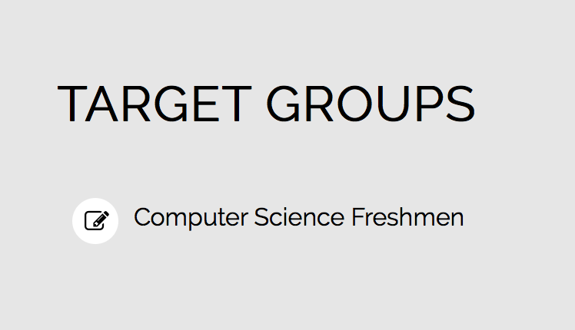

1. Click the trash icon on the corner of the edit dialog to delete the target group



**Adding, Editing, and Deleting Venues**

Venues represent the locations where activities are held.

**Adding**

The user must add venues to his/her account before adding them to activities.

1. Click the **Venues** link



1. Click the **Add Venue** button

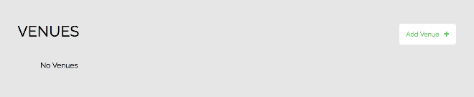

1. Fill out venue name
2. Click the **Confirm** button to finish adding the venue

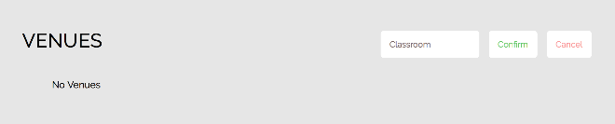

**Editing**

The user may edit a venue’s name.

1. Go to the list of venues
2. Click the edit icon beside the name of the venue to be edited.

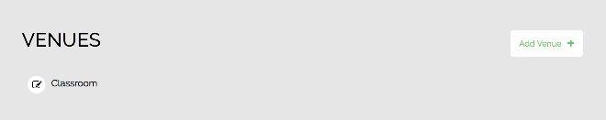

1. Fill out the new name for the selected venue
2. Click the **Confirm** button to save changes made to the venue

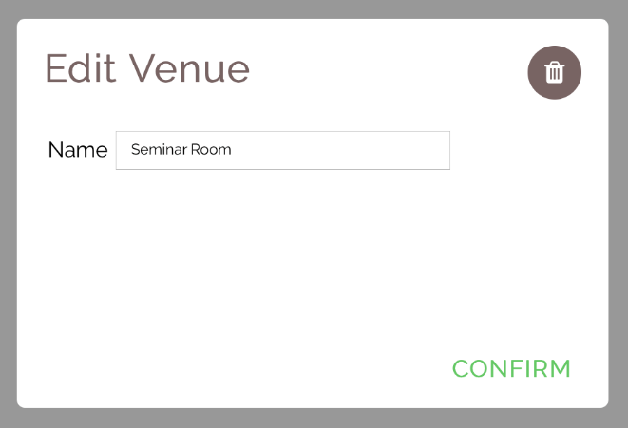

**Adding, Editing, and Deleting Venues**

**Deleting**

The user may delete a venue.

1. Go to the list of venues
2. Click the edit icon beside the name of the venue to be deleted

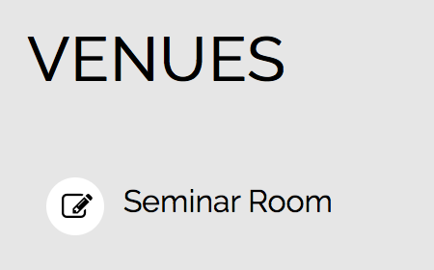

1. Click the trash icon on the corner of the edit dialog to delete the venue



**Creating, Editing, and Deleting a Session**

A sessions represent all the details of a schedule. These details include:

* Name of the session
* Start and end date that bounds the limits of the schedule
* Restricted activity dates and times wherein no activities can be scheduled
* List of activities to be scheduled

**Adding**

The user must create a session in order to add activities and generate schedules.

1. Click the **Sessions** link



1. Click the **Add Session** button

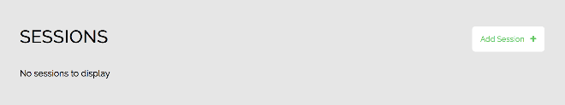

1. Fill out necessary information

Take note:

* The plus button for the specific date must be clicked to add that to the list of restricted dates
* The plus button for the specific time must be clicked to add that time range to the list of restricted times
* Times must be indicated in 24-hour format
  + E.g. 1300 for 1PM

1. Click the **Submit** button to add the session

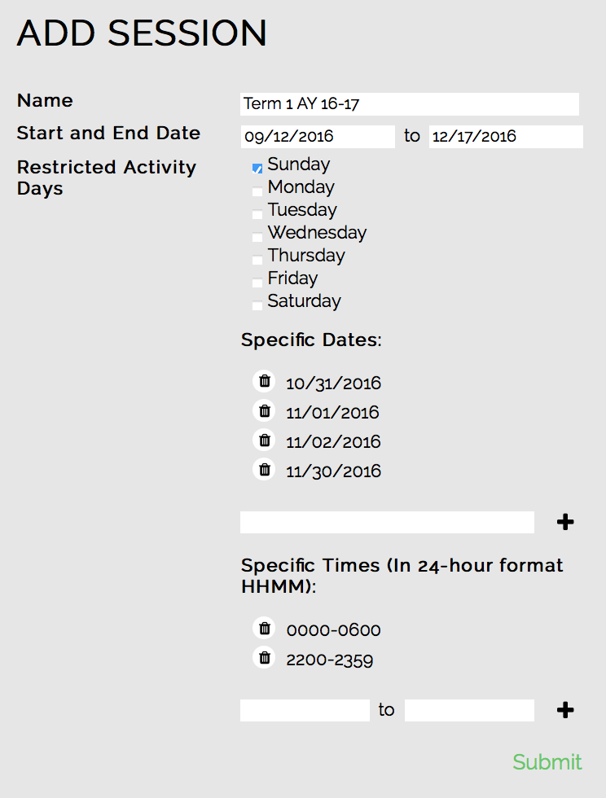

**Creating, Editing, and Deleting a Session**

**Editing**

The user may edit a session’s details after adding it.

1. Go to the list of sessions
2. Click the edit icon on the row of the session to be edited

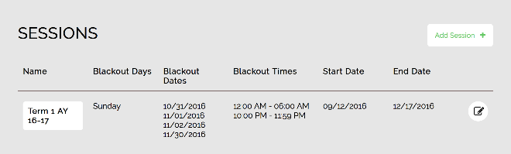

1. Fill out the new session details
2. Click the **Submit** button to save changes

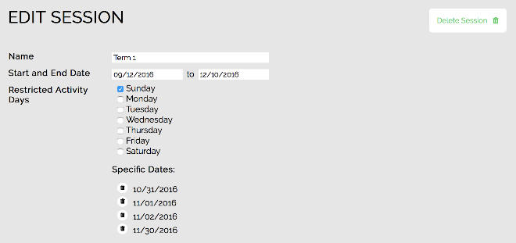

**Deleting**

The user may delete a session.

1. Go to the list of sessions
2. Click the edit icon on the row of the session to be deleted



1. Click the **Delete Session** button to delete the session



**Adding, Editing, and Deleting Activities**

Activities are the main component of a session and of the schedule to be generated. Activities are represented by several details. These details include:

* Name of the activity
* Venue of the activity
* Length of the activity in minutes
* Possible days the activity can be scheduled
* Groups of people the activity targets as participants
* Possible times the activity can be scheduled

**Adding**

The user must add activities and their details in order to generate a schedule.

1. Go to the session the activity will be added to
2. Click the name of the schedule to add activities to



1. Click the **Add Activity** button

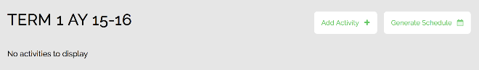

1. Fill out the necessary details

Take note:

* A venue must be added to the account before adding the venue to an activity
* A target group must be added to the account before adding the target group to an activity
* The plus button for the specific date must be clicked to add that to the list of restricted dates
* The **Select All** button may be clicked to select all target groups
* Times must be indicated in 24-hour format
  + E.g. 1300 for 1PM

1. Click the **Submit** button to add the activity

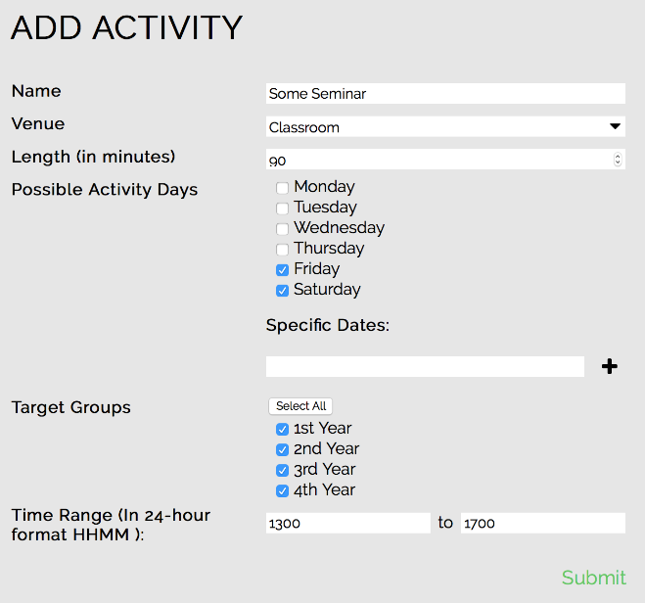

**Adding, Editing, and Deleting Activities**

**Editing**

The user may edit an activity’s details after adding it.

1. Go to the session containing the activity to be edited
2. Click the edit icon on the row of the activity to be edited

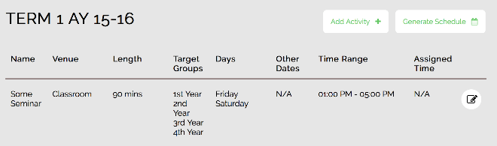

1. Fill out the new activity details
2. Click the **Submit** button to save changes

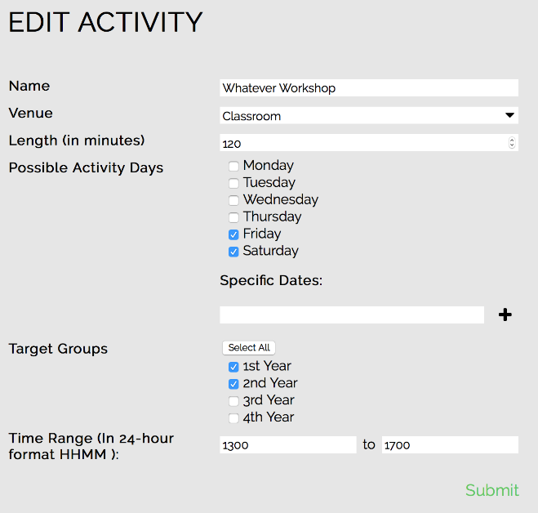

**Deleting**

The user may delete an activity

1. Go to the session containing the activity to be deleted
2. Click the edit icon on the row of the activity to be deleted

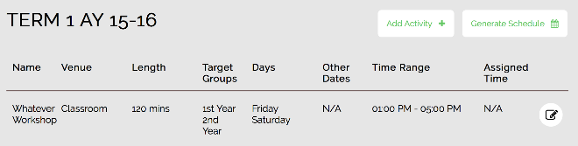

1. Click the **Delete Activity** button to delete the activity

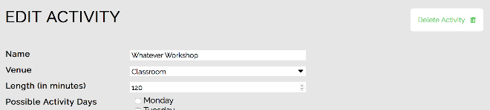

**Generating a Schedule**

Schedules can be generated based on a session’s information and activities. Generated schedules aim to have minimal conflicts among a session’s activities.

1. Go to the session that the schedule will be generated for
2. Click the **Generate Schedule** button

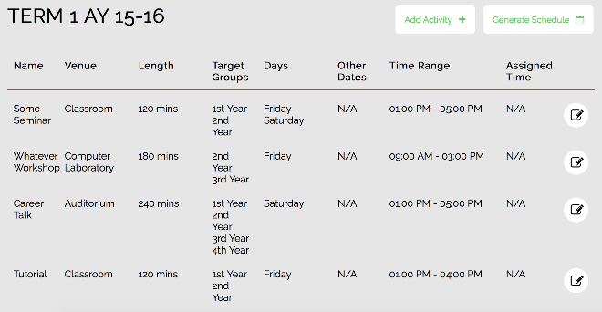

Take note:

* Generated activity times will appear in the **Assigned Time** column of the session
* Refreshing the page arranges the activities by their assigned times

